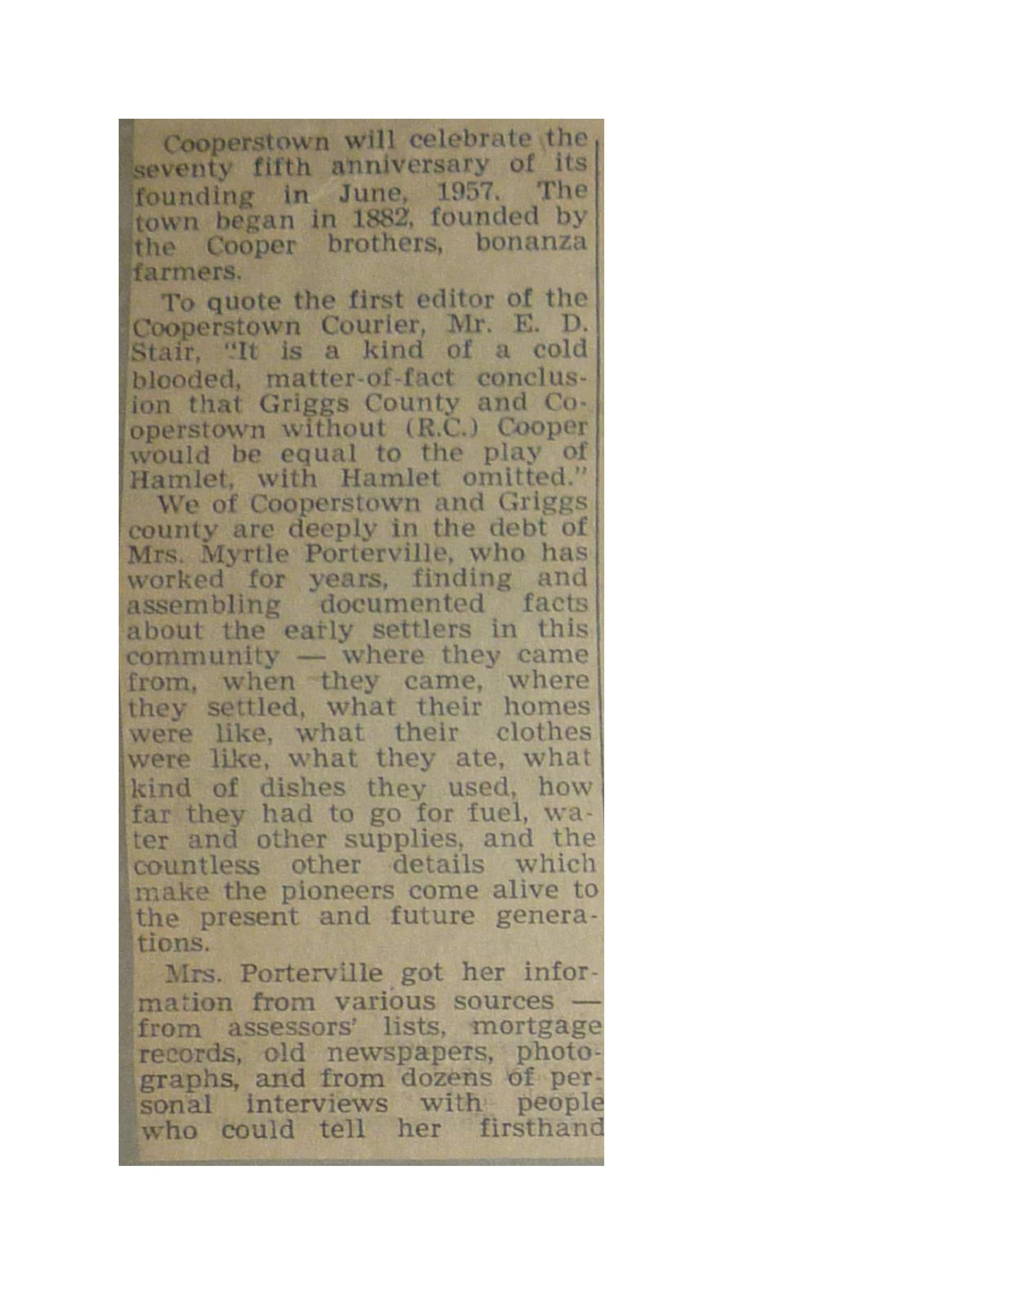
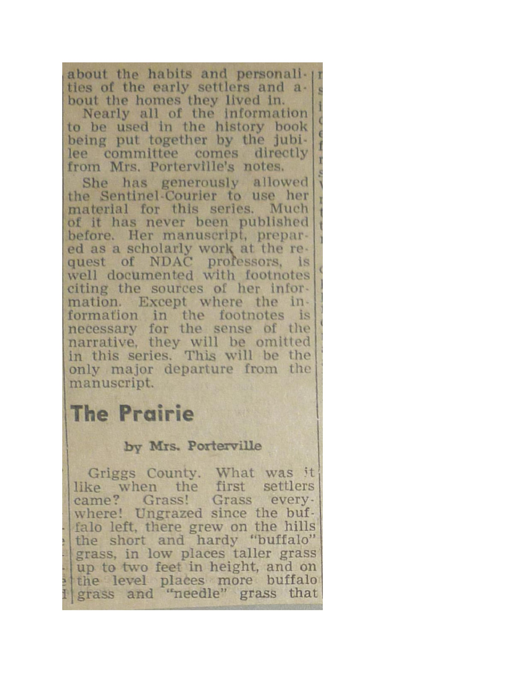
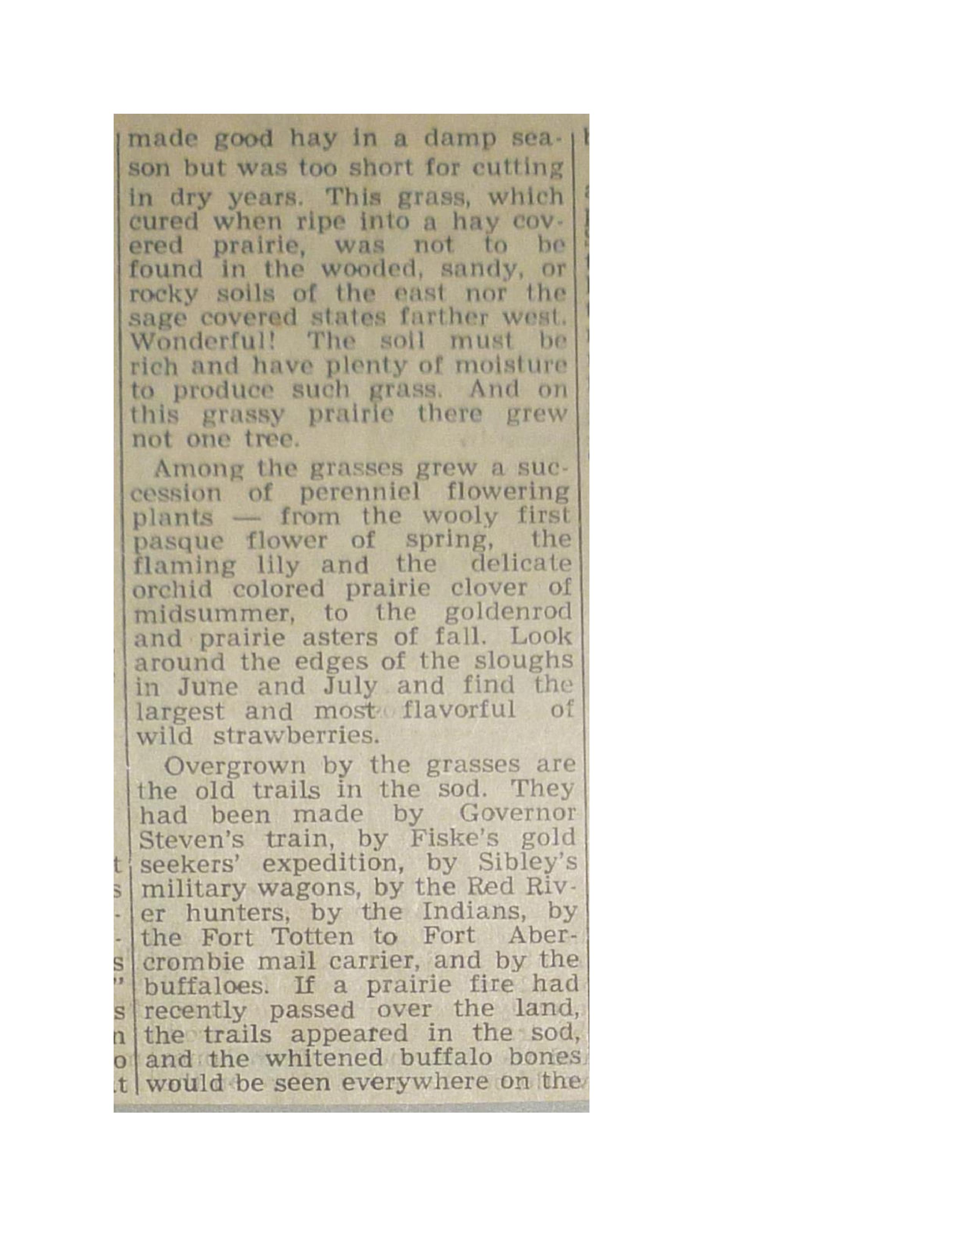
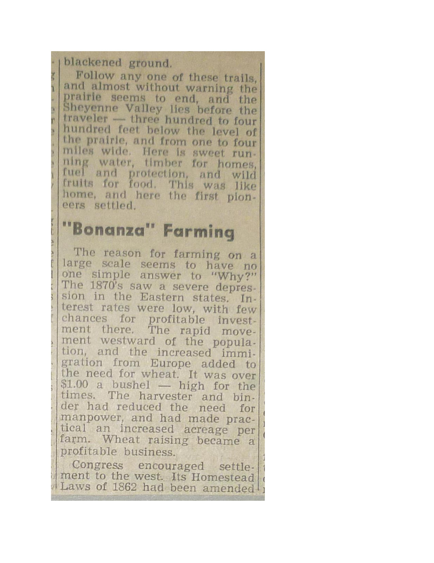
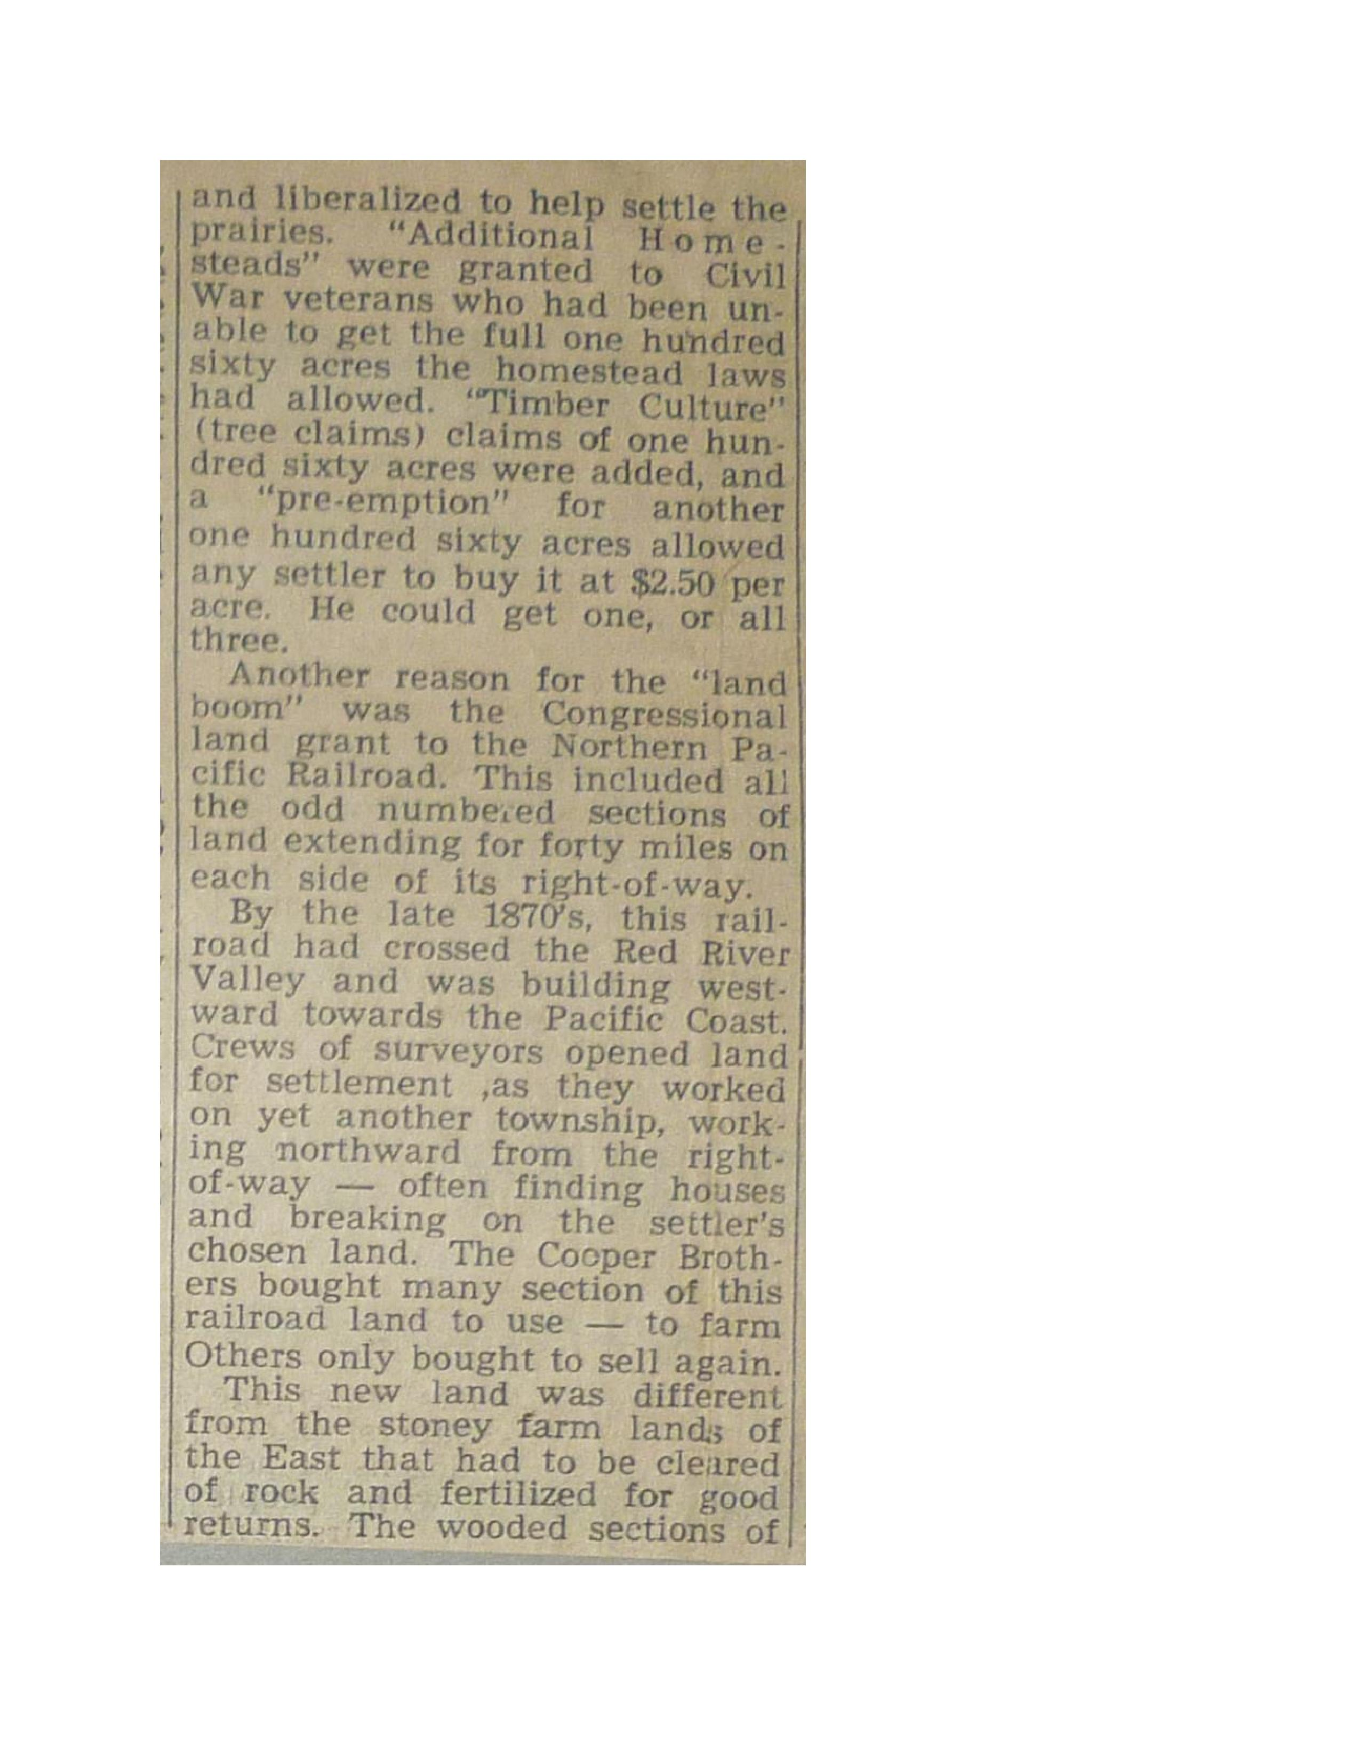
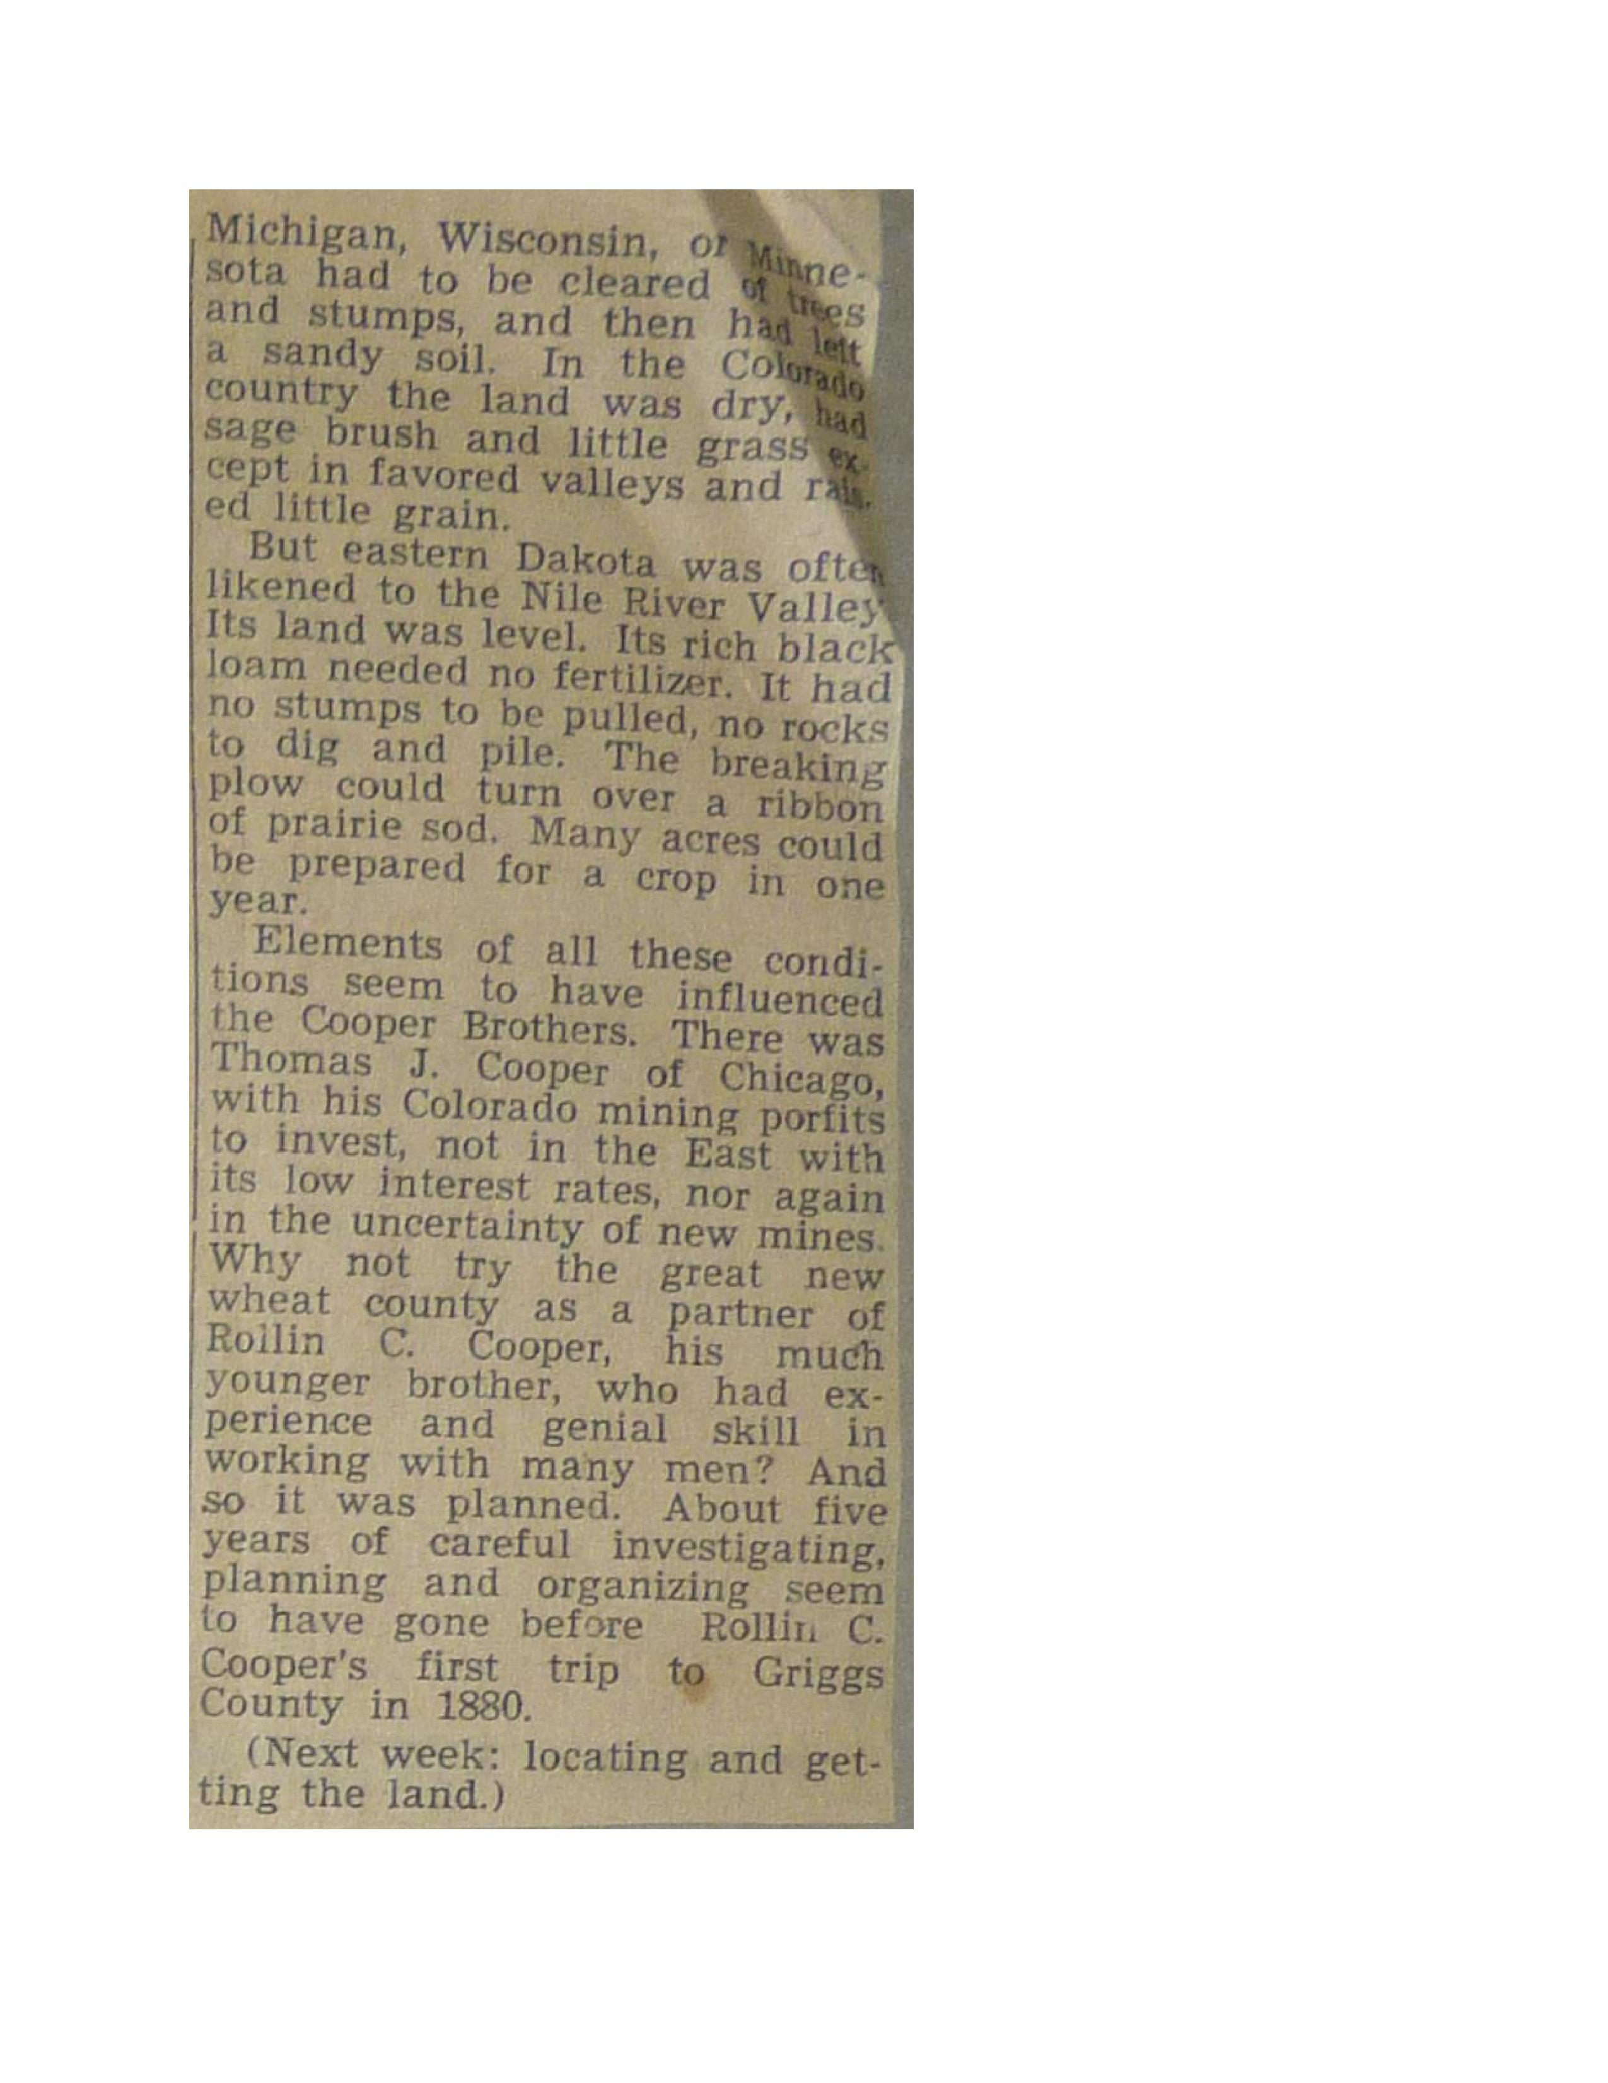
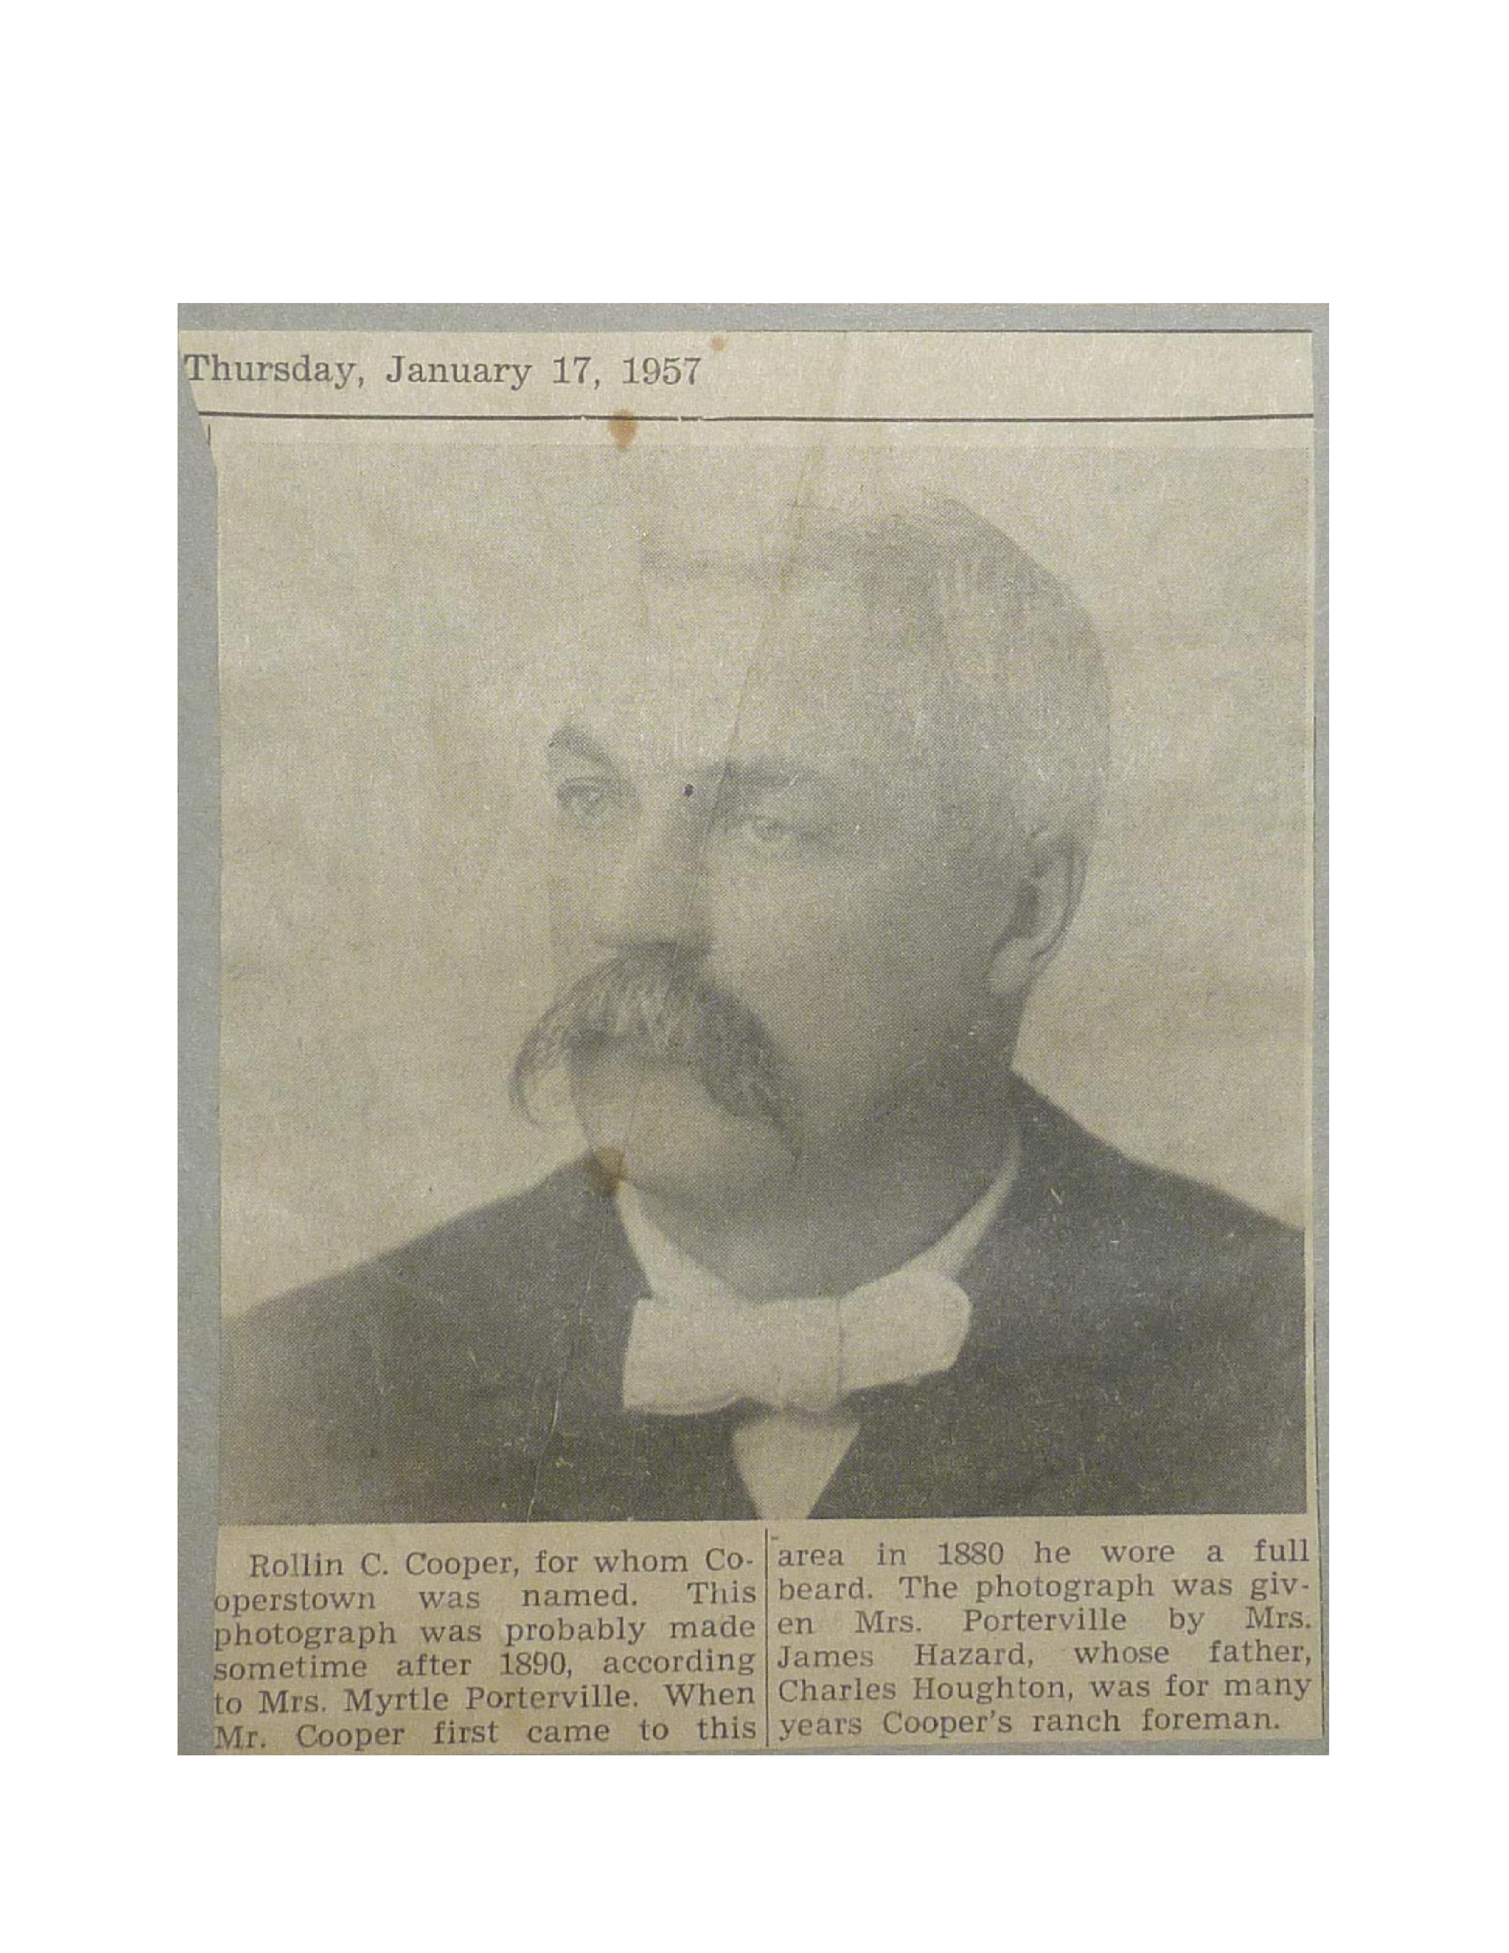
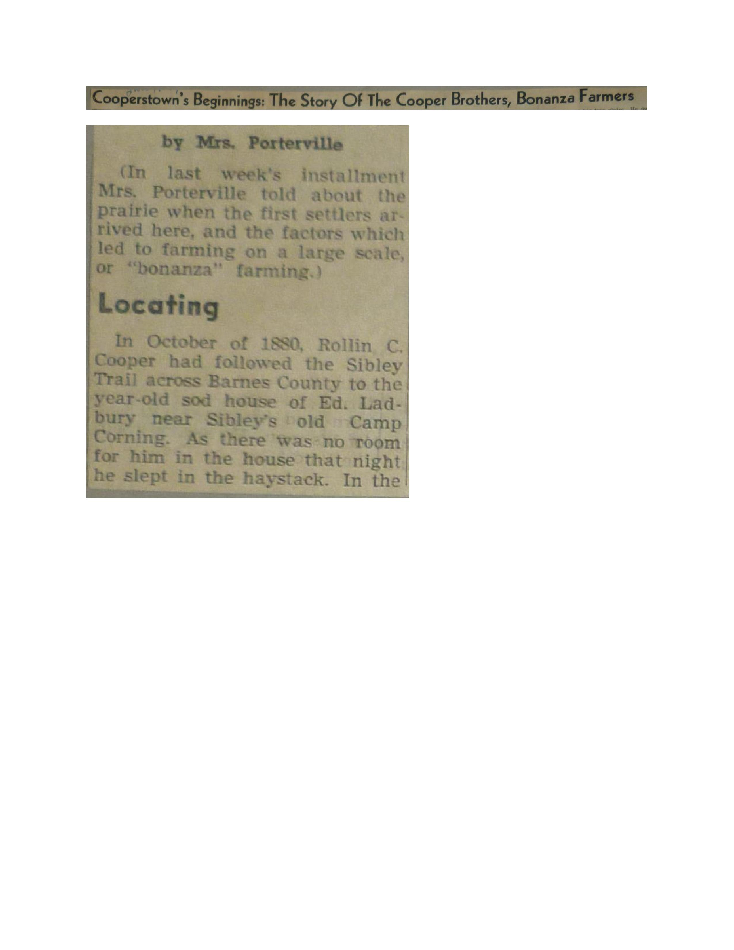
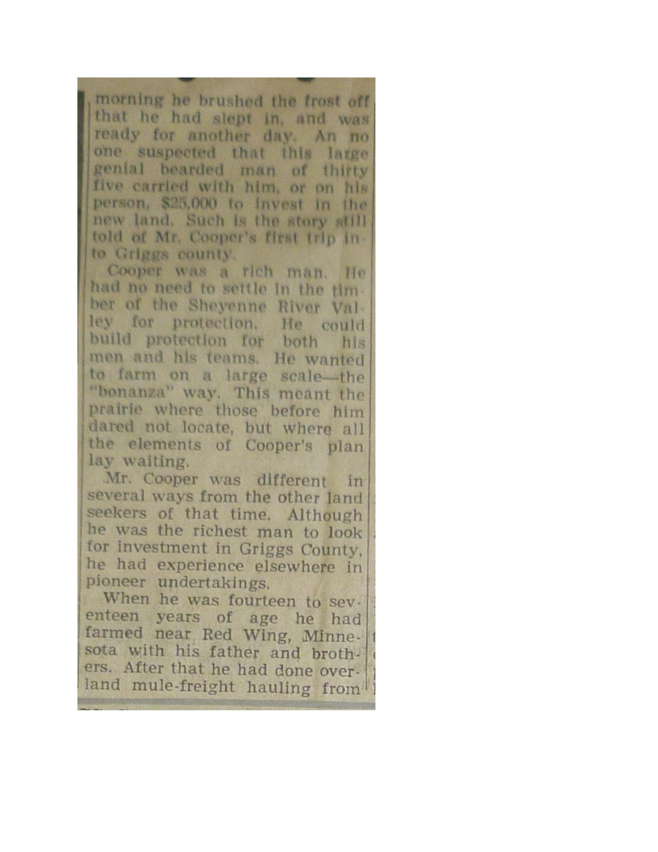
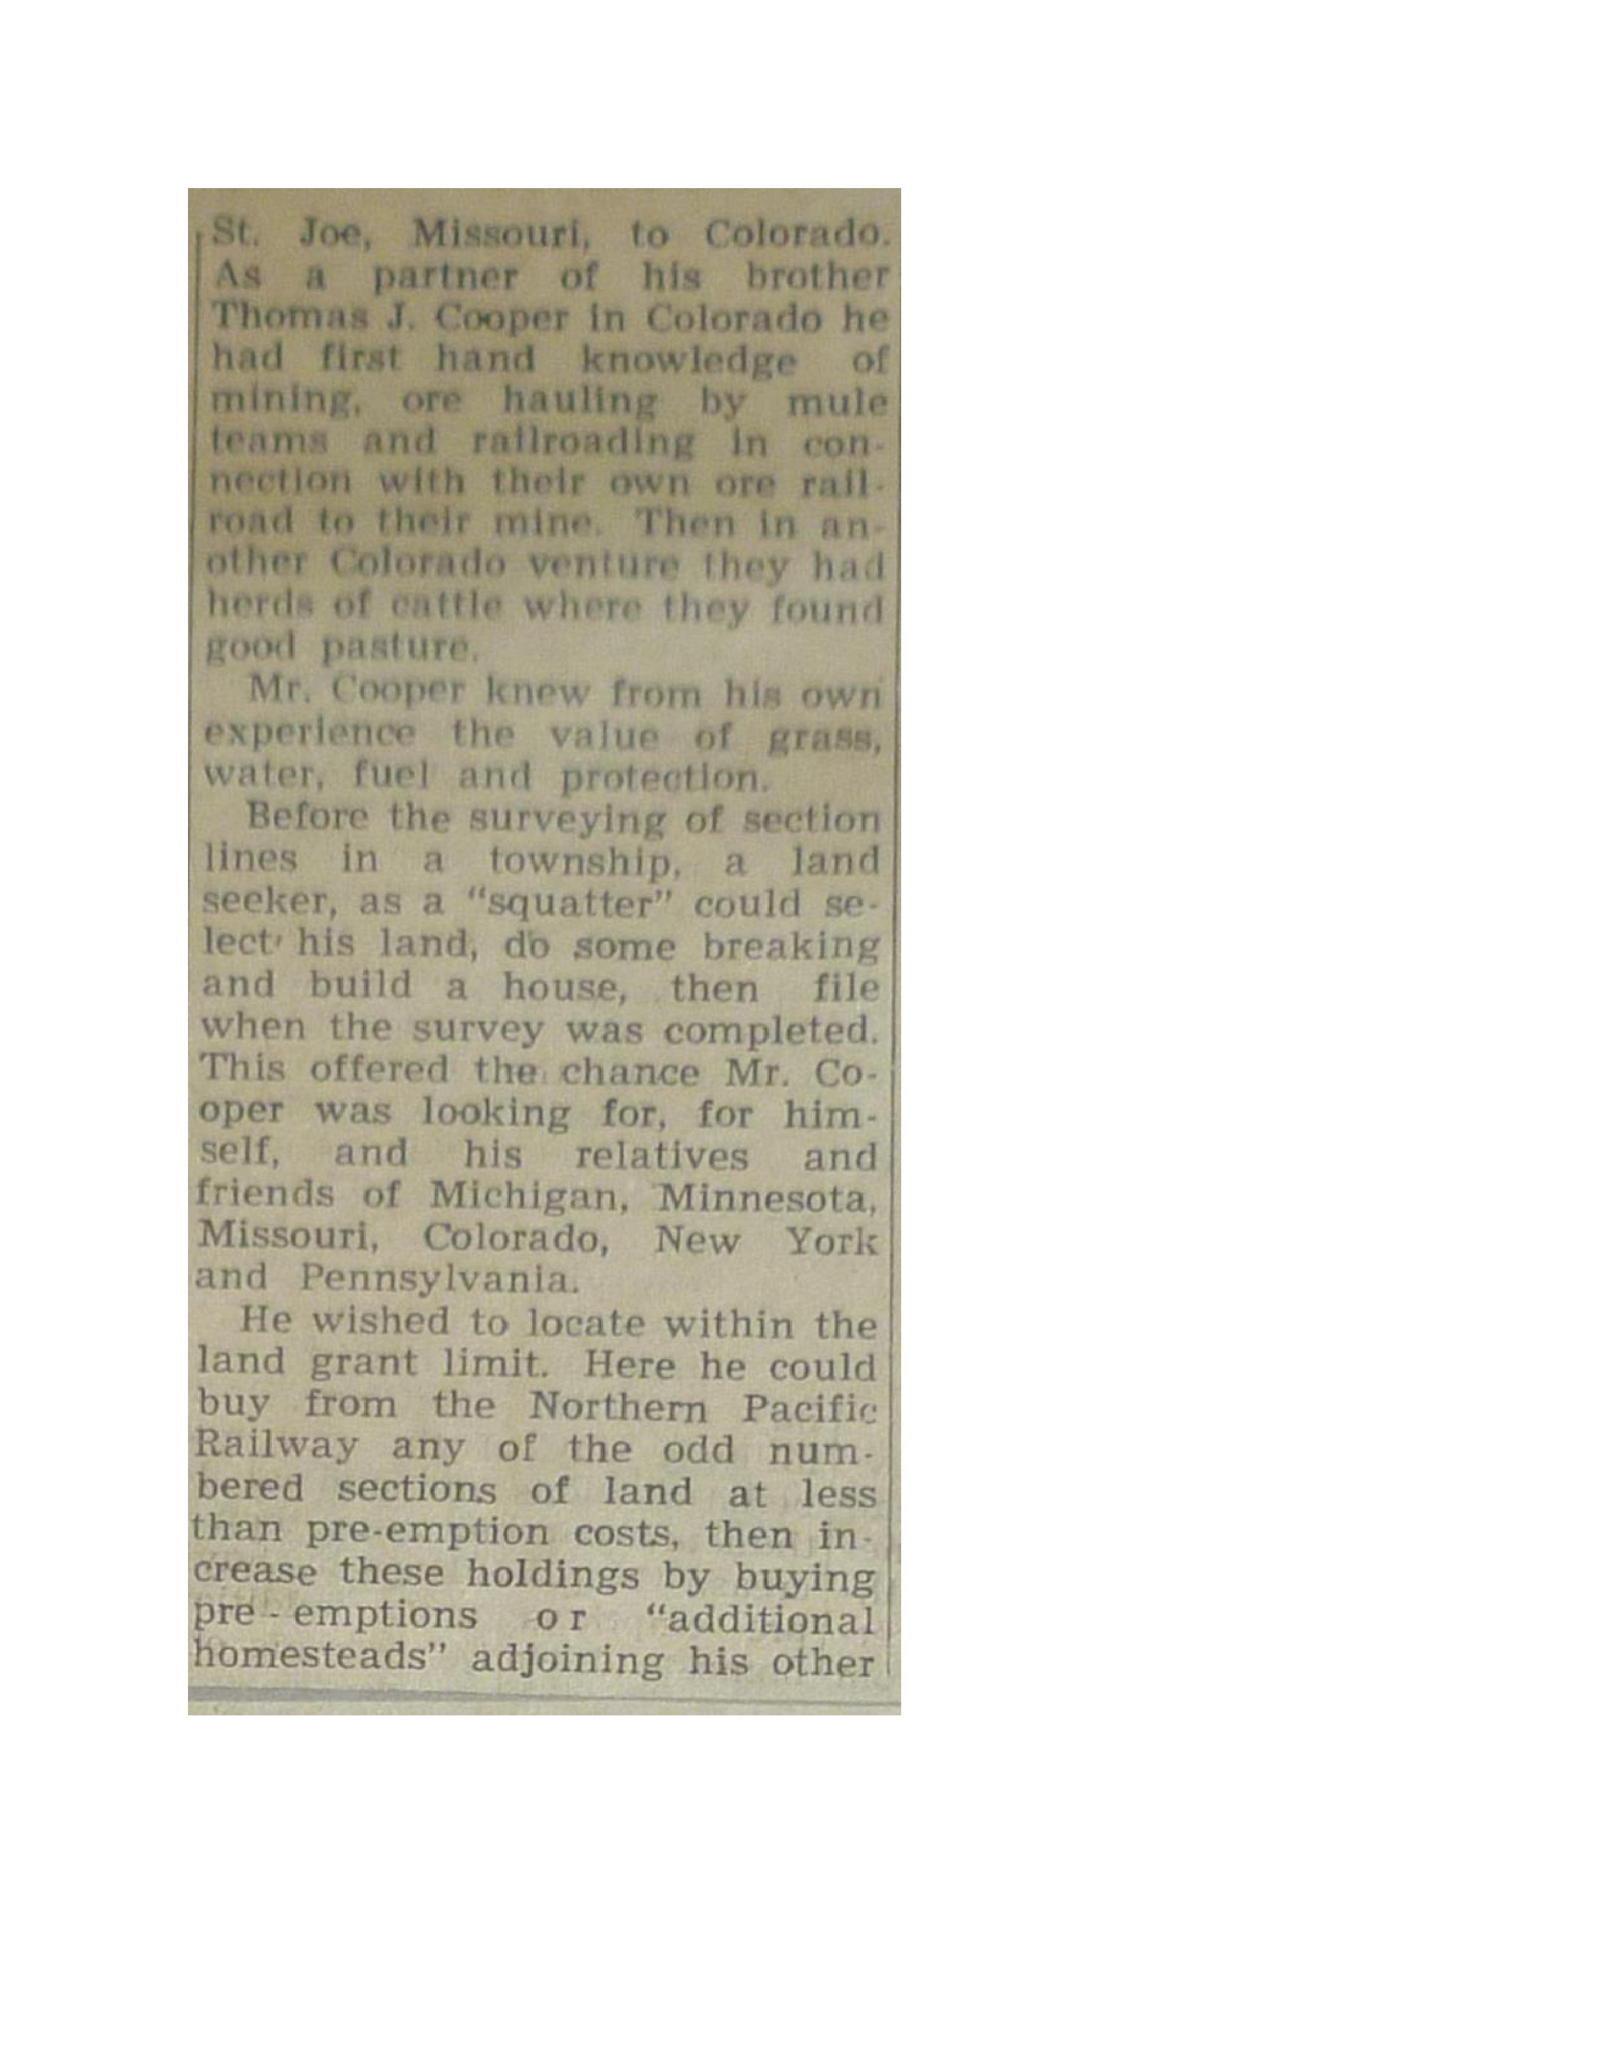
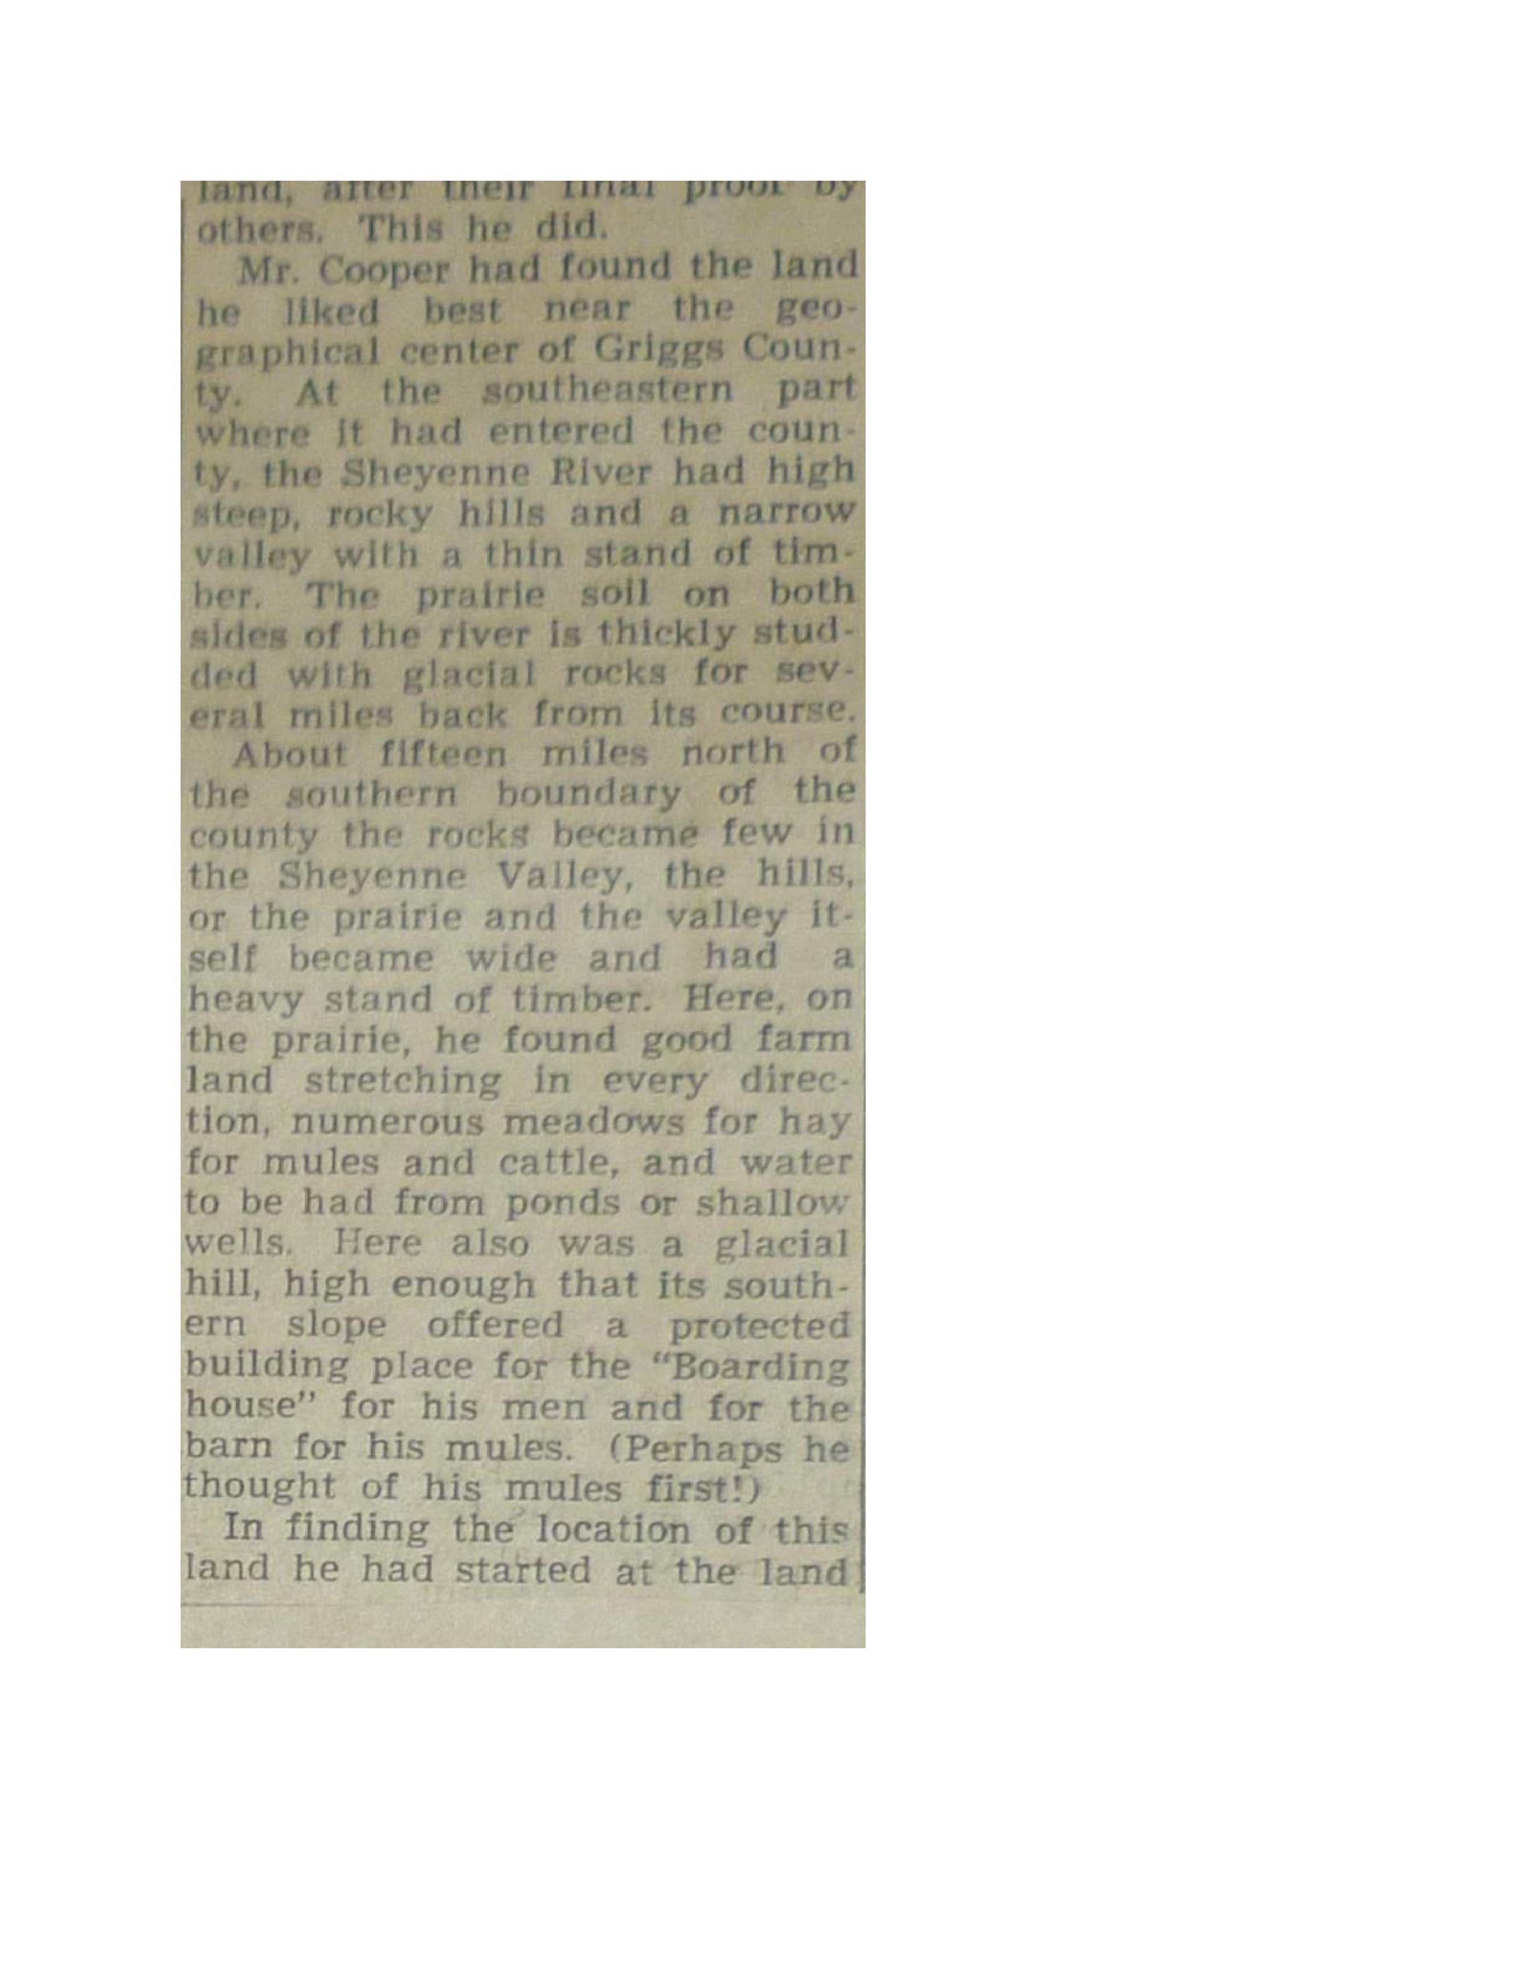
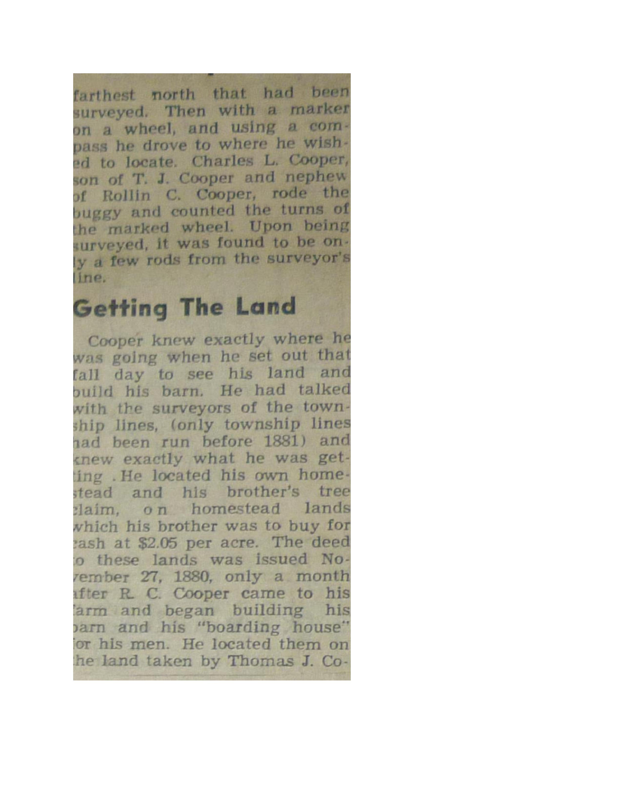
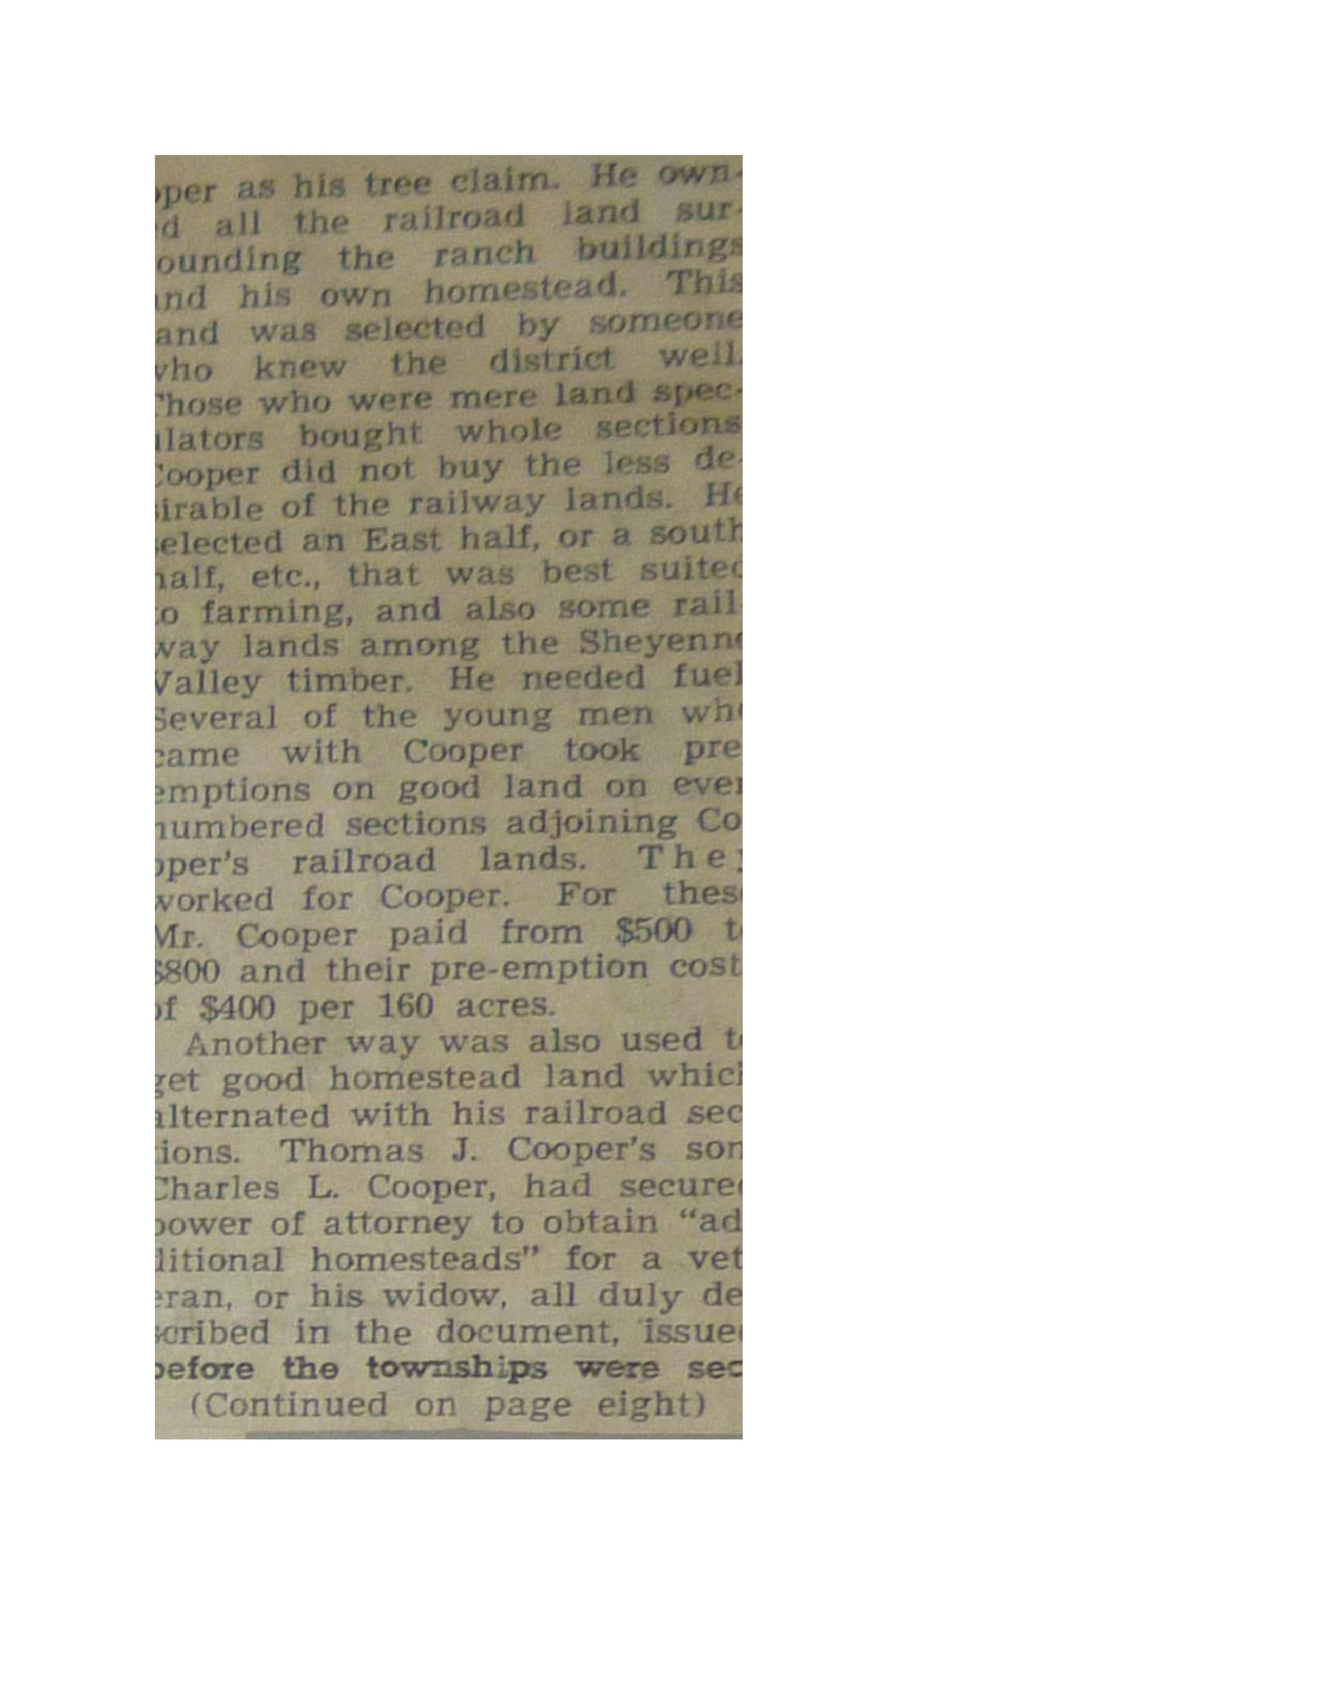
tionalize One was dated Aug. ust 24, Ifig8, and five in 188C from litinkry 21. to Septembei 14, all before Cooper had seen the 1::trui.
The Start
The buildings of the Coope4
'4 Brothers differed from those of the average homesteader. Untif the Coopers came the only set-tlers' buildings in Griggs County were in the valley of the Shey-enne River, because it was a common belief that no one could live on the open prairie. Their houses were of log, or sod, or were "dug outs"—a part base-ment or cave, the rest being of logs or sod, or a combination of both.
But Cooper had planned to farm on a large scale, on the prairie, arid he had the money with which to buy and build. His first need on the prairie ‘vas
:1 for proper buildings.
"Cooper Brothers loaded today and started for their ranch thirty-five miles due north of
'-*''Sanbom. Seventy - five teams
,:with lumber, general supplies,
- merchandise and so on, and they have fifteen carloads of lumber shipped to that point, and daily expect six carloads of oats from Minnesota. They are enterpri-
i.-fiing, energetic and thorough bus-iness men, and they are doing a great deal for the prosperity and development of this part of
ilnienta
ug- "They pay forty cents per 880 hundred pounds for hauling to ber their ranche, which the farmers' 2en nearby all improve the oppor-
tunity to earn a few dollars, by
making a few trips north before
the winter sets in. Cooper Broth-
rs have just finished their per building 20x40 on Main Street." of (From the Daily Argus of Far- 1 Itil go, Dakota Territory of Nov. 11, et- 1880, quoting Sanborn Progress itY of Nov. 8, 1880).
Y- "They have about finished the
a ,hauling of a hundred and fifty ld thousand feet of lumber for
building." (Daily Argus, quoting or Sanborn Progress of Nov. 15. e- 1880).
of "This same fall Cooper bought
Di 1000 bushels of oats from Ole J.
Noe who lived thirteen and a
:o :half east of Sanborn. Mr. Coop-
e tier's freight line came and tool:
y Aft all up in one trip." (told by
J. Moe, son of Ole J. Moe.)
s Mr. Cooper outfitted first at
.;Fargo, for his earliest freighting,
with tents for protection of hip, 1 men and mules. As Mr. Cooper's
f big shipment of Missouri mules
did not come until the spring of 1881, there seems little question but that part of his lumber and supplies of 1880 were hauled for him by the early settlers near Sanborn and Valley City.
"At the same time they built / a long shed stable (30x100 feet) in the vicinity of the present
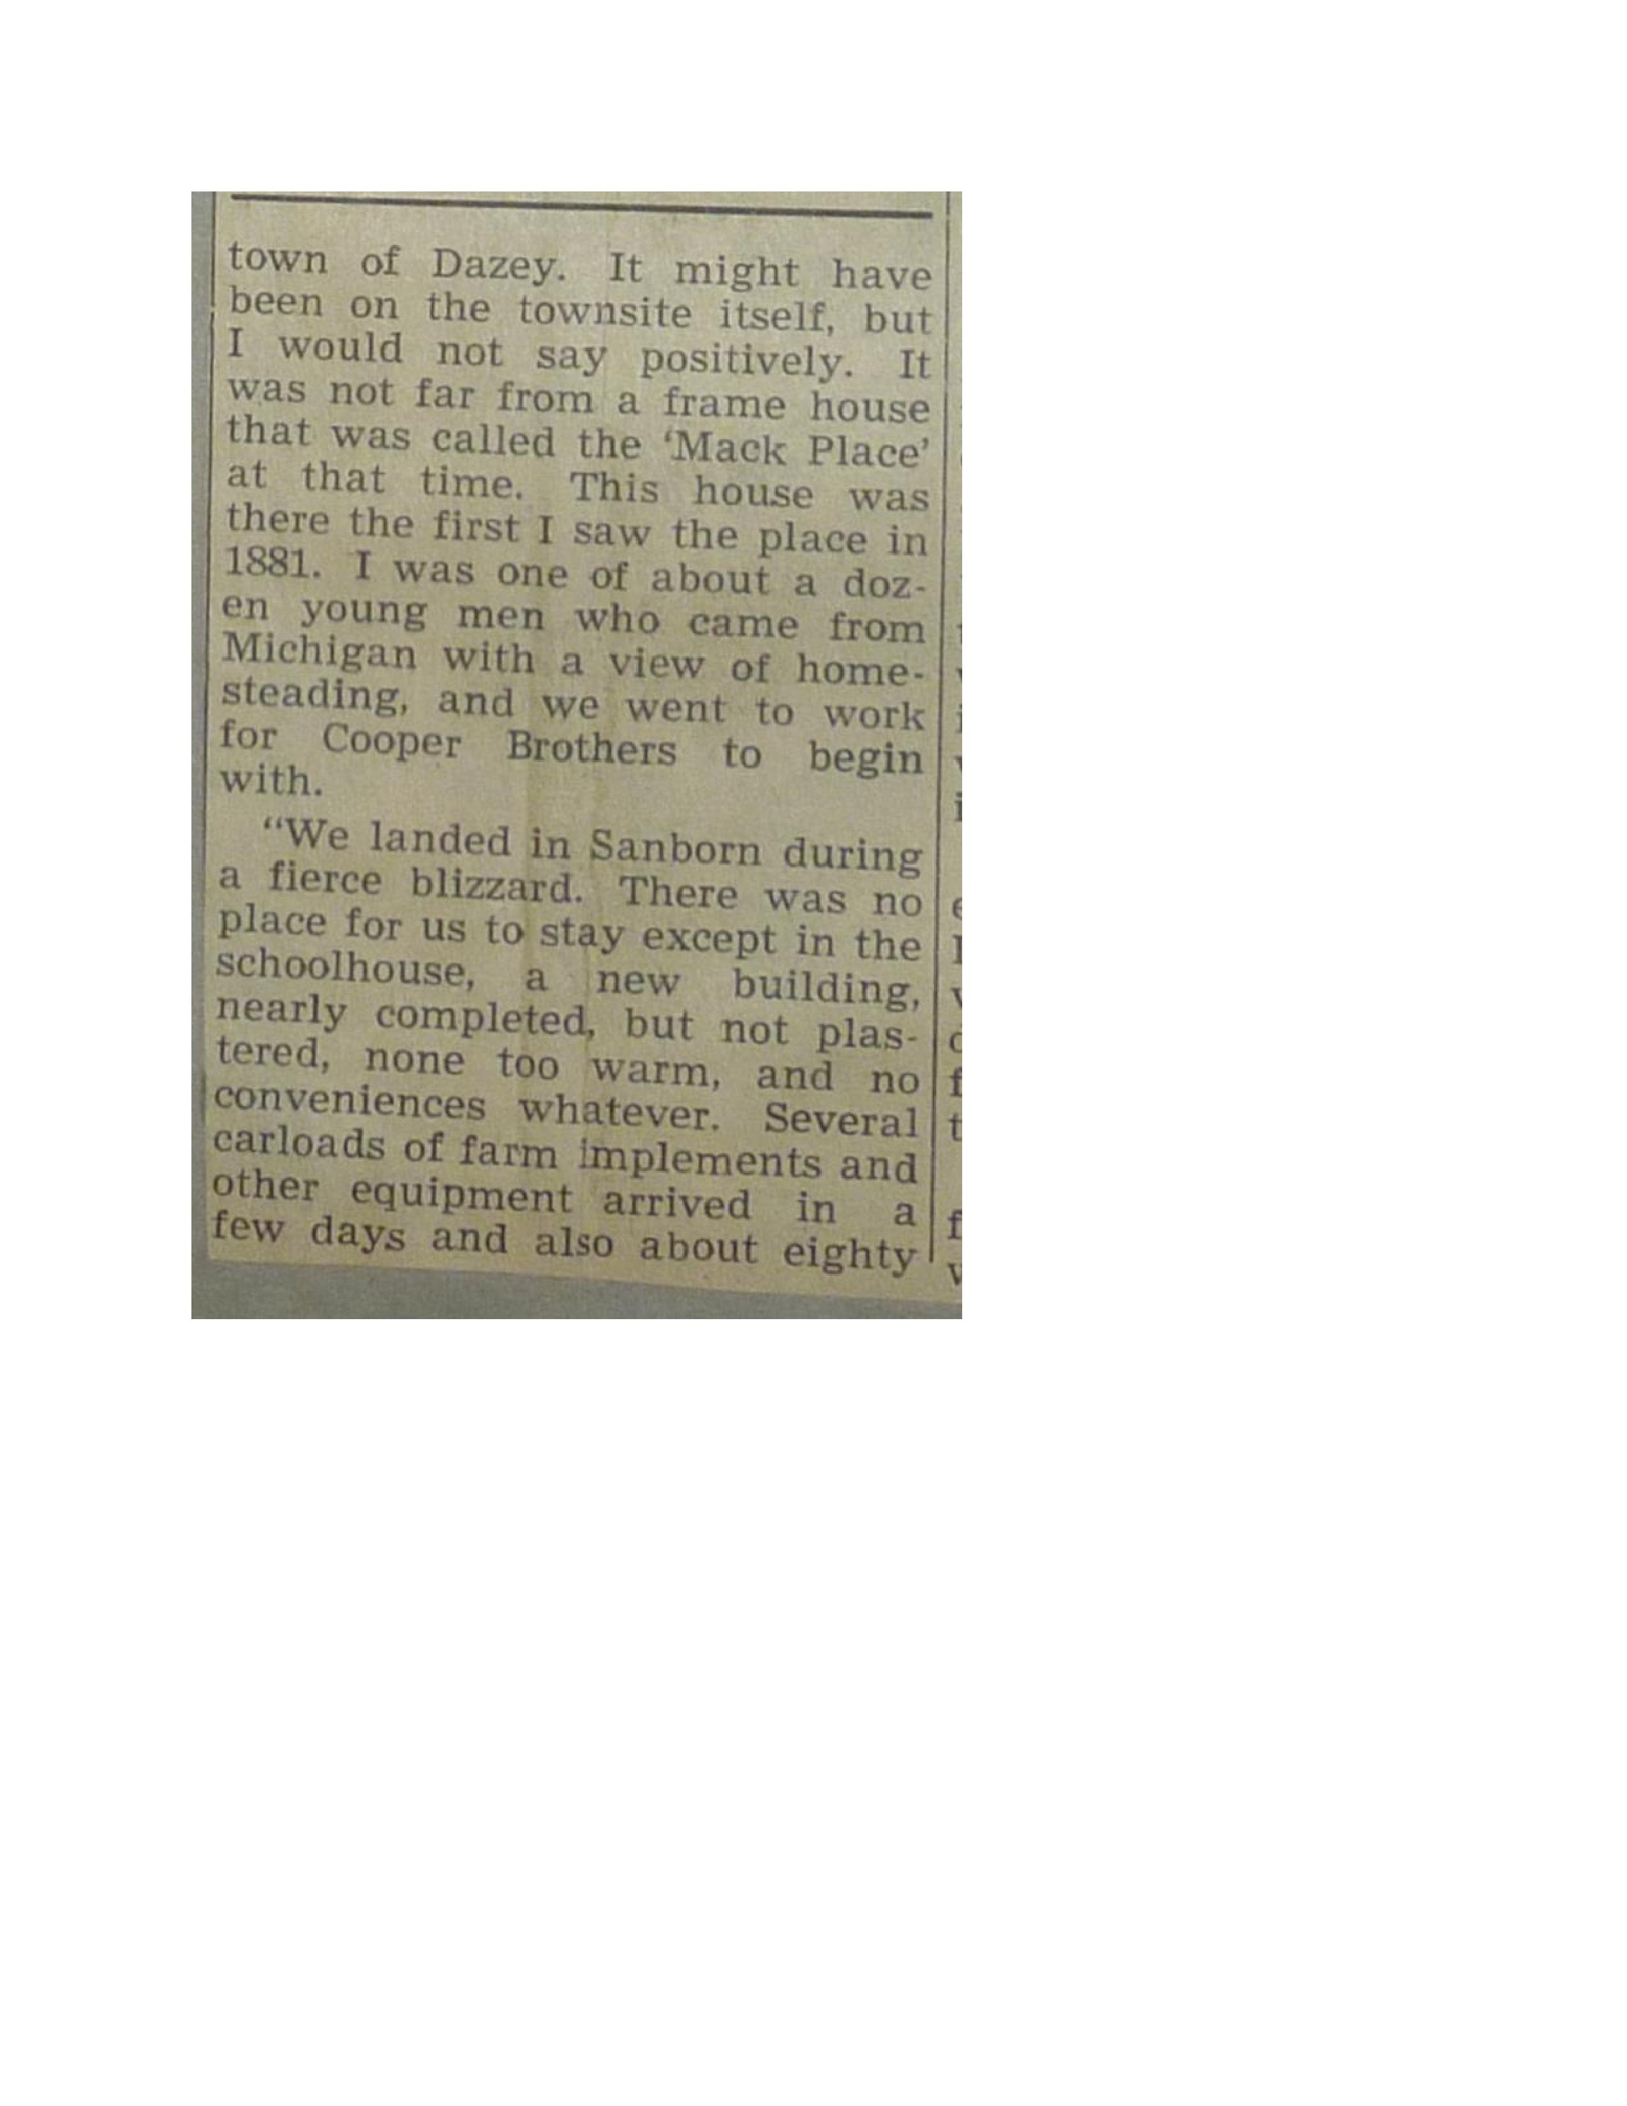
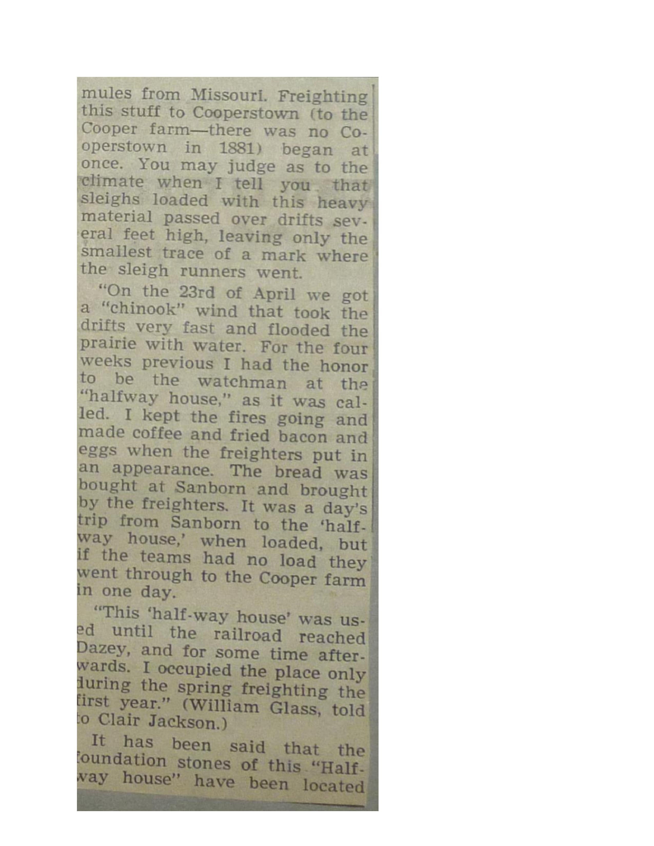
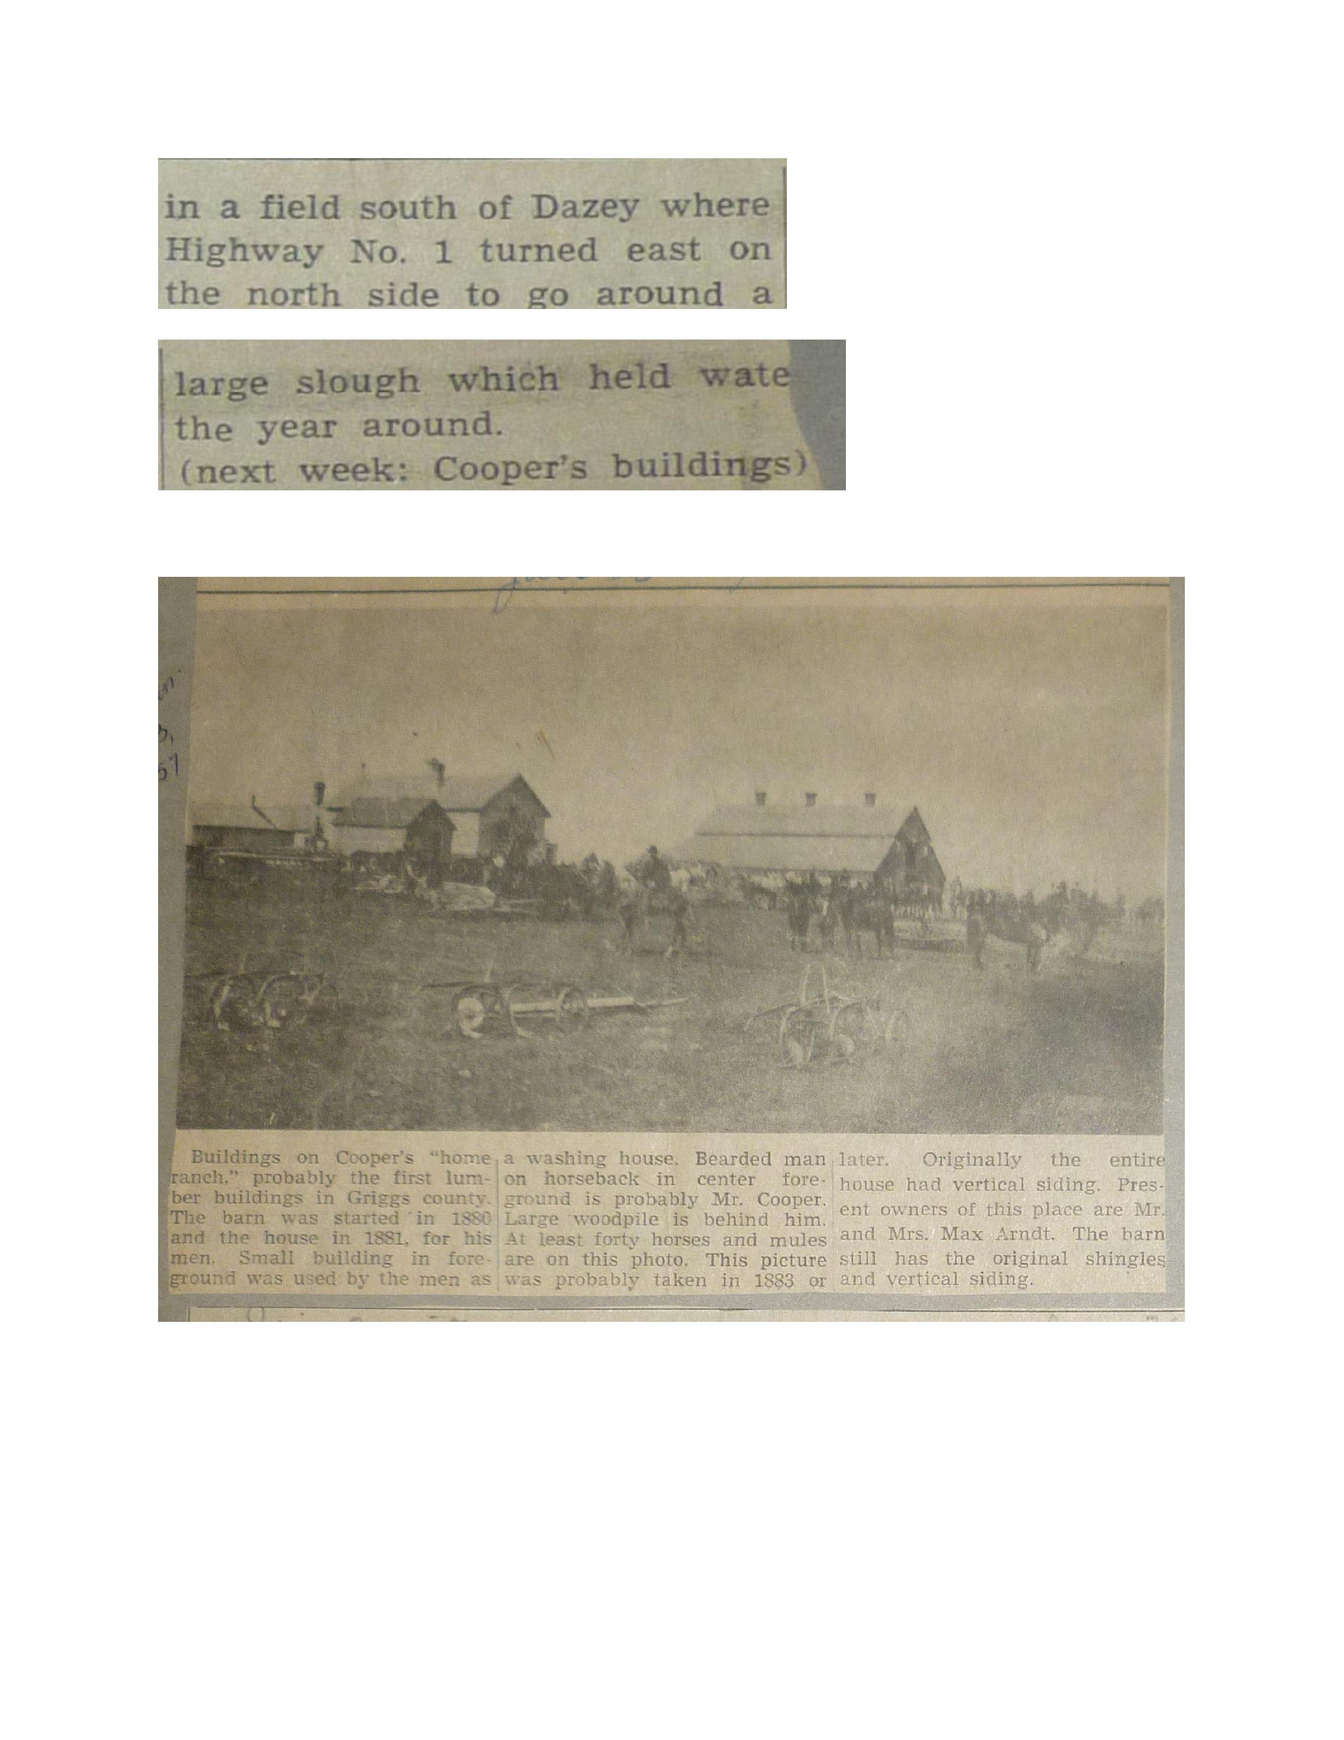
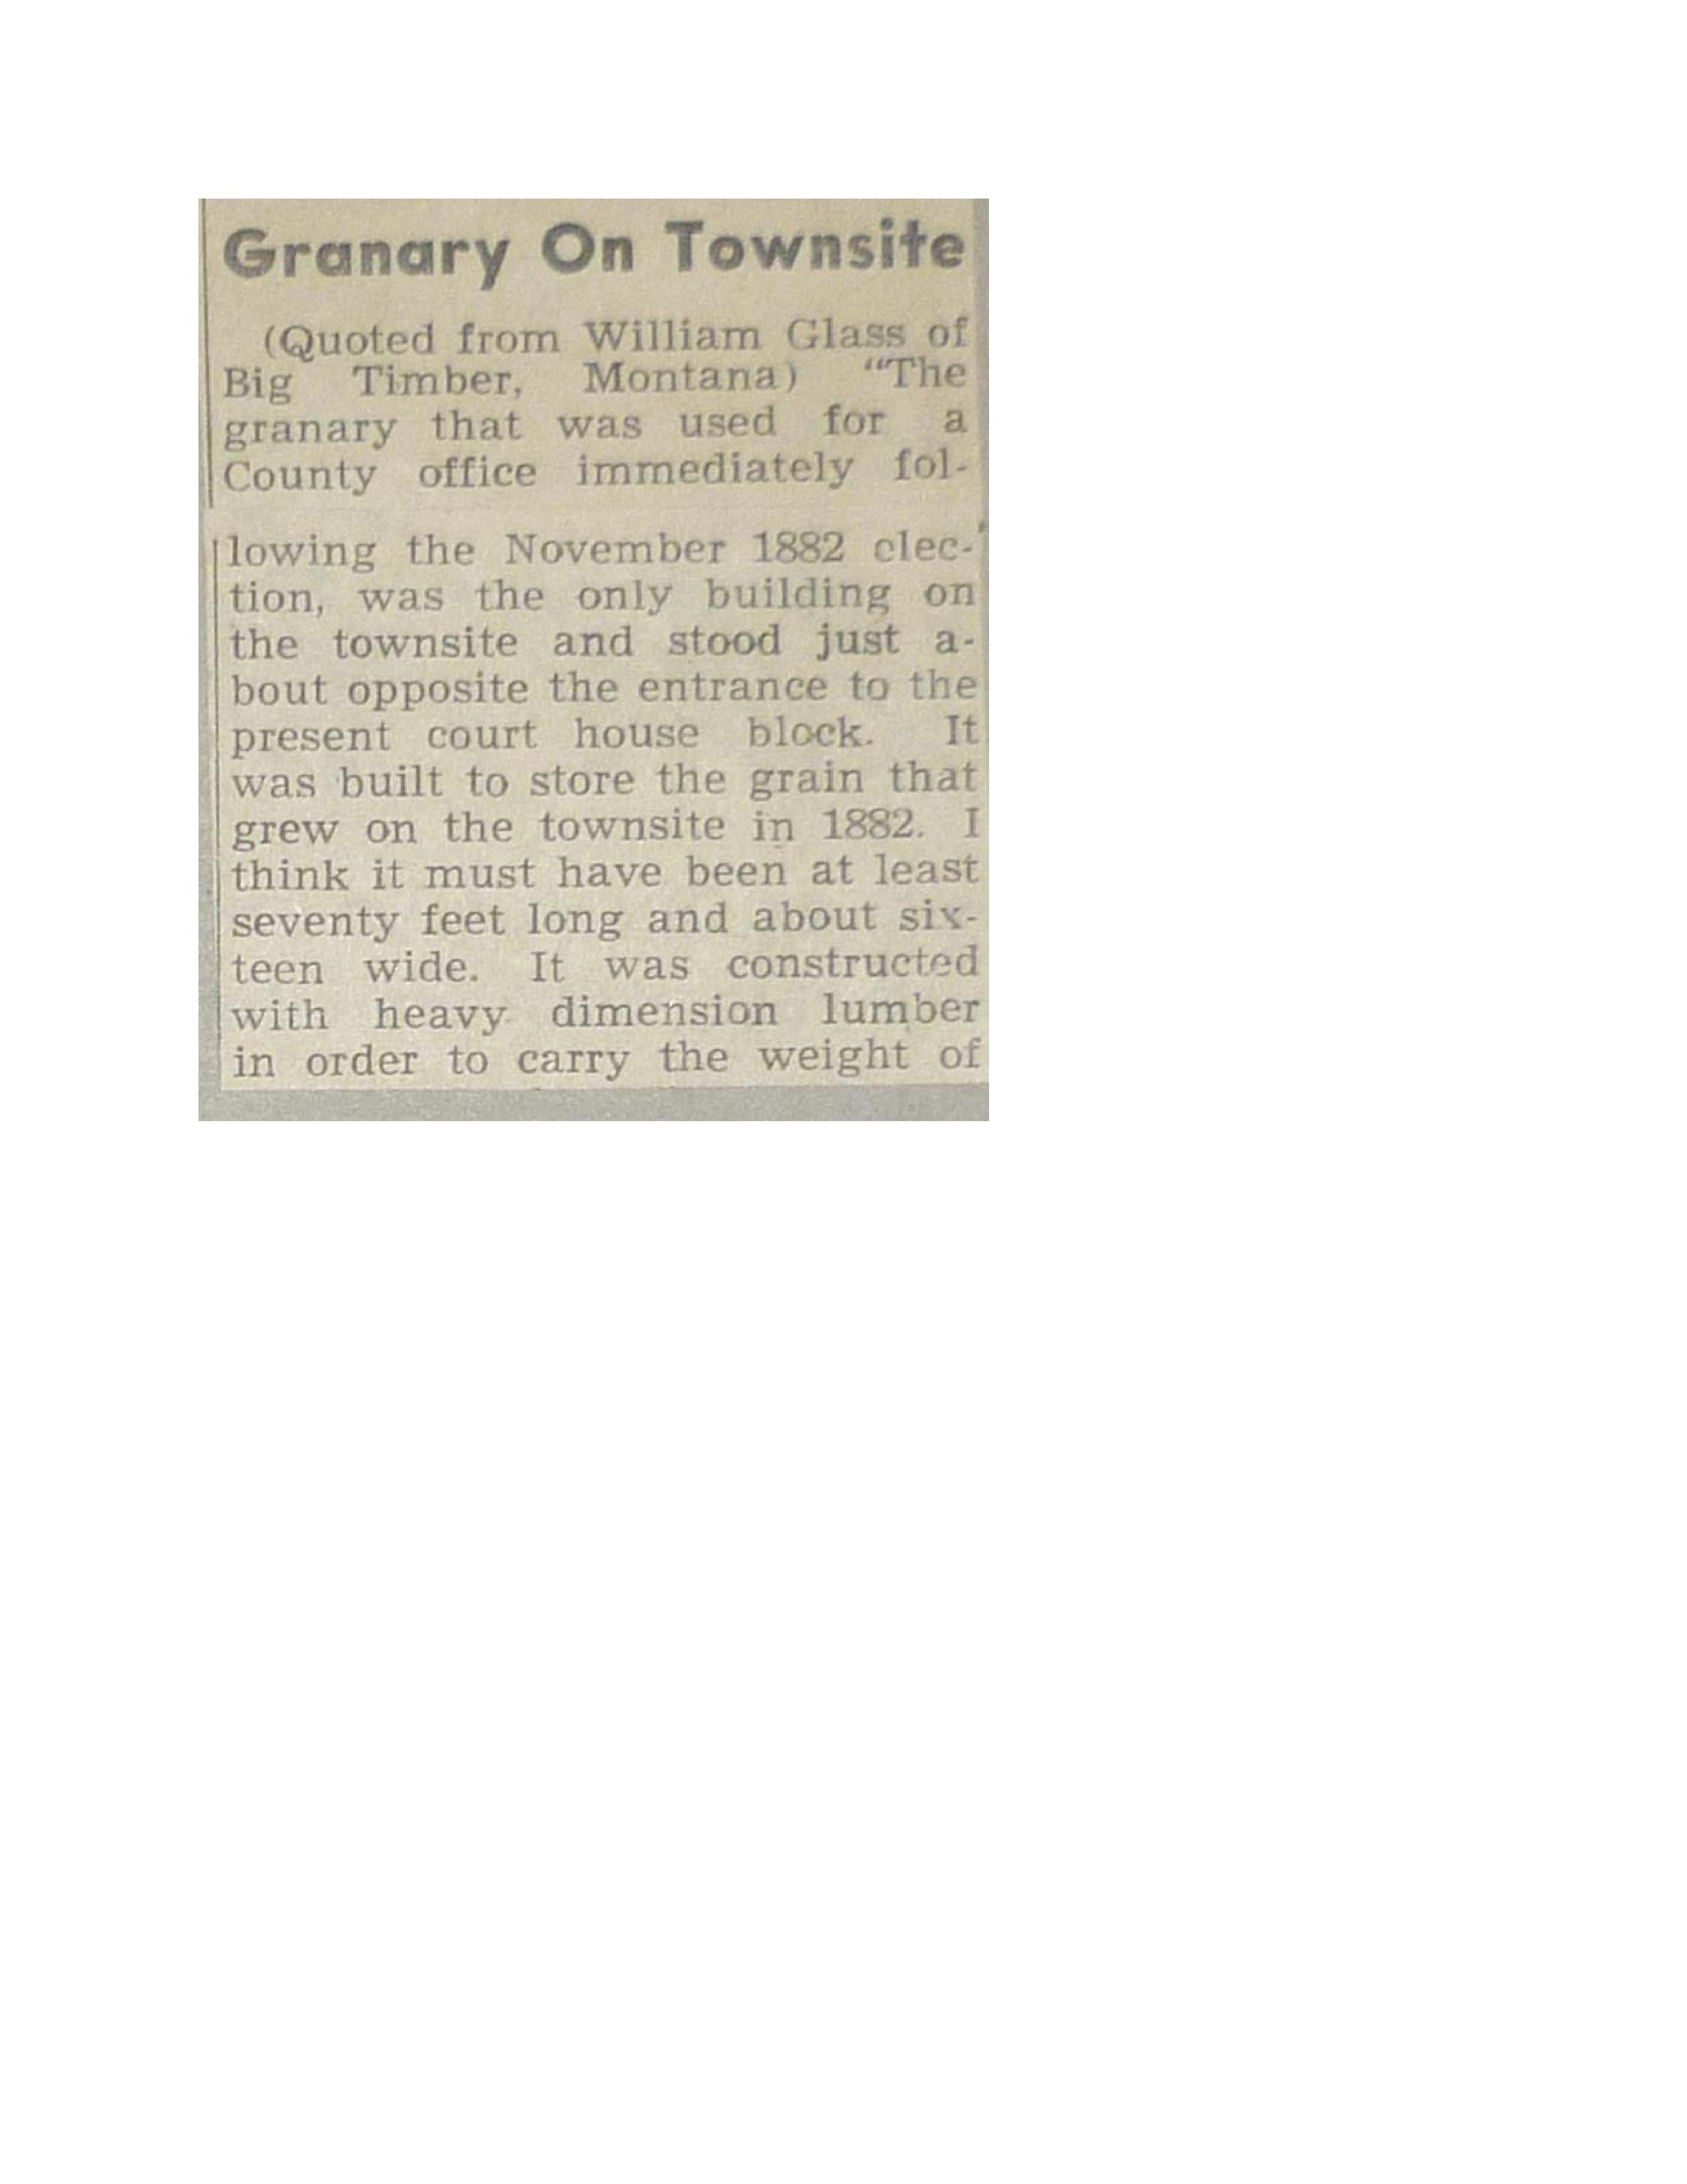
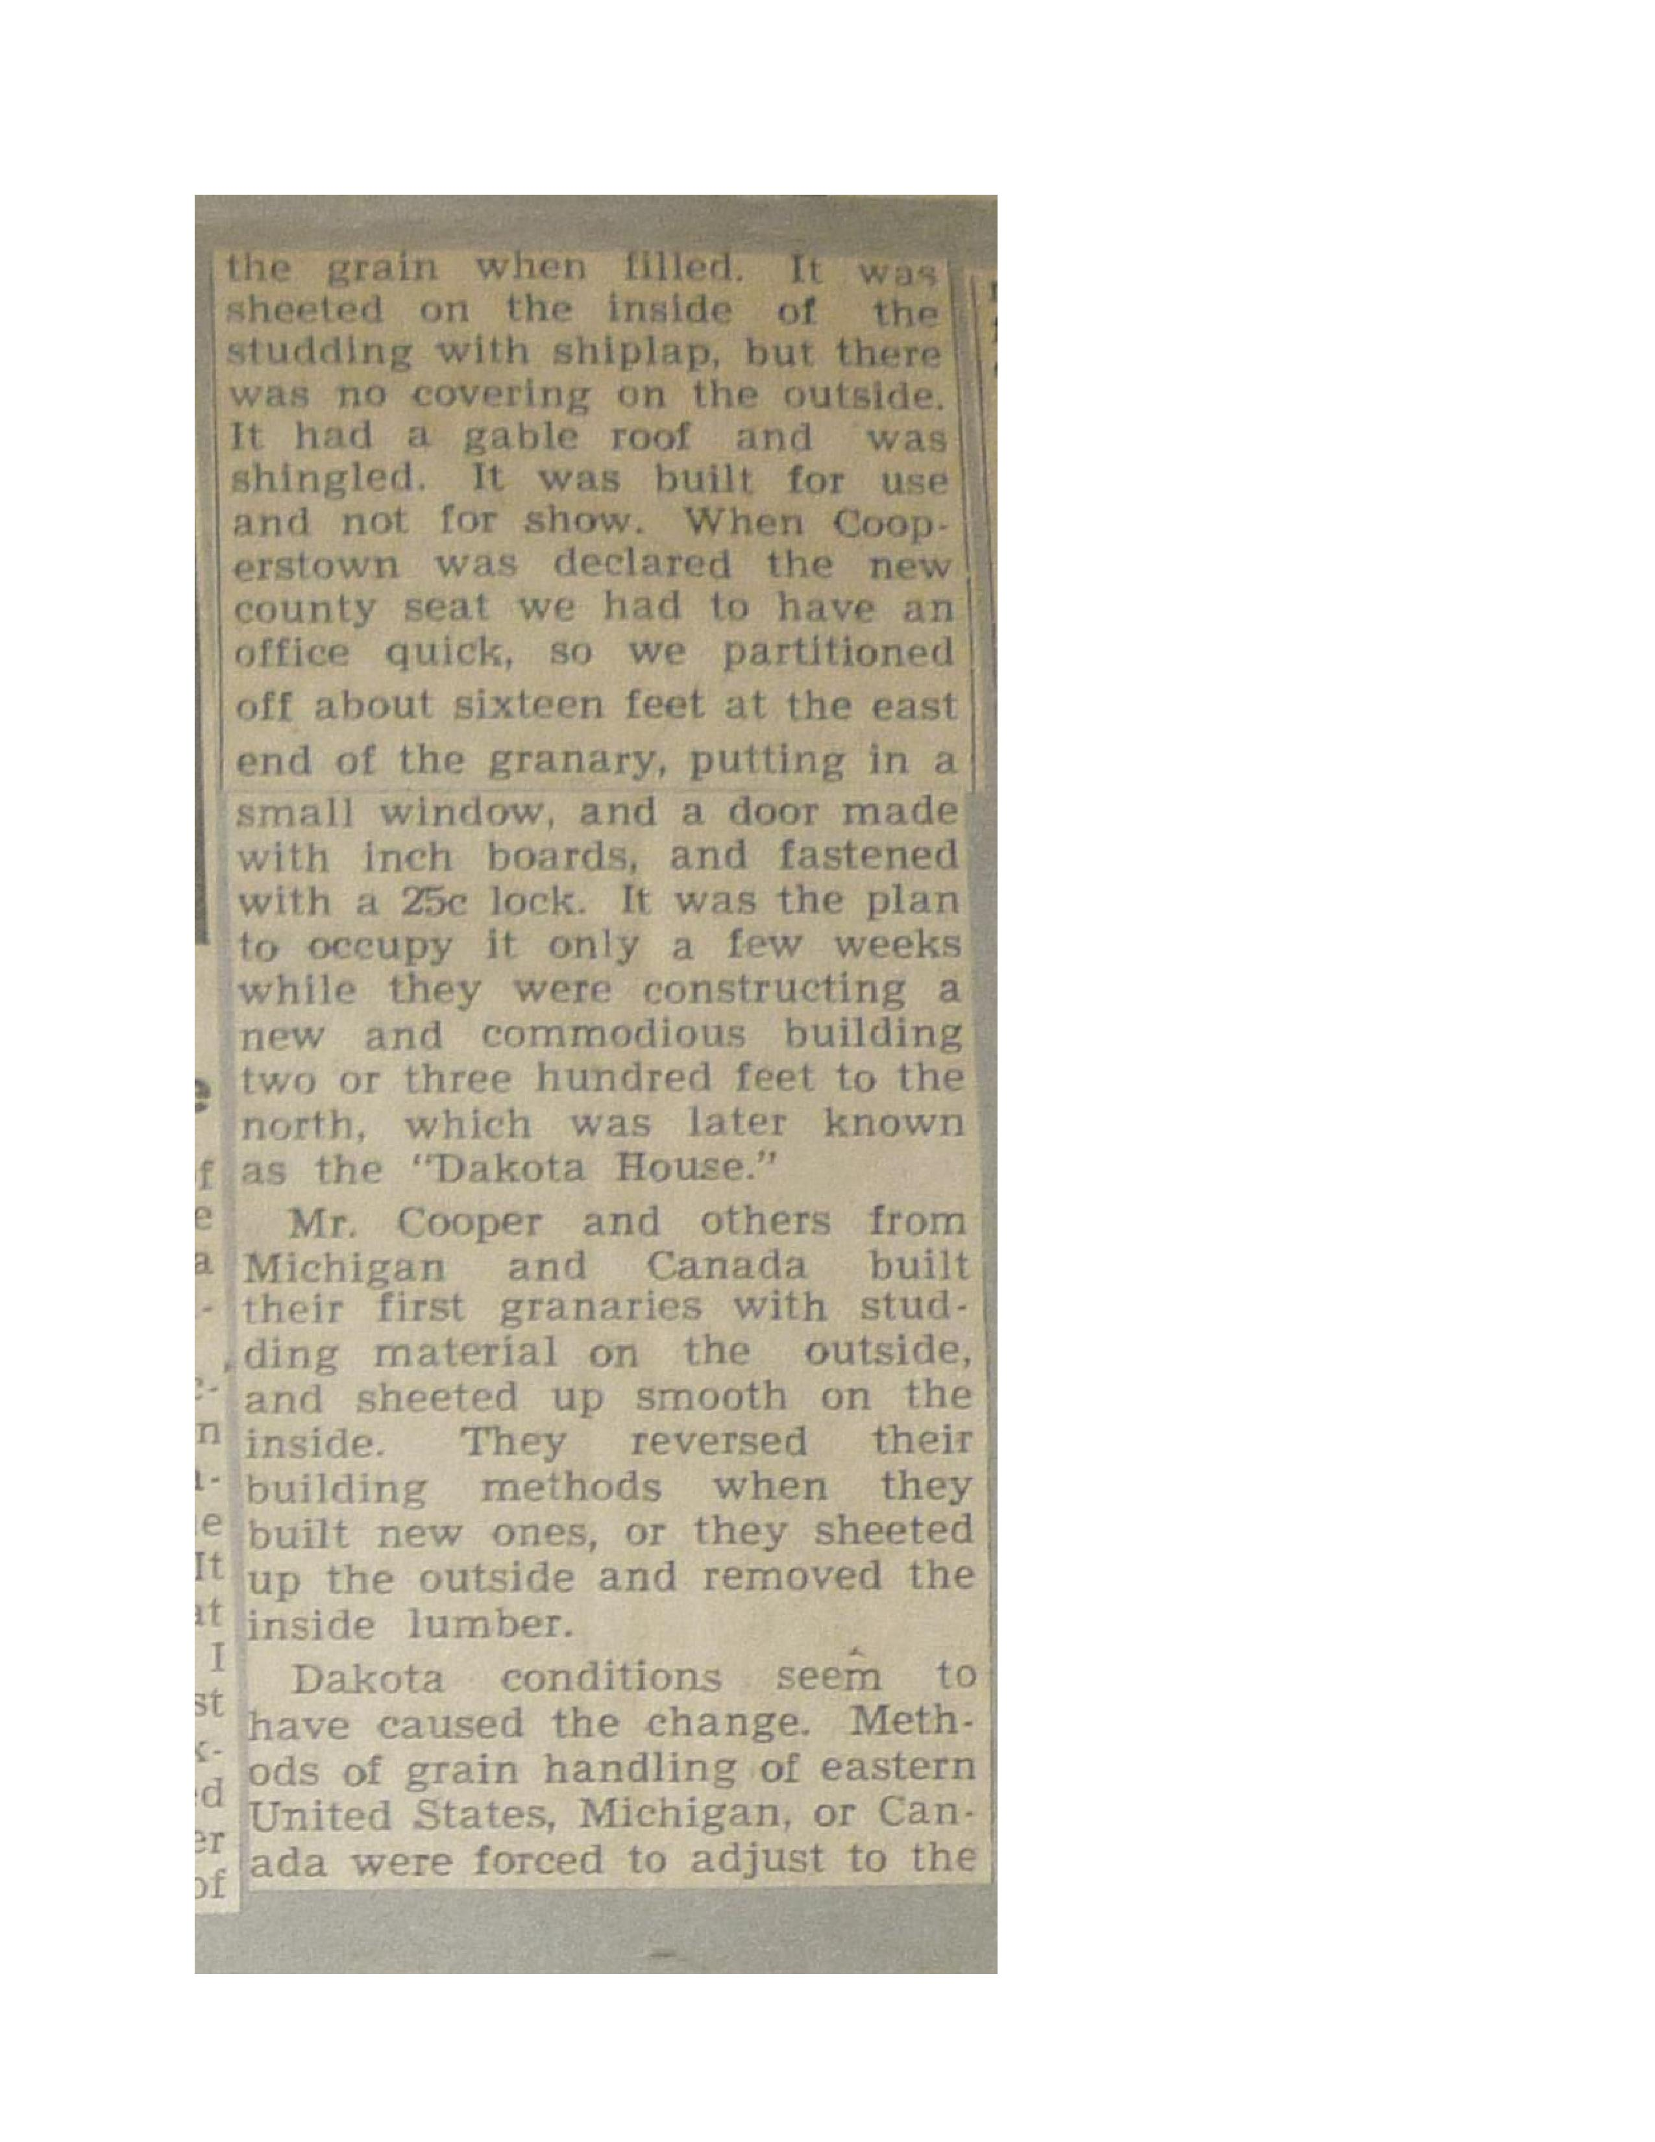
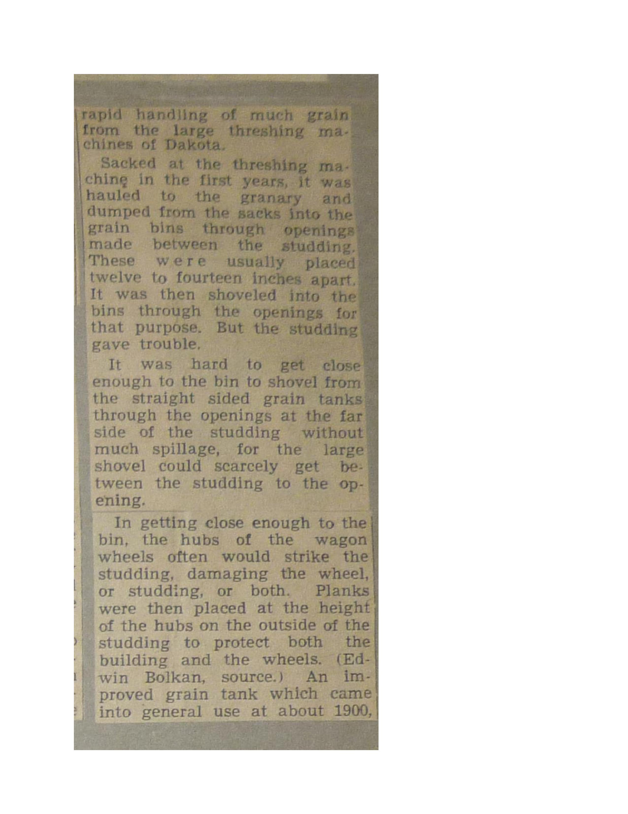
E789A-G00-0TW7-CPA8-Gu
Customer: No, I would like to install omnipage 17 from my disk.
Warda Qureshi: Unfortunately I am not trained to assist you with technical issues; however our support department will be able to help you. Please use the following link and select your product from the drop-down menu :
http://www.nuance.com/support/index.htm
If you would like to speak to them via telephone, you can reach them from anywhere in the United States or Canada by dialing 1- 407-241-0618 and choosing to correct product options.
Warda Qureshi: Omni Tech Support: 407-241-1827 Open Mon-Fri 9:00am - 6:00pm East Time Warda Qureshi: Is there anything else I can help you with?

