http://www.coloradohistoricnewspapers.org/Default/Scripting/ArticleWin.asp?From=Search&Key=DDT/1878/12/25/4/Ar00400.xml&CollName=DDT_Arc&DOCID=62067&PageLabelPrint=4&skin=Colorado&AW=1363028007377&sPublication=AWP&sScopeID=DR&sSorting=Score%2cdesc&sQuery=leadville%3CAND%3Ecooper%3CAND%3Echief&rEntityType=&sSearchInAll=true&sDateFrom=&sDateTo=%2530%2533%252f%2530%2531%252f%2531%2538%2538%2531&RefineQueryView=&StartFrom=15&ViewMode=GIF&FontSize=l2
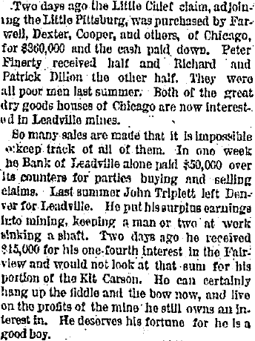

Denver Daily Tribune (Denver, Denver County)
Wednesday, December 25, 1878
Page: 4

http://www.coloradohistoricnewspapers.org/Default/Scripting/ArticleWin.asp?From=Search&Key=FPF/1880/01/01/2/Ar00201.xml&CollName=FPF_Arc&DOCID=3632&PageLabelPrint=2&skin=Colorado&AW=1363028007377&sPublication=LEC&sScopeID=DR&sSorting=Score%2cdesc&sQuery=%22little%20chief%22&rEntityType=&sSearchInAll=true&sDateFrom=%2530%2535%252f%2531%2535%252f%2531%2538%2537%2538&sDateTo=%2530%2531%252f%2530%2531%252f%2531%2538%2538%2530&RefineQueryView=&StartFrom=10&ViewMode=GIF&FontSize=l2

Fairplay Flume (Fairplay, Park County)
Thursday, January 01, 1880
Page: 2
Section: None
Xxxxxxxxxxxxxxxxxxxxxxxxxxxxxxxxxx
http://www.coloradohistoricnewspapers.org/Default/Scripting/ArticleWin.asp?From=Search&Key=CCF/1878/10/31/1/Ar00107.xml&CollName=CCF_Arc&DOCID=81630&PageLabelPrint=1&skin=Colorado&AW=1363028007377&sPublication=LEC&sScopeID=DR&sSorting=Score%2cdesc&sQuery=%22little%20chief%22&rEntityType=&sSearchInAll=true&sDateFrom=%2530%2535%252f%2531%2535%252f%2531%2538%2537%2538&sDateTo=%2530%2531%252f%2530%2531%252f%2531%2538%2538%2530&RefineQueryView=&StartFrom=10&ViewMode=GIF&FontSize=l2
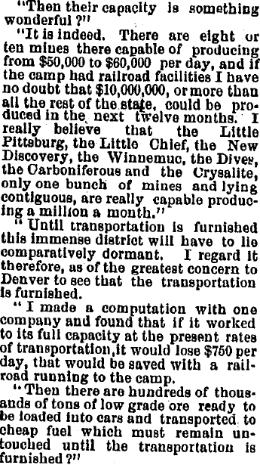

Colorado Weekly Chieftan (Pueblo, Pueblo County)
Thursday, October 31, 1878
Page: 1
Section: Front page
Xxxxxxxxxxxxxxxxxxxxxxxxxxxxxxxxxx
http://www.coloradohistoricnewspapers.org/Default/Scripting/ArticleWin.asp?From=Search&Key=CLM/1879/05/24/2/Ar00202.xml&CollName=CLM_Arc&DOCID=24722&PageLabelPrint=2&skin=Colorado&AW=1363028007377&sPublication=LEC&sScopeID=DR&sSorting=Score%2cdesc&sQuery=%22little%20chief%22&rEntityType=&sSearchInAll=true&sDateFrom=%2530%2535%252f%2531%2535%252f%2531%2538%2537%2538&sDateTo=%2530%2531%252f%2530%2531%252f%2531%2538%2538%2530&RefineQueryView=&StartFrom=15&ViewMode=GIF&FontSize=l2
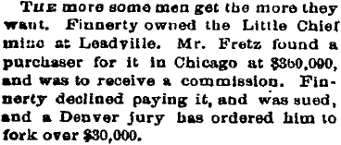
Colorado Miner (Georgetown, Clear Creek County)
Saturday, May 24, 1879
Page: 2
Section: None
Xxxxxxxxxxxxxxxxxxxxxxxxxxxxxxxxxxxxxxxxxxxxxxxxxxxxxxxxxxxxxx
http://www.coloradohistoricnewspapers.org/Default/Scripting/ArticleWin.asp?From=Search&Key=GTC/1879/07/10/3/Ar00305.xml&CollName=GTC_Arc&DOCID=16937&PageLabelPrint=3&skin=Colorado&AW=1363028007377&sPublication=LEC&sScopeID=DR&sSorting=Score%2cdesc&sQuery=%22little%20chief%22&rEntityType=&sSearchInAll=true&sDateFrom=%2530%2535%252f%2531%2535%252f%2531%2538%2537%2538&sDateTo=%2530%2531%252f%2530%2531%252f%2531%2538%2538%2530&RefineQueryView=&StartFrom=15&ViewMode=GIF&FontSize=l2
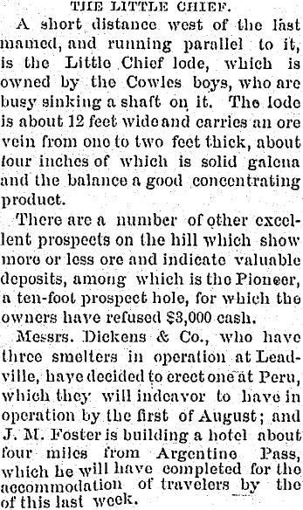

http://www.coloradohistoricnewspapers.org/Default/Scripting/ArticleWin.asp?From=Search&Key=TEC/1878/06/06/1/Ar00100.xml&CollName=TEC_Arc&DOCID=6121&PageLabelPrint=1&skin=Colorado&AW=1363028007377&sPublication=LEC&sScopeID=DR&sSorting=Score%2cdesc&sQuery=%22little%20chief%22&rEntityType=&sSearchInAll=true&sDateFrom=%2530%2535%252f%2531%2535%252f%2531%2538%2537%2538&sDateTo=%2530%2531%252f%2530%2531%252f%2531%2538%2538%2530&RefineQueryView=&StartFrom=20&ViewMode=GIF&FontSize=l2

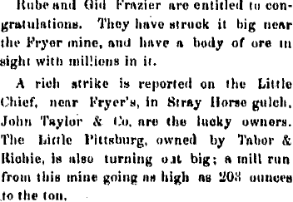
Evening Call (Central City, Gilpin County)
Thursday, June 06, 1878
Page: 1
Section: Front page

Xxxxxxxxxxxxxxxxxxxxxxxxxxxxxxxxxxxxxxxxxxxxxxxxxxxx
http://www.coloradohistoricnewspapers.org/Default/Scripting/ArticleWin.asp?From=Search&Key=LWH/1879/11/08/3/Ar00300.xml&CollName=LWH_Arc&DOCID=8&PageLabelPrint=3&skin=Colorado&AW=1363028007377&sPublication=LEC&sScopeID=DR&sSorting=Score%2cdesc&sQuery=%22little%20chief%22&rEntityType=&sSearchInAll=true&sDateFrom=%2530%2535%252f%2531%2535%252f%2531%2538%2537%2538&sDateTo=%2530%2531%252f%2530%2531%252f%2531%2538%2538%2530&RefineQueryView=&StartFrom=25&ViewMode=GIF&FontSize=l2
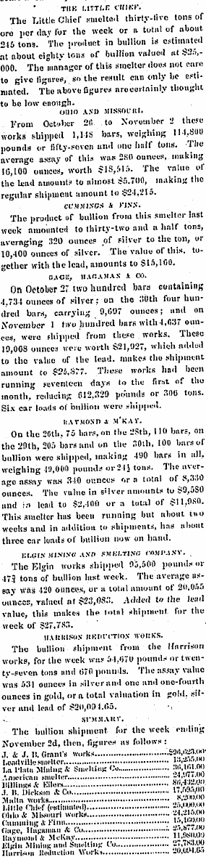
http://books.google.com/books?id=1n8UAAAAYAAJ&pg=PA160&lpg=PA160&dq=little+pittsburg+little+chief+matchless+cooper&source=bl&ots=e9aYnX7cVK&sig=b-rVnvQ4FL2cRU-RivWRf7hY4z8&hl=en&sa=X&ei=gkVBUYe0FYTzyAHZg4CQAQ&sqi=2&ved=0CC4Q6AEwAA#v=onepage&q=little%20pittsburg%20little%20chief%20matchless%20cooper&f=false

http://books.google.com/books?id=1n8UAAAAYAAJ&pg=PA160&lpg=PA160&dq=little+pittsburg+little+chief+matchless+cooper&source=bl&ots=e9aYnX7cVK&sig=b-rVnvQ4FL2cRU-RivWRf7hY4z8&hl=en&sa=X&ei=gkVBUYe0FYTzyAHZg4CQAQ&sqi=2&ved=0CC4Q6AEwAA#v=onepage&q=little%20pittsburg%20little%20chief%20matchless%20cooper&f=false

http://books.google.com/books?id=1n8UAAAAYAAJ&pg=PA160&lpg=PA160&dq=scooper+mine+colorado+t.+j.+cooper&source=bl&ots=e9aYnX7jZQ&sig=lWtsAZvBVPIRdBK80mXpZv7T6gI&hl=en&sa=X&ei=bEhBUf-LMeeayAH91ICADw&ved=0CC4Q6AEwAA#v=onepage&q=scooper%20mine%20colorado%20t.%20j.%20cooper&f=falses

http://books.google.com/books?id=mvVYAAAAYAAJ&pg=PA429&lpg=PA429&dq=scooper+mine+colorado+t.+j.+cooper&source=bl&ots=SnF35_VT9y&sig=HKYjlDs7lRC-FoYtIUGKK--2_R4&hl=en&sa=X&ei=bEhBUf-LMeeayAH91ICADw&ved=0CDEQ6AEwAQ#v=onepage&q=scooper%20mine%20colorado%20t.%20j.%20cooper&f=false
s

