Harvesting with a Flail
There wasn't very much harvesting done the old fashioned way (with a flail) in Griggs County, but there are some records of it. A picture of a flail and farmers using it are shown below.

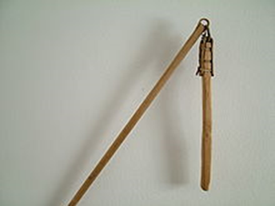  Flail | 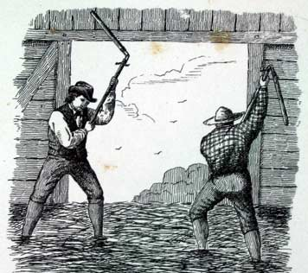  Farmers using flail to thresh
Flails were usually made from two pieces of wood attached by a short chain. Using a flail for threshing dates back thousands of years and one person could thresh about 7 bushels of wheat, 8 of rye, 15 of barley or 18 of oats with it.
The Cooperstown Centennial book mentions that Charles Rothert (1841-1908) and his wife Emelia (1850-1914) arrived in Griggs County in 1883. Emelia was managing the farm operations while Charles worked on the Sanborn-Cooperstown branch of the railroad and also for the Cooper Ranch and it was left to Emelia to broadcast the seed, harvest with a scythe and thresh the crop with a flail. Some of the records of the Opheim family also mention them using a flail for threshing.
I've also read about a homesteader that took his crop out to an ice covered slough in the winter time and then flailed it against the ice and scooped up the kernels.
The next step in the harvesting process was winnowing. The grain would typically be placed in a basket and thrown into the air. When the wind was just right, it would blow the chaff away and most of the kernels would come down into the basket again.
The first pioneers were very used to this and I don't find any records of any of them using threshing machines in Scandinavia or Germany before they emigrated over here.
R.C. Cooper arrived here in October of 1880, but he spent most of his efforts in getting building materials here from Sanborn by mule train in 1881 and 1882. There is some evidence that he harvested some oats in 1881 and possibly some oats and wheat in 1882, but I haven't found any records of the crop being flailed. He may have driven a steam engine and pulled a threshing machine in from Hope or Sanborn in 1881 or 1882 but I haven't found any records of that either. By February of 1883 the railroad was only twelve miles south of town and R.C. was moving in a lot of farm equipment by mule train on that relatively short last twelve miles. That fall the homesteaders could haul their shocks to one of Cooper's three ranches and pay him to thresh them. Other homesteaders were buying binders and threshing machines around 1883 also.
Sometimes it's hard to believe that all we have to do is look back 130 years to find records of the first Griggs County homesteaders using flails to thresh their crops just as it had been done thousands of years ago, and then comparing that to what we have today.

