Threshing Machines
Several weeks ago we talked about harvesting with a flail. That was only used here for a short time and most harvesting was done with threshing machines in 1883 and beyond.
The threshing machine was invented about 1784 by Scottish mechanical engineer Andrew Meikle. As with many inventions, he borrowed ideas and methods heavily from others, but he is accredited as being the first to assemble these systems into a working machine.
One of the first social impacts of these machines were the Swing Riots of 1830 in England. Thousands of men had become unemployed with the introduction of the threshing machine. The wages had dropped with the decreased demand for labor. The rioters smashed over 100 of the popularly hated, labor displacing, threshing machines in August, September and October of 1830 and threatened any farmer that owned one. The rioters were dealt with harshly and nine of them were hung and 450 more were transported to Australia.
This dislike for new technology that displaces someone's job still happens today. Automation, robotic technology, computers and other new technology are going to be naturally despised by anyone who loses their job to new processes.
The first threshing machines were horse powered as shown in the picture below. I've heard stories that horse powered threshing machines were used in Griggs County and that there may still be some left in old farmyards. Let me know if you ever see one and I'm sure our local museum or a neighboring museum would be interested in having it.
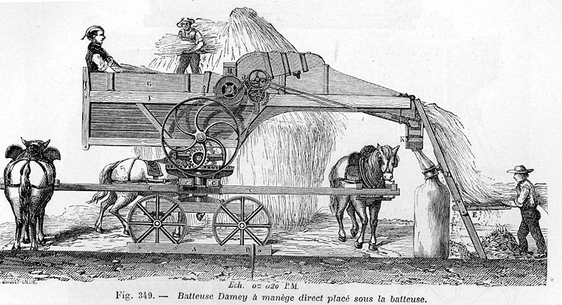
Horse Powered Threshing Machine

The first threshing machines consisted almost entirely of a cylinder rotating at about 500 rpm and a concave that is curved to match the cylinder. Most of the grain is released here and falls through the concave. That process is still used in combines today.
Other things were slowly added to the threshing machine. Straw walkers were added to take the straw out the back of the machine. These straw walkers would shake the straw and cause the heavier chaff and kernels to fall down. Sieves were added below the straw walkers. These sieves were shaken mechanically and had various sized opening to further separate the kernels from the chaff. A fan was added to replace hand winnowing with a basket and the fan was sized and adjusted to blow the lighter chaff out of the back of the machine. A return auger was invented to take the larger chaff pieces that still held grain back to the cylinder and concave where it would be run through again. Feeder chains were added to bring the materials into the cylinder and concave. Rotating augers were added to help move the chaff and kernels around.
Steam power replaced horse power during this time to provide enough power for straw walking, sieve shaking, wind from fan power, return augers, feeder chains and other augers.
We've come a long ways, but our current machines are still based on the many different processes that were invented over the years.

