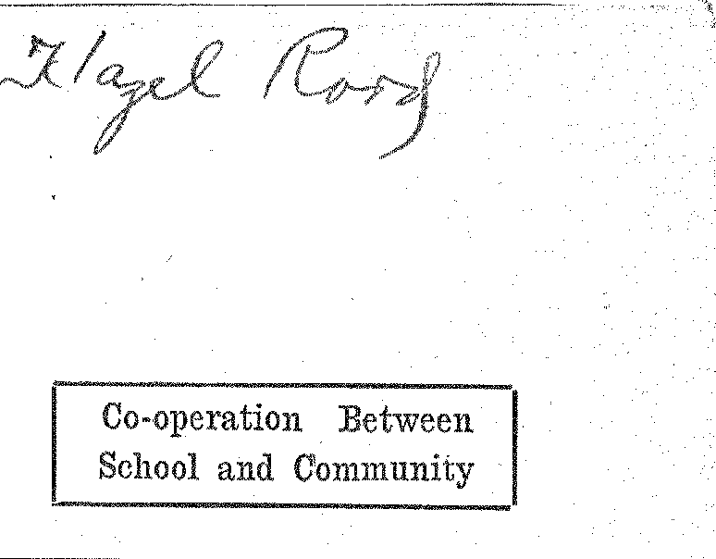
Co-operation Between
School and Community
Higher Scholarship;
Better izenship
VOLUME VI |  |  | 0 ( | .1•11,1- | NUMBER 2

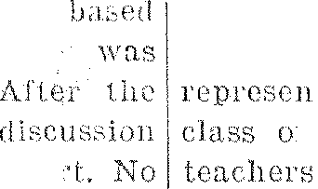
° TEACHERS' INSTITUTE

HOME ECONOMICS DEPARTMENT }EPHEARS FINE
'DRESS BY MISS FINLAYSON, STALL⁻, CTOR
Directs
ThL, ;list,
v says that they intend to put
:slid their program through and perhaps
do more.
Tlo I' nory have plans under way door party and a program for
⁻hich ill be put through
th as mu it ;Aid snap , pos-
it keel) it rho
(I. \V. S. will e of tie n ol's
prominent .tociet.ice.
some Eight
ers
ed n

aints con:. The (it ott
HELD OCTOBER 5-10
County Superintendent and Other
Good Speakers Address Yearly
Gathering of Teachers.
All rural and consolidated school teachers of Griggs county were in attendance at the annual institute licld at the gymnasium from October G to 10. The teachers speak highly of he quality work presented and feel that they received many splendid ideas for their year of work.
Business Men Entertain
At a special welcome the Business Men's Club entertained the teachers durrs at a "get-together" party on Monday evening. Monroe nocmicsIrr Mr. Rogers had charge or the entertainment. The Home Econo nicmics Club served refreshments,
Good Instructors
]Miss Beatrice Johnstone of Grand Forks and Mrs. Simenson of Vallproblem were the instructors for thteachershey know country school problen and the difficulties t
the teaellers in schools must
raodsrefore, they were able
give the teachers helpful ideas and methliods.
In addition to 1,-
tars, Couny Sup(' n endrott I atl lda
Johnson mitt . .t,t,t1, the
Work.
Visit City Schools
While here the advantageachers were invited to visit the city schools. Many took advarttatge of the opportunity, and attended classes in which they Were particularly interested.
Beneficial Results
This was one of the best institutes ever held in Griggs county. and the teachers returned to their respective schools feeling that the week had. been most beneficial to them,
DEBATE QUESTION FOR H. S. LEAGUE CHOSEN
"Resolved, That the Trend front local to Federal 'Control Which Has Characterized Our Government Dur lug Recent Years, is Inimical to t AVelfare of the United States."
is the question which the Rare.' Public Information of rite University Extension Division, Gland Forks,
has determined shall b, the subject et controversy in the High School Debating League of North Dakota. for 1926.
In order to avoid mos, :less ("hems, sloe the praseology of the question;
debating teams shoo accept these
cis: Local control • meant to 'nclude that wielded by city, town_ j , county, district ... state. The
tr, "federal" means the control of the ]Tutted States government through Congress, th • Fres Men t, the decision of the Sepretne Court and by various boards and commissions of the federal government. at Washington, According to the Bureau, the expression "during recent years" refers, to the period of time beginning some fifteen or twenty years ago, including Ile present.
Application for entering the 192G debate contest must be made before the 16th of December. This is earlier than last year. The change is made in order to pair the teams and to notify them before the Christ-
Continued 011 Page Three
GIWS' IVELFP
FREPARAL _
Miss Irene Pia: Selected to Direct
Destinies of Society for Com-
ing School. Year.
171trite years ago, Ivlien the Cla
of '26 were Freshmen, a society girls was organized in high school and called the Girls' V,Telfare
society of this na.tu.e was d
able for protnoiing co-operati,m art good feeling among Die
Women s Senate, a hoard members and one faculty me had up to this time attempted t, these things. r.l'he board, with
assistance of some Avonwri •of
community, hail made a sot of rules which every girl had to follows Anyone who violated these rules was brought before the Senate .111(ri they decided to punish or not to punish the girl. The fount of 'minis
varied with the offense. The objection Avhich the girls raised to this board was that it was too diet atory, so they would rather
other 1:(11111 of union.
As a consequence, Girls' Wel-
fare, Society was ois.
ed to lead and not to die.ate, society met every Friday. The
first part of meeting was
to business and a program around some problent which suggested by the girls. program there was open
in which all the girls took pa. rules were made by the soc garding conduct. Each girl
rule her actions by the dHs
in the meetings,
During the year the society 1••••1⁻
INS PROGRAM IN
:IbAL ACTIVITIES
to plut on a public. program In
middle le year and a get-
iher h ai ty soar the first part of
to
two years the plan was put a,ero. s with great. success aunt the regular meetings were very spirited affairs. Last year, however, they failed to get their public program in because there were so many oiler things going on at the sonic
OkTY RURAL SCHOOLS JUT BY OLD GRADS
graduating classes of Co
School are represent-
teaching faculty of the
tril• one-half of all teach-
the city schools are graduates a. our high school, a total of 31 Claaiini ip this as their alma, nutter•,
class of 1.929 lusts the largest 'I don with 10 members; the 1925 comes second 'with 7 on the list. The class of irc.,(mted by Thelma Ayrea
Skofstad graduated
1916 Oscar Anderson re-
• th 1920. Erma
Continued on I' a participated it neetings of
P.-T.A. Meeting to be Heti the High School Tonight
The regular meeting the
Cooperstown.P.-T. A. will be held
school
night. promptly at 8 o'clock.
The election of officers is the main brashness to be transacted.
The program will be centered around the theme, "Fire Prevention." The grade children will present a playlet, "The Trial of Fire."
cluck sharp.
SUPERINTENDENT HAS GREAT MANY DUTIES
Superfast  very busy week s  .11. In addition | spent as  October  o his regular

classroom and supervisory duties, he
local interest.
On Monday evening he had large the program of
otmsored by the Business Men's tb, and given to the vis achers of tics county who were in

hos :•11 busintets.
edn•sday he spoke to the county institute on the subject of the N.1). E. A., urging their membership in that organization so that it would he more possible that North Dakota secure the best educational privileges for its children. His efforts were rewarded with a. 100 per cent enrollment. by the teachers.
The same afternoon, the superintendent spoke before the W. C. T.U. on the subject, "Aims of a True Home." He brought out the idea⁻that these aims should be founded upon the 'fen Commandments. He illustrated his talk with reading's from the poet, Edgar Guest.
Friday mooting he addressed the assembly on the Greater North Dakota Association. The sante afternoon he presented the advisability of each school in the county having an exhibit at the Griggs County 'Fair next June, and showed by examples of work from the local schools what such an exhibit might contain and how it should be organized,
TAKE UP PROJECT OF MAKING XMAS BOXES
The grade children throughout the state of North Dakota are inching it a point to sacrihce some of their OW11 abundant little belongings anti send to their brothers and sisters across the sea in the BalGan stales.
The boxes tare being filled with toys, pencils, crayons, handkerchiefs and such like articles. The boxes are about four and oneshall by ten inches so that when tilled they contain quite a number of things. The I. rade children of our schools have been working on a number for about two weeks and have tilled five boxes. Mrs. Johnson, county superintendent of schools, supplied the boxes,
'This kind of work is very beneficial to children and should be pacoura.ged.
tendance at the annual Tuesday evening
card of EGocat'on
nstitute. regular
fleeting.
Suggests Organization of Club in
Connection With Department
in Local School.
Miss Finlayson, state vocational home economics director, addressed the members of that department in a special assembly on Friday, Octo, bee 2nd. She began her address by
especially, interested in Cooperstown 1' School because it is in its infancy of Home Econantics training." By this she mean Hutt vocational work has been
adopted and weeks, | working but | 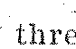

Forming Foundation
"The high_ school girl," she con timed, "is young and perhaps far from home making, but every girl has some tasks which can be better accomplished if she has had special training. As you are forming yourselves now, so will you. be in life. By buying and
buying, and peparing foods, b^{b}r^{y}
providing safeguards to health you will form an excellent foundatiot titer and honsek
Realm of Homemaking
MiSs F.,inlityson stated that. realm of of. homenia}eng consisted
, le family, and keeping the family well, Ali hr-se essentials are stressed in rite course of study offered in the ,partment. However, she added that these were not the only jobs a itousewife has to do, for she must know ow to manage, how to darn, how to entertain, and how to care for the family in case of illness. These principles are also stressed in the work of the course.
r
Value of Course
The speaker emphasized the value of a course in our schools when she stated: "Many a 'woman has wasted half a lifetime learning how to cook (by experimenting.), when site could have learned the same things in a two year course in a domestic science class in the schools."
"Child care is an essential part. of your training," the speaker went on to say, "Vo unsay have little
,Continued on Page Three
"OLD IRONSIDES" TO BE RESTORED BY PEOPLE
The "Constitution," one of the first frigates ordered by Congress is in a deteriorated condition in the Navy yards.
Congress was willing to forward the finances to restore this historical ship to its former condition. On further thought they realized that everyone in the United States would like to have some Intl in the rebuilding of the famous "Old Iron-sides."
With this object in mind they planned drives to be conducted in all the states.
In our state the quota is small and thus a pleasure. to raise. The drive is being sponsored by the Elks lodge.
From October 18th to 241.11 fundS will be received and sent to the directors in charge.
Every high school student is asked to bring one penny toward the betterment of this cause.

