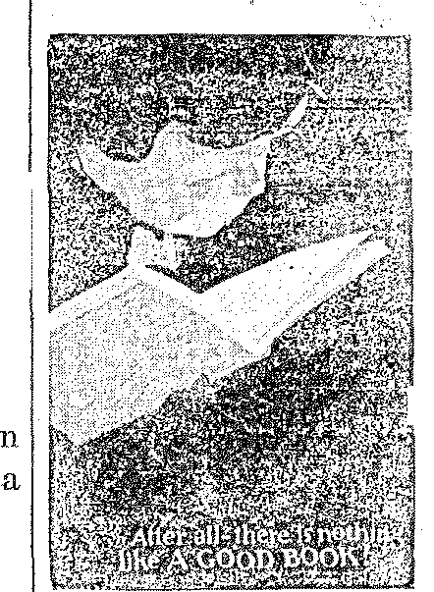
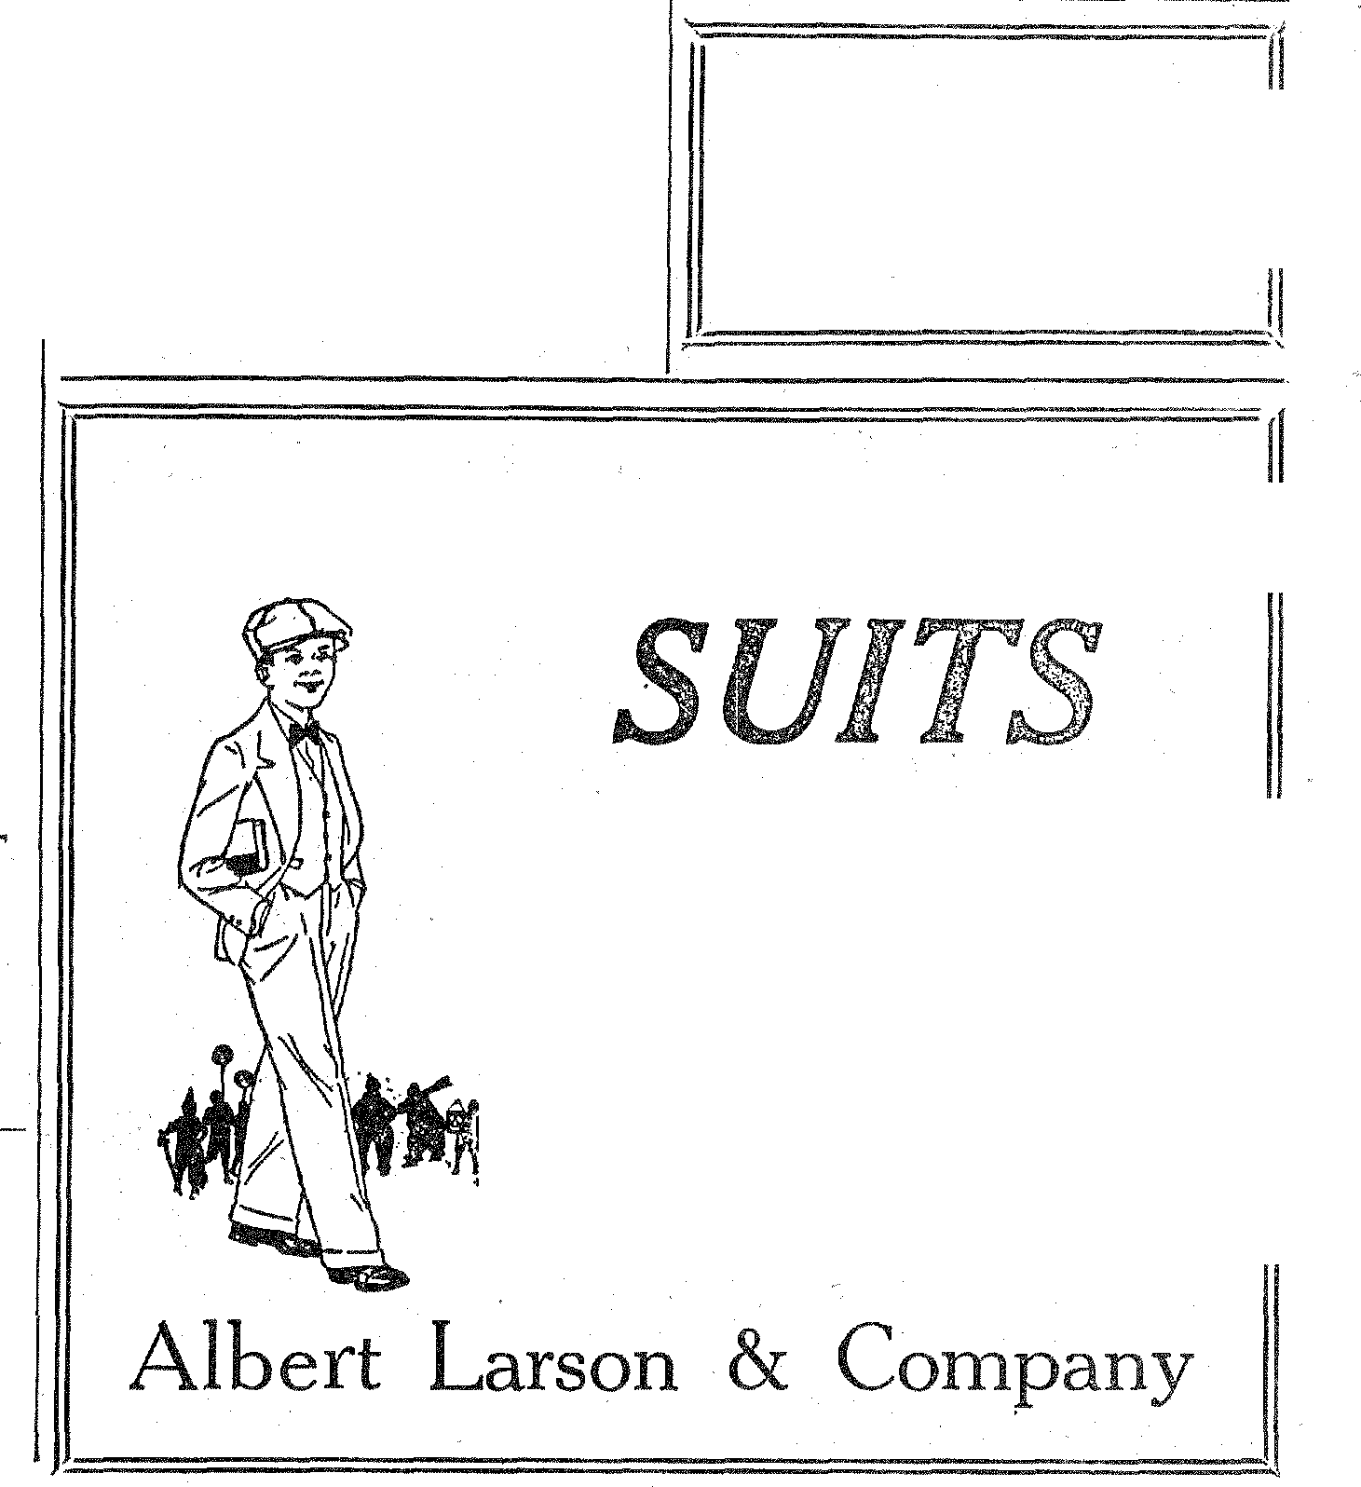
Debate

The Cooper-Hi Zip
Edited by
THE CLASS IN JOURNALISM
Ed i tor—Irene Nelson
Associate Editor—Gladys Langford Business Manriger—Oswald Tufte Assistant Manager—Earl Anderson
DEPARTMENTAL
Social—Muriel Thorne
Humor—Clarence Butler
Sport—Kenneth Thompson
Exchange—John Langford
Alumni—Inez Larson
•
CLASS ROLL
Mabel Anderson Kenneth Thompson Earl Anderson Oswald Tufte
Margaret Johnson Pearl Mathison Conrad Norga.a.rd Clarence Butler
Irene Nelson Muriel Thorne
Inez Larson Gladys Langford
John Langford
Member Central Interscholastic Pres
Association, Madison, Wisconsin
"Zip"—What Does It Mean?
You have often heard the question as to what "Zip" means or stands for. Perhaps at some time or other you have asked the question yourself.
The dictionary says that it is a "sharp, sibilant, hissing sound cooling with great speed; to make or move witn a zip." Phis the name of our paper, covers the ground better than anything we could wish. The paper conies out on thud or ahead of time, it contains news with zest to it. It aims to hit the mark. It shows outsiders what we are doing ar d wakes up and inspres, the student body. It brings out the most important ideals of C. H. S.-• higher scholarship, better citizenship, good sportsmanship and co-Operation between school and community.
Our "zip!" A moves w;t1; a zip —Teirriitshe maik!
Graany's Opinion
(By "Inez")
I went to see Granny one day to hear just what she had to say about our schools, and this is what
had to say:
'When I was young, I didn't go to school to learn to cook and sew. I had to stay at home with Ma,'
'cause she was lonesome without Pa, who worked outside the livelong' day, and didn't have any time to
play golf and such things as me do now. He had to walk behind
plow. Well, in her spare time, which was late at night, Ma would teach me how to read and write.
'This is better,' she would say, 'nal to walk to school three miles away.' But, all you youngsters have to do, is walk about a block or two; or else jump into an automobile and just slide in behind the wheel; then it takes you where you want to go, and not slow at all.
"Yes, youngsters today just can't be fools when the land is full of exCellent schools. You learn about Geometry, Music, History, Biology and so many other things that we young folks when I was young never dreamed about, And you learn how to cook and sew. When you get out into the world, you'll have some show to get along. You don't have to work all day, and then when you are through and night has come and you would better be in bed have to learn the things like I had to do.
"But, tunes have changed and suppose if you didn't learn it a school—well, who knows but that you wouldn't learn it at all, 'caus the time you spend at home is so small.
"The greatest thing in America today is her schools, anti the part they play in training boys to be worth while in making a living; an the girls in how ti live. And if
were young again, and had the priv-
CHILDREN'S BOOK WEEK SET FOR NOVEMBER 8-14
Children's B o o It Week will be oberved •this year from November 8 to 14. Then is he time to consider the reading material both in the home and in the school.
The long win-
TIourtt...y .at„
Assn. Book Pub. t e r evenings
in our stag .flake it a difficult task 0 offer desirable and interesting recreation for children. All children love to read books that appeal to them. It is the duty of the home and school to provide such books.
During the week the schools will
ake an effort to interest the community ill its library as well as in the home library. It would be well worth while for our community to consider a more advisable source of book suply to rits people. We would urge that all persons join in the program that the Sehools will pre-. sent at that time.
Financial Account of Zip
for Period Ending Sept. 30
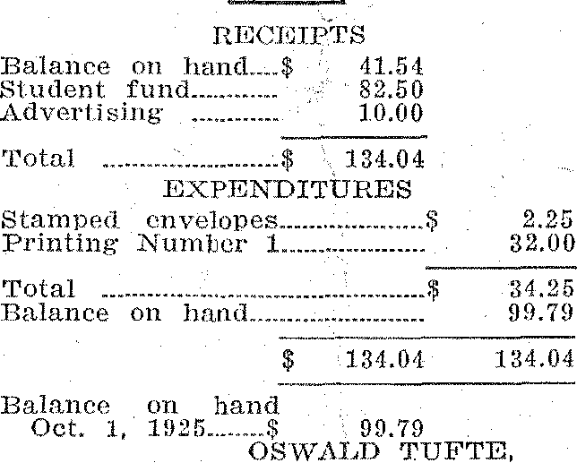
2.25
32.00
Total ............. $ 134.04
EXPENDITURES Stamped envelopes
Printing Nuirdier ...........
34.25
99.79
Total
Balance on 10mil
EEC( iITTS
Balance on hand„..$ 41.51
Si udent fund._ ..... 82.50
Advertising 10.00
$ 134.04 134.04
Balance 011 hand
Oct. 1,
OS WALD TUFTE,
ilegeS„ and opliortunitie5 17.:W.4:1,.. B111, 5(1f.
Will Use Gridagraph
A gridagraph will he used to show the game between Indiana and Mich
igan. [
Bismarck Playmakers Organize
The Bismarck Playmakers have organized and are starting their activities. Cooperstown will perhaps meet them in the Playmakers' contest at Grand Forks in the spring.
Enrollments Increase
Almost every school in the state has had an increase in enrollment. Some of the schools are: University of North Dakota, State School of Science and the Agricultural College.
.20:(4,10.1:14,15.11 mematteagemessmatentammersavanown.
Monthly Talk on School Costs
School year 1923: School year 1924: School year 1925: School year 1926:
;mum •
Gleanings from Authors
Let me but do my work front day to day,
In field or forest, at the desk or loom,
Let me but find it in my heart to say,
When vagrant wishes beckon me
astry,
This is my work, my blessing, not my doom;
Of all who live, I am the one by FROSH!
whom Welcome, Palmer, we are glad to
This work can best be done in the have you back. The Slye Digge will right way. have plenty of material now.
—Henry VanDyke. FROSFI!
A Fish Story
SONG OF THE LAZY STUDENT In English I a Freshman was ask-
ed to give a sentence with the word
I go to school most every day "deficiency" in it. The poor Freshie
Just to spend that time at play. tuined green with the severe mental
per, laugh and write such train, but filially gasped out:
notes "When ya, go fishin', pick up "de-That often get my teachers' goats. ficiency" 'em wiggle." Exit Frosh! Then when its time to go to class, FROSH!
I don't know if I'll flunk, or pass, Notice of Thanks
'Cause I haven't studied my lesson The upper classmen wish to thinit
at all
the class of '25 for the Lynx. One
And my
stor
small. keeps the Freshmen, bless their lit-
The teachers tie hearts, out of the library. You
of work, see they are "scairt" of it.
shirk. Why's?
Now, they are all talking Soph: "Why is you car like a
Getting my lessons or else getting pair of dice?"
out Fresh: "Dunn° (they never
Of the way of those who I ltiioiv). Why?"
To do their work, and t Soph: She shakes, rattles, rolls,
get by. never less than two up and seldom
So, I'd better try really better to be more than twelve. It (the ear)
Or the C, H. S. is no place for me. iicver goes rig⁻ht and the dice are
ivory and the car needs span."
FROSII!
Some Freshmen seem to be goltilig Nostalgia. The teachers are useful in dispelling it.
What's Nostalgia? Why that is
emotional, despondency which affects the son of the soil when he gets away from honie, the food ma cooks, the hawgs, the 00 NV8 and the smell Of the .old man's coth cob
Home sickness? YOU S■lid it but
Science School vs. A. C. Fresh what's that got to do with librar-
The State School of Science at ians? This is it: the Frost' thinks Wahpeton played their first game of home where he is sitting around against the A. C. Freshmen at the fire warming his red sox and Wahpeton. reading "The Road to Thrift," by
Monkey and Ward, when Ma collies
H1111[11111111E111
E SLYE DIGGE
Temptation
Last week one of the Freshmen refused to have his picture taken with a mule because lie was afraid that the temptation to label it "Two of a Rind' would be too great.
of knowledge is very
are tired of this sort
And they often tell me I FROSH!
must not
about
really try
not jus
1111111111111N1111111111111111¹,1111!111111FM1111¹,11111'TIIIIL '::1111111111111111111E11111111111111111
EXCHANGE
N. D. U. Beats Jamestown
In the best game which they have
played for several years, Irth Dakota defeated Jamestown by a score of 58 to 0.
EVERY BOY LIKES OUR
Good quality at moderate prices
Four-piece Suits, a coat, a vest and two pairs of trousers, sizes from 4 to . . . . . .$6.00
Sizes from 12 to 14.. . . . $19.50
To See Them is to Buy Them
Debate is one of our most important and beneficial outside activities. The debate season is close at hand and C. H. S. wants to start right out and get a team early. Don't be backward about trying out. The larger the number to try out the better team we'll get. Don't thin yu can't do it. You never know what you can do until you've tried. If no one ever tried anything, this would be a sorry place.
When try-outs are announced give in your name. Talk it up among others and show your school spirit by boosting it in every way.
—c. s.—
Noise in the Halls
The students who are excused at the end of the seventh period are very careless in their conduct iii the halls. There is loud laughing heavy tramping of feet, dropping of books and almost every other possible disturbance.
The early dismissal has only been in use for a week and each day it gets noisier. At this rate, what will it be at the end of the term?
The noise does not only disturb the other high school students who are in their classes, but also the grades in the building.
We, as high school students ough to be able to restrain ourselves until we get outside the building. Let's start in right now to alter this disagreeable thing. How about it?
Young Delinquent
We regret to state that one o our honored Freshmen was arrested yesterday for violation of the prohibition act. He W`LS found with liquor in the pocket edition of Webster he was carrying. Let this be a lesson to the rest of the little tots to keep to the straight and narrow way.
have I must confess I'd take up my work at C. H. S."
This is what she had to say about our modern schools.
The Zip believes that the general public is interested in knowing what it is costing in local taxation to finance the schools of our city. Many times people who gather on the street o rin the home talk about the "great amount of money that our schools are costing us." It is only fair that the public have some gential knowledge of the real costs of schools to the local taxpayer.
There are several funds from which school moneys are derived. The one that affects local taxpayers lost is the tax levy for the local district, all of which is paid by the property owners in Cooperstown. For this reason, we are giving you the figures taken from the records of the clerk of the Board of Education.
We will go back five years for our statistics. In 1921 the local Board of Education made a local levy of $25,064 to pay the costs of the local schools. This was the high figure for the five year period. The following year the levy was reduced to $24,000. The next year saw the levy decreased to $20,700. Then, in 1924, the Board of Education decided that the local levy should be cut to as low a figure as possible. They made a levy of $12,000. This is the sum available through local tax levy for running the schools the past
More Fish
Freshie (in a restaurant) : "Do you serve fish. If you don't I won't eat here.
Waitress: "Yes, we cater to everybody."
And the Freshman does not know why the other diners laughed.
Broadcast Football Games
St. Olaf College has started the novel idea of broadcasting their football games.
year,—less than 50 Per cent of the local levy for the school year 1922. In three years the 'Board cut your local taxes by ITIOre than 50 per 000t, as far as school costs are coll-
^{.-}led,
In the meantime, the property o the local school had been allowed to deteriorate, and many needed repairs were not made. Realizing that repairs had to he made the Board its meeting last .Tune decided that i would be necessary to raise the local school levy to meet the cost of again putting the school property in workable tnd economical. repair. They, thieiefoic, decided upon a levy $16,000 for the present school year. This levy is still $4,700 less than the levy of the year two years previous. Are, school taxes too high? Would you say that the local school board has not been economical in ts policies when such reductions have been made? Comparo, the local levy with that of other towns our size and you will be satisfied that Cooperstown does NOT have high school taxes.
School year 1922:
A Narrow Escape
A dog, size 6¹/₂ in. x 3¹4 in., came pretty close to itilhin a Freshie the other night. The dog barked, the Freshie climbed a tree and stayed up the tree all night. It was very cold that night, so the poor Freshie almost froze to death.
of its admirable qualities is that it
along and says "Move!" and he does.
Now transplant this scene to the library of the C. H. S. Little William Alexander is reading the latest Digest, when the librarian comes ill and says "Move!" The subconscious mind of the Freshie (if he has rue) links that he is home, thereby dispelling the Nostalgia.
FROSH!
Cover Your Feet With
Quality Shoes
HANSON SHOE STORE

