==Introduction==
Photo from www.novanumismatics.com
The Faithful Steward was a ship that was carrying passengers from Ireland to America. It ran aground near Indian River Inlet, Delaware on September 1, 1785. Even though it was only about 150 yards from shore, there were only about 68 survivors out of the nearly 250 on board. Construction

==Construction==
The Faithful Steward was a three-masted 150 foot long vessel owned by John Maxwell Nesbitt, James Campbell, and William Allison, who were all Philadelphia merchants.

==Voyage==
The Faithful Steward left Londonderry, Ireland on July 9, 1785.[The Faithful Steward Shipwreck]

==Crew==
There were 13 crew members on board. All of them survived the sinking. The captain was Con M. Some of the survivors reported that the Captain and First Mate had been drinking at the time of the accident.[In Search of]A young couple was celebrating their anniversary. There was lots of drinking and dancing and the Captain and First Mate were reportedly carried unconscious to their cabins. [Shipwreck of the Delaware.] The Captain and some others made it to shore, but the lifeboats were unable to return to the ship because of the violent surge.[Faithful]
The crewmen were:
Capt. Con. M'Causland | Samuel Irwin, (sailor)
Mr. Standfield, (1st mate) | John Quigly, sailor
Mr. Given (Gwyn), (2nd mate) | Pat (rick). Mourn, (sailor)
Mr. (William) Lin (Linn), boatswain | Edward M'Caffry (Caffrey), (sailor)
John Brown, (sailor) | Pelick Hudson, (sailor)
Wm. Dalrample (Dalrymple), sailor | Owen Phillips, (sailor)
Robert Kelly, sailor

==Passengers==
A ships manifest has never been found so there is no record of passenger names. Most reports claim there were either 240[DiscoverSea][Faithful Steward] or 249[The Faithful Steward][Delaware Public] [Ulster Ancestry]passengers on board.

==Cargo==
The ship took on 400 barrels of coins at xxx before departing for America. They were mostly penny and half-penny coins. The coins have been washing up on the beach ever since the wreck. [Faithful Coins Wash Ashore] They would have a value of about $1.5 million dollars today.[The Faithful Steward]

==Sinking==
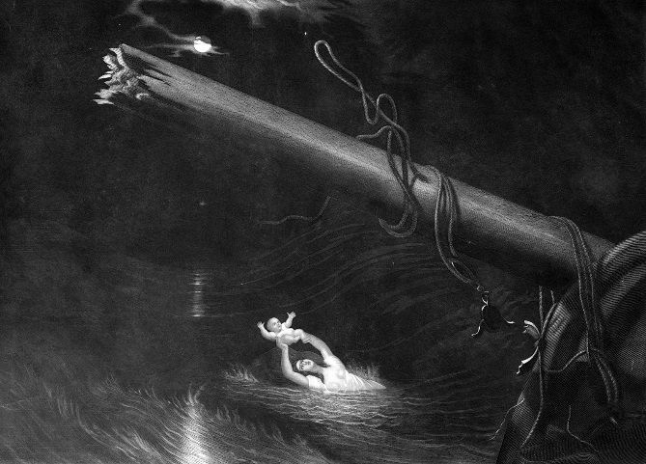
Falmanac 1985: Faithful Steward Sinks

The ship broke up the following day about 100 years from shore. There were about 68 survivors. Only 7 of the 100 women and children

==Survivors==
Many lists of the survivors have been published and most of them include 68 names. [Ulster Ancestry]

Cabin Passengers | Thomas Calhoun (Colhoun) | Gustavus Calhoun (Colhoun)
John O'Neill (O'Neil) | James Dougherty | James Marshall
Thomas Blair | John M'Calister (McCallister) | Robert Laurence
John York | Samuel Heburn
Passengers
Samuel Moore | James Beaty | James Devin
Sarah Campbell | Thomas Moore (More) | Alexander Moore
Arthur Higginbottom | Charles M'Williams | Samuel Wright
George Munro | Andrew Watt | James Watt
James Smyth (Smith) | Robert Dinmore (Dinsmore) | Wm. M'Clintock
John M'Illheney (McIlheney) | John M'Nab | John Brocket
Neill M'Kinon | Sarah M'Kinon | John Aspill
James Aspill | Thomas Ranolles (Ranolls) | John M'Mullen (McMullan)
Mary Burns | James M'Intire, senior | James M'Intire, junior
Rebecca M'Intire | John Scott | John Spires
James Stunkard (Stankard) | James Lee | Mary Lee
Thos. Baskin | Margaret Kincade | Doctor M'Dougle (McDougal)
Mary Maginniss (Maginnis) | Matthew Caldwell | Hugh M'Clean
John Shaw | Matthew (Mathew) M'Manes | Simon Ellist (Ellit)

James Ellist (Ellit) | John Davis | George Richford

The exact number of survivors is unknown. Some later reports add about 4 more names to the survivor list.

==Aftermath==
Many stories have been written about the survivors.[Bob Elmwood]
Among them was a young man named James Lee, his parents, three brothers,two sisters, a brother's wife, three uncles, three Aunts and thirty three cousins - in all, forty eight members of one family. Of the 48 members of the James Lee's family who sailed on The Faithful Steward, only he and his sister in law, Mary Lee and four cousins survived. [Ulster Ancestry]
There were about 50 members of the Elliott family and significant numbers from the Stewart and Espey families. [Shipwrecks of the Delaware Coast]

==References==
- Bob Elmwood's Guestbook
- DiscoverSea Shipwreck Museum
- Delaware Public Archives
- Faithful Coins Wash Ashore
- Faithful Steward Survivors
- Historic Sites and Shipwrecks
- Hurricanes and the Middle Atlantic States
- In Search of Faithful Steward
- Irish Emigrants in North America - Parts 4-5
- Londonberry Journal February 21, 1786.
- Nova Numismatics
- Shipwrecks of the Delaware Coast Tales of Pirates, Squalls,
- Shipwrecks, Sea Raiders, and Maritime Disasters along the Delmarva Coast, 1632-2004
- The Faithful Steward Shipwreck
- Ulster Ancestry

