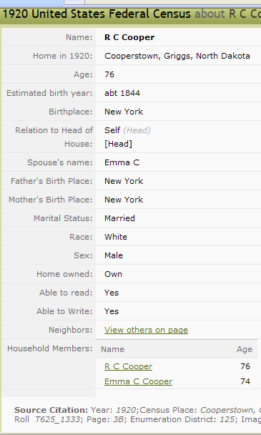

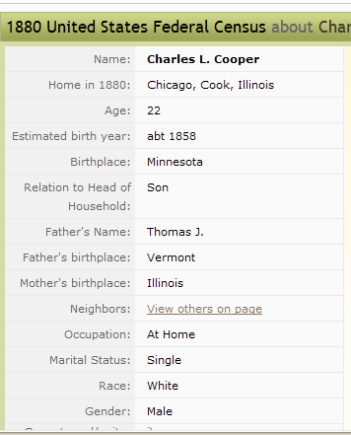

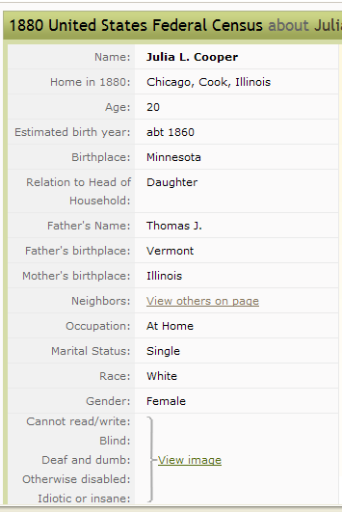

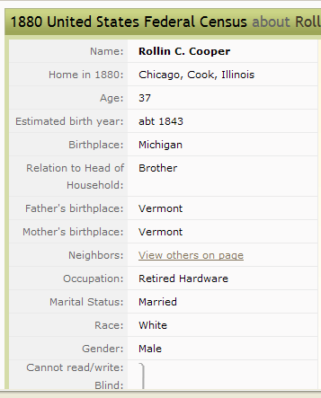

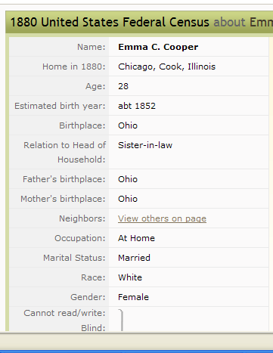

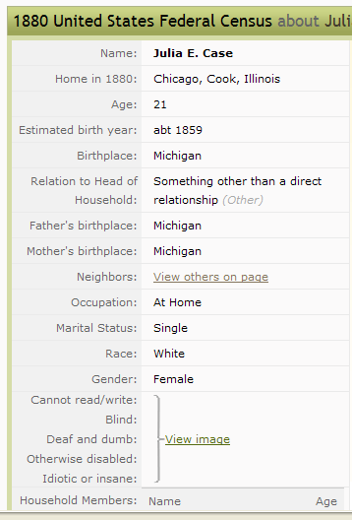

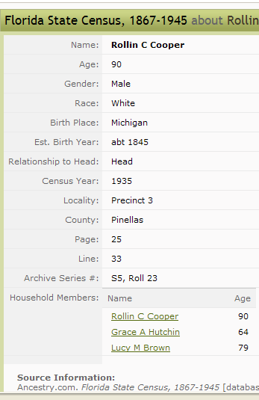

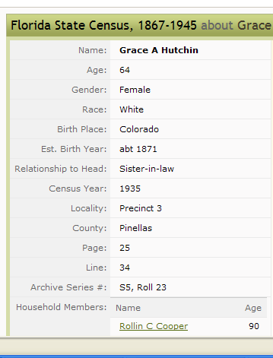

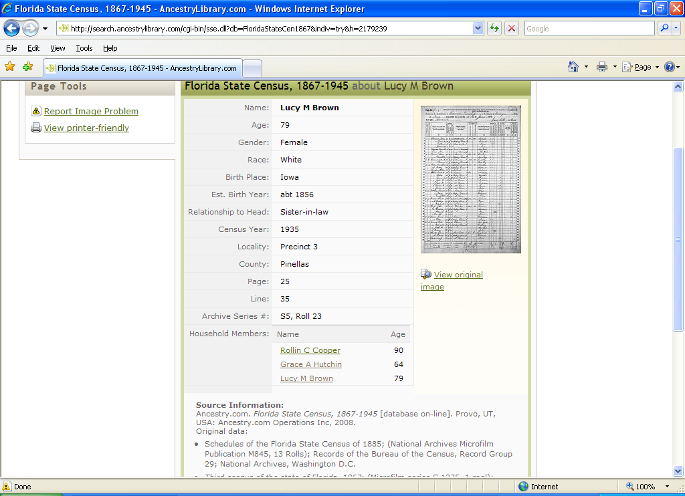

1900 United States Federal Census about Rollin C Cooper
Name: | View  Original  Record  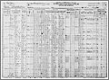  View original image  View blank form
  Rollin C Cooper
  Home in 1900: | Cooperstown, Griggs, North Dakota
  Age: | 54
  Birth Date: | Sep 1845
  Birthplace: | Michigan
  Race: | White
  Gender: | Male
  Relationship to Head of House: | Head
  Father's Birthplace: | Vermont
  Mother's Birthplace: | Vermont
  Spouse's name: | Emma C
  Marriage Year: | 1870
  Marital Status: | Married
  Years Married: | 30
  Residence : | Cooperstown Village, Griggs, North Dakota
  Occupation: | View on Image
  Neighbors: | View others on page
  Household Members:
    Name | Age
    Rollin C Cooper | 54
    Emma C Cooper | 49
    Florence Cooper | 15
    Laes Watne | 27
    Fred Gaden | 45
    Nels Dronen | 21
    Carl J Watne | 24
    Gerhart Watne | 29
    John J Skange | 34
    Halver St*Land | 22
    Knut Johnson | 27
    Martin Johnson | 25
    Nerby Clara | 18
    Cora Skause | 27
    Mons Foland | 22
    L G Ravndal | 22
    Hans Bickern | 29
    Arnt Johnson | 24
    Larvald Wig* | 19
    Adel W?Gstrom | 21
    Nels Wirdahl | 40
    Anna Wirdahl | 21
    Ole L Anderson | 23
    Adolph | 26
    Frank W | 17
    Martin Odronen | 19
    Anton Anderson | 19
    Carl Knutsen | 18
    Crist Peterson | 41
    Charles E Mckety | 33
    Herbert Basset | 37
    George Houghton | 28
    Nels Pertland | 42
    Manngle Paulson | 39
    O H Magnes | 37
    Adolph Johnson | 33
    Robert Basset | 20
    Edward Scott | 22
    Edwin Bardah | 48
    Gene Lina | 27
    Lewis Anderson | 33
    Adolph Johnson | 36
Source Citation: Year: 1900; Census Place: Cooperstown, Griggs, North Dakota; Roll T623_1228; Page: 2B; Enumeration District: 76.

