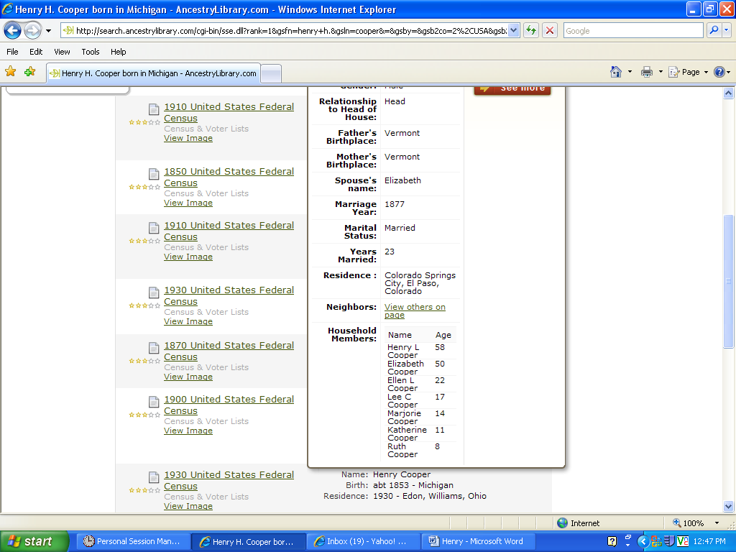
Henry H. Cooper 1900 Census

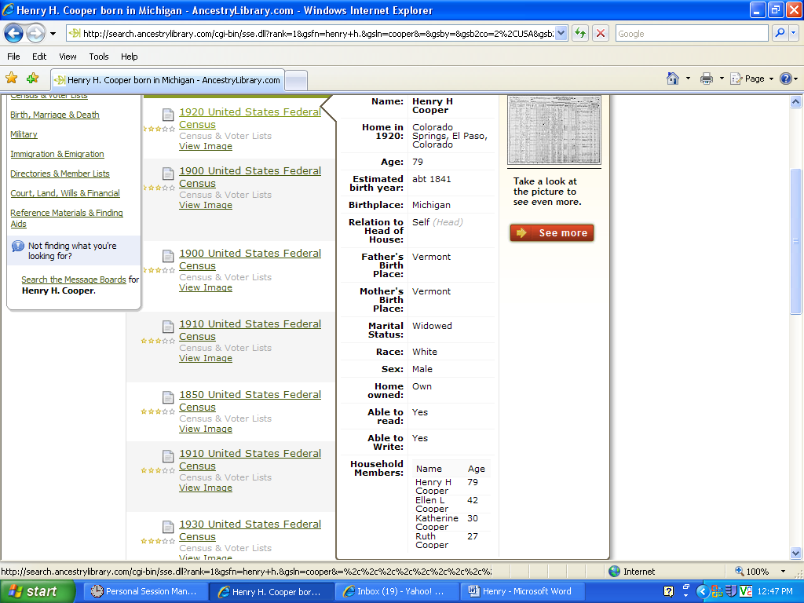
Henry 1920 Census

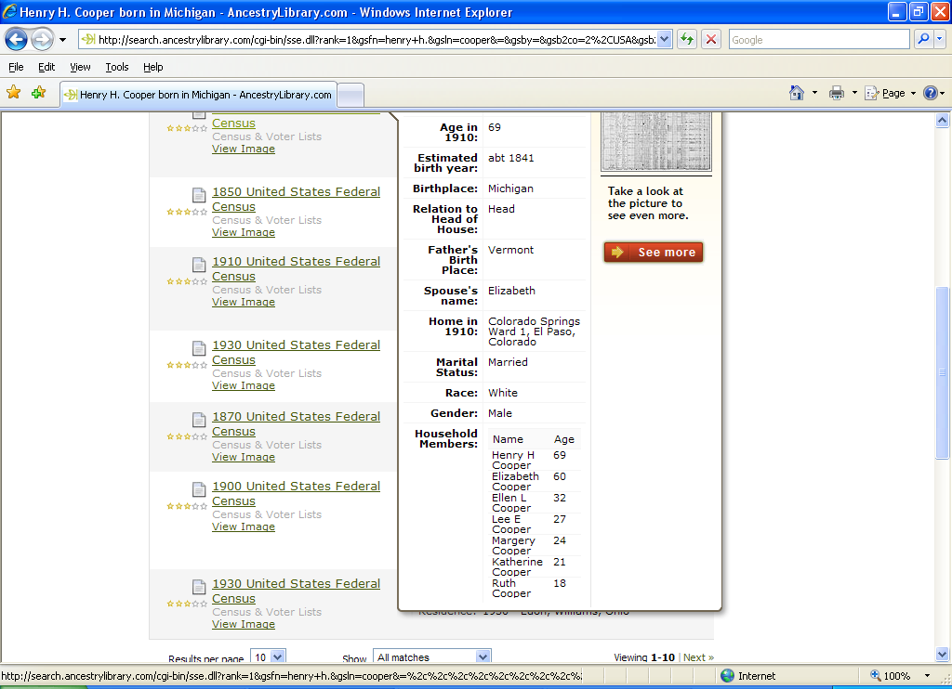
Henry H. Cooper
1910 Census

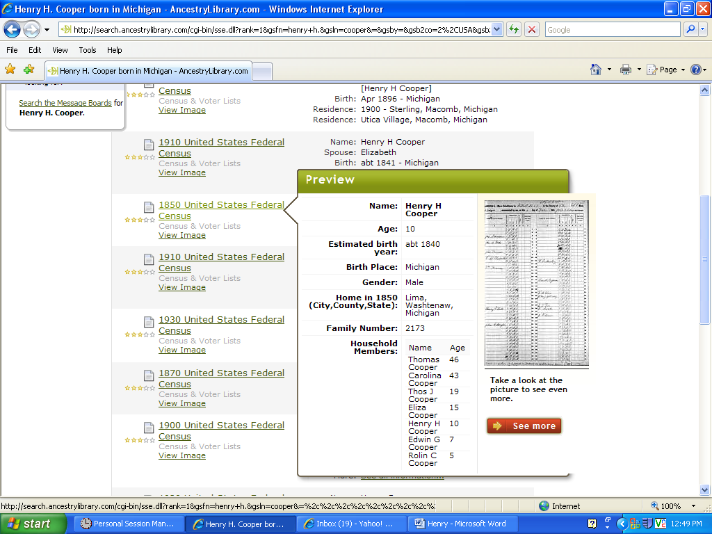
Thomas J. 1850 Census

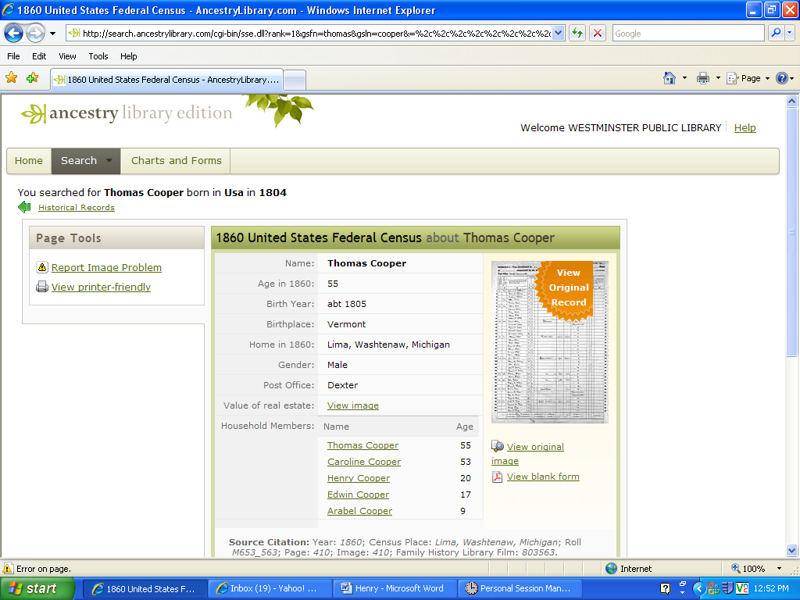
Henry Cooper 1860 Census

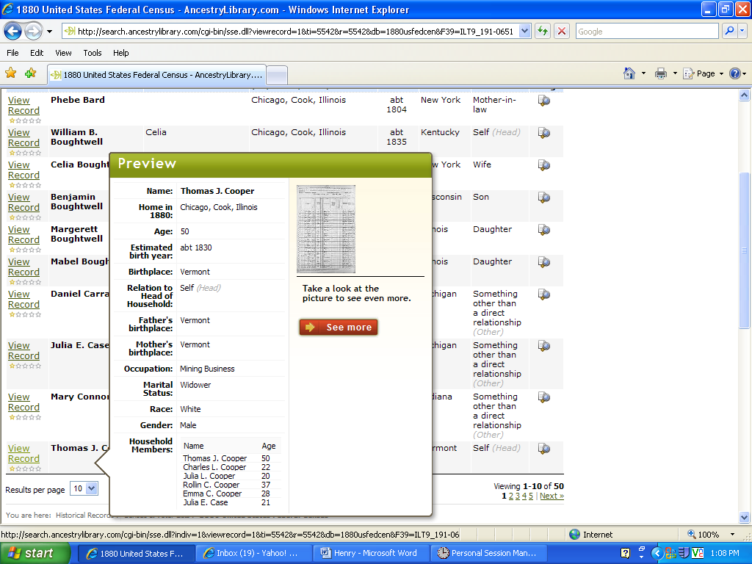

Thomas J. Cooper
1880 Census

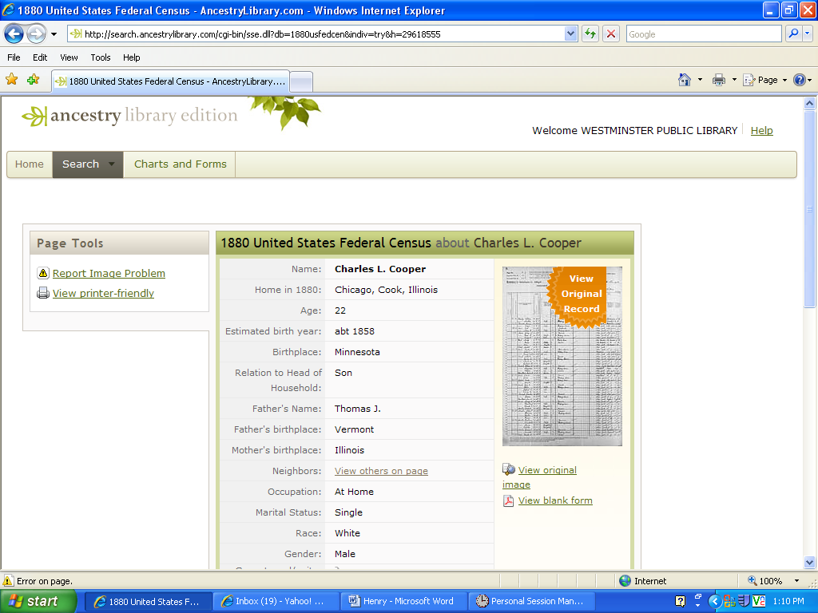

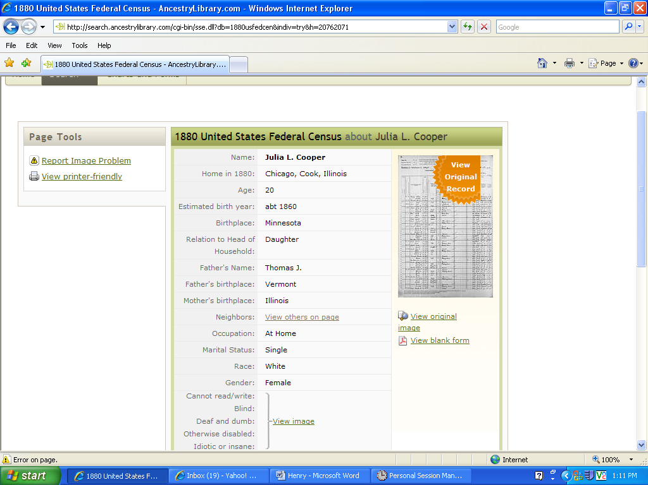

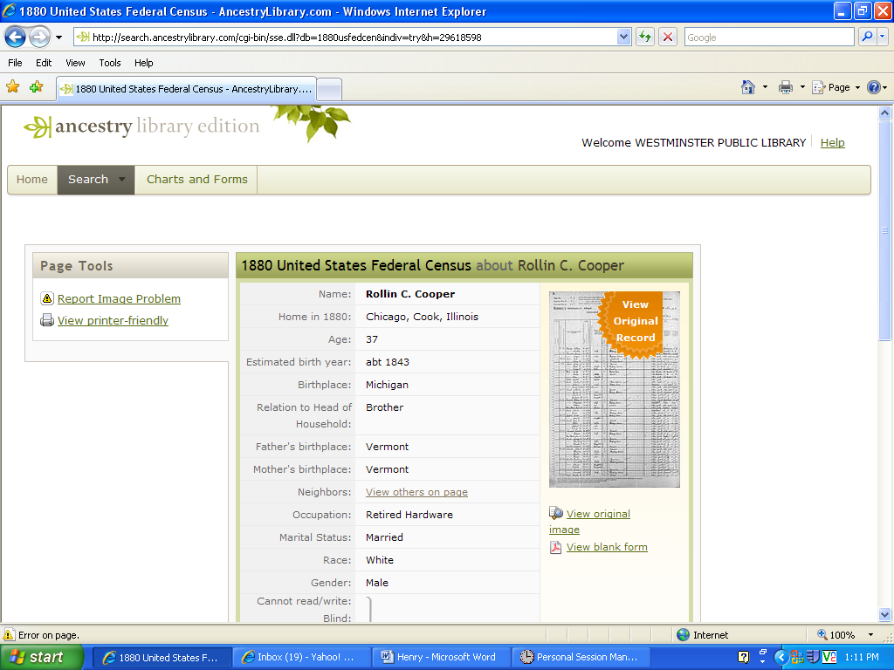

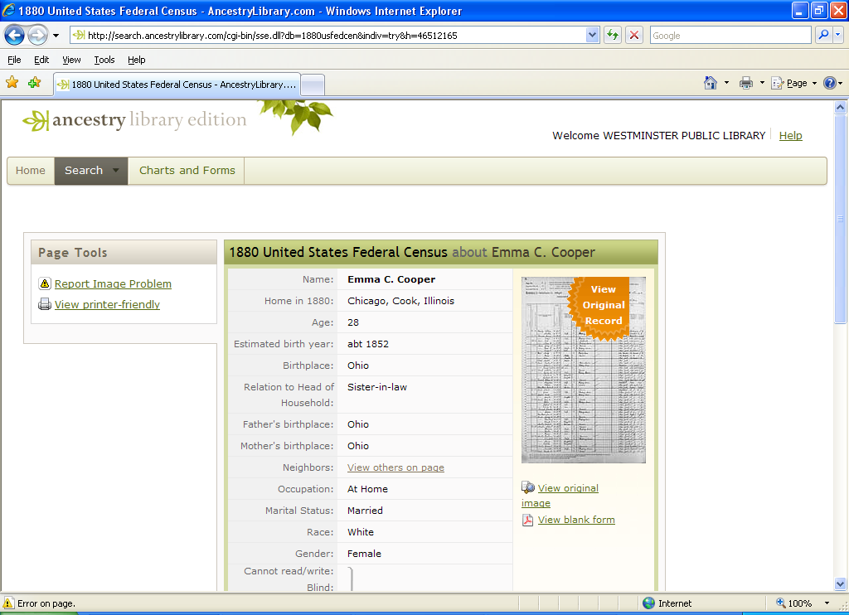

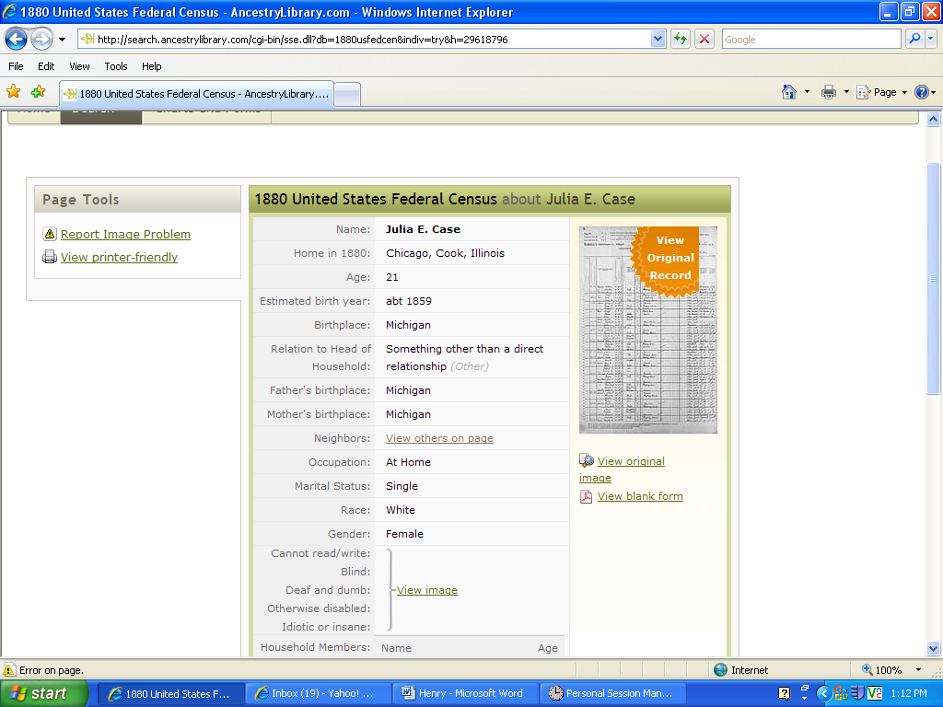

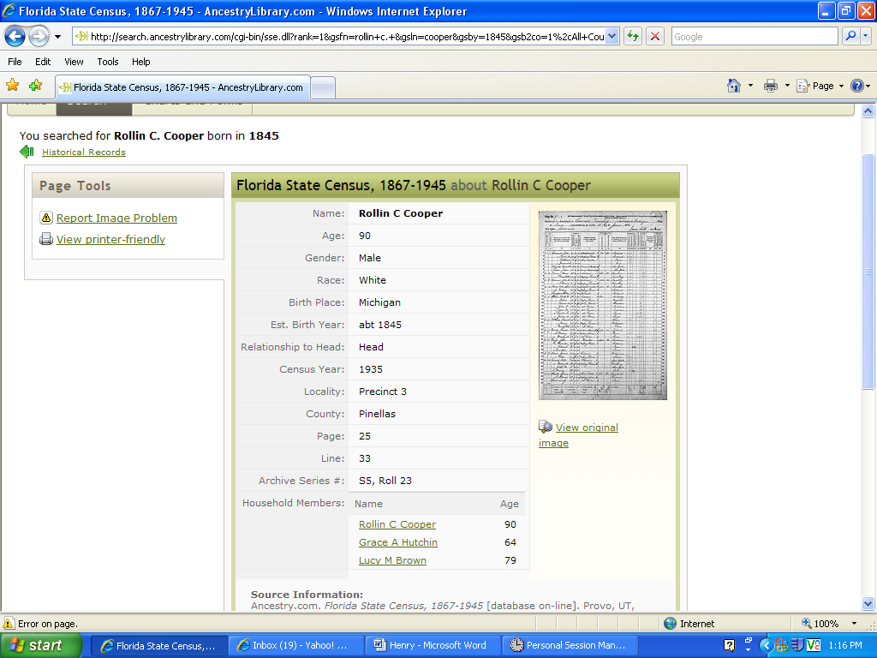

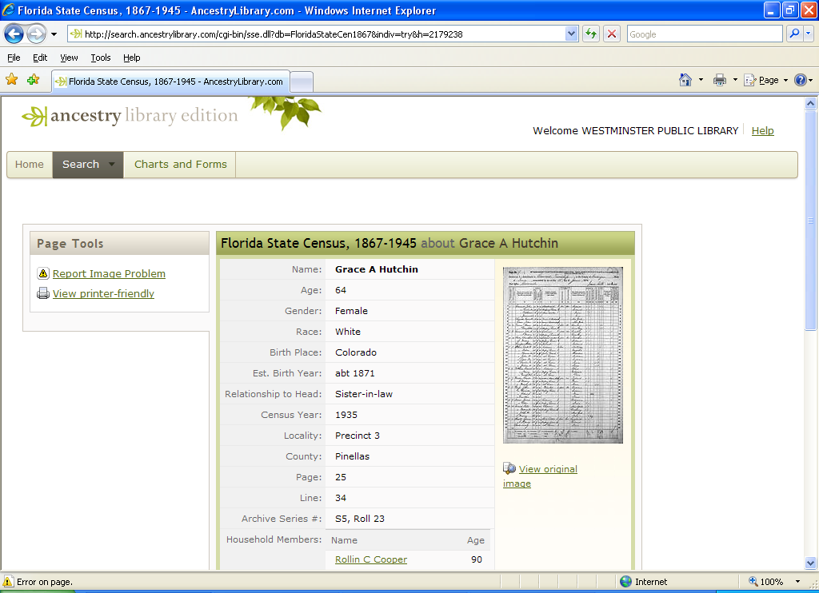

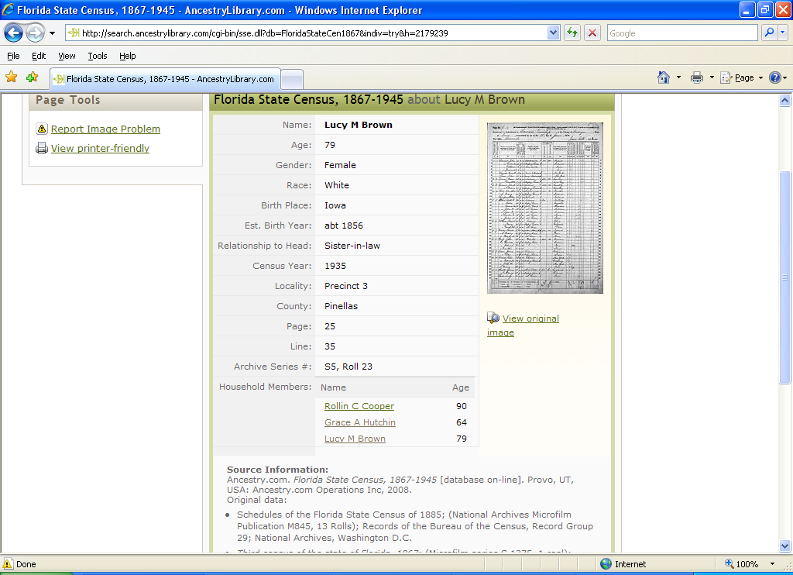

1900 United States Federal Census about Rollin C Cooper
Name: | View  Original  Record  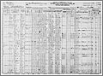  View original image  View blank form
  Rollin C Cooper
  Home in 1900: | Cooperstown, Griggs, North Dakota
  Age: | 54
  Birth Date: | Sep 1845
  Birthplace: | Michigan
  Race: | White
  Gender: | Male
  Relationship to Head of House: | Head
  Father's Birthplace: | Vermont
  Mother's Birthplace: | Vermont
  Spouse's name: | Emma C
  Marriage Year: | 1870
  Marital Status: | Married
  Years Married: | 30
  Residence : | Cooperstown Village, Griggs, North Dakota
  Occupation: | View on Image
  Neighbors: | View others on page
  Household Members:
    Name | Age
    Rollin C Cooper | 54
    Emma C Cooper | 49
    Florence Cooper | 15
    Laes Watne | 27
    Fred Gaden | 45
    Nels Dronen | 21
    Carl J Watne | 24
    Gerhart Watne | 29
    John J Skange | 34
    Halver St*Land | 22
    Knut Johnson | 27
    Martin Johnson | 25
    Nerby Clara | 18
    Cora Skause | 27
    Mons Foland | 22
    L G Ravndal | 22
    Hans Bickern | 29
    Arnt Johnson | 24
    Larvald Wig* | 19
    Adel W?Gstrom | 21
    Nels Wirdahl | 40
    Anna Wirdahl | 21
    Ole L Anderson | 23
    Adolph | 26
    Frank W | 17
    Martin Odronen | 19
    Anton Anderson | 19
    Carl Knutsen | 18
    Crist Peterson | 41
    Charles E Mckety | 33
    Herbert Basset | 37
    George Houghton | 28
    Nels Pertland | 42
    Manngle Paulson | 39
    O H Magnes | 37
    Adolph Johnson | 33
    Robert Basset | 20
    Edward Scott | 22
    Edwin Bardah | 48
    Gene Lina | 27
    Lewis Anderson | 33
    Adolph Johnson | 36
Source Citation: Year: 1900; Census Place: Cooperstown, Griggs, North Dakota; Roll T623_1228; Page: 2B; Enumeration District: 76.

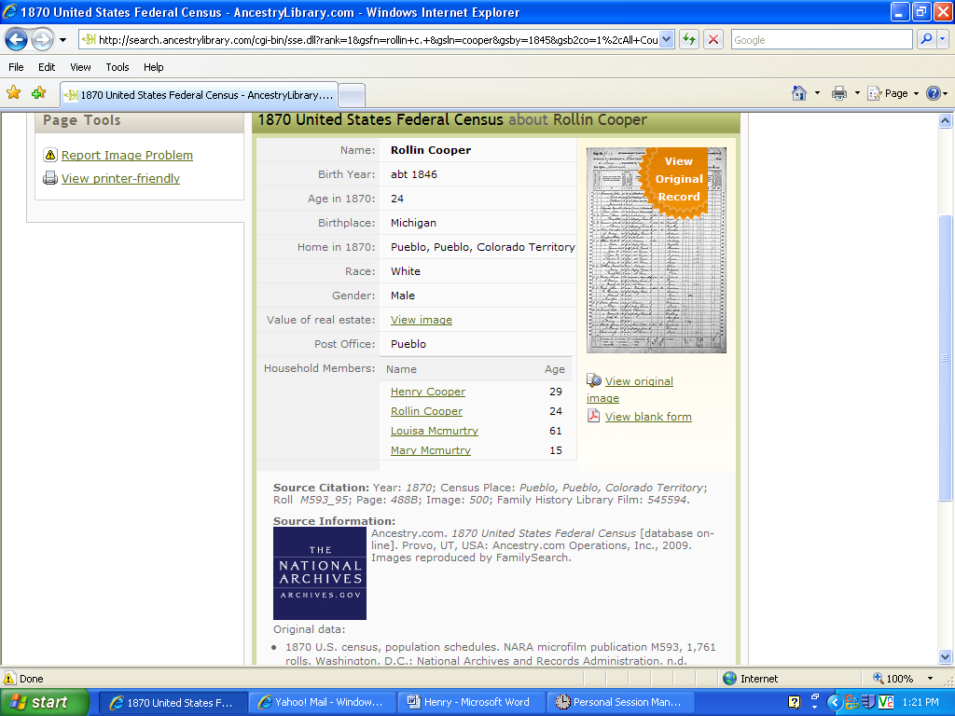

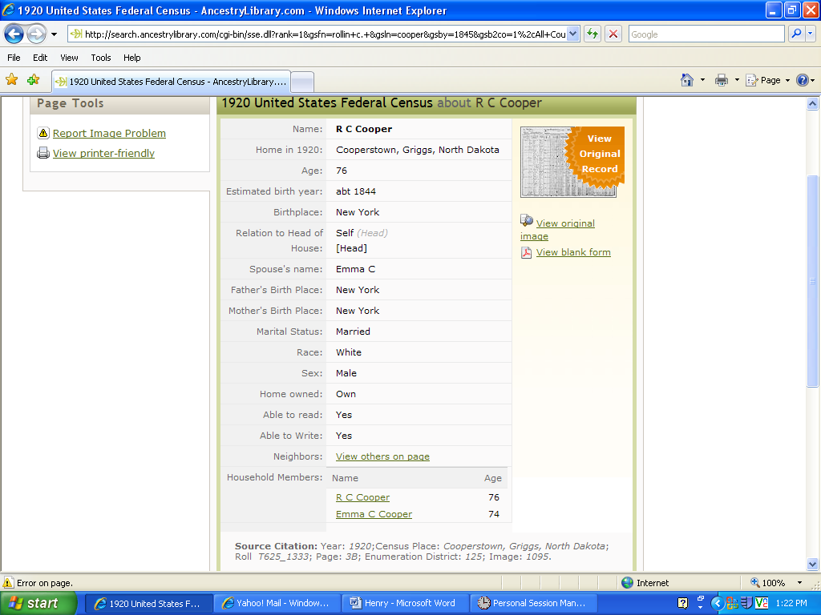

1920 C ensus

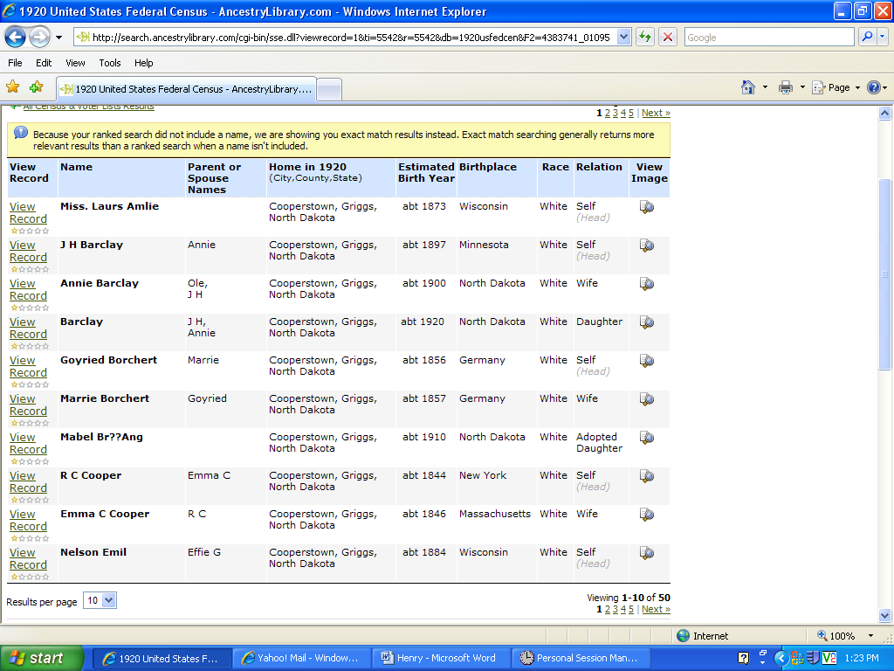
1920 Census

