Don and Duna,

I’m having a real hard time trying to sort out some of the Stavanger group.

I found the handwritten stuff below in Mrs. Porterville’s files in Fargo.

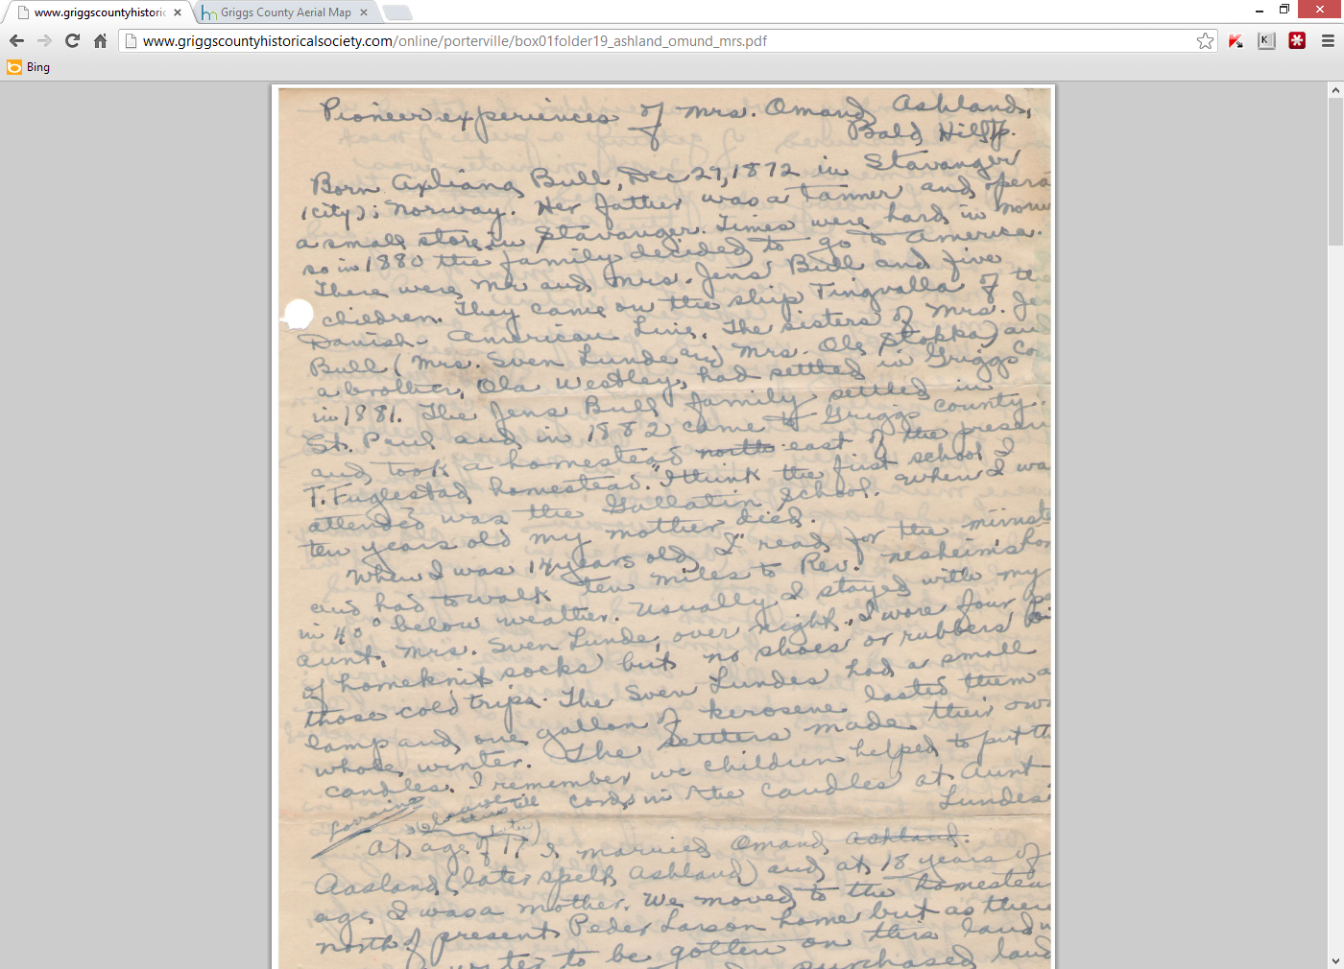

**I think I transcribed it accurately as:**

Born Axliana Bull, December 27, 1872 in Stavanger (City); Norway. Her father was a tanner and operated a small store in Stavanger. Times were hard in Norway so in 1880 the family decided to go to America.

There were Mr. and Mrs. Jens Bull and five children. They came on the ship Tingvalla of the Danish-American line. The sisters of Mrs. Jens Bull (Mrs. Sven Lunde and Mrs. Ole Stokka) and a brother, Ola Westley, had settled in Griggs County in 1881. The Jens Bull family settled in…

I show Sven Lunde only having one wife, Justina Westley and I don’t have Justina being an aunt of Axliana.

I show Ole Stokka only having one wife, Maria Hansdatter Westley and I also don’t have her being an aunt of Axliana.

I do show Axliana Bull having a sister Malliene Bull Jensen that married Ommund Westley, son of Ola Hans Westley. So Ola would have been Axliana’s sister’s father-in-law instead of a brother of Mrs. Jens Bull.

Another place I’m getting confused is the link at <http://www.findagrave.com/cgi-bin/fg.cgi?page=gr&GRid=92403386>

It is maintained by Kimberly Rueth Ueland and I need to figure out who she is to so I can try to contact her.

On this link and several other places I see the Froiland name and it might be a farm name.

If you click on Christian Seldal, Kimberly mentions 7 known children but only 3 known children from the wife Amelia.

Then I got to the link at <http://section20.com/NjaaFamily/Family_History_Ver_4-06.htm> from Jeanette Njaa and clicked on some of the links and then gave up.

I think my computer has created some links on its own and created some marriages that don’t exist.

If you have this straight Don, I’ll try to get with you in January. Any light you can shed on it Duna would be great.

I also attached a future Courier article on Omund Ashland. I was trying to verify the last paragraph on this article when I ran into problems. Duna, do you think I should contact Gordon or Bart or anybody before the story runs? And let me know what you think about the appropriateness of the entire article.

See you guys in a few weeks…

Ron