The Swedish Family of Brita Esbjörnsdotter
by Thomas Sievertsson, Uppsala, Sweden

Brita Esbjörnsdotter’s Parents and Siblings.

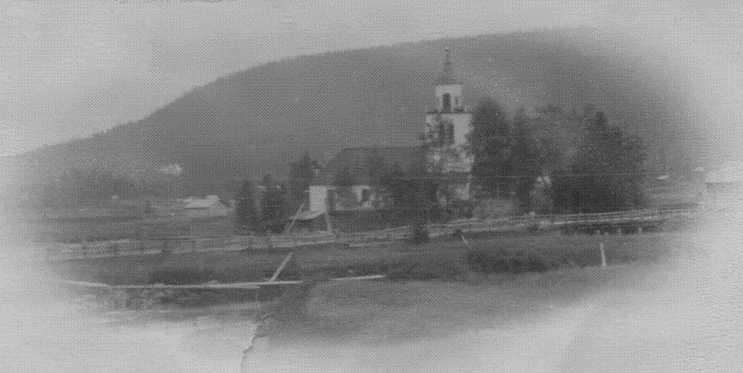
The church in Överhogdal

This documents my knowledge of Brita Esbjörnsdotter and her siblings. There are many names and dates, and it is possible that there may be a few errors. If you believe you have found errors, or if you have questions or comments, I would appreciate hearing from you. My e-mail address is tsievertsson@hotmail.com.

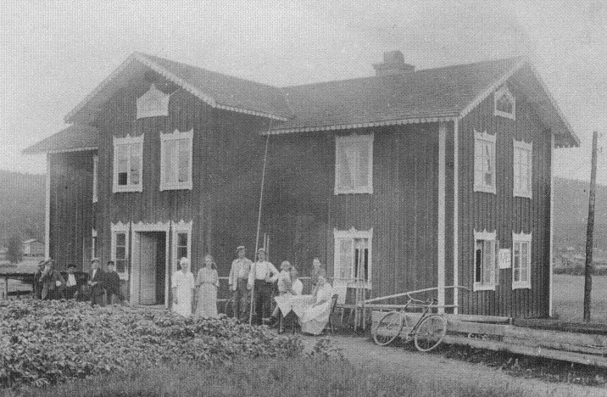
“Svens”, the farm in wich Esbjörn Svensson’s family lived in. This photo
is taken in the 1920’ies. Then this old building was used as a bakery.

There were six siblings in this family: four brothers and two sisters. All of Brita’s siblings remained in Överhogdal after she departed for America. Three of them still have living descendants in Överhogdal and other parts of Sweden.

The siblings, Sven, Olof, Hans, Sönne, Jonas and Brita, were the children of Esbjörn Svensson and his wife Brita Hansdotter. Esbjörn Svensson was born on the 14th of December 1797 in Överhogdal. Esbjörn Svensson and Brita Hansdotter were married on the 20th of April 1823. Brita Hansdotter came from another village, and was born in Boda parish in the province of Dalarna on the 8th of December 1795. In 1823, Esbjörn Svensson took over the operation of his ancestor’s old farm, “Svens”, from his stepfather.

“Svens” had been in the family since the first preserved records. It had been handed down from father to son. Esbjörn Svensson had the responsibility for “Svens” until 1852. Afterwards, Esbjörn Svensson and Brita Hansdotter remained at “Svens” and lived with their son Olof Esbjörnsson. Brita Hansdotter died on the 10th of October 1862 and Esbjörn Svensson died on the 17th of December 1882.

The Esbjörnsson brothers were great hunters. It is told that, in their youth, their main activity was hunting. One of the brothers, either Sven, Jonas or Hans, shot several bears. I’ve been told that, when they were out hunting, they would go to a chamber in the mill at “Kvarnbacken” to rest. (This homestead in Överhogdal will be described later.) The sound from the waterfall in the little creek would put them to sleep.

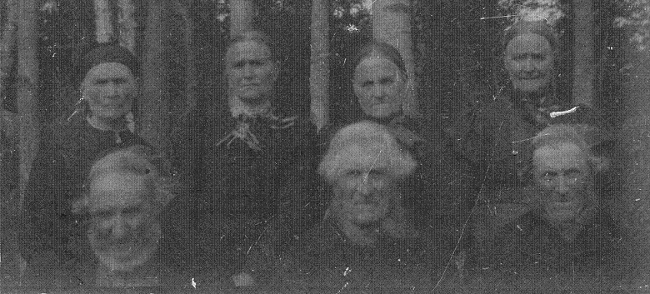
Maria Jonsdotter Sönne Esbjörnsdotter Margta Jonsdotter Gertrud Jonsdotter
Sven Esbjörnsson Olof Esbjörnsson Hans Esbjörnsson

An interesting thing about the Esbjörnsson brothers is that three of them married sisters! Olof Esbjörnsson was married in 1855 to Margta Jonsdotter Wallster and Hans Esbjörnsson was married in 1864 to Gertrud Jonsdotter Wallster. Jonas Esbjörnsson was married in 1872 to Maria Jonsdotter Wallster. Margeta, Gertrud and Maria were all daughters of Jonas Wallster (1800-1887) and his wife Ingrid Jönsdotter (1808-1887) from the farm “Nyåkern” in Överhogdal.
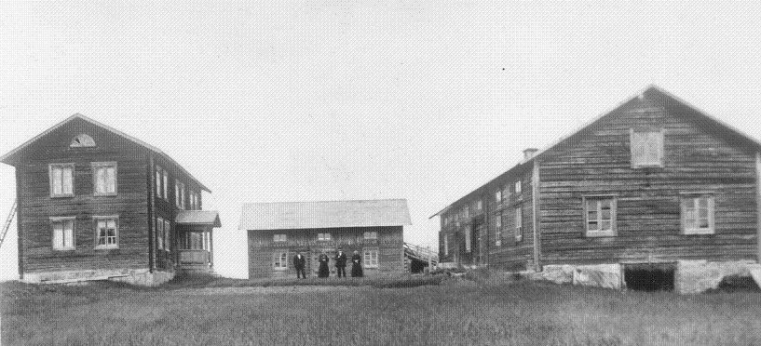
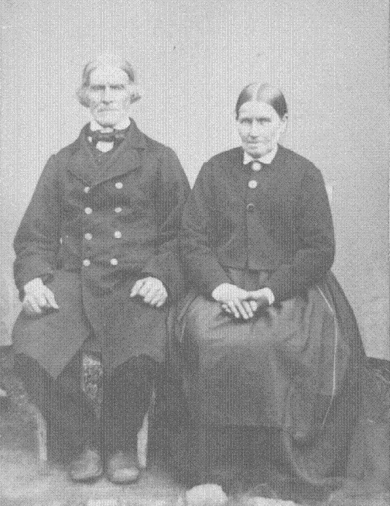

Above: The farm ”Nyåkern” in Överhogdal
To the left: Jonas Wallster and Ingrid Jönsdotte

Brita Esbjörnsdotter

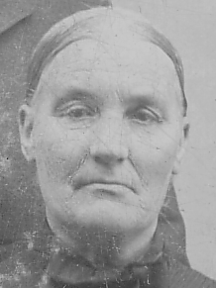
Brita Esbjörnsdotter

Here is what I was able to learn about Brita Esbjörnsdotter:

Brita was born on the 8th of September 1838 in Överhogdal.

Brita married Jonas Olofsson from Sätern, a part of Överhogdal parish. Jonas was born on the 12th of January 1837 in Överhogdal. He was a farmer at farm number 28 (old number 18) in Överhogdal, a farm named “Ol-Lars”. Jonas brother, Lars Olofsson, who was born the 23rd of December 1816, and Jonas, took over their parents farm, “Ol-Lars”, from their father who was named Olof Larsson. Jonas Olofsson was a farmer at “Ol-Lars” until his death in 1882.

Jonas and Brita were married on the 20th of June 1864. They had seven children:

Olof (born on the 13th of April 1865)
a still born son (born on the 3rd of October 1867)
Sigrid (born on the 5th of May 1869)
Esbjörn (born on th 15th of May 1872)
Jonas (born on the 25th of November 1874,
dead on the 12th of December 1875)
Johan (born on the 29th of November 1878)
Brita (born on the 12th of October 1881)

Jonas Olofsson died on the 29th of December 1882, according to the death record, when he was 45 years, 11 months and 17 days old. The cause of death stated in the death record is “lungsot” (I do not know the English word for it, but it would mean, “a disease in the lungs”. Nothing more specific is mentioned.)

Brita Esbjörnsdotter and her five children left Sweden for America on the 12th of May 1883.

After that Brita Esbjörnsdotter emigrated to America in 1883, her part of the farm “Ol-Lars” was owned by Ljusne Woxna AB (a company). It seems as if the farm stood uninhabited for a couple of years after Brita went to America with her children. This was the case until December 4th 1888 when a man named Sven Pettersson rented “Ol-Lars”.

In Överhogdal, there are two preserved photos. They once belonged to Hans Esbjörnsson, Brita Esbjörnsdotter’s brother. I have learned that these photos show Brita Esbjörnsdotter and her family. This proves that Hans and Brita kept in contact.

This is all that I know about Brita Esbjörnsdotter.

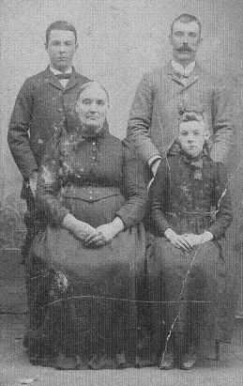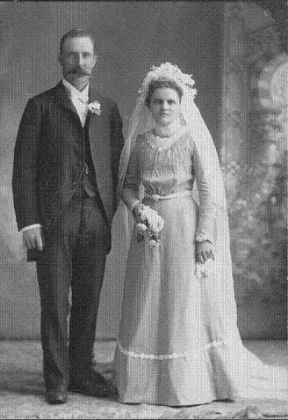
John Johnson Olof Johnson Olof Johnson and his wife Lisa Brita Johnson
Brita Esbjörnsdotter Brita (Betsy) Johnson

Sven Esbjörnsson, Brita Esbjörnsdotter’s brother.

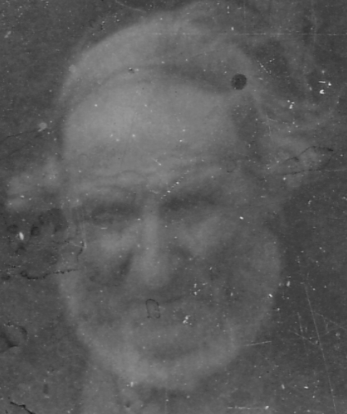

Sven Esbjörnsson was born on the 4th of August 1824. He was the oldest son of Esbjörn Svensson and Brita Hansdotter.

For some unkown reason, Sven Esbjörnsson did not take over the farm called “Svens”. For hundreds of years, this farm had been passed on from father to oldest son, but in this generation, the oldest son did inherit “Svens”. It is possible that the siblings (at least the sons) drew lots on who should get the farm. This was sometimes done, but I do not know if this was the case on this particular occasion.

Sven Esbjörnssons father, Esbjörn Svensson, bought a croft, which is today called “Påles” (also in Överhogdal). In 1851, Sven Esbjörnsson bought “Påles”. When Sven had a place of his own, he got married. Sven was married on the 12th of June 1853 to Gertrud Jonsdotter (Born 14th of December 1818.). Sven and Gertrud had two children:

Esbjörn (born 19th of June 1854)
Brita (born 29th of January 1856, dead 15th of January 1857).

Sven’s wife, Gertrud Jonsdotte,r died on the 5th of December 1866.

Sven remarried on the 22nd of April 1872 to Brita Jonsdotter (born on the 26th of June 1832). On the 10th of May 1873 their daughter, Brita Svensdotter was born.

As will be told later (See Jonas Esbjörnsson.), Sven and Jonas exchanged homesteads, and in 1874, Sven Esbjörnsson and his wife and children moved to “Kvarnbacken”. At “Kvarnbacken”, Sven Esbjörnsson became a miller. He was then called “Mjölnar’n” in Överhogdal (simply meaning “the miller”).

On the third of August 1877, Sven and Brita had a daughter Anna Svensdotter, but she died on the 15th of September 1877.

On the 8th of April 1888, Sven Esbjörnsson’s son, Esbjörn Svensson, (called “Kvarn-Svensa”) left Sweden for America. Where “Kvarn-Svensa” went I do not know. The following year on the 1st of February 1889, Sven’s wife, Brita Jonsdotter died, and in 1890, their daughter Brita Svensdotter also died. Brita Jonsdotter died from diphtheria that was rife in Överhogdal that year. Sven was now alone. However, “Kvarn-Svensa” came back from America to Överhogdal on the 21st of July 1894.

“Kvarn-Svensa” didn’t stay in Överhogdal for long. In 1900, he moved to the parish of Rätan, a neighbouring village to Överhogdal, and lived there until his death in on the 9th of February 1922.

Sven Esbjörnsson stayed at “Kvarnbacken”. In 1906, Sivert Jonsson, my great grandfather, bought ”Kvarnbacken”, on the condition that Sivert and his wife, Sofia, would take care of Sven Esbjörnsson or “Kvarngubben” (That was what he was then called, It means something like the old miller.), until he died. So they did. When “Kvarngubben” was old, he still helped and worked as a guard when they drove timber on the creek.

Sven Esbjörnsson spent his last days on the sofa in the kitchen in “Kvarnbacken”. Sivert’s wife, Sofia, took care of him and said that he was very heavy.

Sven Esbjörnsson died on the 25th of January 1917.

Sivert and Sven Esbjörnsson were related. Sivert’s father and Sven were cousins.

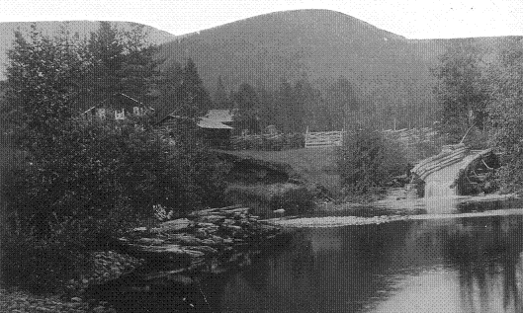
Kvarnbacken

Olof Esbjörnsson, Brita Esbjörnsdotter’s Brother

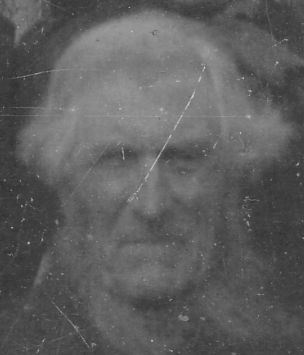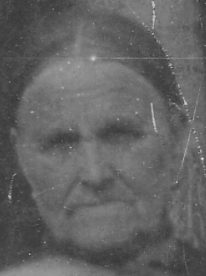
Olof Esbjörnsson Margta Jonsdotter Wallster

Olof Esbjörnsson was born on the 13th of December 1826.

For some reason, Olof took over the farm “Svens” from his father Esbjörn Svensson, even though he was the second oldest son. This was in 1852.

Olof Esbjörnsson was married on the 10th of June 1855 to Margeta Jonsdotter Wallster.

Olof and Margeta had six children:

Esbjörn Olsson (born 4th of November 1855)
Brita Olsdotter (born 13th of August 1858)
Ingrid Olsdotter (born 26th of June 1860)
Marget Olsdotter (born 24th of December 1862)
Jonas Olsson (born 12th of July 1865, dead 25th of October 1878)
Olof Olsson (born 31st of May 1870)

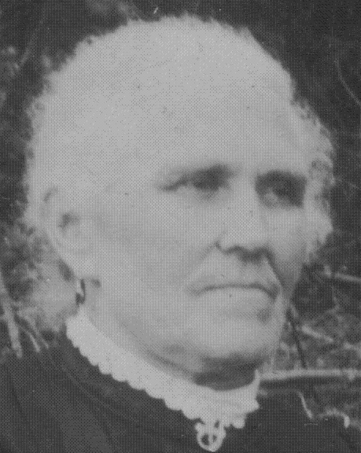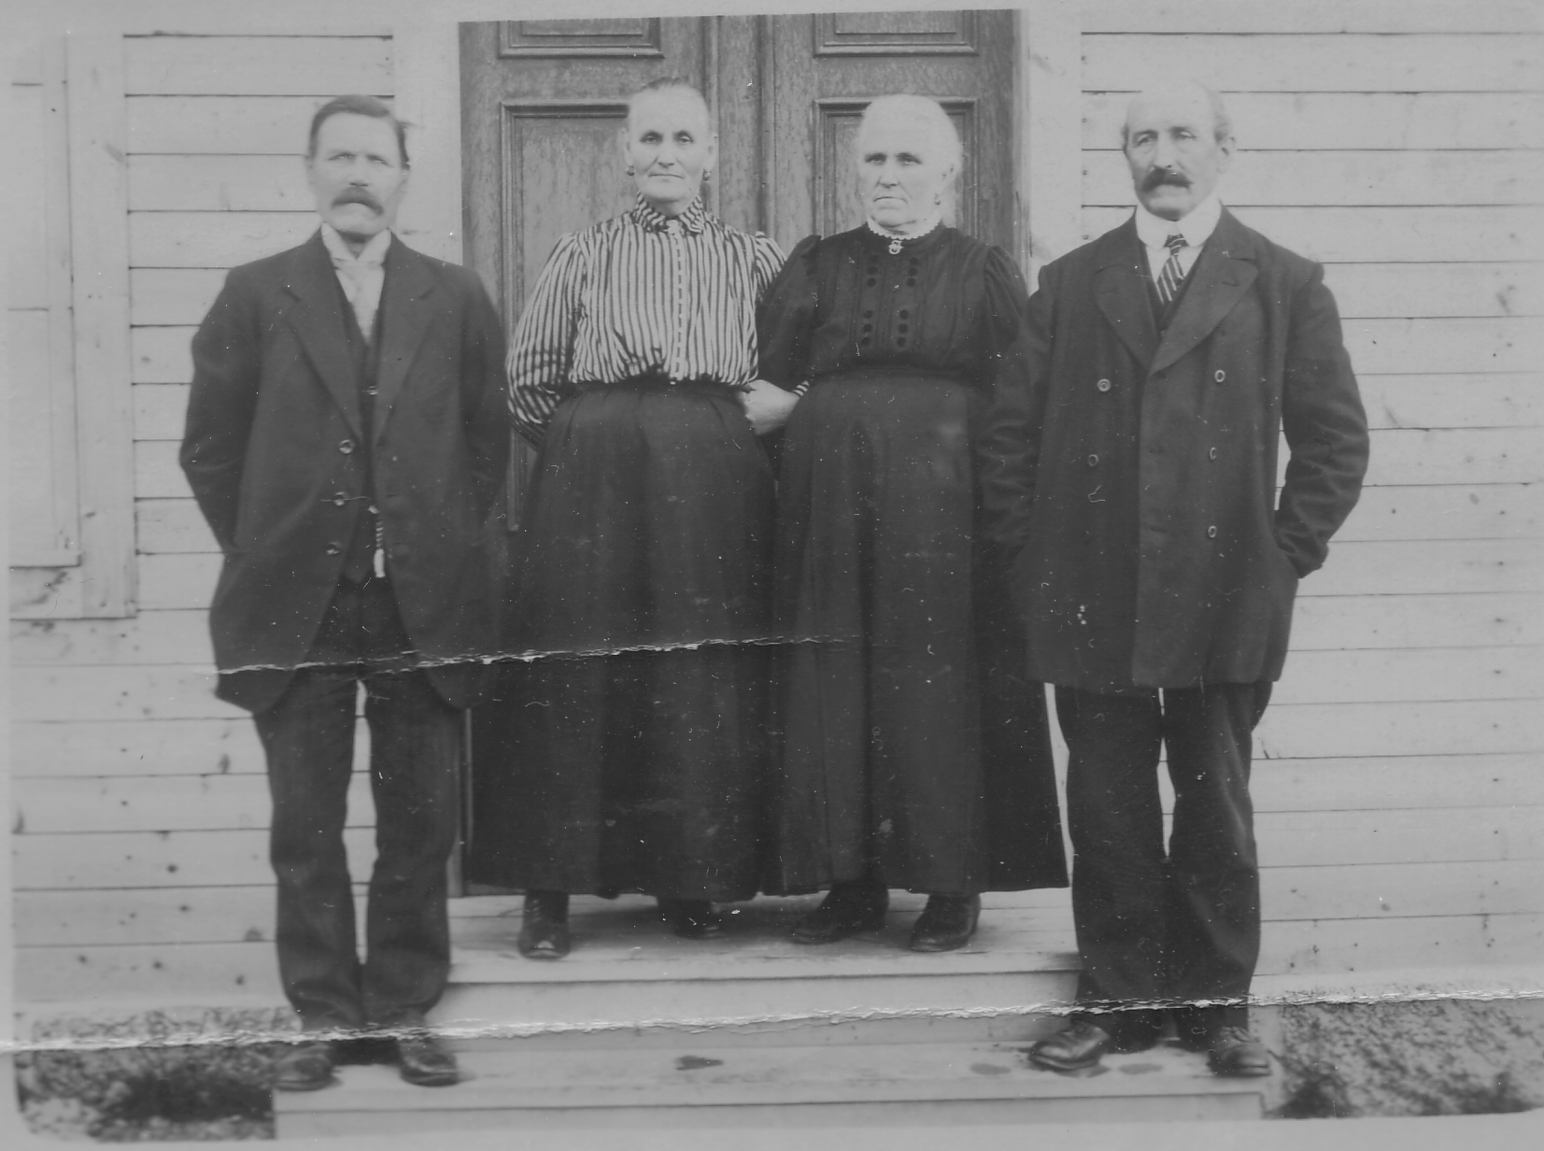
Ingrid Olsdotter, called “Prinsbacks-Ingri” Esbjörn Olsson, Brita Pålsson, Ingrid Olsson. Olof Olsson, 1920

I know very little about Olof Esbjörnsson. The only thing still remembered about Olof Esbjörnsson is that Olof’s son has said that Olof Esbjörnsson saw and heard a long row of “vättar”, a kind of goblin or troll that was around in the old days. Along with the “vättar”, came their small cattle. They passed close to Olof’s “fäbod”.

Like his brothers, Olof was a hunter and had a muzzle loading rifle.

Olof Esbjörnsson used the “Svens” until the 1880s.

Both Margeta Jonsdotter Wallster and Olof Esbjörnsson died in 1912.

About Olof Esbjörnsson’s children:

Esbjörn Olofsson, called “Esbje”, got a part of the farm “Svens” and moved it to a new location, where it remains, and the farm has from that time (1888) been called “Svensbacken”. Esbjörn Olofsson’s son’s son’s son, Leif Esbjörnsson lives on, and owns “Svensbacken” today.

Brita Olofsdotter married Jonas Pålsson from Älvros parish.

Ingrid Olofsdotter married Jonas Olofsson, They received a part of the old “Svens” homestead. This new homestead was called “Prinsbacken”, and Ingrid was called “Prinsbacks-Ingri”.

Marget Olofsdotter married Per Jonsson.

Olof Olofsson was called “Ol-Orsa”, and was married to Beata.

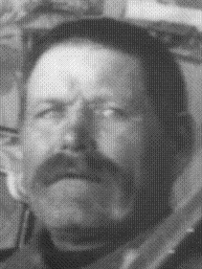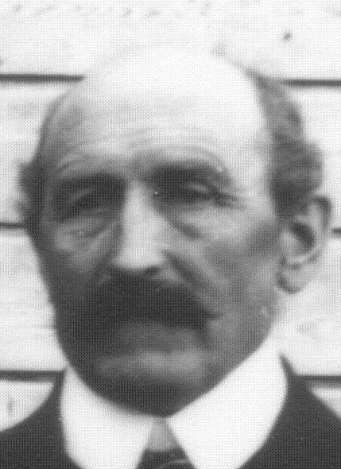
Esbjörn Olsson called ”Esbje” Olof Olsson called ”Ol-Orsa”

Hans Esbjörnsson, Brita Esbjörnsdotter’s Brother

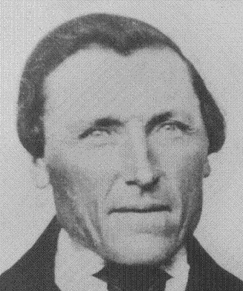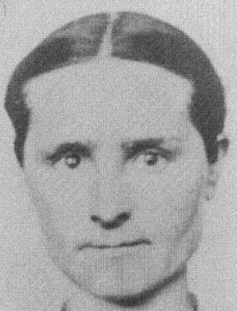
Hans Esbjörnsson Gertrud Jonsdotter Wallster

Hans Esbjörnsson was born on the 29th of March 1829.

In his youth, 1863-64, Hans was a farmhand for his brother Sven Esbjörnsson at “Påles”.

On the 12th of March 1864, Hans Esbjörnsson married Gertrud Jonsdotter Wallster. For a couple of years, Hans and Gertrud lived with Gertrud’s parents, Jonas Wallster and Brita Jönsdotter, at their farm in called “Nyåkern” in Överhogdal. Here they had their only child, Jonas Hansson, born on the 4th of September 1866.

In 1868, Hans Esbjörnsson had an opportunity to buy a farm for himself. The previous farmer, at the farm called “Bjurs” in Överhogdal, left with his family for America in 1868. Hans bought “Bjurs” and started his career as a farmer. After this, Hans was called “Bjurs-Hans”.

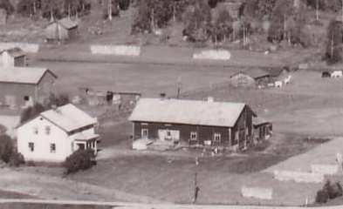
Bjurs

It is said, after buying “Bjurs”, Hans no longer had time to hunt. He worked all day and did carpentry work at night.

Hans worked all the time. He was also very careful to look out for the waters he claimed as his. He built a cottage on the lake called Rosången. The cottage consists of one small room. For the southern wall, a big stone was used against which the fireplace is built.

Hans gave the farm “Bjurs” to his son Jonas Hansson in 1890.
When “Bjurs-Hans” was old, he lived through a catastrophe. In 1893 there was an occurrence in Överhogdal, known as “Den Stora Branden” (The Great Fire). In June, when most of the people were out in the “fäbod”, one of the farms caught fire. It was a farm called “Olagår’n”. It was windy, and it was not long before the farm next to “Olagår’n”, called “Gunnars”, also caught fire. When the flames engulfed “Gunnars” they had no difficulty getting to “Bjurs”. These three farms burned down completely. Altogether, 22 buildings were destroyed by the fire. The next farm downwind, called “Sjules”, was saved by the inhabitants who took rag carpets they had wetted and laid them on the roof. It must have been a terrible feeling for “Bjurs-Hans” seeing his lifetime achievement literally go up in smoke. All the houses he had put into order, and all the furniture and equipment that he had made during the last 25 years was destroyed.
When Hans was old, he talked much about his brothers and their hunting adventures.

“Bjurs-Hans” lived for another 20 years after the catastrophe, and during this time, he saw a new and more modern “Bjurs” being created by his son Jonas. “Bjurs-Hans” lived with his son in “Bjurs” until he died on the 16th of April 1913. His wife, Gertrud, died on the 3rd of January 1920.

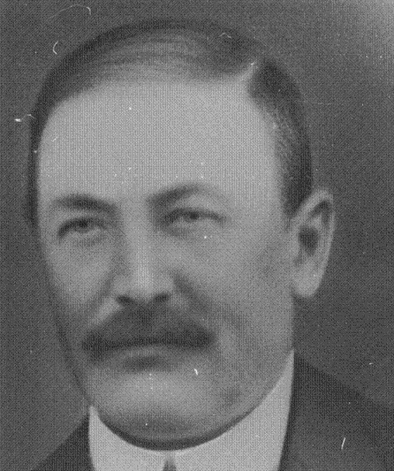
Jonas Hansson

Hans Esbjörnsson has many descendants. Several of them still live in Överhogdal. “Bjurs” is now owned by Hans’ descendant.

Sönne Esbjörnsdotter, Brita Esbjörnsdotter’s Sister

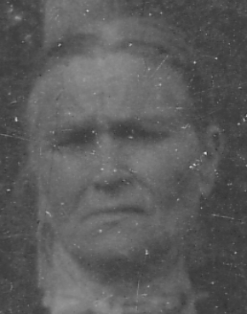

Sönne Esbjörnsdotter was born on the 8th of August 1831. Sönne was named after her grandmother, Sönne Sjulsdotter.

Sönne Esbjörnsdotter was married on the 10th of January 1853 to Olof Olofsson (born on the 7th of February 1829). Olof was the son of Olof Jonsson and Sigrid Olofsdotter.

In Överhogdal in those days, there was no large mill. There were many small mills called “skvaltkvarn”. One, two or three farms had one “skvaltkvarn” of their own. Olof Olofsson had an idea in 1855 that he wanted to build a big modern mill for the entire village to use. In 1858, Olof had obtained all legal permissions and had made the dam and acquired all the timber for the mill house. However, for some reason, he changed his mind and sold everything. Olof and Sönne moved to a small lake in Överhogdal, called Rosången. There they built a croft called “Laverviken”.

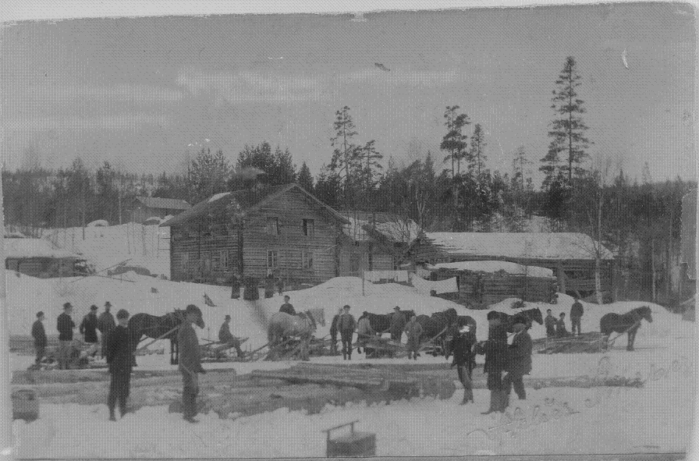
”Laverviken”, the homestad of Olof Olofsson and Sönne Esbjörnsdotter

Olof and Sönne had three children:

Brita (born 13th of March 1853)
Esbjörn (born 18th of February 1861)
Sigrid Mathilda (born 13th of March 1869)

Olof Olofsson died on the 10th of September 1898. Sönne Esbjörnsdotter died 1917.

Brita Olofsdotter (1853) married Lars Andersson, who was from a farm in Överhogdal called “Eskils”. Lars Andersson (born 11th of February 1846) and Brita Olofsdotter were married on the 29th of November 1875. They were farmers at “Eskils” from 1873 to 1882. With their son, they left Sweden for America on the 13th of April 1882. Their children:

Andreas (born 27th of January 1877, dead 21st of June 1879)
Olof (born 27th of February 1879).

Esbjörn (1861) married Anna Maria Magnusdotter. Esbjörn called himself Esbjörn Wiik. Esbjörn and Anna took over “Laverviken” from Esbjörn’s parents, and after them, their children owned “Laverviken”. Unfortunately, today, there is nothing left of “Laverviken”, but Sönne Esbjörnsdotter’s (and Esbjörn Wiik’s) descendants still live in Överhogdal.

Sigrid Mathilda (1869) married Anders Andersson Hedström.

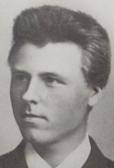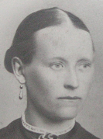
Esbjörn Wiik Anna Maria Magnusdotter (Wiik)

Jonas Esbjörnsson, Brita Esbjörnsdotter’s Brother

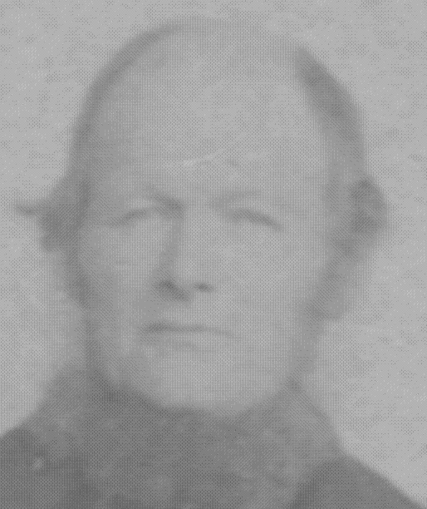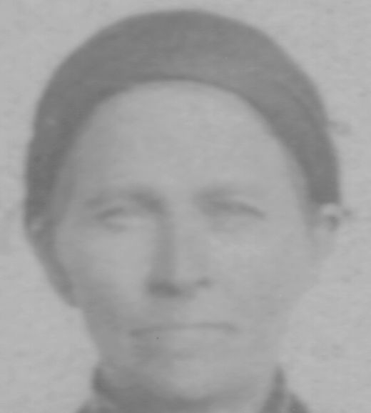
Jonas Esbjörnsson Maria ”Kvarn-Maria” Jonsdotter Wallster

Jonas Esbjörnsson was born on the 1st of February 1835.

Jonas was married on the 3rd of April 1872 to Maria Jonsdotter Wallster, who was born on the 16th of April 1842).

First, Jonas Esbjörnsson was a miller at the mill that Sönne Esbjörnsdotter and her husband, Olof Olofsson, started to build in 1855. He bought “Kvarnbacken” in 1873. (Probably, he worked as a miller even before 1873, but then he didn’t own the mill.)

In 1874 Jonas and his wife, Maria (called “Kvarn-Maria”) and Jonas’ brother, Sven Esbjörnsson, and his wife, Brita Jonsdotter, exchanged farms with each other. Until then, Sven and Brita had lived on the croft that is today called “Påles”, and Jonas and Maria on “Kvarnbacken”. “Påles” and “Kvarnbacken” neighbour each other. Maria and Brita did not get on well in their respective homes. Therefore, they exchanged homes. This is the reason that Jonas Esbjörnsson and “Kvarn-Maria” came to “Påles”.

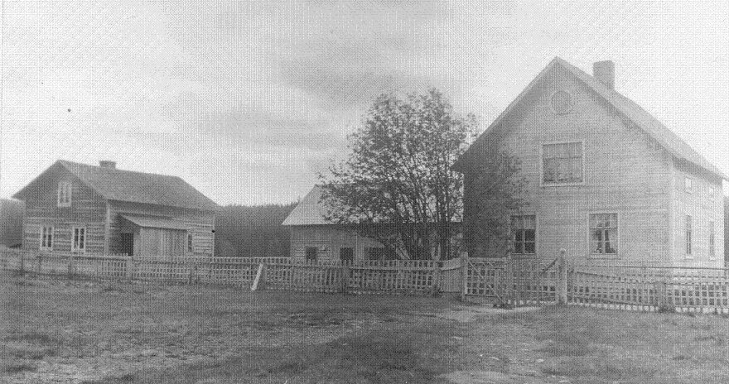
Påles 1928

It is said that “Kvarn-Maria” was Överhogdal’s midwife.

Jonas and Maria had a son, Esbjörn Jonsson, called “Lill-Esbjörn” (“Little Esbjörn”. His cousin, Esbjörn Svensson in “Kvarnbacken”, was “Big Esbjörn”). Esbjörn was born on the 24th of May 1872, and died young on the 27th of December 1875. Jonas and Maria also had a daughter, Ingrid Jonsdotter, born on the 5th of October 1876.

Jonas Esbjörnsson died on the 22nd of November 1878, and the daughter Ingrid died on the 9th of August 1894.

On the 9th of August 1894, Ingrid Jonsdotter died. Then, “Kvarn-Maria” was alone. Maria had a niece, also named Ingrid. She and her family then came to “Påles” in 1901 and they got the farm, and took care of “Kvarn-Maria”.

When Kvarn-Maria got old, she got a bit demented. She often said that she was going home. She meant “Nyåkern”, the farm she was born on. Sometimes Kvarn-Maria” had disappeared, but it was just to go the five miles to “Nyåkern”, and that is where she could be found.

“Kvarn-Maria” died on the 25th of January 1931.

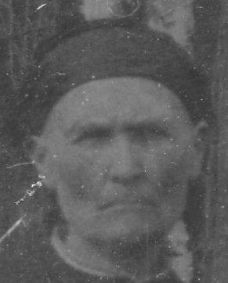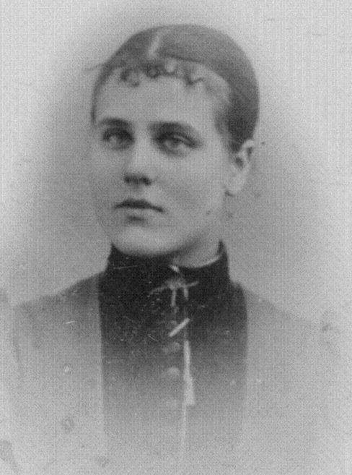
Maria ”Kvarn-Maria” Jonsdotter Wallster Ingrid Jonsdotter, the daughter of Jonas and Maria

Ingrid’s descendants’ own “Påles” today.

Written in August 2006 by Thomas Sievertsson, in Uppsala, Sweden

A croft is a fenced or enclosed area of land, usually small and arable with a crofter’s dwelling thereon. A crofter is one who has tenure and use of the land. (www.wikipedia.org)
There is no proper English translation of the word “fäbod”. It is a remotely located grassland, often deeply situated in the woods. The available grassland was not sufficient in summer for all the village’s cattle. People and cattle took to this grassland after midsummer and stayed until September. Almost every village in the northern part of Sweden had these remotely located settlements.

