The Fisk Expedition went through Griggs County in 1862 and 1863. Captain James L. Fisk was leading groups to the newly opened gold mines in western Montana and Idaho. He stopped and camped at Jessie Lake on both expeditions and we are fortunate that his records still survive.

On the 1862 expedition he wrote “Arriving at Lake Jessie we camped between the lake and one half a mile to the south, about a mile in diameter, which Captain Fisk named Lake Lydia in honor of his wife. Lake Jessie is a beautiful sheet of water, five or six miles in circumference, surrounded by a belt of timber. Its waters, as also those of Lake Lydia, are strongly impregnated with salt; but we discovered a spring a little less than a mile to the westward, which after being improved by a few moments’ digging, yielded us pure cold water for culinary purposes.” Later he says that “At Lake Jessie we took on wood for several days and filled our casks with water from the spring, as we expected the water for some distance ahead, to be brackish and unpalatable. We named our camp at Lake Jessie “Camp Aldrich” in honor of one of Minnesota’s representatives in Congress”.

A few days later he wrote “We did not take on wood enough at Lake Jessie to last us until we find timber again” and “wood is not essential for camping purposes so long as the substitute in buffalo chips (dried manure) remains as plentiful as present”.

On the 1863 expedition he had the following entries.

July 21 Road over rolling prairie to Lakes Lydia and Jessie, where we camped at noon and remained to rest stock, &c. The water of Lakes Lydia and Jessie (twin lakes) is slightly saline, soda and magnesia prevailing. There is, however, a good spring three-quarters of a mile southwest of our camp, in a ravine on the shore of Lake Lydia, Shale crops out at the edge of the lakes, and one of our party discovered coal on Lake Jessie. Both of these lakes are very beautiful; they are surrounded by bold bluffs, well timbered. Our camping place was between the two lakes on a small eminence. In the wood at the back of camp we heard an incessant noise of birds, and we found the trees full of nests; it was a perfect rookery; there were cranes, crows, gulls, storks, shite- pokes, &a &c., with plenty of ducks and geese on the lakes beyond.”

Later he wrote that “We found abundance of wild cherries in the thickets round camp…”

James Fisk group weren’t the first white men to stop at Lake Jessie but he was one of the first to try to describe it as the beautiful Garden of Eden that we know it as today.

Source info starts here:

The next oldest site is where Captain J. L. Fisk camped in 1862 and 1863.  That site is on Section 22 in Addie Township and there the state has put up an impressive marker and owns the plot of land on which the marker was erected.  Source: Griggs County History 1879 - 1976 page 4

1862

http://books.google.com/books?id=xGRNAAAAYAAJ&printsec=frontcover&source=gbs_ge_summary_r&cad=0#v=onepage&q=june%2016&f=false

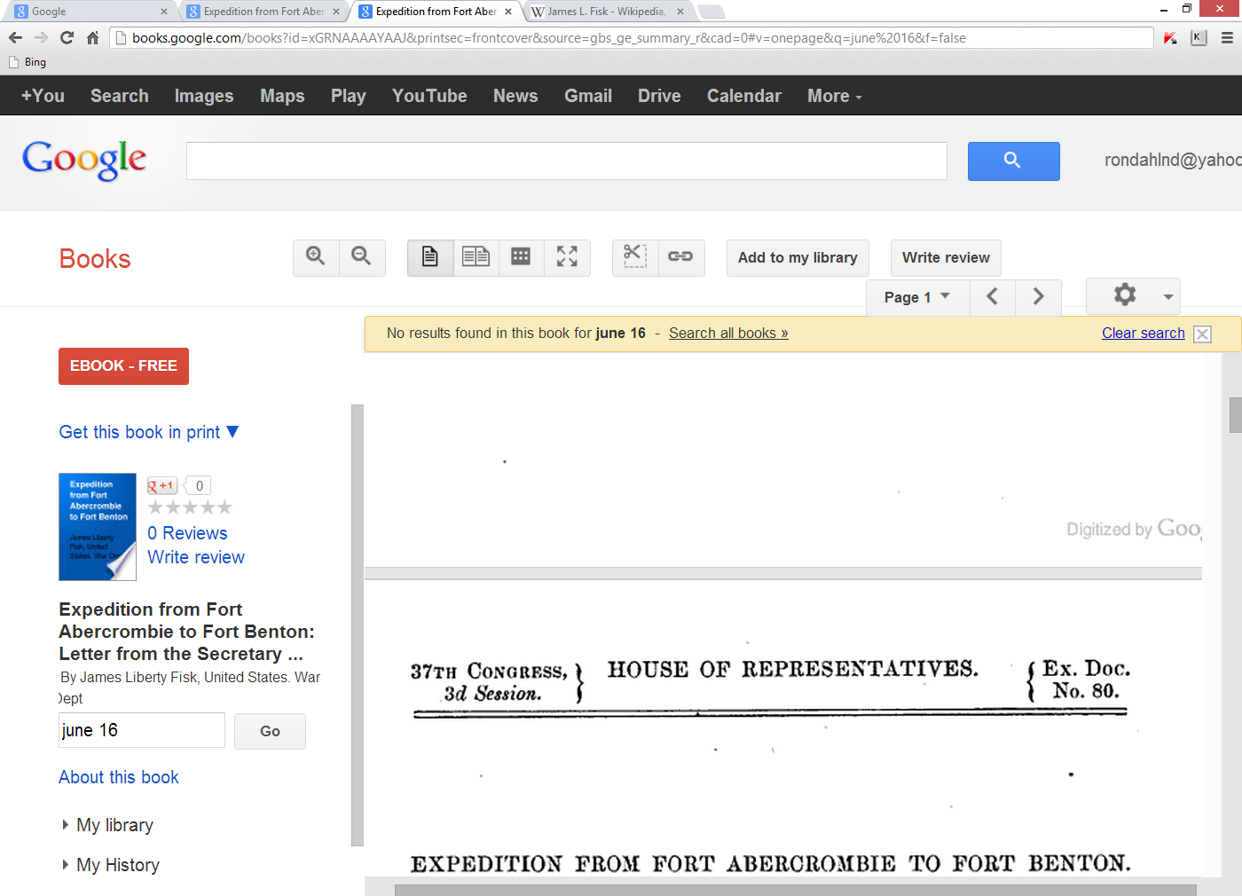

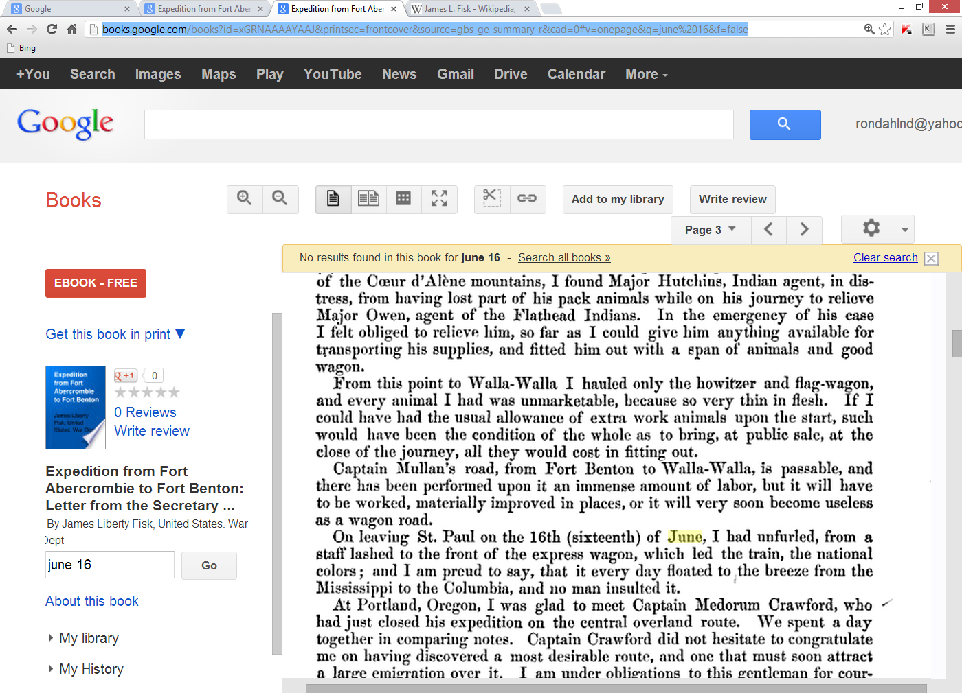

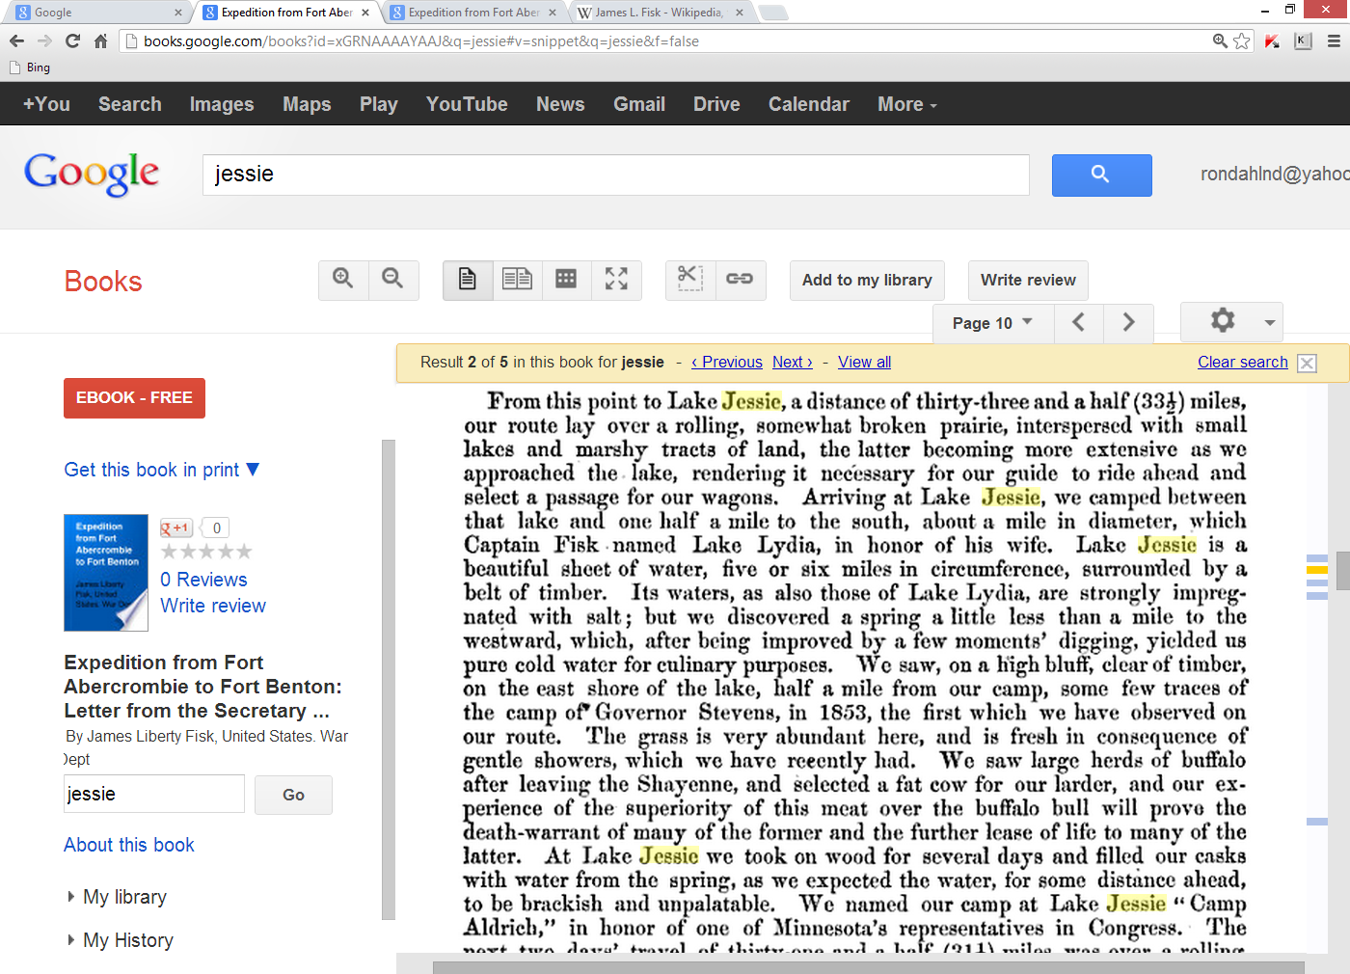

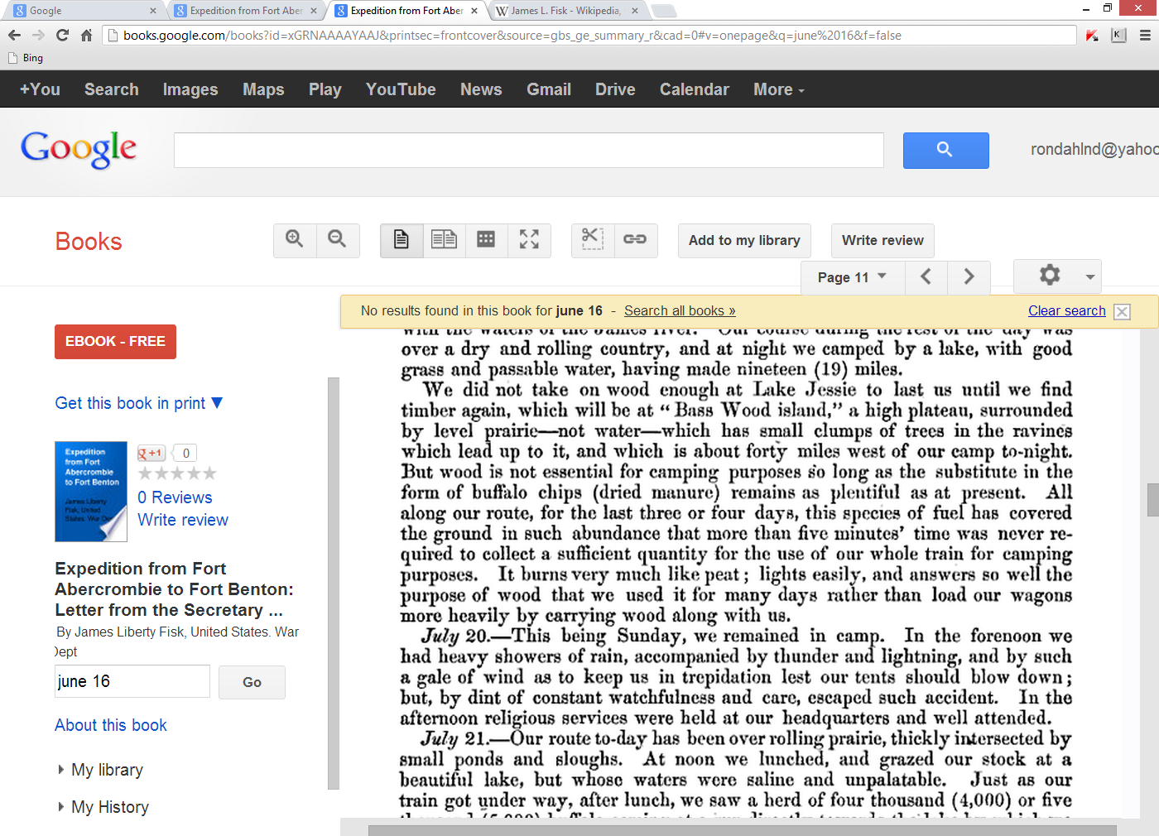

1863

<http://books.google.com/books?id=BQctAAAAYAAJ&pg=PA5&lpg=PA5&dq=fisk+expedition+jessie&source=bl&ots=gV8FuK7hFX&sig=JtWxgTGwJrpDi_ISI8Bi0un6-AA&hl=en&sa=X&ei=tIfDUIetEoSJywGJxIDYAQ&ved=0CC4Q6AEwAQ#v=onepage&q=fisk%20expedition%20jessie&f=false>

