Mrs. White has in progress a book on emigrant expeditions across the northern plains in the 1860s.

Like her previous article, which appeared in the June, 1962, issue of this magazine, the present study is a by-product of her many years of research on the subject.

Captain Fisk Goes to WASHINGTON

Helen McCann White

Captain James Liberty Fisk was known in the 1860s as a propagandist for Western emigration and as the leader of four overland expeditions from Minnesota to the Montana gold fields. Less famous are the experiences of Fisk, the soldier-lobbyist in the East during these years. Four times between 1862 and 1865 he traveled to Washington on official business involving his military duties, personal projects, and the interests of his home state. His broad objective, shared by many other Minnesotans of his day, was to gain the support of the federal government for enterprises designed to extend Minnesota's influence into the northwestern region between the Mississippi River and the Pacific Ocean.1 The story of his Eastern journeys supplies meaningful background for his expeditions into the West and reveals much about Fisk himself.

In the capital between assignments, Fisk was snarled in red tape, threatened with court-martial, and annoyed by a clamoring creditor. He fought his battles adroitly. Handling tongue and pen with the same skill that distinguished his aim with the rifle, he successfully defended himself against those who impugned his honesty, sobriety, gallantry to ladies, and sacred honor.

Like many another soldier passing through Washington in the Civil War years, he posed for a souvenir photograph in John Holyland's Pennsylvania Avenue studio. There, as elsewhere, his natural flamboyance and growing sense of mission led him to dramatize himself out of the ordinary ranks. In one hand he held papers emblazoned with a legend, and the other, finger pointed, stretched toward the West.

He wanted to be an explorer, a pathfinder, a road builder — and incidentally a colonel. Although he saw himself marching into the West at the head of a mighty column on the pathway to empire, he remained a captain, and the emigrants he escorted across the plains during his army career numbered less than five hundred. Nevertheless, with the help of Minnesota politicians and the press, he left Washington three times with money in his pockets. The fourth time, with neither money nor commission, and "poorer than a church Mouse," he remained irrepressible. 2

Fisk was twenty-six years old in the fall of 1861 when he entered the Union army as a private in the Third Minnesota Volunteer Infantry. He had worked at a variety of jobs; the most significant among them was that of an apprentice on the Daily Courier of Lafayette, Indiana. Although this was apparently his only major experience in newspaper work, he gave his occupation upon enlistment as that of an editor, and he was obviously at home with newsmen. The taste for journalism was seemingly a family trait, for four of his five brothers subsequently became professional newsmen. 3

While employed on the Courier Fisk read Congressional reports of expeditions into the West and became fascinated with the region. Eager to see it firsthand, he went to Minnesota some time during the 1850s and settled near White Bear Lake, where he married and for a time engaged in farming. Soon, however, he became associated with the Fort Ridgely and South Pass wagon road expedition of William H. Nobles, and with the Dakota Land Company, which he later served as secretary. These two projects, aimed at extending Minnesota influence into the West, took him out on the plains and introduced him to the booster spirit then rampant in Minnesota. 4

His frontier experiences and associates were almost certainly responsible for his first summons to Washington, which came on May 19, 1862, while Fisk was serving with the Third Minnesota near Columbia, Tennessee. Always restive under discipline, he had, on the very day the message arrived, forced the guard and left camp for six hours in violation of regulations. Whether this sortie was in any way connected with his new assignment is not known, but it was a portent of the future that Private Fisk reached Washington one short step ahead of disciplinary action, 5

He arrived in the capital on or about May 29, and was commissioned captain and assistant quartermaster of volunteers in the quartermaster corps. He was also notified that he had been appointed superintendent of emigration under legislation passed in January, on a route between Fort Abercrombie, Dakota, and Fort Walla Walla, Washington. Between May 29 and 31 he took his oath of office and executed a bond for ten thousand dollars. Among its cosigners were Nobles and the three Minnesota Congressmen who had recommended Fisk for the appointment, Representatives Cyrus Aldrich and William Windom, and Senator Morton S. Wilkinson, 6 Five thousand dollars was placed to his account in the United States treasury and Secretary of War Edwin M. Stanton formally instructed him to organize and outfit a corps for the protection of emigrants "against all dangers" that might beset their way west. He was further advised to fix a time for a rendezvous and arrange for wide advertising of his plans. 7

The assignment was challenging, but it posed a number of practical difficulties. Fisk's instructions were a hasty revision of those prepared for another superintendent with a much larger budget on a different route and were not well tailored to fit the circumstances. He was, for example, authorized to recruit men for an estimated four months' journey at salaries and wages well over his total appropriation. He was also told to outfit the expedition "in the most complete manner," to secure guns and ammunition, gifts for the Indians, and emergency supplies of food and medicines. At the end of the journey he was expected to auction the travel-worn wagons and animals and any other surplus government property and realize enough money to pay off all outstanding bills. 8

Performing this task in the face of wartime inflation and gold rush profiteering would have been difficult under any circumstances, but for a man of Fisk's temperament, the situation was fraught with particular hazard. Though his instructions warned him to stay within his budget, their ambiguous wording constantly invited him to look beyond it. Fisk was a frontier citizen-soldier, new to command and unschooled in military ways, and he was far more interested in the spirit than in the letter of his instructions. Inclined to be careless in financial matters, he consistently spent more than his allotted funds and did not succeed in finally settling his expeditions' accounts until years after he had left the army. 9

There were still further possibilities for trouble in the situation. Fisk was commissioned in the quartermaster corps, yet the quartermaster kept no financial records of his activities; he was on detached duty under assignment from the secretary of war, yet he was a volunteer and owed his appointment to influence from Minnesota; he was ordered to report regularly to the adjutant general, yet he had no immediate superior who was at all concerned with what he was doing. His Western duties were of no great importance to the war department in its preoccupation with the larger concerns of the Civil War. Fisk had, in short, enough rope to hang himself.

It was fortunate for the captain that his was a political appointment and that the Minnesotans who supported him were more interested in what he did for Western emigration than in how he observed the regulations of the war department. Political influence and frontier know-how carried him safely past the obstacles of protocol and official procedure that beset the course of his military service.

His first expedition, in the summer 1862, took some **130 emigrants** safely across of the northern plains to the region which in the next year became a part of Idaho Territory. Probably in early February, 1863, Captain Fisk returned to the capital. On February 7 Congress passed another bill for the protection of overland emigration, allotting this time ten thousand dollars for the northern route. On the seventeenth the adjutant general's office received Fisk's official report. Pleased with the highly successful results of his enterprise, and with the taste of command in his mouth, the captain did not hesitate to include in his letter advice to the department about the conduct of military affairs on the northern plains and to suggest the possibility of opening a shorter, more direct route from Minnesota to the Idaho gold fields. Before the end of the month the report was submitted by the secretary of war to Congress and on March 2, the House ordered five thousand copies of it printed. 10

On the same day, Senators Wilkinson and Henry M. Rice, and Representatives Aldrich and Windom addressed a letter to the secretary of war in Fisk's behalf. Although signed by each of the Congressmen in his own hand, the letter was in the penmanship and graceful phrases of Samuel R. Bond, journalist of the 1862 expedition. Captain Fisk, it pointed out, had conducted an expedition for the protection of emigrants over the northern route the previous summer with results "entirely satisfactory to the Emigrants under his Escort, to the people of our state and the northwest, and to all feeling an interest in this new route." In consideration of his experience and "natural ability and fitness for command," no one, the letter the continued, was more competent than he to conduct an expedition in the 1863 season, It also asked that the appropriation be supplemented by seven thousand dollars of the balance unexpended on the central route the previous year for a more adequate corps and outfit to meet the Indian menace resulting from the Sioux Outbreak. 11

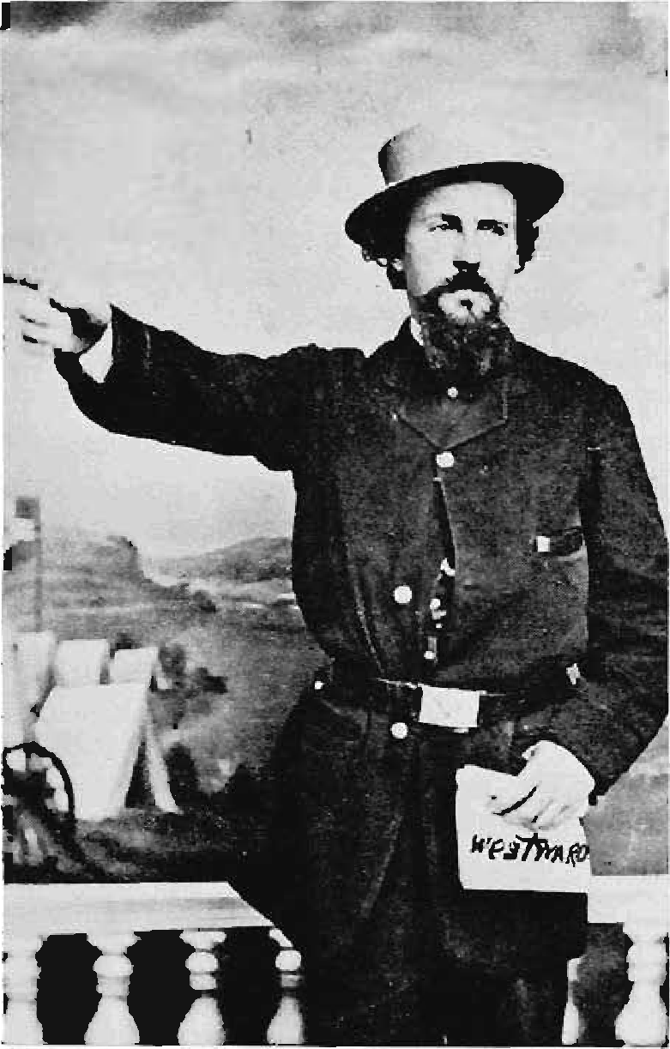

Captain James Liberty Fisk

While Fisk awaited reappointment and tried to settle the tangled accounts of his first expedition, he was busy advertising the northern trail and the gold fields. Before the end of March, copies of his official report had been received by Minnesota newspapers. Fisk, in the meantime, wrote a fresh introduction to the report, adding comments on the significance of the northern route and up-to-date news of the mining region. He then arranged for its publication by John A. Grey of New York City. 12

On April 1 the secretary of war reassigned Fisk as superintendent of emigration on the northern route and issued new instructions. These were little changed from the previous year except in the total budget. The request for an additional seven thousand dollars was, however, ignored. The captain left Washington before the middle of April and reached Minnesota the first week in May, after stops in New York and Chicago. With more time and money than he had in 1862, he purchased a splendid outfit, and again overspent his budget. 13

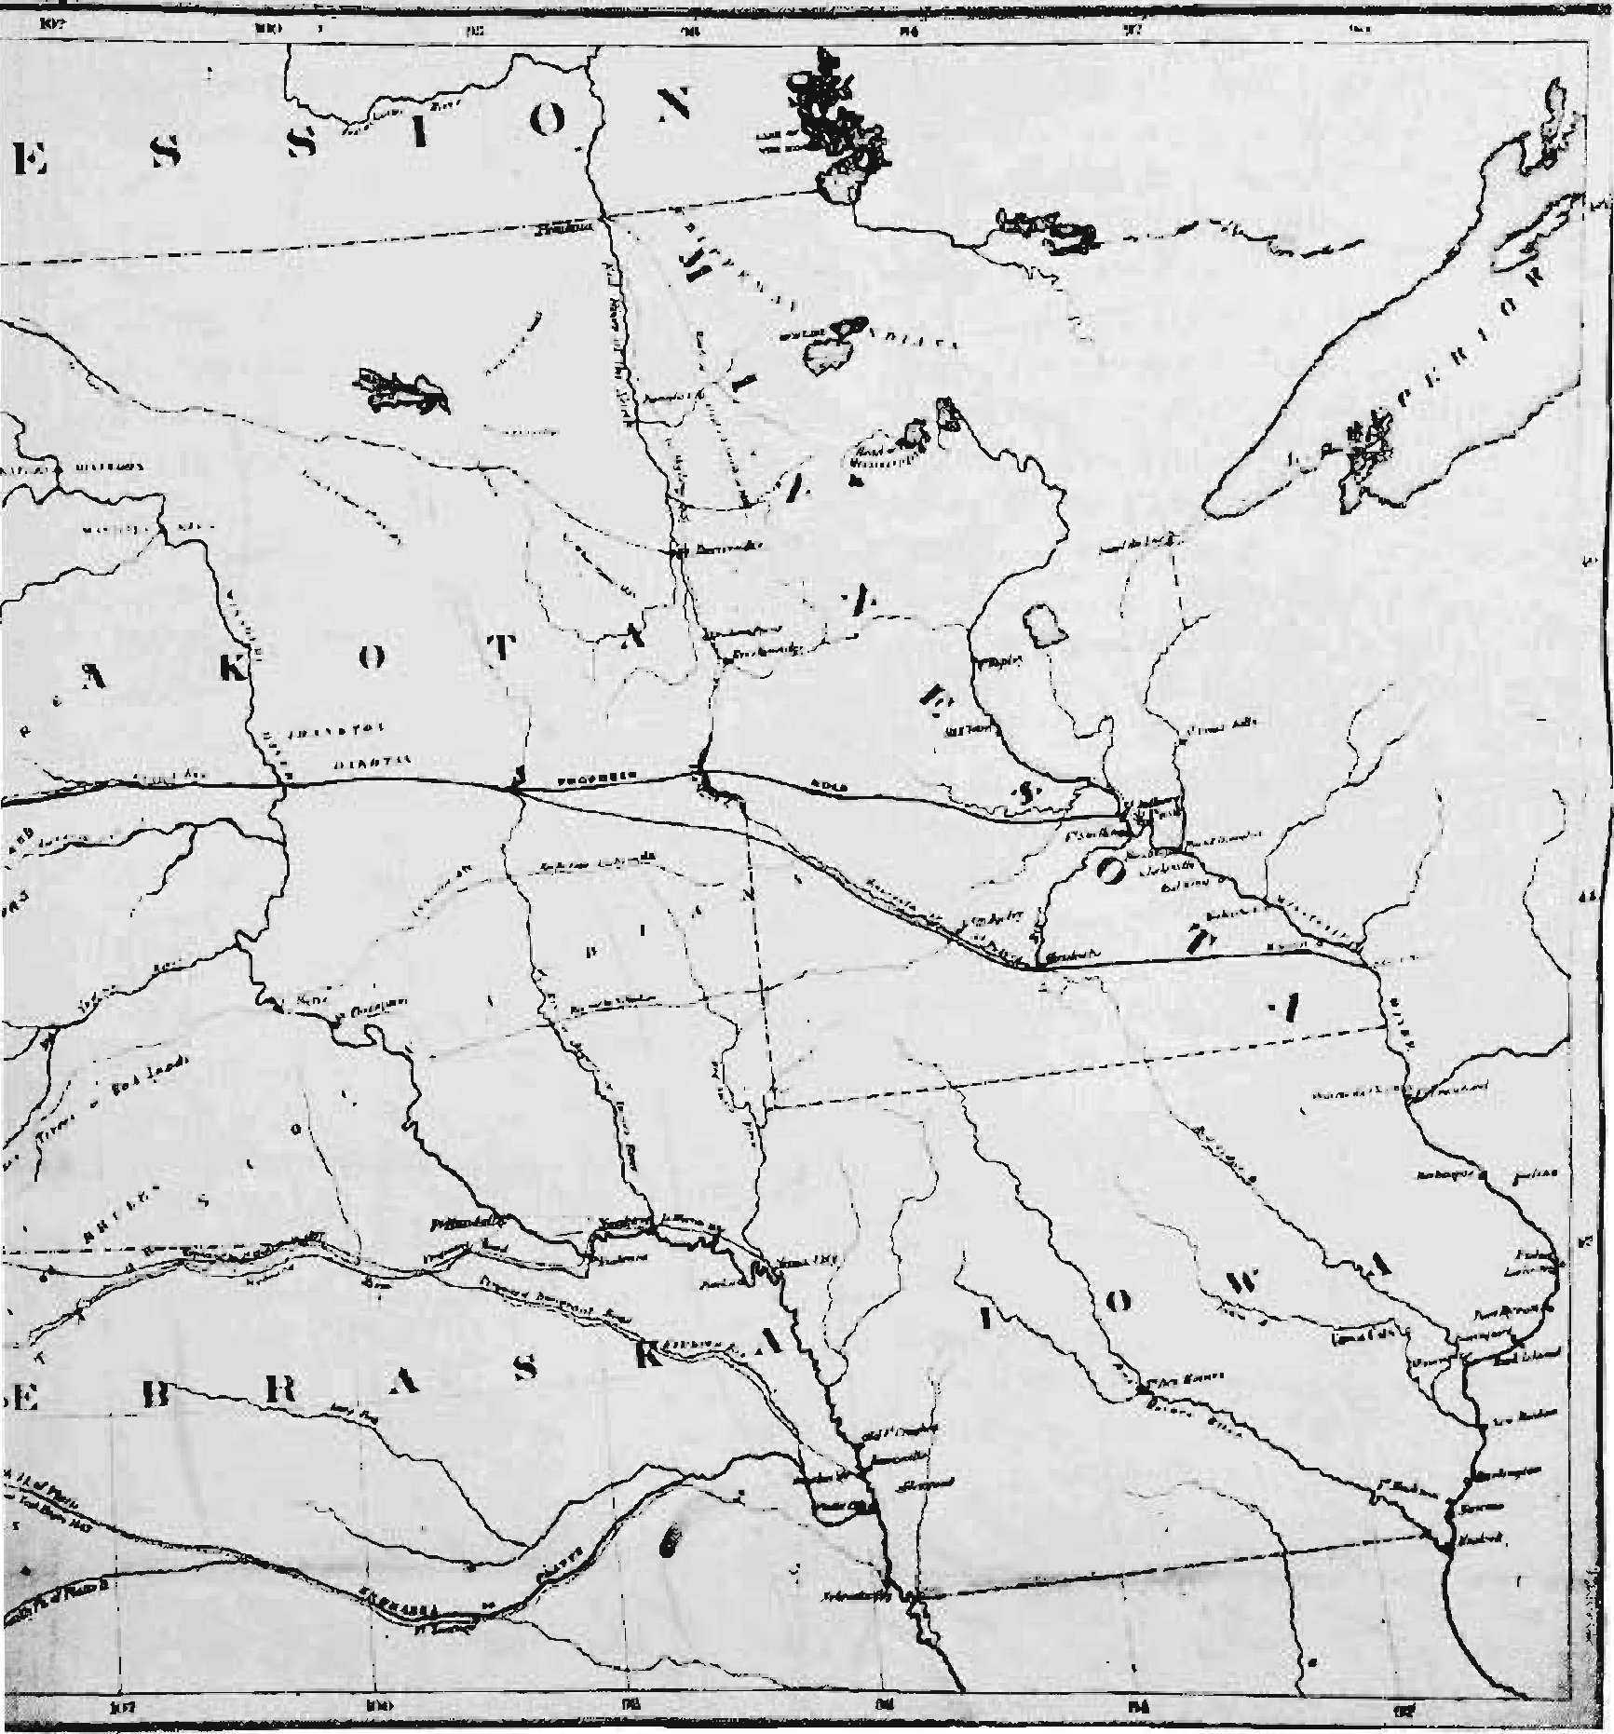

Well equipped, Fisk hoped for a larger train of emigrants than he had in 1862, but fear of the Indians held many back, while some who might have accompanied the captain had gone instead with Henry H. Sibley's expedition across the Dakota plains. A few emigrants from other states, including a number of men assigned by the government to survey the Washington-Oregon boundary, joined the Minnesotans to make a group of only **sixty-two persons**. A large number of them were on Fisk's payroll either as members of his staff or of the protective corps. 14

In spite of the small size of the group Fisk seems not to have considered abandoning the expedition. His instructions said nothing about how many emigrants he should escort. It is very unlikely that his backers would have supported any attempt to close out the expedition, for such action would have implied fear of the Indians or lack of confidence in the route. Minnesotans felt deeply the importance of demonstrating its practicality for a wagon road or for a railroad.

Fisk turned somewhat north of his 1862 route because of widespread drought on the plains but reached the headwaters of the Missouri early in September after a successful journey. A few seemingly inconsequential incidents of the trip assumed greater importance when he returned to Washington. One July day on the plains he had purchased some oxen from a man named E, D. Cobb. Because early and deep snows in the mountains made it impossible for Fisk to follow his orders and go on to Walla Walla, he sold his stock at Virginia City, Idaho. There and at Bannack he heard of plans for an expedition the next spring to look for rich new gold fields suspected to exist in the Big Horn and Yellowstone regions. 15

Some of the 1862 emigrants gave Fisk gold to take back to their families in Minnesota and one old miner gave him some gold nuggets to carry to Washington as a gift to President Abraham Lincoln. Completing his business, Fisk stuffed the gold and his official papers into his battered valise. Then with two of his staff he set out for home by stagecoach on a journey which provided another incident to keep him busy during his next sojourn in Washington. 16

A few days' travel east of Salt Lake City his valise fell through a rotten boot of the stagecoach and was lost in the snow. When the Overland Stage Line showed no interest in trying to recover it, Fisk went thirty miles back to a military post at Camp Collins, Colorado, and obtained a sergeant and ten men to go with him to search for it. Ninety miles hack on the trail they found the valise and its precious contents in the hands of an honest teamster. Thus delayed, Fisk finally reached Minnesota on the first leg of his journey to Washington, on December 13. 17

He lost no time in launching an ambitious publicity campaign to tell people about his two successful expeditions and his grandiose plans for 1864. Foremost among these visions was a wagon road fortified by military posts direct from Minnesota to the promising Big Horn-Yellowstone region. Fisk proposed that it should follow closely the forty-fifth parallel, upon which both St. Paul and Virginia City were located. 18

He made speeches and pronouncements at Anoka, St. Paul, Minneapolis, and Winona, and on his journey to Washington at La Crosse, Milwaukee, Chicago, and New York. He and Lieutenant Samuel H. Johnson, the journalist-clerk of his 1863 expedition, called on newspapermen, chambers of commerce, and boards of trade on their way. Everywhere Fisk went people responded to the glamour with which he invested his plans for the future, his exciting tales of life on the trail, and his visions of gold in the West. 19

His third arrival in the capital on February 23, 1864, was less than triumphal. No sooner had he entered the city than he was arrested by a military police patrol for failure to show a pass. Though not taken into custody, he was ordered to report to military headquarters the next morning. On the twenty-fourth, when he appeared before a local military police officer and showed his instructions from the secretary of war he was furnished a pass, but in the press of more important matters he ignored the summons to headquarters. Instead, he reported at once to Ignatius Donnelly, who had replaced Cyrus Aldrich as Representative in Congress from Minnesota's second district. Donnelly himself was a shrewd propagandist, and it is scarcely surprising that the meeting of two such ingenious minds resulted five days later in a splendid Minnesota publicity coup. 20

On February 29 Donnelly and Fisk, accompanied by Senator Alexander Ramsey, Nobles, and Lieutenant Johnson called on President Lincoln at the White House to present the nuggets of gold, a map of Fisk's proposed route, and a memorial from the St. Paul Chamber of Commerce asking for the establishment of a government wagon road into the West and a line of military posts to protect it. Senator Ramsey read the memorial to the president, and Lincoln expressed sympathy with the Minnesota objectives but was apprehensive of the cost. "'I wish to God the road was built,'" the president was quoted as saying, but the project outlined would "'run up an immense bill for the government to pay.'" He nevertheless endorsed the memorial to the secretary of war, with a promise to send it on by special messenger to Congress.

Fisk then presented the nuggets from the Virginia City diggings. The largest one was said to be worth $122. Attached to it was a smaller head-shaped nugget, its features "strongly resembling the President." A third one attached to the others bore the message: "Give this to Old Abe for me. A Minnesota Miner, East Side, Idaho, 1863." Fisk told the president that the old miner had "heern tell" that "Old Abe" was the homliest man in the United States, and that nugget was the gol durndest homliest nugget in the whole gulch.'" Fisk concluded his presentation with the miner's final words to the president, "'Tell him I hope he's enlisted for the war.'" The president "enjoyed this complimentary reference to his personal beauty and laughed heartily," and shaking the captain's hand told him to "'give my respects to that miner when you go back, and tell him that's the work of the best artist that ever took my portrait.'" 21

The story of Fisk and the nuggets of gold was widely publicized in the newspapers that spring, and the interview was certainly the high point of the captain's 1864 season in Washington — indeed, of his whole career in the army. 22 But he was not long on the heights, for on March 14 the adjutant general's office issued special orders for him to appear before the military commission of Washington and show cause why he should not be dismissed from the service for failing to report when under arrest. On the morning of March 16 he appeared before the commission to present his case. His defense was considered satisfactory, "exemption from dismissal" was recommended, and he was free to turn to another problem. 23

This was the "Case of the Protested Draft," which was presented to Fisk in a letter from the office of Quartermaster General Montgomery C. Meigs, calling the captain's attention to an unpaid draft on the assistant treasurer of the United States. Was it, the general wanted to know, incurred in the settlement of public or private indebtedness? Why had it not been paid? 24

The difficulty had all begun on that July day on the plains when Fisk had bought the oxen from Cobb and had given him a treasury draft in payment. Cobb sold the draft in August to Willius Brothers and Dunbar, St. Paul bankers. Presenting it to the United States treasury, they were informed that Fisk's funds were exhausted. On the captain's return to St. Paul the bankers presented him with the draft, but he successfully put them off with a promise to pay when he settled his accounts in Washington. On January 28, as he prepared to leave St. Paul, he gave them his personal note for $258.30 due in Washington in twenty days. A letter from the bankers demanding payment reached Washington before Fisk and was returned to the senders. Their patience exhausted, the bankers on February 27 addressed a letter to the secretary of war, enclosing Fisk's draft and the Treasury note and requesting payment out of any funds due the captain from the department. They implored the secretary to do all in his power "to protect innocent holders of government drafts against frauds of this kind by Government officers."

The secretary's office referred the matter to the quartermaster general and it was in response to this letter from Willius Brothers and Dunbar that General Meigs contacted Fisk on March 16. Fisk's brief reply was dated the following day. The draft on the United States treasury had been given in payment of a public indebtedness and would be settled on closing his accounts with the department. As for the personal note, it was given, Fisk said, "to appease the nervousness of these gentlemen."

In the meantime a copy of the letter was sent to the adjutant general's office and forwarded to headquarters military department of Washington, which referred it to the provost marshal, requesting that it be served on Fisk and a report of the service immediately sent to the commanding general. Fisk received the letter on March 26 and stated to the captain of the provost guard that the matter of the draft had been submitted to him and that he had replied to it in a communication to General Meigs on March 17. 25

On March 24, Willius Brothers and Dunbar wrote again to the secretary of war, asking, "What further information can you give us on the subject?" The letter was sent to the quartermaster corps and returned with a note stating that Fisk had no accounts with the quartermaster since he was on duty under direct orders of the secretary of war.

As the case moved through channels, letters of inquiry, copies of answers, drafts of answers, letters of referral with enclosures, and letters of complaint from Willius Brothers and - Dunbar all laden with endorsements - were wrapped about the original letter and journeyed between Fisk and the various war department offices until the file contained fourteen items.

On April 7 a communication was drafted in the war department to Willius Brothers and Dunbar acknowledging receipt of their letters of February 27 and March 24, and stating that a reply was delayed "in hopes of being able to send you a definite answer," but these words were crossed out and replaced by the words "to inform you that the matter has received due attention." On the same day the office of the secretary of war asked Fisk to explain in a more satisfactory fashion why the draft had not been paid and why "checks drawn in behalf of the government should be dishonored and the public credit made to suffer."

Fisk then took pen in hand to tell the story of the protested draft. He explained that he had expected to be in funds before Cobb presented the draft for payment and that he had cautioned Cobb not to allow it to be "hawked about." When he sold the government property and paid off his men, Fisk stated, he had no money to forward to the treasury. Pointing out that he had only meager sums at best to perform work of "considerable importance," he stated that he had been embarrassed in his attempts to organize an efficient corps and do "some credit at least to the Honorable Department." Moreover, he insisted, he had supposed that $1,700 would be available to him when the first year's accounts were finally settled. He proposed to pay the bankers either out of private or government funds. He expressed his regret that the whole unfortunate affair should have occurred at all and that it should have been "magnified" to such an extent. If delays in the payment of government drafts were allowed to reflect on the character of government agents, Fisk asserted, there 'would not long remain a Quartermaster in the service." He concluded his letter with the hope that "nothing further may interpose to mar my relations with the Government,"

Satisfied for the moment, Inspector General James A. Hardie wrote to Willius Brothers and Dunbar on April 15, returning the two notes and a copy of Fisk's reply. The bankers wrote again on April 23 and May 19. They had not heard from Fisk and wanted to know what proper steps should be taken to recover the money. The case was referred to the quartermaster corps again on May 30 and returned to the secretary of war with a reminder that the corps did not have Fisk's accounts. The last date in the file is June 3, when the papers were sent again from the office of the inspector general to the adjutant general. No final settlement is recorded in the adjutant general's files, but it seems likely that Fisk paid Willius Brothers and Dunbar shortly after the first of June, as soon as funds were available for his new expedition.

EVEN as Fisk expressed the pious hope that he would have no further difficulties with the department, another complaint was being registered against him.

The "Case of the Depredations on the Overland Route," including a "hatch of documents" relating to Fisk's activities on his journey home, was placed in his hands on the morning of April 10. 26 The matter had come officially to the attention of the war department on December 8, 1863, when the postmaster general reported that a detachment of soldiers under, the command of a Captain Fisher (later corrected to read Fisk) had committed depredations on the Overland Stage Line. The adjutant general's office immediately telegraphed Colonel John M. Chivington of the First Colorado Cavalry, reporting the postmaster general's charge and directing Chivington to "guard against a repetition of these depredations." On December 29, Colonel Chivington submitted to the department a highly critical letter and supporting documents.

According to Chivington, Captain Fisk, armed with "extraordinary powers given him from the Government," had showed his letter of authority at Camp Collins and obtained a detail of men to go with him to look for his lost valise. Fisk alone was responsible for what happened, and it was he who had led the men of Chivington's command into all the mischief that followed. The captain was not, Chivington asserted hotly, under his authority. Moreover, he had been informed that Fisk was drunk and had insulted ladies. The colonel, a former minister who within the year was to be associated with the controversial massacre of Indians at Sand Creek, Colorado, sermonized on the importance of sobriety in the army and hoped that the department would in future take care not to send drunken officers "clothed with extraordinary powers" to disgrace his command. 27

The position of the Overland Stage Line was set forth in three letters; the captain and his men were drunk, it was asserted, and took complete possession of every station they visited, turning company mules out into the storm and putting their horses in the stables. They took eight hams being transported by stage to one of the stations; they and their horses consumed eighty-six meals, seventy-five bushels of corn, and five tons of hay, wasting fully as much of the last as they used and they committed many smaller depredations on company property. Fisk himself had also grossly insulted the wives and families of several company agents.

When the adjutant general's office received Chivington's letter and its enclosures, someone in the department who either did not read them or knew little of Western geography, forwarded the papers to the Department of the Pacific, with headquarters in San Francisco, asking for an explanation from Captain Fisk. On March 10 San Francisco communicated with Washington, stating that a diligent inquiry had revealed that the captain had returned to the East, and the papers were being forwarded to him in care of Senator Ramsey of Minnesota.

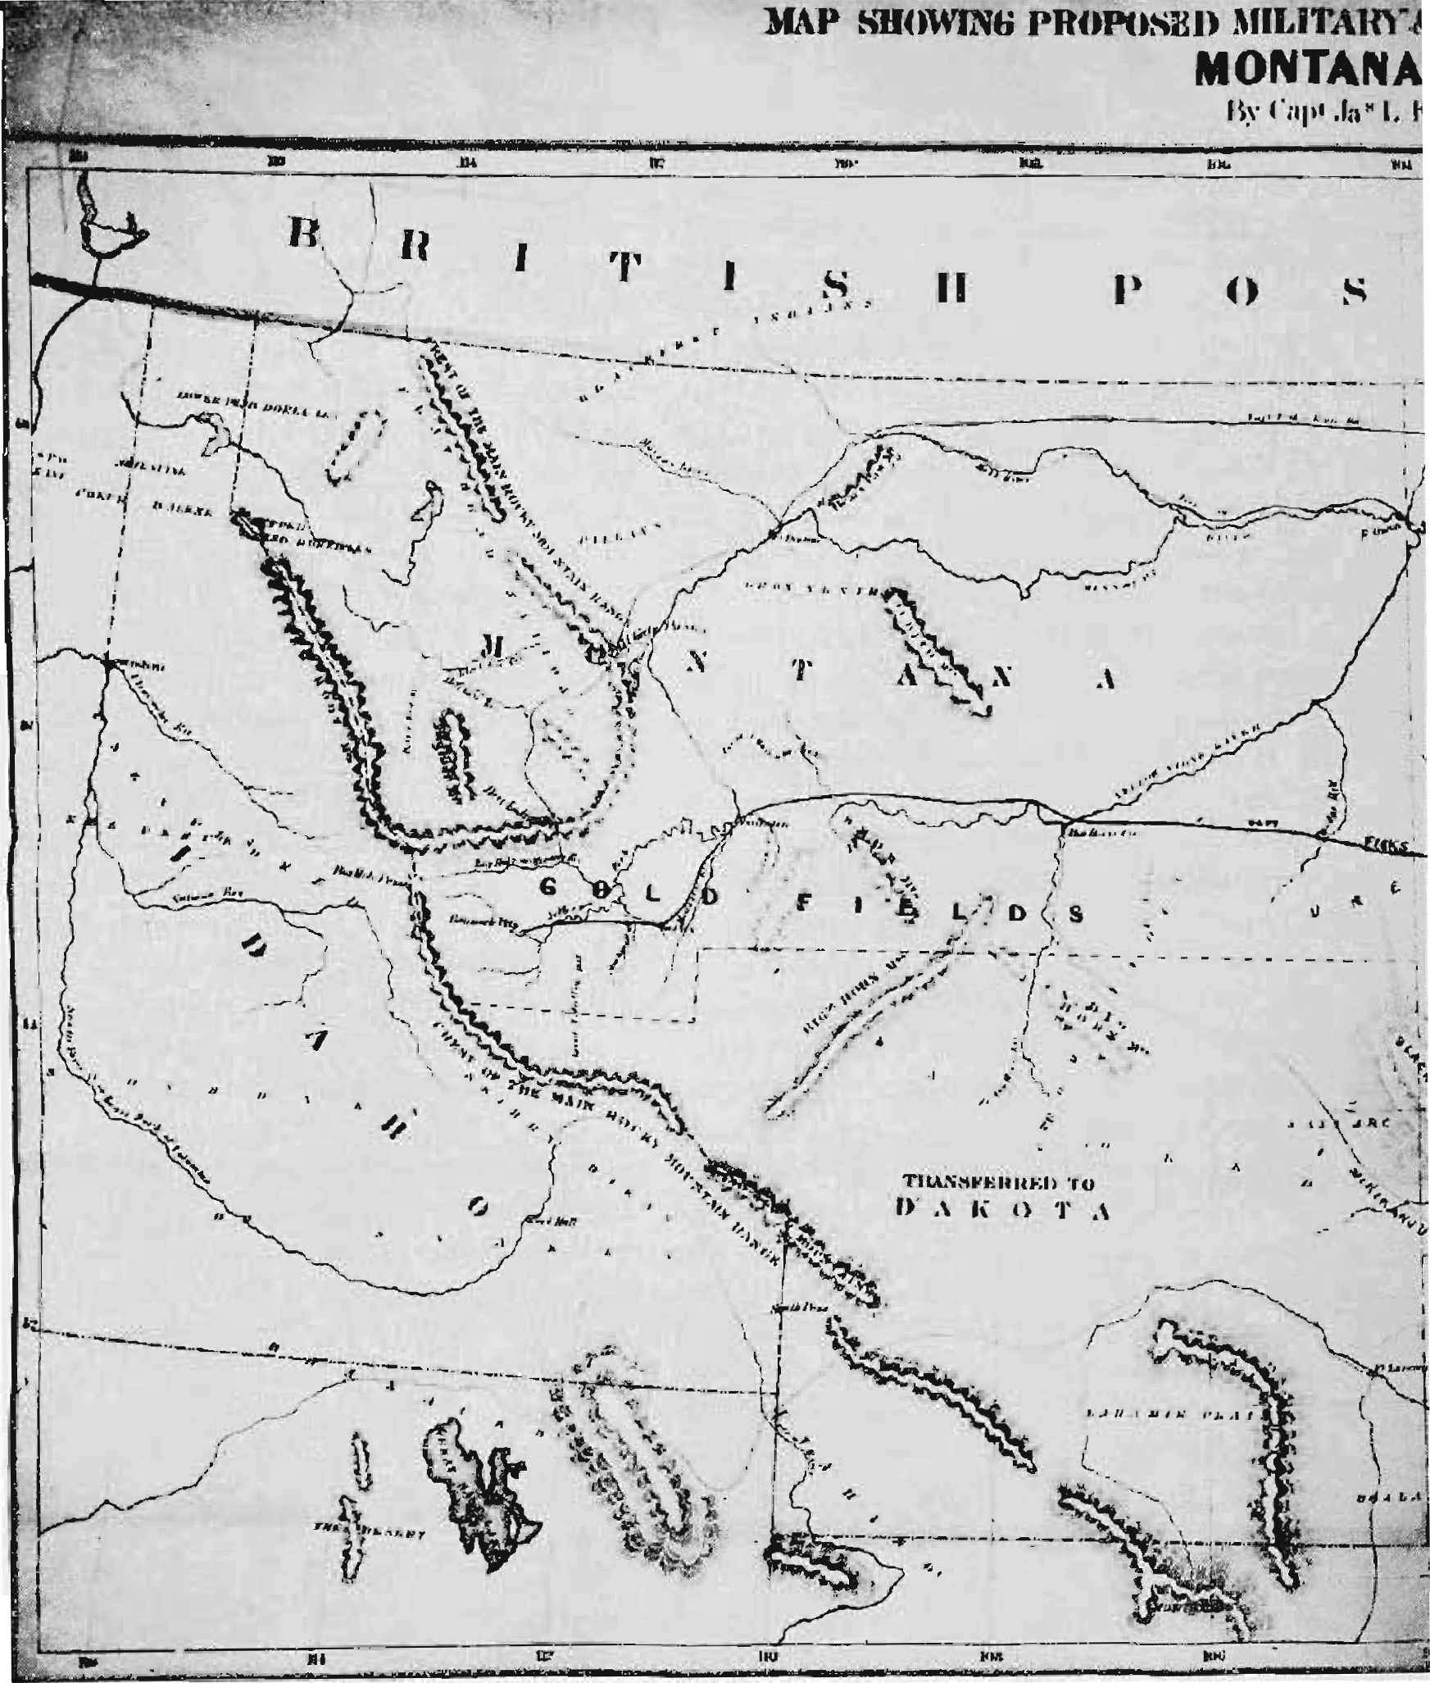

A month later the complaint at last reached Fisk and he again sat down to pen a reply to the "false and damnable charges against my private character and official conduct."28

He asked the secretary of war to read a portion of the official report which Fisk had submitted to the department in January. In it were described the events of his return journey on the Overland Stage Line. 29 What he said there, Fisk averred, could be substantiated by "unimpeachable witnesses." He had been delayed eighteen days at a personal cost of two hundred dollars by the negligence of the company in losing the valise and the indifference of employees and agents to its recovery. Since it was impracticable to take rations or forage along in the search for the missing bag "it was decided to procure the trifle we should consume at Stations along the way." He claimed that he "was most particular" not to waste "a spear of hay, a kernel of corn, or a mouthful of food." The list of losses was highly exaggerated. Had his little party consumed a quarter of what was set against them, Fisk asserted, they would have been "gluttons mounted on elephants," and certainly none of them could have survived the trip.

As for being drunk: "No living man ever saw me 'drunk,' or rendered unfit for responsible duty by the use of intoxicating liquors." The search party had started out, he said, with an allowance of three pints of whisky and "the Agent of the Road very well knows that not a drop of spirits is allowed to be kept at any Company's Station along the route.' Where, then, in the midst of winter on the wild plains would a party of men have found whisky? The men of Company B were sober, as well as obedient, soldierly, faithful, and unflinching in duty through the storms. They would, Fisk believed, testify that all the charges against him were false. The man who in cold blood had manufactured that "basest of all base falsehoods" — that Fisk had insulted the wives and families of the employees — such a man, the captain wrote angrily, was no doubt capable of such a deed himself. No wife or daughter would ever be found to perjure herself by confirming such an allegation against Captain Fisk!

He went on to make what was probably a telling point: serious complaints had already come to the postmaster general about the Overland Stage Line's carelessness with the mail. The firm had been publicly accused, he pointed out, of being "a shelter, receptacle, and employer of renegade disloyalists, copperheads, and thieving rebels," and was "corrupt in its copperhead and open secession proclivities. 30

While Fisk avoided paying his debt, defended his reputation in the department, and again attempted to settle his expedition's accounts, the winter crept on in Washington. Minnesotans of all sorts appeared and departed. The First Minnesota Volunteers came from the battlefield, and were feted by their fellow Minnesotans in the capital; a Chippewa Indian delegation from the state arrived, created a brief stir, and then went on; a group from Idaho, including Nathaniel P. Langford, one of Fisk's staff on the 1862 expedition, gave support to the captain's projects as they worked for the organization of Montana Territory. Living was high in Washington — higher, one correspondent wrote, "than anywhere else on the loyal side of Dixie," and the city was cold and filthy and the wind fierce. 31

On March 15 both House and Senate approved resolutions to have five thousand copies of Fisk's report of the 1863 expedition printed. One Senator remarked that its publication would save him -much trouble in correspondence" because he had received so many requests for the information it contained. The document included a colorful description of the overland journey, as well as advice to the government on various matters of policy. It also spelled out Fisk's ambitions for the coming season and thus became a prospectus for the new wagon road he wanted to open. 32

Since Fisk maintained cordial relations with the Minnesota delegation in Congress, he could probably have been recommended for reappointment at any time as superintendent of emigration over his old route. Funds for this purpose amounting to ten thousand dollars had been appropriated early in March. But no letter of recommendation was written until June. The reason for the delay was apparently Fisk's hope for wagon road legislation - a hope which rested on bills introduced into the House in mid-March by Donnelly and Territorial Delegate William H. Wallace of Idaho. These were referred to the committee on roads and canals from which Wallace's measure, H.R. 323, eventually emerged. In this omnibus bill, Wallace embraced provisions favored by his Minnesota and Iowa colleagues and called for construction of a number of wagon roads, including one along the forty-fifth parallel, for which $100,000 was to be appropriated. To direct the building of such a road over a route that he himself had widely advertised and with an appropriation ten times that afforded the protector of an emigrant train must have appealed greatly to Fisk. There is no other evidence to explain his staying on in Washington through the entire spring. Finally, however, on May 31, H.R. 323 was referred to the committee of the whole with little chance of passage. 33

In the meantime all signs pointed to a heavy wave of emigration in 1864. The army had announced that a line of forts close to Fisk's proposed route was to be established west of Fort Ridgely. Minnesota newspapers told of mass meetings and reported that groups were already outfitting for the journey across the plains, and the superintendents of the other overland routes had already been appointed. 34

At last, on June 4, Senator Wilkinson wrote to the secretary of war suggesting Fisk's appointment as superintendent of the northern route. He reminded the secretary that the expedition should start as soon as possible since emigrants were waiting for Fisk, and he suggested that the captain be instructed to take a shorter, more direct route west, in which case "it would be well to make Mankato the place of rendezvous." The secretary was adamant, however, and again instructed Fisk to travel west from Fort Abercrombie on the route specified by Congress. Wilkinson made one last attempt on June 10 to have the route changed by an amendment to the act, but this move also failed. 35

More than half of the emigrants who would have gone with Fisk in 1864 started west before his return to Minnesota. When he arrived others were already on their way to rendezvous at Fort Ridgely where they assumed that Fisk would meet them. 36 At that point Fisk chose to ignore his instructions altogether and follow the forty-fifth parallel. After hurriedly outfitting, he joined the emigrants at the fort.

With excellent military co-operation along the line of new posts, Fisk traveled safely to Fort Rice on the Missouri. However, with success almost in his grasp, he made a number of careless moves which brought disaster only a few miles short of the Montana border. The captain's cockiness and stubborn insistence on following his new route; wagons left unguarded; Indian attacks which caused the death of twelve men; the emigrants' retaliation with guns and poison; a captive white woman; a dreary siege while men rode back to Fort Rice for help; and the rescue and return to the fort—all are incidents in a true story to rival the most imaginative tale in Western fiction. 37

The corps was disbanded at Fort Rice, the members of the expedition scattered, and the captain and a few of his staff went back to Minnesota. There the general view was favorable to Fisk and simply blamed his failure on the Indians. Military authorities, however, charged him with "disrespect and disrespectful language," and "gross military offenses" and said that he was "too reckless and too ignorant to be trusted." William Lamed, one of the emigrants and himself a former army officer, criticized Fisk privately for passing the bottle often and for acting in an irresponsible way on numerous occasions, yet despite the captain's obvious faults Lamed added, "I still like him, for his great good nature covers a great many defects." 38

Fisk's account of the melancholy affair, forwarded to the adjutant general on January 13, included a clear statement of what the overland projects meant to him and probably to many other Minnesotans. Fisk asserted boldly that the expeditions were not primarily for the protection of emigrants. He did not hesitate, he wrote, to deviate from the letter of his instructions in 1864 because he felt that the real purpose of the expeditions was "to explore the country of which so little is definitely known, and establish . . . if possible, the feasibility of a shorter and more direct route for the use of the Military, mails and emigration between the northwestern border and the Rocky Mountains." Fisk recognized the need for more adequate legislation to achieve these aims, however, and concluded his report with a reference to H.R. 323, "the bill endorsed by the committee on Roads & Canals last winter," asking for an appropriation of $100,000 for establishing the road he wanted. He hoped that it would be passed by Congress and "the North West be connected by the route desired with the rich gold fields of the eastern slopes of the Rocky Mountains." 39

On January 26, the St. Paul Pioneer published a letter from Fisk answering criticisms of him in Eastern newspapers. These had resulted from an incident of the expedition in which numbers of Indians had been poisoned with strychnine-injected hardtack, left by some of the emigrants and soldiers at an abandoned camp. The episode had become, in Fisk's words, "the choice bit of food for the minds of insatiate or monomaniac humanitarians throughout the country." The captain said he had no apologies or further explanations; neither he nor the government had been responsible. The use of this "unwarlike means of destruction" had saved his "weak and beleaguered party," and when he had discovered what was done, he said, "I was glad 'twas WELL done!" The paper commended Fisk's "fearless frankness" and said that those whose ideas of Indians came from popular romances could sympathize with the savages, but men of the West "will not be apt to denounce their own race for exercising the instincts of self-preservation against bloodthirsty, remorseless foes, who never practice and cannot be made to understand, the theory of civilized warfare."40

FISK'S FOURTH and last sojourn as an army officer in Washington began in February, 1865. From March to July his headquarters were at the Union Hotel in Georgetown, where he stayed with his wife - and family" — presumably a baby daughter born about this time. 41 He had by no means given up his dream of going to the Yellowstone, but his projects were very nearly submerged in the great drama being played out in Washington that spring.

Again Congress considered protection of overland emigrants, but the fact that two of the previous year's expeditions had failed discouraged the passage of new legislation. The adjutant general reported to the House committee on military affairs that although final accounts were not in, a large share of the 1864 appropriation for emigrant protection was probably unexpended. This balance of funds tantalized Fisk and gave him hope. 42

Toward the end of the session Congress enacted other legislation of great interest to northwestern expansionists. In a wagon road bill introduced by Senator Wilkinson and similar to H.R. 323 of the previous year, the lawmakers authorized the construction of roads from the Minnesota and Iowa borders to the Idaho gold fields. If Fisk had any hope for an appointment under the act, he was soon disillusioned. Its administration was in the hands of the secretary of the interior, who gave the political plums to Iowa and Dakota. 43

The close of the war and the assassination of Lincoln changed many things. New political alignments followed President Andrew Johnson into the White House, and the rapid demobilization of the Union army let loose a flood of men, uprooted, unemployed, and ready for any promising adventure. Among them was Fisk's brother Dan, who soon joined the captain in an elaborate scheme for a new expedition. In association with John Nininger, the brother-in-law of Senator Ramsey, they drew up a grandiose plan, clearly designed to appeal to discharged soldiers. It called for a town-site on the Yellowstone, complete with a sawmill, mining and farm equipment, and a printing press. 44

On May 22 Fisk submitted his resignation to the adjutant general. He was yielding, he wrote, to the requests of many of the thousands who were being daily thrown out of employment and to the desire of Minnesotans to have him serve as superintendent of emigration from the Northwest to the gold fields of Idaho and Montana. He wanted to be discharged immediately so that he could engage at once in the work of organizing." 45

Fisk did not turn to private enterprise, however, without one last try for the government's unexpended funds. On May 24 Senator Ramsey addressed a long letter to the president, endorsing Fisk's application for the position of superintendent of emigration. This project was a matter of national importance, Ramsey told the president. The disbanded troops and discharged civilian employees of the war department formed a new "army of unemployed . . . seeking in vain for occupation." The Senator asserted that in helping many of these "deserving men" to reach the gold fields, Fisk would perform a service to them and to the national government, and he therefore urged that Fisk be granted half of the "$8,000 and upwards" remaining in the emigrant fund. 46

Apparently Fisk was willing to stay in the service if necessary in order to carry out his schemes, since Ramsey's letter went on to suggest that he be retained as captain and assistant quartermaster; "that he be detailed to resume the Superintendence of Emigration from the Northwest to the Gold bearing Mountain Territories on such basis ... as to him may seem best." A few days later Fisk himself called at the White House, and though it is not clear whether he actually saw the president, he did chat in the waiting rooms with William P. Dole, commissioner of Indian affairs, who forthwith penned a note on White House stationery, endorsing "the retention of Capt. Fisk in the service for some years" as superintendent of emigration. 47

But all efforts proved fruitless. Fisk may have alienated both war and interior department officials by his intemperate remarks and his conduct of the 1864 expedition. The unfavorable publicity in the Indian poisoning incident, a decline of Minnesota influence in Washington, the general political confusion following the death of Lincoln, and the reorganization of the war department after the end of hostilities were all possible factors in the captain's defeat.

On June 12 Fisk received his discharge, officially ending his career in the army. Grass was already green on the plains, and he should have gone immediately to Minnesota to organize his Yellowstone expedition. As always, however, the temptation to speak and propagandize was strong, and he accepted an invitation to address the Traveler's Club in New York on June 23. Thus it was not until the end of June or early in July that Fisk and his family finally departed from the Union Hotel, leaving behind a debt of $850 incurred during their stay. 48

Although this was Fisk's final trip to Washington in the service of the government, the capital had by no means seen the last of him. In 1866 he led a large and successful private expedition to Montana, but he returned to Washington for at least a year in the 1870s, and for another thirty years he dreamed of the gold just beyond his grasp in Washington and in the West. A few months before his death in 1902, he insisted that the government owed him a considerable sum and regretted that ill health had prevented his "return to the national capital in proper condition for effecting authentic Settlement." Eight months after his death his application for a Civil War pension was still traveling from department to department in the bureaucratic recesses of Washington. 49