1. The entire Sheyenne Valley is on the other side of the continental divide from Jamestown and Carrington. This area was **not** a part of the Louisiana Purchase and was first settled by French fur traders.

[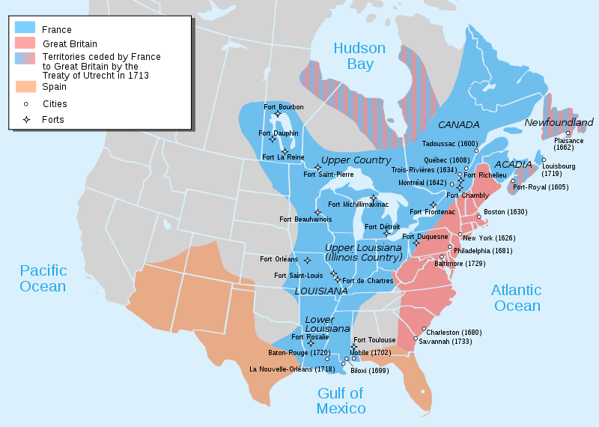](http://upload.wikimedia.org/wikipedia/commons/b/b0/Nouvelle-France_map-en.svg)

1. Located west of the town of Jessie, Griggs County, Lake Jessie State Historic Site marks the July 25 camp of the Nicollet-Frémont expedition of 1839. Joseph Nicholas Nicollet, a French astronomer and cartographer, came to the United States to study the physical geography of North America. He wanted to explore the region between the Mississippi and Missouri rivers in the area that now makes up the states of Minnesota, North Dakota, and South Dakota. Nicollet was assisted by **John Charles Frémont**, a lieutenant in the Topographical Bureau of the Corps of Engineers. The lake was named for Jessie Ann Benton, daughter of Senator Thomas Hart Benton of Missouri, who later married Frémont. Nicollet’s 1843 “Hydrographic Basin” map is a masterpiece of nineteenth-century cartography.
2. A campsite on Lake Jessie was also used by Isaac I. Stevens and his party on July 10-11, 1853, during a survey of a proposed railroad route. This was also a stopping point on July 15-16, 1862, on July 20, 1863, and in 1866 by James L. Fisk and his wagon trains on their way to the Montana gold fields (see Fort Dilts). Mail carriers who crossed through the area between 1867 and 1872 sought shelter on the east end of Lake Jessie.