### http://en.wikipedia.org/wiki/History_of_the_United_States

### French colonization

*See also:* [*New France*](http://en.wikipedia.org/wiki/New_France)*and* [*Fort Caroline*](http://en.wikipedia.org/wiki/Fort_Caroline)

[New France](http://en.wikipedia.org/wiki/New_France) was the area [colonized](http://en.wikipedia.org/wiki/French_colonization_of_the_Americas) by France in North America during a period extending from the exploration of the [Saint Lawrence River](http://en.wikipedia.org/wiki/Saint_Lawrence_River), by [Jacques Cartier](http://en.wikipedia.org/wiki/Jacques_Cartier) in 1534, to the cession of New France to Spain and [Britain](http://en.wikipedia.org/wiki/Kingdom_of_Great_Britain) in 1763. At its peak in 1712 (before the [Treaty of Utrecht](http://en.wikipedia.org/wiki/Treaty_of_Utrecht)), the territory of New France extended from [Newfoundland](http://en.wikipedia.org/wiki/Newfoundland_(island)) to the [Rocky Mountains](http://en.wikipedia.org/wiki/Rocky_Mountains) and from [Hudson Bay](http://en.wikipedia.org/wiki/Hudson_Bay) to the [Gulf of Mexico](http://en.wikipedia.org/wiki/Gulf_of_Mexico). The territory was divided in five colonies, each with its own administration: [Canada](http://en.wikipedia.org/wiki/Canada,_New_France), [Acadia](http://en.wikipedia.org/wiki/Acadia), [Hudson Bay](http://en.wikipedia.org/wiki/Hudson_Bay), [Newfoundland](http://en.wikipedia.org/wiki/Newfoundland_(island)) and [Louisiana](http://en.wikipedia.org/wiki/Louisiana_(New_France)).

Also during this period, French [Huguenots](http://en.wikipedia.org/wiki/Huguenot), sailing under [Jean Ribault](http://en.wikipedia.org/wiki/Jean_Ribault), attempted to found a colony in what became the southeastern coast of the United States. Arriving in 1562, they established the ephemeral colony of [Charlesfort](http://en.wikipedia.org/wiki/Charlesfort) on [Parris Island](http://en.wikipedia.org/wiki/Parris_Island,_South_Carolina) in what is now [South Carolina](http://en.wikipedia.org/wiki/South_Carolina). When this failed, most of the colonists followed [René Goulaine de Laudonnière](http://en.wikipedia.org/wiki/Ren%C3%A9_Goulaine_de_Laudonni%C3%A8re) and moved south, founding the colony of [Fort Caroline](http://en.wikipedia.org/wiki/Fort_Caroline) at the mouth of the [St. Johns River](http://en.wikipedia.org/wiki/St._Johns_River) in what is now [Jacksonville, Florida](http://en.wikipedia.org/wiki/Jacksonville,_Florida) on June 22, 1564. Fort Caroline was destroyed in 1565 by the Spanish under [Pedro Menéndez de Avilés](http://en.wikipedia.org/wiki/Pedro_Men%C3%A9ndez_de_Avil%C3%A9s), who moved in from [St. Augustine](http://en.wikipedia.org/wiki/St._Augustine,_Florida), founded to the south earlier in the year.

http://en.wikipedia.org/wiki/History_of_the_United_States

French

**New France** ([French](http://en.wikipedia.org/wiki/French_language): *Nouvelle-France*) was the area [colonized](http://en.wikipedia.org/wiki/French_colonization_of_the_Americas) by [France](http://en.wikipedia.org/wiki/France) in [North America](http://en.wikipedia.org/wiki/North_America) during a period extending from the exploration of the [Saint Lawrence River](http://en.wikipedia.org/wiki/Saint_Lawrence_River), by [Jacques Cartier](http://en.wikipedia.org/wiki/Jacques_Cartier) in 1534, to the cession of New France to [Spain](http://en.wikipedia.org/wiki/Spain) and [Britain](http://en.wikipedia.org/wiki/Kingdom_of_Great_Britain) in 1763. At its peak in 1712 (before the [Treaty of Utrecht](http://en.wikipedia.org/wiki/Treaty_of_Utrecht)), the territory of New France extended from [Newfoundland](http://en.wikipedia.org/wiki/Newfoundland_(island)) to the Rocky Mountains and from [Hudson Bay](http://en.wikipedia.org/wiki/Hudson_Bay) to the [Gulf of Mexico](http://en.wikipedia.org/wiki/Gulf_of_Mexico). The territory was then divided in five colonies, each with its own administration: [Canada](http://en.wikipedia.org/wiki/Canada,_New_France), [Acadia](http://en.wikipedia.org/wiki/Acadia), [Hudson Bay](http://en.wikipedia.org/wiki/Hudson_Bay), [Newfoundland](http://en.wikipedia.org/wiki/Newfoundland_(island)) [(Plaisance)](http://en.wikipedia.org/wiki/Placentia,_Newfoundland_and_Labrador),[[1]](http://en.wikipedia.org/wiki/New_France#cite_note-0) and [Louisiana](http://en.wikipedia.org/wiki/Louisiana_(New_France)). The Treaty of Utrecht resulted in the relinquishing of French claims to mainland Acadia, the Hudson Bay and Newfoundland colonies, and the establishment of the colony of [Île Royale](http://en.wikipedia.org/wiki/Cape_Breton_Island) (Cape Breton Island) as the successor to Acadia.[[2]](http://en.wikipedia.org/wiki/New_France#cite_note-1)[[3]](http://en.wikipedia.org/wiki/New_France#cite_note-2)

France ceded the rest of New France to Great Britain and Spain at the [Treaty of Hubertusburg](http://en.wikipedia.org/wiki/Treaty_of_Hubertusburg), which ended the [Seven Years War](http://en.wikipedia.org/wiki/Seven_Years_War) (the [French and Indian War](http://en.wikipedia.org/wiki/French_and_Indian_War)). Britain received all lands east of the [Mississippi River](http://en.wikipedia.org/wiki/Mississippi_River), including Canada, Acadia, and parts of Louisiana, while Spain received the territory to the west – the larger portion of Louisiana. Spain returned its portion of Louisiana to France in 1800, but the French sold it to the [United States](http://en.wikipedia.org/wiki/United_States) in the [Louisiana Purchase](http://en.wikipedia.org/wiki/Louisiana_Purchase) of 1803, permanently ending French colonial efforts on the North American mainland.

<http://en.wikipedia.org/wiki/New_France>

[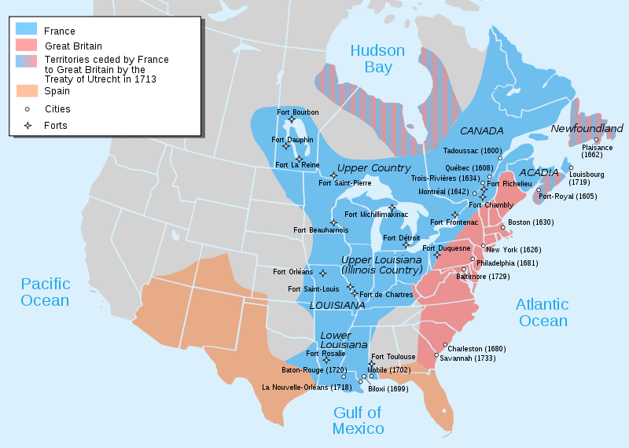](http://upload.wikimedia.org/wikipedia/commons/b/b0/Nouvelle-France_map-en.svg)