http://en.wikipedia.org/wiki/File:Spanish\_America\_XVIII\_Century\_(Most\_Expansion).png

[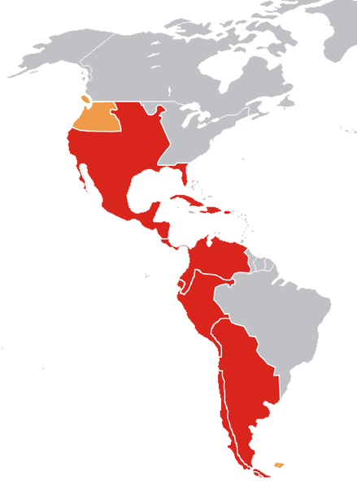](http://upload.wikimedia.org/wikipedia/commons/7/7d/Spanish_America_XVIII_Century_(Most_Expansion).png)

<http://upload.wikimedia.org/wikipedia/commons/9/90/Spanish_Empire_Anachronous_0.PNG>

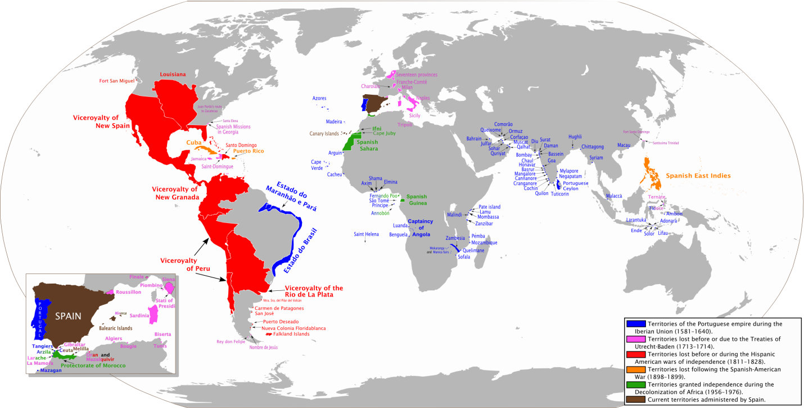

http://en.wikipedia.org/wiki/History\_of\_the\_United\_States

[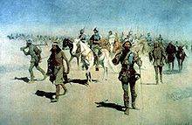](http://en.wikipedia.org/wiki/File:Coronado-Remington.jpg)

[http://bits.wikimedia.org/skins-1.5/common/images/magnify-clip.png](http://en.wikipedia.org/wiki/File:Coronado-Remington.jpg)

*Coronado Sets Out to the North* (1540) by [Frederic Remington](http://en.wikipedia.org/wiki/Frederic_Remington), oil on canvas, 1905.

[Spanish](http://en.wikipedia.org/wiki/Spanish_people) [explorers](http://en.wikipedia.org/wiki/List_of_explorers) came to what is now the United States beginning with [Christopher Columbus](http://en.wikipedia.org/wiki/Christopher_Columbus)' [second expedition](http://en.wikipedia.org/wiki/Voyages_of_Christopher_Columbus), which reached Puerto Rico on November 19, 1493.[[7]](http://en.wikipedia.org/wiki/History_of_the_United_States#cite_note-6) The first confirmed landing in the continental US was by a Spaniard, [Juan Ponce de León](http://en.wikipedia.org/wiki/Juan_Ponce_de_Le%C3%B3n), who landed in 1513 on a lush shore he christened [La Florida](http://en.wikipedia.org/wiki/Florida).[[8]](http://en.wikipedia.org/wiki/History_of_the_United_States#cite_note-de_leon-7)

Within three decades of Ponce de León's landing, the Spanish became the first Europeans to reach the [Appalachian Mountains](http://en.wikipedia.org/wiki/Appalachian_Mountains), the [Mississippi River](http://en.wikipedia.org/wiki/Mississippi_River), the [Grand Canyon](http://en.wikipedia.org/wiki/Grand_Canyon)[[9]](http://en.wikipedia.org/wiki/History_of_the_United_States#cite_note-8) and the [Great Plains](http://en.wikipedia.org/wiki/Great_Plains). In 1540, [Hernando de Soto](http://en.wikipedia.org/wiki/Hernando_de_Soto) undertook an extensive exploration of the present US and, in the same year, [Francisco Vázquez de Coronado](http://en.wikipedia.org/wiki/Francisco_V%C3%A1zquez_de_Coronado) led 2,000 Spaniards and Native Mexican Americans across the modern [Arizona](http://en.wikipedia.org/wiki/Arizona)–Mexico border and traveled as far as central [Kansas](http://en.wikipedia.org/wiki/Kansas)[[10]](http://en.wikipedia.org/wiki/History_of_the_United_States#cite_note-9). Other Spanish explorers include [Lucas Vásquez de Ayllón](http://en.wikipedia.org/wiki/Lucas_V%C3%A1squez_de_Ayll%C3%B3n), [Pánfilo de Narváez](http://en.wikipedia.org/wiki/P%C3%A1nfilo_de_Narv%C3%A1ez), [Sebastián Vizcaíno](http://en.wikipedia.org/wiki/Sebasti%C3%A1n_Vizca%C3%ADno), [Juan Rodríguez Cabrillo](http://en.wikipedia.org/wiki/Juan_Rodr%C3%ADguez_Cabrillo), [Gaspar de Portolà](http://en.wikipedia.org/wiki/Gaspar_de_Portol%C3%A0), [Pedro Menéndez de Avilés](http://en.wikipedia.org/wiki/Pedro_Men%C3%A9ndez_de_Avil%C3%A9s), [Álvar Núñez Cabeza de Vaca](http://en.wikipedia.org/wiki/%C3%81lvar_N%C3%BA%C3%B1ez_Cabeza_de_Vaca), [Tristán de Luna y Arellano](http://en.wikipedia.org/wiki/Trist%C3%A1n_de_Luna_y_Arellano) and [Juan de Oñate](http://en.wikipedia.org/wiki/Juan_de_O%C3%B1ate). The Spanish sent some settlers, creating the first permanent European settlement in the continental United States at [St. Augustine, Florida](http://en.wikipedia.org/wiki/St._Augustine,_Florida) in 1565. Later Spanish settlements included [Santa Fe](http://en.wikipedia.org/wiki/Santa_Fe,_New_Mexico), [Albuquerque](http://en.wikipedia.org/wiki/Albuquerque,_New_Mexico), [San Antonio](http://en.wikipedia.org/wiki/San_Antonio), [Tucson](http://en.wikipedia.org/wiki/Tucson), [San Diego](http://en.wikipedia.org/wiki/San_Diego), Los Angeles and San Francisco. Most Spanish settlements were along the California coast or the [Santa Fe River](http://en.wikipedia.org/wiki/Santa_Fe_River_(New_Mexico)) in New Mexico[[11]](http://en.wikipedia.org/wiki/History_of_the_United_States" \l "cite_note-10)

### [[edit](http://en.wikipedia.org/w/index.php?title=History_of_the_United_States&action=edit&section=3)] Dutch colonization