1492 Columbus

1493 Papal Bull

1494 The **Treaty of Tordesillas** 7 June 1494, divided the newly discovered lands outside [Europe](http://en.wikipedia.org/wiki/Europe) between [Spain](http://en.wikipedia.org/wiki/Spanish_Empire) and [Portugal](http://en.wikipedia.org/wiki/Portuguese_Empire) The lands to the east would belong to Portugal and the lands to the west to Spain.

22 April of [1529](http://en.wikipedia.org/wiki/1529) The Treaty of Zaragoza stated the continuation of the meridian of Tordesillas in the opposite hemisphere

1534 Jacques Cartier

1670 Rupert's Land charter created the Hudson Bay Trading Co.

1713 Treaty of Utrecht France ceded to Great Britain its claims to the [Hudson's Bay Company](http://en.wikipedia.org/wiki/Hudson%27s_Bay_Company) territories in [Rupert's Land](http://en.wikipedia.org/wiki/Rupert%27s_Land)

1763 by the [Treaty of Paris](http://en.wikipedia.org/wiki/Treaty_of_Paris_(1763)), which involved a complex series of land exchanges, the most important being France's cession to Spain of [Louisiana](http://en.wikipedia.org/wiki/Louisiana_(New_France)), and to Great Britain the rest of New France.

In 1762, France had ceded Louisiana to Spain, but by the secret Treaty of San Ildefonso (1800) the French had regained the area

1783 Treaty of Paris left it in Spanish hands.

Accordingly, in April 1803 he offered to sell Louisiana to the United States.

Treaty of 1818

The **Webster–Ashburton Treaty**, signed August 9, 1842 this treaty reaffirmed the border and further detailed the border by modifying the border definition to instead read as "... at the Chaudiere Falls, from which the Commissioners traced the line to the most northwestern point of the Lake of the Woods, thence, along the said line to the said most northwestern point, being in latitude 49°23′55″ north, and in longitude 95°14′38″ west from the Observatory at Greenwich; thence, according to existing treaties, due south to its intersection with the 49th parallel of north latitude, and along that parallel to the Rocky Mountains ..."

According to the contract that Columbus made with King Ferdinand and Queen Isabella, if Columbus discovered any new islands or mainland, he would receive many high rewards. In terms of power, he would be given the rank of Admiral of the Ocean Sea **and appointed Viceroy and Governor of all the new lands**. He had the right to nominate three persons, from whom the sovereigns would choose one, for any office in the new lands. He would be entitled to 10% of all the revenues from the new lands in perpetuity; this part was denied to him in the contract, although it was one of his demands. Additionally, he would also have the option of buying one-eighth interest in any commercial venture with the new lands and receive one-eighth of the profits.

On the evening of 3 August 1492, Columbus departed from [Palos de la Frontera](http://en.wikipedia.org/wiki/Palos_de_la_Frontera) with three ships; one larger [carrack](http://en.wikipedia.org/wiki/Carrack), [*Santa María*](http://en.wikipedia.org/wiki/Santa_Mar%C3%ADa_(ship)), nicknamed *Gallega* (*the Galician*), and two smaller [caravels](http://en.wikipedia.org/wiki/Caravel), [*Pinta*](http://en.wikipedia.org/wiki/Pinta_(ship)) (*the Painted*) and *Santa Clara*, nicknamed [*Niña*](http://en.wikipedia.org/wiki/Ni%C3%B1a) after her owner Juan Niño of Moguer.[[32]](http://en.wikipedia.org/wiki/Christopher_Columbus#cite_note-31) They were property of [Juan de la Cosa](http://en.wikipedia.org/wiki/Juan_de_la_Cosa) and the [Pinzón brothers](http://en.wikipedia.org/wiki/Pinz%C3%B3n_brothers) ([Martín Alonso](http://en.wikipedia.org/wiki/Mart%C3%ADn_Alonso_Pinz%C3%B3n" \o "Martín Alonso Pinzón) and [Vicente Yáñez](http://en.wikipedia.org/wiki/Vicente_Y%C3%A1%C3%B1ez_Pinz%C3%B3n)), but the monarchs forced the [Palos](http://en.wikipedia.org/wiki/Palos_de_la_Frontera) inhabitants to contribute to the expedition. Columbus first sailed to the [Canary Islands](http://en.wikipedia.org/wiki/Canary_Islands), which were owned by [Castile](http://en.wikipedia.org/wiki/Crown_of_Castile), where he restocked the provisions and made repairs. On 6 September he departed [San Sebastián de la Gomera](http://en.wikipedia.org/wiki/San_Sebasti%C3%A1n_de_la_Gomera) for what turned out to be a five-week voyage across the ocean.

Land was sighted at 2 [a.m.](http://en.wikipedia.org/wiki/12-hour_clock) on 12 October 1492, by a sailor named [Rodrigo de Triana](http://en.wikipedia.org/wiki/Rodrigo_de_Triana) (also known as Juan Rodríguez Bermejo) aboard *Pinta*.[[33]](http://en.wikipedia.org/wiki/Christopher_Columbus#cite_note-book2-32) Columbus called the island (in what is now [The Bahamas](http://en.wikipedia.org/wiki/The_Bahamas)) *San Salvador*; the natives called it [Guanahani](http://en.wikipedia.org/wiki/Guanahani). Exactly which island in the Bahamas this corresponds to is an unresolved topic; prime candidates are [Samana Cay](http://en.wikipedia.org/wiki/Samana_Cay), [Plana Cays](http://en.wikipedia.org/wiki/Plana_Cays), or [San Salvador Island](http://en.wikipedia.org/wiki/San_Salvador_Island) (so named in 1925 in the belief that it was Columbus's San Salvador). The [indigenous people](http://en.wikipedia.org/wiki/Indigenous_Peoples_of_the_Americas) he encountered, the [Lucayan](http://en.wikipedia.org/wiki/Lucayan), [Taíno](http://en.wikipedia.org/wiki/Ta%C3%ADno) or [Arawak](http://en.wikipedia.org/wiki/Arawak), were peaceful and friendly. From the 12 October 1492 entry in his journal he wrote of them, "Many of the men I have seen have scars on their bodies, and when I made signs to them to find out how this happened, they indicated that people from other nearby islands come to San Salvador to capture them; they defend themselves the best they can. I believe that people from the mainland come here to take them as slaves. They ought to make good and skilled servants, for they repeat very quickly whatever we say to them. I think they can very easily be made Christians, for they seem to have no religion. If it pleases our Lord, I will take six of them to Your Highnesses when I depart, in order that they may learn our language."[[34]](http://en.wikipedia.org/wiki/Christopher_Columbus#cite_note-33) He remarked that their lack of modern weaponry and even metal-forged swords or pikes was a tactical vulnerability, writing, "I could conquer the whole of them with 50 men, and govern them as I pleased."[[35]](http://en.wikipedia.org/wiki/Christopher_Columbus#cite_note-34)

According to the [Bull of Pope Alexander VI,](http://www.reformation.org/bull-of-borgia.html) New Spain now included not just Mexico . . . but the ENTIRE New World. That meant that Mexico City was now considered the capital city of the entire New World!!

New Spain included the entire New World!!

Bull of Pope Alexander VI

The Inter Caetera, Papal Bull of May 4, 1493.

"Containing in this donation, whatsoever main lands or islands are found or to be found toward India, or toward any other part whatsoever it be, being distant from, or without theaforesaid line drawn a hundred leagues toward the west and south from any of the islands which are commonly called De los Azores and Cape Verde. All the islands therefore, and main lands, found and to be found, discovered and to be discovered, from the said line toward the west and south, such as have not actually been heretofore possessed by any other Christian King or Prince, until the day of the nativity of our Lord Jesus Christ last past, from the which beginneth this present year, being the year of our Lord M.CCCC.LXXXXIII., whensoever any shall be found by your messengers and captains, We by the authority of Almighty God granted unto us in Saint Peter, and by the office which we bear on the earth in the stead of Jesus Christ, do for ever by the tenour of these presents, give, grant, and assign' to you, your heirs and successors (the Kings of Castile and Legion), all these lands and islands,with their dominions, territories, cities, castles, towers, places, and villages, with all the right and jurisdiction thereunto pertaining : constituting, assigning, and deputing you, your heirs and successors, the lords thereof, with full and free power, authority, and jurisdiction. Decreeing, nevertheless, by this our donation, grant, and assignation, that from no Christian Prince, who actually hath possessed the aforesaid islands and main lands unto the day of the nativity of our Lord aforesaid, their right obtained to be understood hereby to be taken away, or that it ought to be taken away. Furthermore we command you, in virtue of holy obedience (as you have promised, and as we doubt not you will do upon mere devotion and princely magnanimity), to send to the said main lands and islands, honest, virtuous, and learned men, such as fear God and are able to instruct the inhabitants in the Catholic faith and good manners, applying all their possible diligence in the premises. We furthermore inhibit all manner of persons, of what state, degree, order, or condition soever they be, although of Imperial and regal dignity, under the pain of the sentence of excommunication which they shall incur if they do to the contrary, that they in no case presume, without special licence of you, your heirs and successors, to travel for merchandise or for any other cause, to the said lands or islands, found or to be found, discovered or to be discovered, towards the west and south, drawing a line from the Arctic pole to the Antarctic pole, whether the main lands and islands found and to be found, be situate toward India or toward any other part, being distant from the line drawn a hundred leagues toward the west from any of the islands commonly called De los Azores and Cape Verde : Notwithstanding constitutions, decrees, and Apostolical ordinances whatsoever they are to the contrary : In Him from whom empires, dominions, and all good things do proceed : Trusting that Almighty God directing your enterprises, if you follow your godly and laudable attempts, your labours and travels herein shall in a short time obtain a happy end with felicity and glory of all Christian people. But forasmuch as it should be a thing of great difficulty for these letters to be carried to all such places as should be expedient, we will, and of like motion and knowledge do decree that whithersoever the same shall be sent, or wheresoever they shall be received with the subscription of a common notary thereunto required, with the seal of any person constituted in ecclesiastical dignity, or such as are authorised by the ecclesiastical court, the same faith and credit to be given thereunto in judgment or elsewhere, as should be exhibited to these presents.

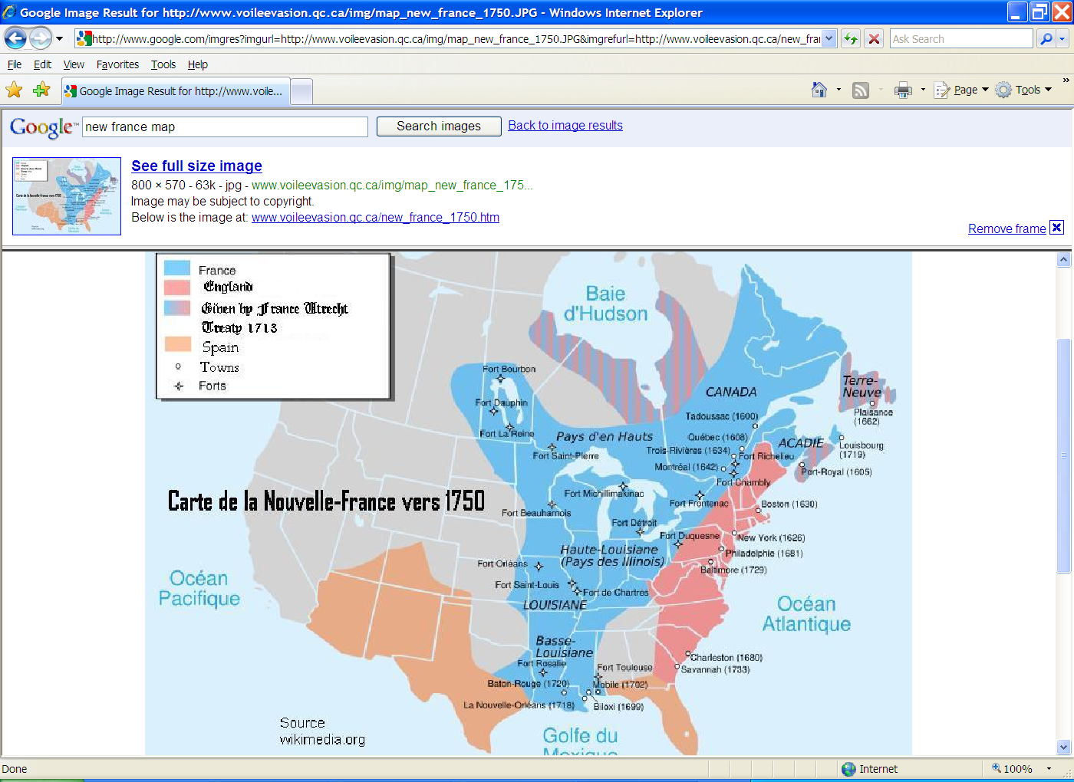

New France was the area [colonized](http://en.wikipedia.org/wiki/French_colonization_of_the_Americas) by France from the exploration of the [Saint Lawrence River](http://en.wikipedia.org/wiki/Saint_Lawrence_River), by [Jacques Cartier](http://en.wikipedia.org/wiki/Jacques_Cartier) in 1534. At its peak in 1712, the territory claimed by New France extended from [Nova Scotia](http://en.wikipedia.org/wiki/Nova_Scotia) to [Lake Superior](http://en.wikipedia.org/wiki/Lake_Superior) and from the Hudson Bay to the Mississippi River and the [Gulf of Mexico](http://en.wikipedia.org/wiki/Gulf_of_Mexico). The territory was then divided into five colonies, each with its own administration: [Canada](http://en.wikipedia.org/wiki/Canada,_New_France), [Acadia](http://en.wikipedia.org/wiki/Acadia), [Hudson Bay](http://en.wikipedia.org/wiki/Hudson_Bay), Newfoundland and [Louisiana](http://en.wikipedia.org/wiki/Louisiana_(New_France)). About 16,000 settlers came from France, and concentrated in villages along the St. Lawrence River and Acadia. There were few settlers elsewhere. Britain seized as spoils of war almost all the French areas east of the Mississippi by 1763. The [area around New Orleans](http://en.wikipedia.org/wiki/Louisiana_(New_France)) and west of the Mississippi passed to Spain, which ceded it to France in 1803, allowing France to sell it as the [Louisiana Purchase](http://en.wikipedia.org/wiki/Louisiana_Purchase) to the United States.[[1]](http://en.wikipedia.org/wiki/Colonial_history_of_the_United_States#cite_note-Cooke_1998-0)

The Anglo-French hostilities were ended in 1763 by the [Treaty of Paris](http://en.wikipedia.org/wiki/Treaty_of_Paris_(1763)), which involved a complex series of land exchanges, the most important being France's cession to Spain of [Louisiana](http://en.wikipedia.org/wiki/Louisiana_(New_France)), and to Great Britain the rest of New France except for the islands of [St. Pierre and Miquelon](http://en.wikipedia.org/wiki/St._Pierre_and_Miquelon). France was given the choice of retrieving either [New France](http://en.wikipedia.org/wiki/New_France) or its Caribbean island colonies of [Guadeloupe](http://en.wikipedia.org/wiki/History_of_Guadeloupe) and [Martinique](http://en.wikipedia.org/wiki/History_of_Martinique), and chose the latter to retain these lucrative sources of [sugar](http://en.wikipedia.org/wiki/Sugar),[[27]](http://en.wikipedia.org/wiki/Seven_Years%27_War#cite_note-26) writing off New France as an unproductive, costly territory.[[28]](http://en.wikipedia.org/wiki/Seven_Years%27_War#cite_note-27) France also returned Minorca to the British. Spain lost control of [Florida](http://en.wikipedia.org/wiki/Spanish_Florida) to Great Britain, but received part of [New Orleans](http://en.wikipedia.org/wiki/New_Orleans) and the [Louisiana Territory](http://en.wikipedia.org/wiki/Louisiana_Territory) west of the [Mississippi River](http://en.wikipedia.org/wiki/Mississippi_River) from the French. The exchanges suited the British as well, as their own Caribbean islands already supplied ample sugar, and with the acquisition of New France and Florida, they now controlled all of North America east of the Mississippi.

In 1762, France had ceded Louisiana to Spain, but by the secret Treaty of San Ildefonso (1800) the French had regained the area. Napoleon Bonaparte (the future Emperor Napoleon I) envisioned a great French empire in the New World, and he hoped to use the Mississippi Valley as a food and trade center to supply the island of Hispaniola, which was to be the heart of this empire. First, however, he had to restore French control of Hispaniola, where Haitian slaves under TOUSSAINT L'OUVERTURE had seized power (1801; see HAITI). In 1802 a large army sent by Napoleon under his brother-in-law, Charles Leclerc, arrived on the island to suppress the Haitian rebellion. Despite some military success, the French lost thousands of soldiers, mainly to yellow fever, and Napoleon soon realized that Hispaniola must be abandoned. Without that island he had little use for Louisiana. Facing renewed war with Great Britain, he could not spare troops to defend the territory; he needed funds, moreover, to support his military ventures in Europe. Accordingly, in April 1803 he offered to sell Louisiana to the United States.

Treaty of 1818

* Article II set the boundary between British North America and the United States along "a line drawn from the most [northwestern point](http://en.wikipedia.org/wiki/Northwestern_point_of_the_Lake_of_the_Woods) of the [Lake of the Woods](http://en.wikipedia.org/wiki/Lake_of_the_Woods), [due south, then] along the [49th parallel](http://en.wikipedia.org/wiki/49th_parallel_north) of north latitude..." to the "Stony Mountains"[[3]](http://en.wikipedia.org/wiki/Treaty_of_1818#cite_note-Canado-American_Treaties_Text-2) (now known as the [Rocky Mountains](http://en.wikipedia.org/wiki/Rocky_Mountains)). Britain ceded all of [Rupert's Land](http://en.wikipedia.org/wiki/Rupert%27s_Land) south of the 49th parallel, including the [Red River Colony](http://en.wikipedia.org/wiki/Red_River_Colony). This settled a boundary dispute caused by ignorance of actual geography in the boundary agreed to in the 1783 [Treaty of Paris](http://en.wikipedia.org/wiki/Treaty_of_Paris_(1783)) that ended the [American Revolutionary War](http://en.wikipedia.org/wiki/American_Revolutionary_War). That earlier treaty had placed the boundary between the United States and British possessions to the north along a line going westward from the [Lake of the Woods](http://en.wikipedia.org/wiki/Lake_of_the_Woods) to the [Mississippi River](http://en.wikipedia.org/wiki/Mississippi_River). The parties failed to realize that the river did not extend that far north, so such a line would never meet the river. The new treaty also created the anomalous [Northwest Angle](http://en.wikipedia.org/wiki/Northwest_Angle), the small section of the present state of [Minnesota](http://en.wikipedia.org/wiki/Minnesota) that is the only part of the United States outside [Alaska](http://en.wikipedia.org/wiki/Alaska) north of the 49th parallel.

Treaty of Utrecht

The **Treaty of Utrecht**, which established the **Peace of Utrecht**, comprises a series of individual [peace treaties](http://en.wikipedia.org/wiki/Peace_treaty), rather than a single document, signed in the [Dutch](http://en.wikipedia.org/wiki/Dutch_Republic) city of [Utrecht](http://en.wikipedia.org/wiki/Utrecht_(city)) in March and April 1713

In addition, Spain ceded [Gibraltar](http://en.wikipedia.org/wiki/Gibraltar) and [Minorca](http://en.wikipedia.org/wiki/Minorca) to Great Britain and agreed to give to the British the [Asiento](http://en.wikipedia.org/wiki/Asiento), a valuable monopoly [slave-trading](http://en.wikipedia.org/wiki/Slave_trade) contract. In North America, **France ceded to Great Britain its claims to the** [**Hudson's Bay Company**](http://en.wikipedia.org/wiki/Hudson%27s_Bay_Company) **territories in** [**Rupert's Land**](http://en.wikipedia.org/wiki/Rupert%27s_Land)**,** [**Newfoundland**](http://en.wikipedia.org/wiki/Newfoundland_(island)) **and** [**Acadia**](http://en.wikipedia.org/wiki/Acadia). The formerly partitioned island of [Saint Kitts](http://en.wikipedia.org/wiki/Saint_Kitts) was also ceded in its entirety to Britain. France was required to recognize British [suzerainty](http://en.wikipedia.org/wiki/Suzerainty) over the [Iroquois](http://en.wikipedia.org/wiki/Iroquois) and commerce with the Far Indians was to be open to traders of all nations. France retained its other pre-war North American possessions, including Île-Saint-Jean (now [Prince Edward Island](http://en.wikipedia.org/wiki/Prince_Edward_Island)) as well as Île Royale (now [Cape Breton Island](http://en.wikipedia.org/wiki/Cape_Breton_Island)), on which it erected the [Fortress of Louisbourg](http://en.wikipedia.org/wiki/Fortress_of_Louisbourg).