The [**Neolithic**](http://en.wikipedia.org/wiki/Neolithic) **Revolution** was the first agricultural revolution. It was the transition from [hunting and gathering](http://en.wikipedia.org/wiki/Hunter-gatherer) to [agriculture](http://en.wikipedia.org/wiki/Agriculture) and settlement. Archaeological data indicates that various forms of plant and animal [domestication](http://en.wikipedia.org/wiki/Domestication) evolved independently in 6 separate locations worldwide circa 10,000–7000 years [BP](http://en.wikipedia.org/wiki/Before_Present) (8,000–5,000 [BC](http://en.wikipedia.org/wiki/Before_Christ)).

When the first settlers started arriving in Griggs County, they used many of the same farming methods that had been used for the last 10,000 years.

The Cooperstown Centennial Book states that:

*You must break the land with a breaking plow, you do not plow very deep, only enough to turn the sod so it can decay, then you plow again and your land is ready to seed. You do not have a drill so you sow by hand, tie a rope on a bucket or a sack and hang this around your neck so it hangs near your stomach, then you begin to walk and very artfully broadcast the seeds by throwing. You do not have a drag yet either so you go to the river and obtain some small trees, tie them together and use the bushy top for a drag to smooth the land and cover the seeds. Since you can only break a few acres a day, you do not have much crop in the first year but during the growing season you are busy breaking more land for next year. Then it is time to harvest and you cut your grain with a scythe and tie the grain into neat bundles using straw for ties. Then the bundles are brought home and it is the women's job to thresh. This is done by placing the bundles on blankets and pounding the grain out with a club or stick. The wheat is ground into flour so the household can use it as a food staple during the coming winter.*

Let’s take a look at some of these methods in more detail.

One of the most important things the pioneer had were his draft animals. Nearly every farmer had a yoke. Having two oxen for the yoke would be much less common. Sometimes a farmer would use a combination of horse, cow and oxen to try to get two healthy animals hitched to the breaking plow. Sometimes a farmer would only have 1 ox and would work with another neighbor who had only one ox so that they could get two animals hitched to the plow.

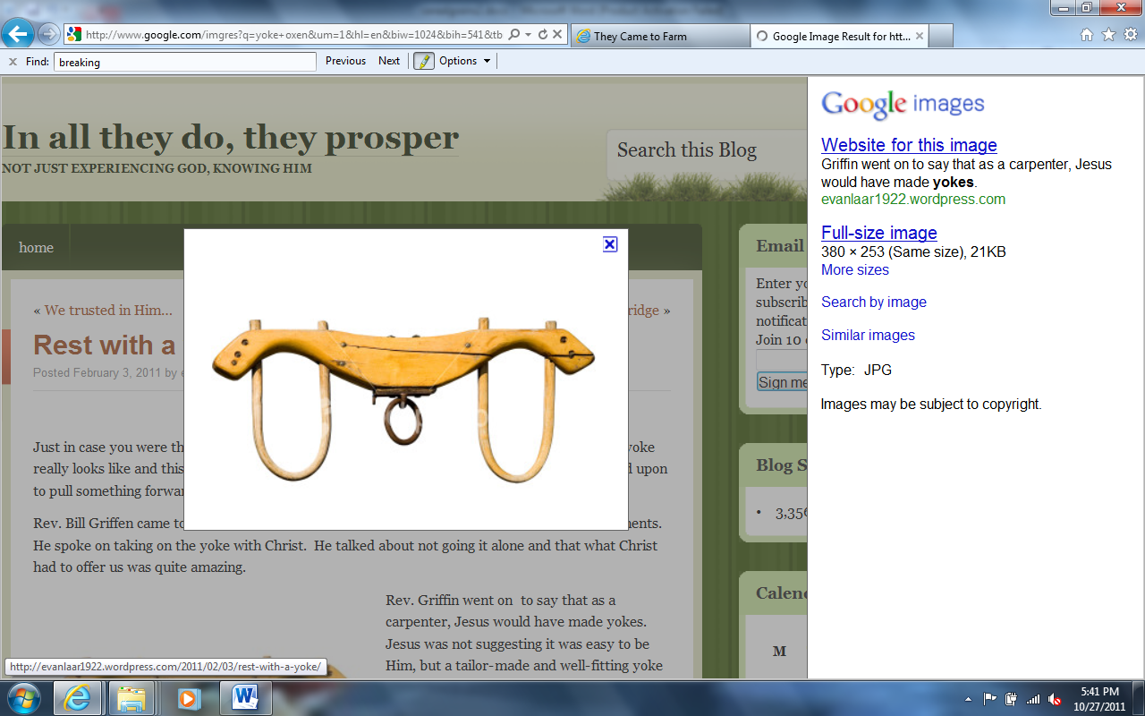

Mrs. Charles Rothert in about 1885:

*broadcast seed, harvested with a scythe and threshed with a flail. She often walked the thirteen miles to Cooperstown for family provisions and either carried or used a wheelbarrow to get them home.*

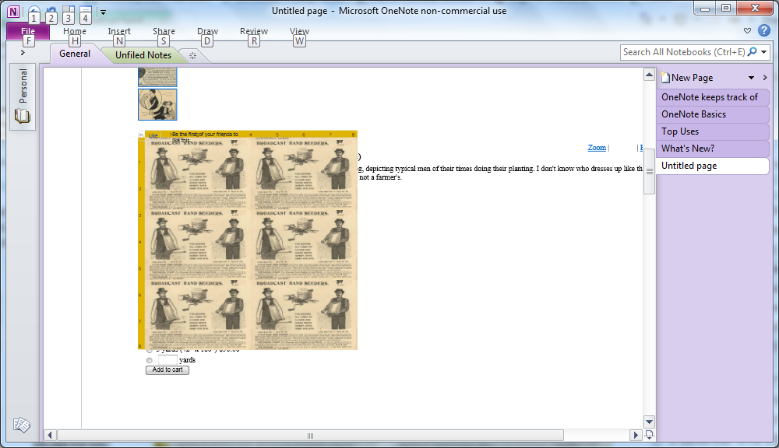

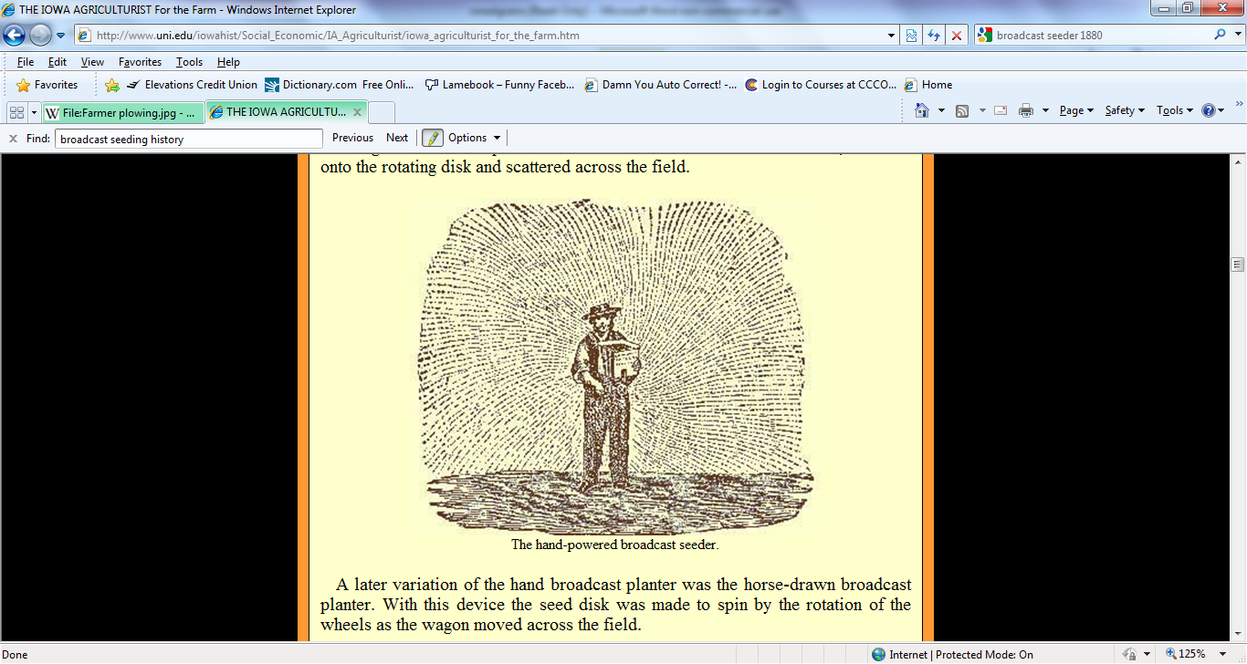

The seeds were typically planted by hand. Various forms of hand held rakes, drags and hoes were used to cover the seeds with dirt and then to cultivate the weeds out of the field. The most important technological innovation used was replacing the sickle with the scythe.

The development of the sickle in Mesopotamia can be traced back to times that pre-date the Neolithic Era. Large quantities of sickle blades have been excavated in sites surrounding Palestine that have been dated to the ‘Epi-Palaeolithic’ (18,000-8,000 B.C.) era.

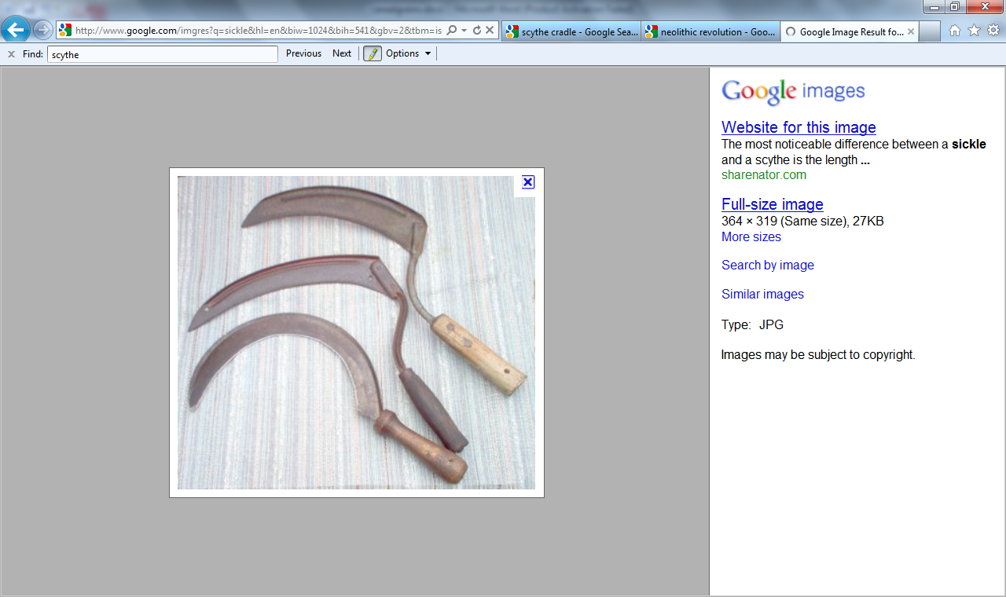

The scythe was invented in about 500 BC and appeared in Europe during the 12th and 13th centuries. Initially used mostly for mowing grass, it replaced the [sickle](http://en.wikipedia.org/wiki/Sickle) as the tool for reaping crops by the 16th century, the scythe allowing the reaper to stand rather than stoop. In about 1800 the addition of light wooden fingers above a scythe blade produced a form of scythe called the [*cradle*](http://en.wikipedia.org/wiki/Cradle_(grain)) which soon replaced the simple scythe for reaping grain and mowing other tall vegetation such as reeds. In the [developed world](http://en.wikipedia.org/wiki/Developed_world), all of these have now largely been replaced by motorized [lawnmowers](http://en.wikipedia.org/wiki/Lawnmower) and [combine harvesters](http://en.wikipedia.org/wiki/Combine_harvester).

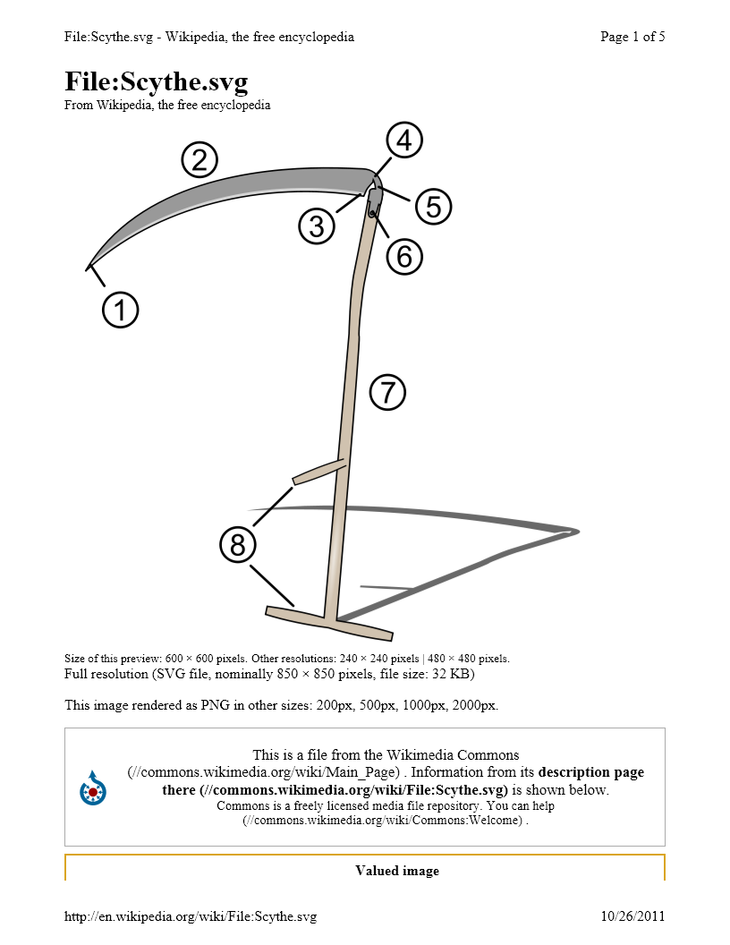

An example of a scythe:

1. Toe  
2. Chine  
3. Beard  
4. Heel  
5. Tang  
6. Ring  
7. Snath or snaith  
8. Grips

A scythe consists of a wooden shaft about 170 centimetres (67 in) long called a *snaith*, *snath*, *snathe* or *sned* (modern versions are sometimes made from [metal](http://en.wikipedia.org/wiki/Metal) or [plastic](http://en.wikipedia.org/wiki/Plastic)). The snaith may be straight, or with an "S" curve, but the more sophisticated versions are curved in three dimensions, allowing the mower to stand more upright. The snaith has either one or two short handles at right angles to it – usually one near the upper end and always another roughly in the middle. A long, curved blade about 60 to 90 centimetres (24 to 35 in)) long is mounted at the lower end, perpendicular to the snaith. Scythes always have the blade projecting from the left side of the snaith when in use, with the edge towards the mower. In principle a left-handed scythe could be made, but it could not be used together with right-handed scythes in a team of mowers, as the left-handed mower would be mowing in the opposite direction.

A scythe blade is made by [peening](http://en.wikipedia.org/wiki/Peening) the leading edge of the blade. In some uses, such as for mowing grass, the blade-edge is made almost as thin as paper. After peening, the edge is finished and subsequently maintained by very frequent stropping or [honing](http://en.wikipedia.org/wiki/Sharpening) with a [whetstone](http://en.wikipedia.org/wiki/Sharpening_stone) or *rubber* (fine-grained for grass, coarser for cereal crops), and peened again as necessary to recover the fineness of the edge.

The "American" scythe blade is not usually peened as part of sharpening, being made using a stamping process that produces a harder blade than other styles of scythe blade. The harder blade is more difficult to draw out the edge with peening.

A **flail** is an [agricultural](http://en.wikipedia.org/wiki/Agriculture) tool used for [threshing](http://en.wikipedia.org/wiki/Threshing) to separate [grains](http://en.wikipedia.org/wiki/Cereal) from their husks.

It is usually made from two or more large sticks attached by a short chain; one stick is held and swung, causing the other to strike a pile of grain, loosening the husks. The precise dimensions and shape of flails were determined by generations of farmers to suit the particular grain they were harvesting. For example, flails used by farmers in [Quebec](http://en.wikipedia.org/wiki/Quebec) to process [wheat](http://en.wikipedia.org/wiki/Wheat) were generally made from two pieces of wood, the handle being about 1.5 m long by 3 cm in diameter, and the second stick being about 1 m long by about 3 cm in diameter, with a slight taper towards the end. Flails for other grains, such as [rice](http://en.wikipedia.org/wiki/Rice) or [spelt](http://en.wikipedia.org/wiki/Spelt), would have had different dimensions.

Threshing is just one process in getting cereals to the grinding mill and customer. The wheat needs to be grown, cut, stooked (shocked, bundled), hauled, threshed, and then the grain hauled to an [elevator](http://en.wikipedia.org/wiki/Elevator) and the chaff [baled](http://en.wikipedia.org/wiki/Straw_bale).

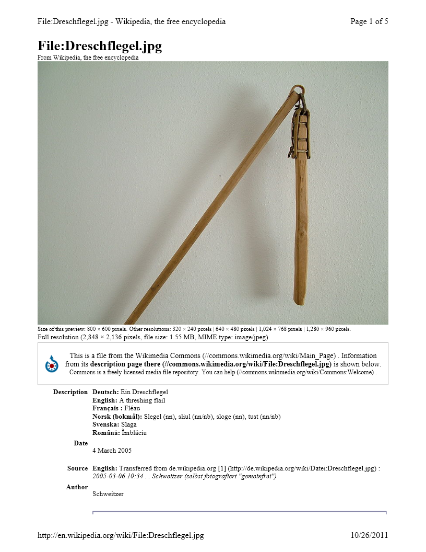

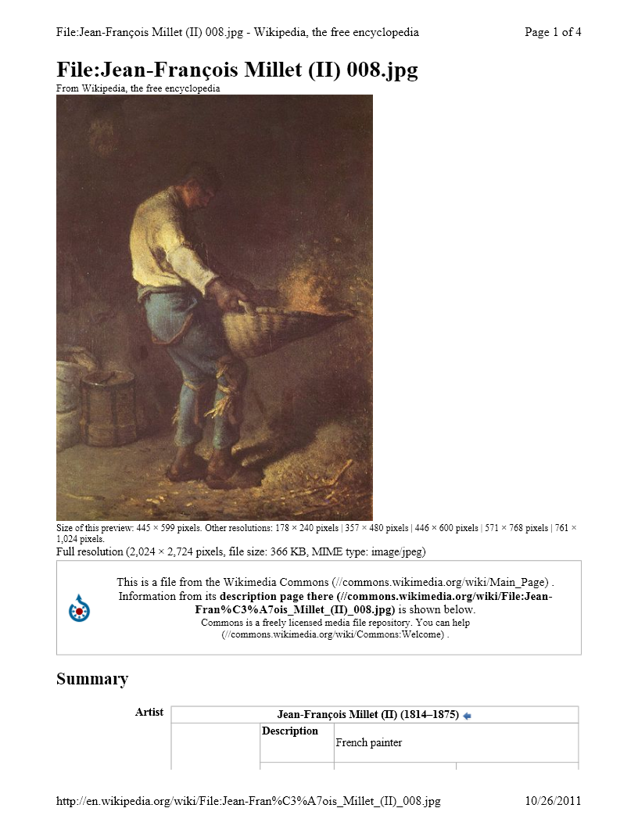

Winnowing

**Wind winnowing** is an [agricultural](http://en.wikipedia.org/wiki/Agriculture) method developed by ancient cultures for separating [grain](http://en.wikipedia.org/wiki/Cereal) from [chaff](http://en.wikipedia.org/wiki/Chaff). It is also used to remove [weevils](http://en.wikipedia.org/wiki/Weevils) or other pests from stored grain. [Threshing](http://en.wikipedia.org/wiki/Threshing), the separation of grain or seeds from the husks and straw, is the step in the chaff-removal process that comes before winnowing. "Winnowing the chaff" is a common expression.

In its simplest form it involves throwing the mixture into the air so that the wind blows away the lighter chaff, while the heavier grains fall back down for recovery. Techniques included using a winnowing fan (a shaped basket shaken to raise the chaff) or using a tool (a [winnowing fork](http://en.wikipedia.org/w/index.php?title=Winnowing_fork&action=edit&redlink=1) or shovel) on a pile of harvested grain.

The earliest Griggs County pioneers arrived about this time.

A simple cradle scythe using a loop made from a twig attached to the snath, rather than wooden fingers, was described as early as the 13th century. A "scythe frame" or "scythe bow" consisting of the bow covered with wire mesh, and later, a rake-like wooden frame were used in Germany.

[Jethro Tull](http://en.wikipedia.org/wiki/Jethro_Tull_(agriculturist))'s [seed drill](http://en.wikipedia.org/wiki/Seed_drill) (ca. 1701) was a mechanical seed spacing and depth placing device that increased crop yields and saved seed. It was an important factor in the [British Agricultural Revolution](http://en.wikipedia.org/wiki/British_Agricultural_Revolution).[[1]](http://en.wikipedia.org/wiki/Mechanized_agriculture#cite_note-McNeil1990-0)

Since the beginning of agriculture threshing was done by hand with a [flail](http://en.wikipedia.org/wiki/Flail), requiring a great deal of labor. The [threshing machine](http://en.wikipedia.org/wiki/Threshing_machine), which was invented 1794 but not widely used for several more decades, simplified the operation and allowed the use of animal power.

Before the invention of the [grain cradle](http://en.wikipedia.org/wiki/Cradle_(grain)) (ca. 1790) an able bodied laborer could reap about one quarter acre of wheat in a day using a sickle. It was estimated that for each of Cyrus McCormick's horse pulled reapers (ca. 1830s) freed up five men for military service in the U.S. Civil War.[[2]](http://en.wikipedia.org/wiki/Mechanized_agriculture#cite_note-1) Later innovations included raking and binding machines. By 1890 two men and two horses could cut, rake and bind 20 acres of wheat per day.[[3]](http://en.wikipedia.org/wiki/Mechanized_agriculture#cite_note-2)

In the 1880s the reaper and threshing machine were combined into the [combine harvester](http://en.wikipedia.org/wiki/Combine_harvester). These machines required large teams of horses or mules to pull.

Steam power was applied to threshing machines in the late 19th century. There were steam engines that moved around on wheels under their own power for supplying temporary power to stationary threshing machines. These were called *road engines,* and Henry Ford seeing one as a boy was inspired to build an automobile.[[4]](http://en.wikipedia.org/wiki/Mechanized_agriculture#cite_note-3)

With internal combustion came the first modern tractors in the early 1900s, becoming more popular after the [Fordson tractor](http://en.wikipedia.org/wiki/Fordson_tractor) (ca. 1917). At first reapers and combine harvesters were pulled by tractors, but in the 1930s self powered combines were developed.[[5]](http://en.wikipedia.org/wiki/Mechanized_agriculture#cite_note-4) (*Link to a chapter on agricultural mechanization in the 20th Century at reference*)

The horse population in the U.S. began to decline in the 1920s after the conversion of agriculture and transportation to internal combustion. Peak tractor sales in the U.S. were around 1950.[[6]](http://en.wikipedia.org/wiki/Mechanized_agriculture#cite_note-5) In addition to saving labor, this freed up much land previously used for supporting draft animals.[[7]](http://en.wikipedia.org/wiki/Mechanized_agriculture#cite_note-6)

The greatest period of growth in agricultural productivity in the U.S. was from the 1940s to the 1970s, during which time agriculture was benefiting from internal combustion powered tractors and harvesting machines, chemical fertilizers and the green revolution.[[8]](http://en.wikipedia.org/wiki/Mechanized_agriculture#cite_note-7)

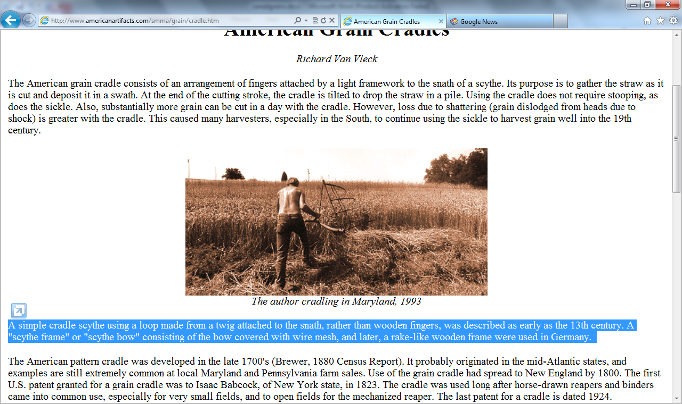

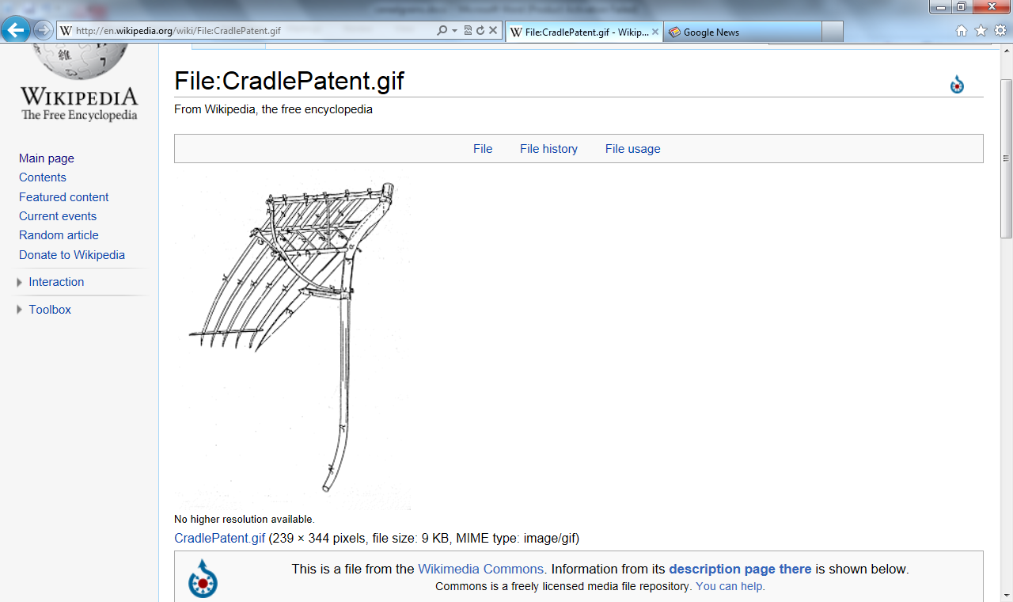

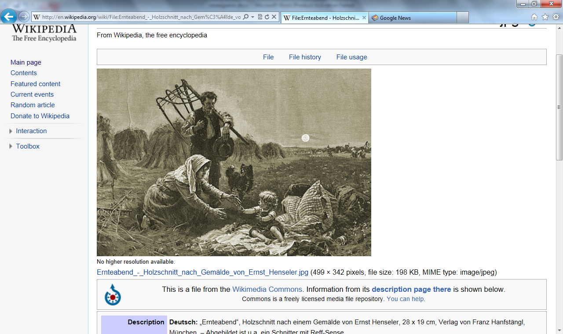

Timeline

Sickle 10,000 BC to 1500 BC

Scythe 1500 BC to1900 AD

Scythe with Cradle

Scythe with cradle first patent in 1823

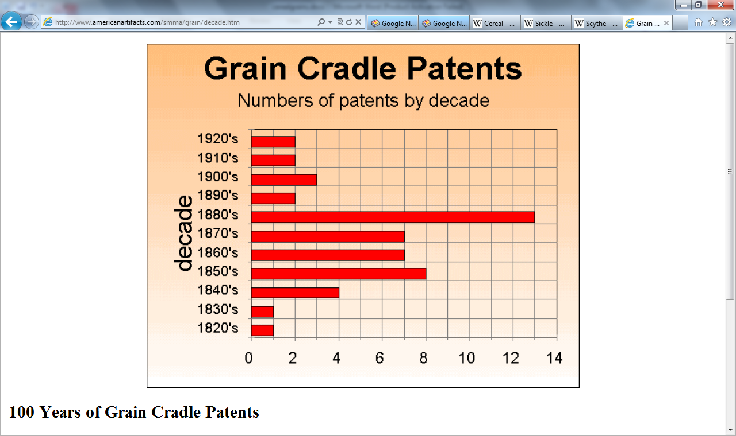

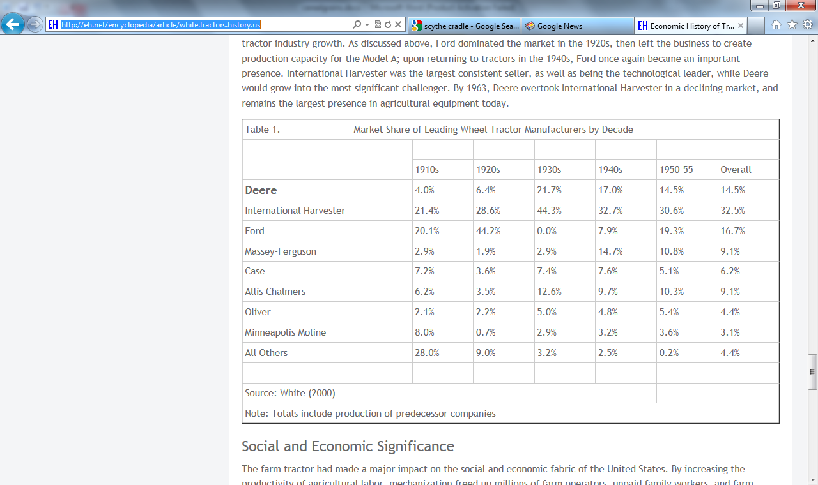

The first known European seed drill was attributed to Camillo Torello and patented by the Venetian Senate in 1566. A seed drill was described in detail by Tadeo Cavalina of [Bologna](http://en.wikipedia.org/wiki/Bologna) in 1602.[[2]](http://en.wikipedia.org/wiki/Seed_drill#cite_note-temple-1) In [England](http://en.wikipedia.org/wiki/England), the seed drill was further refined by [Jethro Tull](http://en.wikipedia.org/wiki/Jethro_Tull_(agriculturist)) in 1701 in the [Agricultural Revolution](http://en.wikipedia.org/wiki/British_Agricultural_Revolution). However, seed drills of this and successive types were both expensive and unreliable, as well as fragile. Seed drills would not come into widespread use in Europe until the mid-19th century.

<http://en.wikipedia.org/wiki/Cereal>

<http://en.wikipedia.org/wiki/Scythe>

<http://en.wikipedia.org/wiki/Cradle_(grain)>

<http://en.wikipedia.org/wiki/Sickle>

<http://en.wikipedia.org/wiki/Reaper>

<http://en.wikipedia.org/wiki/Twine_binder>

<http://en.wikipedia.org/wiki/Mechanized_agriculture>

http://eh.net/encyclopedia/article/white.tractors.history.us

<http://en.wikipedia.org/wiki/Threshing_machine>

<http://www.loghoj.dk/holbaek-1.htm>

<http://en.wikipedia.org/wiki/Flail>

<http://www.antiquefarmtools.info/page5.htm>

<http://en.wikipedia.org/wiki/Threshing>

<http://en.wikipedia.org/wiki/Combine_harvester>

<http://en.wikipedia.org/wiki/Winnowing>

<http://www.machine-history.com/Agricultural%20Machinery>

<http://en.wikipedia.org/wiki/List_of_tractor_manufacturers>

<http://www.ploughmen.co.uk/ploughhistory.htm>