[**http://www.ebay.com/itm/Cooperative-Farm-Tractor-Catalogs-1922-1926-CD-/260796237508?pt=BI_Books_Manuals&hash=item3cb8aac6c4**](http://www.ebay.com/itm/Cooperative-Farm-Tractor-Catalogs-1922-1926-CD-/260796237508?pt=BI_Books_Manuals&hash=item3cb8aac6c4)

Abenaque (USA)

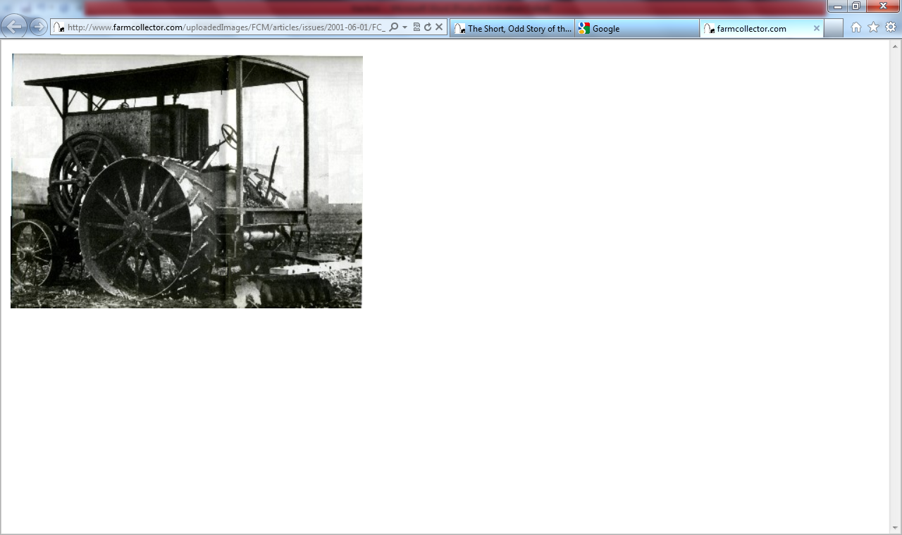

The founder of the Abenaque Machine Works, Frederick M. Gilbert, was traveling in a party of six in the late 1880s headed to Portland, Maine, when one of the horses developed pink eye. 'They stopped in Westminster, Vt., to seek aid,' write Patricia A. Haas and Alice C. Caggiano in Abenaque Machine Works. 'A good man across the Connecticut River in Walpole (N. H.) was recommended. The horse was left in his care and a replacement purchased.'

On the way back, the party stopped and discovered the horse had died. But the time spent in the area had been fruitful. Frederick Gilbert had been so impressed by the Westminster-Walpole area that he chose to build his home there.

So in 1893, Frederick Gilbert and his family 'packed their belongings,' say Haas and Caggiano, 'including all their money, gold and jewelry, in barrels.' The barrels were then transported by a team of horses and a wagon to a bank in Keene, N.H., where, Haas and Caggiano write, 'Mr. Gilbert simply backed the horse and wagon to the door (of the bank) and unloaded the containers.' A curious method of making a deposit, and the curious beginning to the interesting history of the Abenaque tractor.

By the middle of 1893, Frederick was constructing the buildings that would house the Abenaque Machine Works. Rumor had it he was building a corn-starch factory, as he had previously been in the starch business, and his new buildings were near the corn canning factory.

Instead, he signed up an inventor for his new machine business. He convinced John Ostenberg, who was working in the Des Moines, Iowa, business of Frederick's father, to move to Westminster Station, and sign a five-year contract at $1,000 a year to create inventions for the new business.

However, Gilbert and Ostenberg must not have gotten along, because before the five years were up, John Ostenberg moved to San Jose, California, where he opened the Ostenberg Manufacturing Company.

Ostenberg's moving doesn't seem to have affected Abenaque Machine Works a great deal, in part because he had already applied for five patents - all of which were approved and assigned to Gilbert's name, from 1898-1903. The most important was for an 'explosion,' or gasoline (or as they spelled it, 'gasoline') engine.

Ostenberg described his engine and hinted at how it was named in his patent application: 'The invention is preferably embodied in what is known as a four cycle engine in which every other stroke is idle, the return of the piston serving to compress the air and gas before the explosion takes place ...' He also invent ed a circuit-breaker to be used as an igniting device for the engine, a separate invention for improved construction for inlet and exhaust ports in the engine, as well as an improved water jacket for stationary gasoline engines.

Using Ostenberg's plans, the engines were manufactured in sizes ranging from two hp through 25 hp. As the Abenaque Gasoline Traction Engine booklet says, 'Abenaque gas and gasoline engines are made in sizes of from 2-25 H.P., of several different types, and, we believe, are adapted to more varied applications than any other one make of engine at present on the market. For portable work particularly we believe they are unexcelled, as, being entirely self-contained, the engine is ready to be started up at any time, there being no connections to be made after each change of location.'

For the next 15 years, these 'explosion engines' were staples of the Abenaque Machine Works line.

But the company manufactured or handled many other products, as well: a circular saw outfit, portable combination drag and circular saw outfit, stationary saw frames, portable air compressor out fits, Papecensilage cutters, feed grinders, hay presses, grain threshers, and power pumps.

Companies have always published testimonials to show the world how good their product was, and the Abenaque Machine Works was no different. A man wrote on November 5, 1896: 'As I have used one of your gasoline engines for about a year and a half (or, rather seven teen months), I believe a long enough time for a fair trial, I must say it has filled the requirements in first-rate shape, not only by doing the work well, but without repair expense. I use the engine to run sewing-machines for stitching heavy cloth, and those who do the work and have used other power say they have never had better or more even than this ... I positively know that ALL so called gas or gasoline engines are not good, some being practically useless, as I have tried some of this kind. Some others are good, but I believe I have THE BEST engine made, which is your make.'

In 1906, James E. Hattan wrote, 'My engine has never given me any trouble at all - most satisfactory in fact. Am using it right along and have nothing but good words for it.'

It is, perhaps, understandable that Abenaque avoided publishing the following letter, dated July 28, 1905, from the So. Lancaster Printing Company: 'Please send us one set of brushes for our dynamo, also a spring for same. For several months our engine has not been giving good satisfaction. It leaks air in cylinder, the rings seem to be worn on the lower side. It seems to us that this ought not to be in an engine guaranteed as this one is. We have not had it a year yet. Kindly let us hear from you.'

That the Abenaque tractor ever became a viable machine is a mystery, if only because it was manufactured in a city and state - Westminster Station, Vt. - far from the largest market for tractors: The U.S. central plains, where farmers would doubtless have been attracted to its strong suit, as written in its advertising literature: 'The Abenaque tractors have been developed to meet the hilly conditions which obtain in the East, and hence are all the more suitable for work in a more level country.'

That the Abenaque tractor ever became a viable machine is a mystery, if only because it was manufactured in a city and state - Westminster Station, Vt. - far from the largest market for tractors: The U.S. central plains, where farmers would doubtless have been attracted to its strong suit, as written in its advertising literature: 'The Abenaque tractors have been developed to meet the hilly conditions which obtain in the East, and hence are all the more suitable for work in a more level country.'

Abenaque Machine Works manufactured several sizes of tractors. The smallest was the 12 hp Abenaque, which came with 14 inch or 20 inch tires on the driving wheels, as desired.

The Abenaque 15 hp tractor had drive wheels that were 56 inches in diameter, exclusive of cleats, with 20-inch tires. Front wheels were 36 inches in diameter.

Abenaque also made a 25 hp tractor. The company praised the machine for its short turning radius. It could pull three 14-inch bottom plows under favorable conditions, getting through eight acres a day. It could haul loads of 20,000 pounds.

The booklet also says, 'We are advised by the road commissioners of a New York town owning and operating one of our machines, that the weekly expense when using six horses on the road machine has been $84 per week (including two-horse team hire at the rate of $4 each per day). They state that when operating the scraper by means of the Abenaque tractor they accomplish one third more work at a total weekly expense, including cost of gasoline, cylinder oil and operators, of $36, or a net saving of $48 per week plus one third more work.' That, in a nutshell, could explain why tractors were becoming favored over horses at this time. The gasoline traction engine booklet also gave directions on how the tractor could best be used on the farm, for contractors' work, or highway construction.

The Abenaque tractor only did well for four years; in 1915, the entire company went bankrupt, at which time an announcement was published (on September 23):

PUBLIC, ATTENTION. The business of the Abenaque Machine Works, Westminster Stations, Vt, manufacturers of the famous Abenaque Gasoline Engine and Wood Sawing Outfits was on September 1st, 1915, taken over by new interests and the purpose of this advertisement is to advise the public that business will be continued along the same lines as formally except under greatly improved conditions.

Our stock of both engines and repairs is very complete and if you are considering the purchase of an outfit can assure you it will be to your advantage to get our catalogue and prices before purchasing. Write today.

The business limped on for six more years, still under the Gilbert family auspices, until it filed its final bankruptcy in 1921.

### Abenaquotation

The 1900 Abenaque catalog offered the following answers to the question: WHY SHOULD YOU BUY AN ABENAQUE GASOLENE ENGINE?

BECAUSE it is built of the best material and is of the best workman ship.

BECAUSE it can be put to more uses than any other single engine ever built.

BECAUSE it consumes less gasoline than any other engine.

BECAUSE it is not an experiment. It has been tested by a variety of users and has never been found wanting.

BECAUSE it has no gasoline or water tanks to be moved and connect ed every time the engine is moved. Everything is on it at all times, ready for use.

BECAUSE the parts of the engine receiving the greatest strain are at rest at all times except when needed to fill their functions, and will therefore last longer.

BECAUSE it starts easier and quicker than any other engine you ever saw. No starting machines are necessary. One turn of the fly-wheel is all that is necessary to start it.

BECAUSE it is not built on wheels like other portable engines, thereby causing a great additional expense and making the engine useless for indoor work. It can be carried on a wagon body or a sled, and set to running in any position without truing up.

BECAUSE each engine is used to run our machinery for several days before it leaves our shop, and is known to be in perfect working order.

OUR GUARANTEE. Each engine is guaranteed to be made from the best material and of the best workmanship, and to develop five actual brake horse power.

Bill Vossler is a frequent contributor to Farm Collector.

Acason

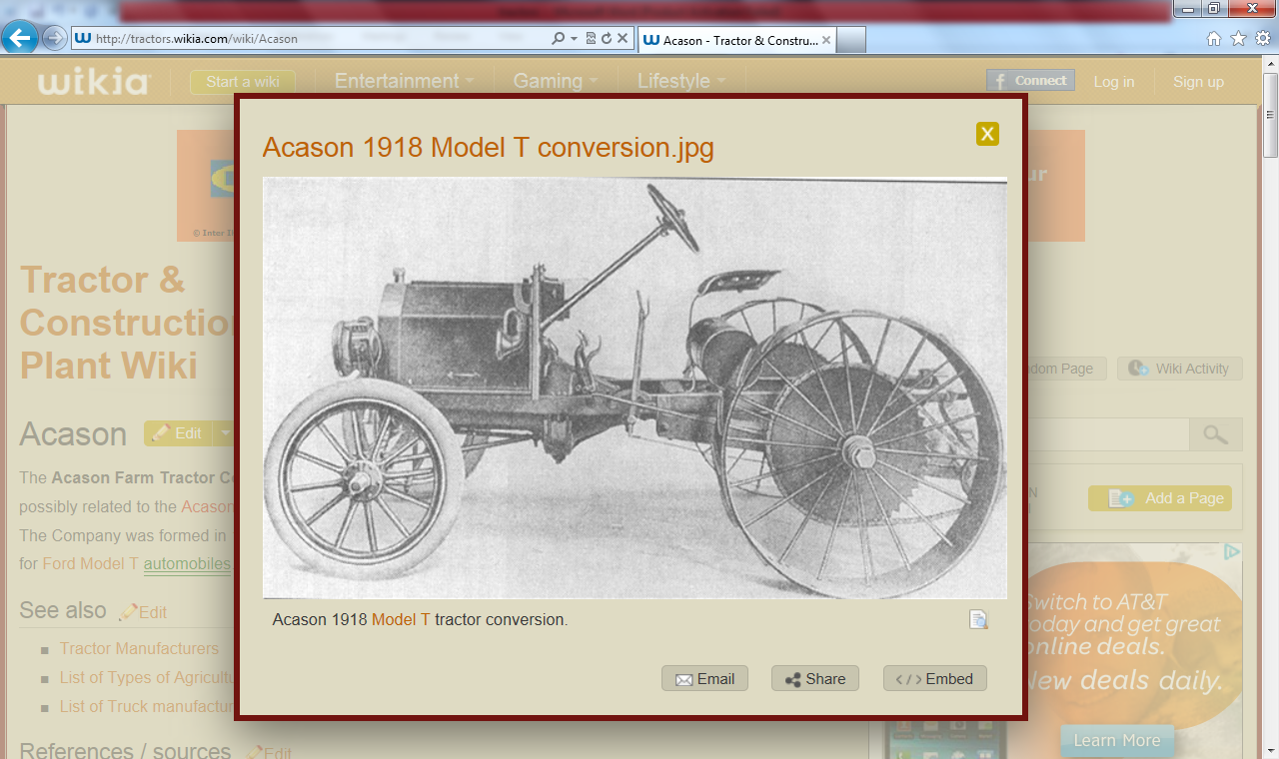

The **Acason Farm Tractor Co.** of Detroit, Michigan, in the USA is possibly related to the [Acason Motor Truck Co.](http://tractors.wikia.com/index.php?title=Acason_Motor_Truck_Co.&action=edit&redlink=1) of the same city. The Company was formed in [1918](http://tractors.wikia.com/wiki/1918) to make tractor conversion kits for [Ford Model T](http://tractors.wikia.com/wiki/Ford_Model_T) [automobiles](http://tractors.wikia.com/wiki/Acason). Acason shut down in 1925.

ACME (USA)



Adams Husker (USA)

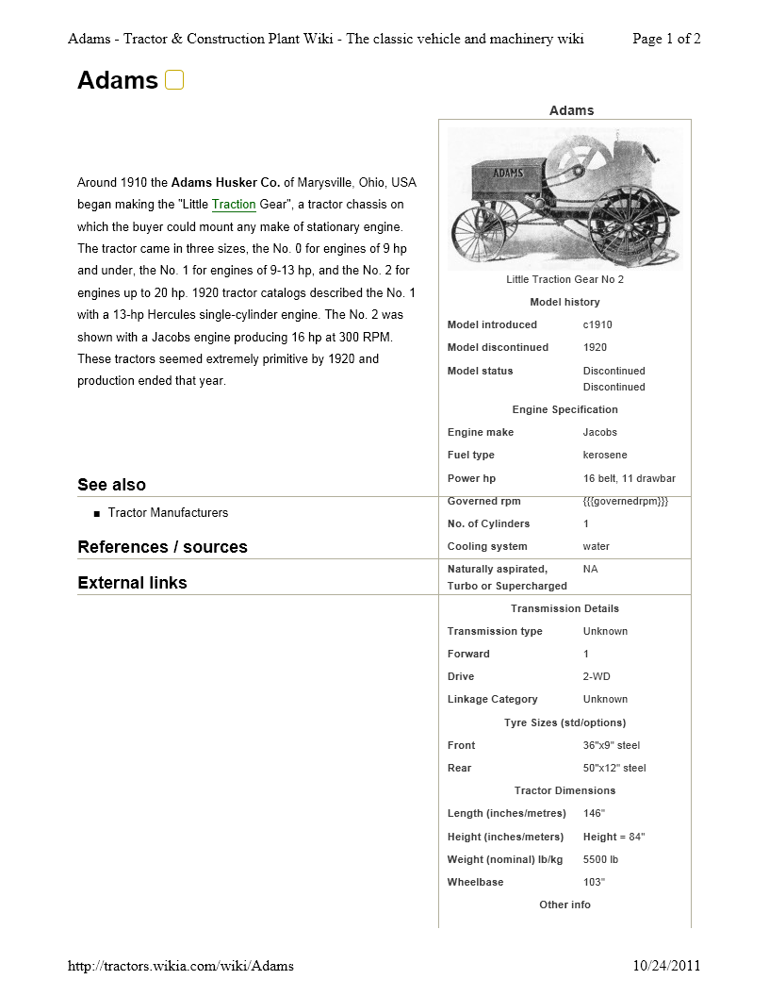

Around 1910 the **Adams Husker Co.** of Marysville, Ohio, USA began making the "Little [Traction](http://tractors.wikia.com/wiki/Adams) Gear", a tractor chassis on which the buyer could mount any make of stationary engine. The tractor came in three sizes, the No. 0 for engines of 9 hp and under, the No. 1 for engines of 9-13 hp, and he No. 2 for engines up to 20 hp. 1920 tractor catalogs described the No. 1 with a 13-hp Hercules single-cylinder engine. The No. 2 was shown with a Jacobs engine producing 16 hp at 300 RPM. These tractors seemed extremely primitive by 1920 and production ended that year.

Adams Sidehill (USA)

One of the most unusual of all tractors ever made seemed to be predicated on the old joke told to tenderfoots who asked how cows could stand on steep hills and eat. “Why, the legs on one side are shorter than those on the other side,” the joshers said.

Such might be said of the Adams Sidehill tractor. It was manufactured by Adams Sidehill Tractor Co. of The Dalles, Ore., in 1927. As Wendel writes, “In an effort to conquer sidehills, this tractor had a leveling arrangement to keep everything on an even keel. Apparently the two rear wheels could be individually raised and lowered, presumably by hand levers. Conquering, the sidehills with power machinery has long been a dream, and this machine provided one solution to the problems. Ordinary tractors were rather unsuitable on sidehills because of the danger of upset.”

Adams-Farnham (USA)

Advance (USA) - purchased by [Rumely](http://en.wikipedia.org/wiki/Advance-Rumely)

Meanwhile, [Advance Thresher Company](http://en.wikipedia.org/wiki/Advance_Thresher) was founded in 1881 with a factory in [Battle Creek, Michigan](http://en.wikipedia.org/wiki/Battle_Creek,_Michigan). In addition to their namesake threshing machines, this company was also a prolific producer of steam traction engines.

[Advance-Rumely](http://en.wikipedia.org/wiki/Advance-Rumely) - purchase by [Allis-Chalmers](http://en.wikipedia.org/wiki/Allis-Chalmers)

From 1911-1912, M. Rumely Company began purchasing other firms in the agricultural equipment business. Both Advance Thresher Company and [Gaar-Scott](http://en.wikipedia.org/wiki/Gaar-Scott) & Company were acquired during 1911.[[2]](http://en.wikipedia.org/wiki/Advance_Thresher#cite_note-1) Then, in 1912, Rumely expanded further with the purchase of [Northwest Thresher](http://en.wikipedia.org/w/index.php?title=Northwest_Thresher&action=edit&redlink=1) Company (out of [Stillwater, Minnesota](http://en.wikipedia.org/wiki/Stillwater,_Minnesota)) and the [American-Abell](http://en.wikipedia.org/w/index.php?title=American-Abell&action=edit&redlink=1) Engine and Thresher Company (out of [Toronto, Ontario](http://en.wikipedia.org/wiki/Toronto,_Ontario)).[[3]](http://en.wikipedia.org/wiki/Advance_Thresher#cite_note-2)

All these companies were first reorganized in 1913 as two connected firms: the existing M. Rumely Co. Inc. (effectively the manufacturing side), and the new Rumely Products Co. (the sales and distribution side). A further reorganization brought about the final Advance-Rumely Company by 1915, a move which both streamlined the organization and highlighted its famous forebears. Advance-Rumely hadn't quite finished its expansion goals, either: the [Aultman-Taylor](http://en.wikipedia.org/w/index.php?title=Aultman-Taylor&action=edit&redlink=1) Company of [Mansfield, Ohio](http://en.wikipedia.org/wiki/Mansfield,_Ohio) was picked up in 1923.

Advance-Rumely Thresher Company was later purchased by [Allis-Chalmers](http://en.wikipedia.org/wiki/Allis-Chalmers) Mfg. Co.

Agcostar (USA) - part of [AGCO Corporation](http://en.wikipedia.org/wiki/AGCO_Corporation) formed from McConnell

Agracat (USA)(imported)

Agrimotor (USA)

Wichita, Kansas

Mid-West 9-18 (1921-1924)

Agri-Power (USA)

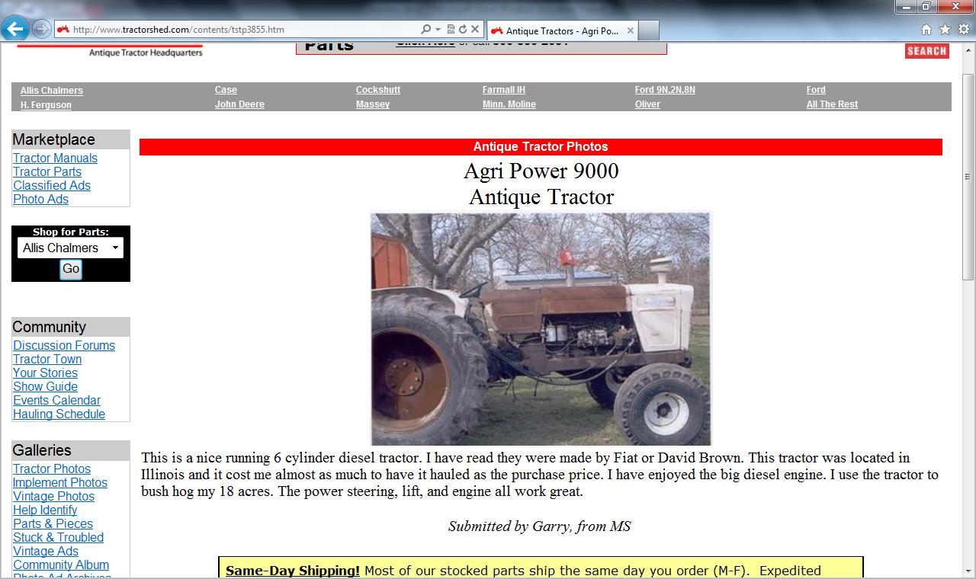

Ahlborn

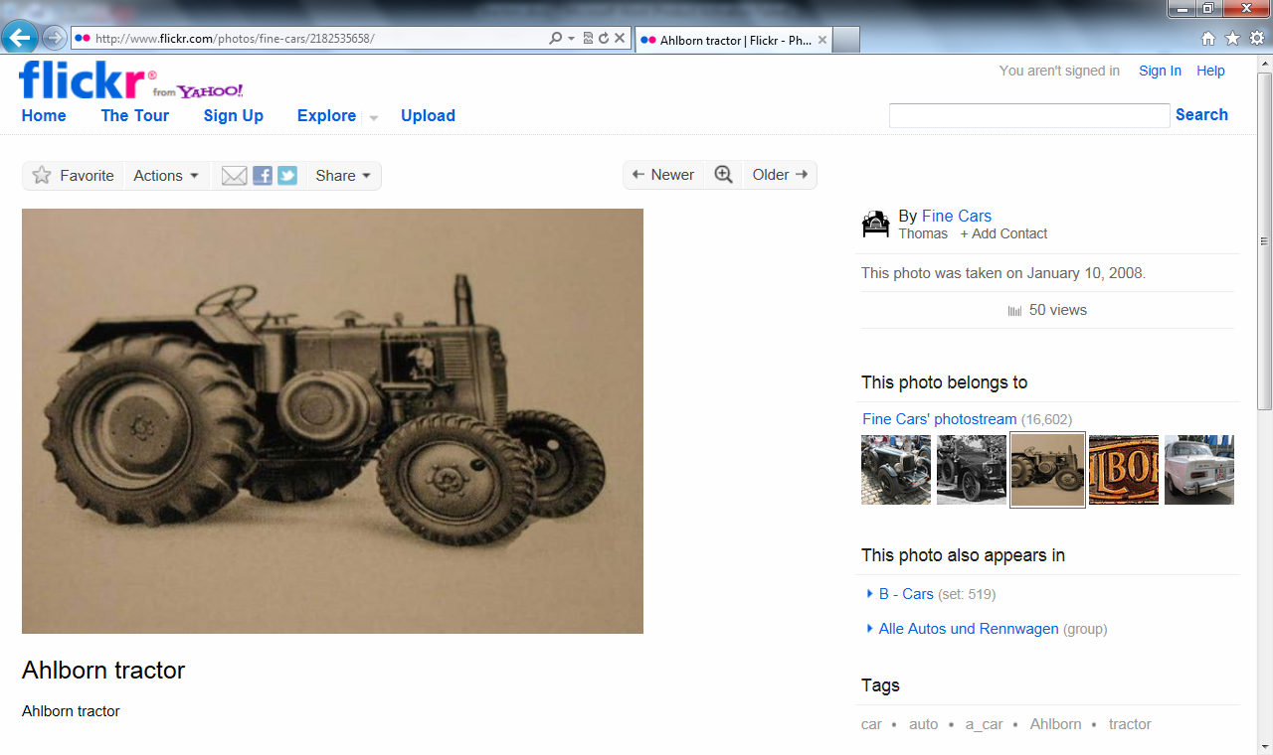

Ajax (USA)

Allaeys

Alliance

[Allis-Chalmers](http://en.wikipedia.org/wiki/Allis-Chalmers) (USA) - purchased by [AGCO Corporation](http://en.wikipedia.org/wiki/AGCO_Corporation)

[Allwork](http://en.wikipedia.org/wiki/Allwork_tractors) (USA)

Alu-Trac

Amepic

American (USA)

American ([American Tractor Corporation](http://en.wikipedia.org/wiki/American_Tractor_Corporation)) (USA) - purchased by [JI Case](http://en.wikipedia.org/wiki/JI_Case)

American Harvestor (USA)

American Steel (USA)

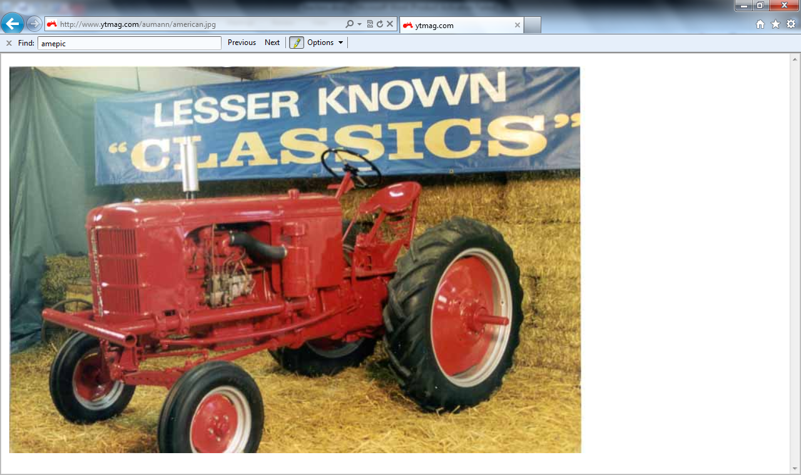

American Tractor (USA)

Andrews (USA)

1919-1921

Andrews-Kinkade (USA)

**The Angleworm tractor**  
  
Perhaps one of the worst-named tractors ever was the Angleworm 10, made (and named badly, one might say) by Badley Tractor Co. of Portland, Ore., in 1936. It was a small tracked tractor weighing 2,600 pounds, and sitting only 37 inches high. It disappeared the same year it was introduced.

Antigo (USA)

Appleton (USA)

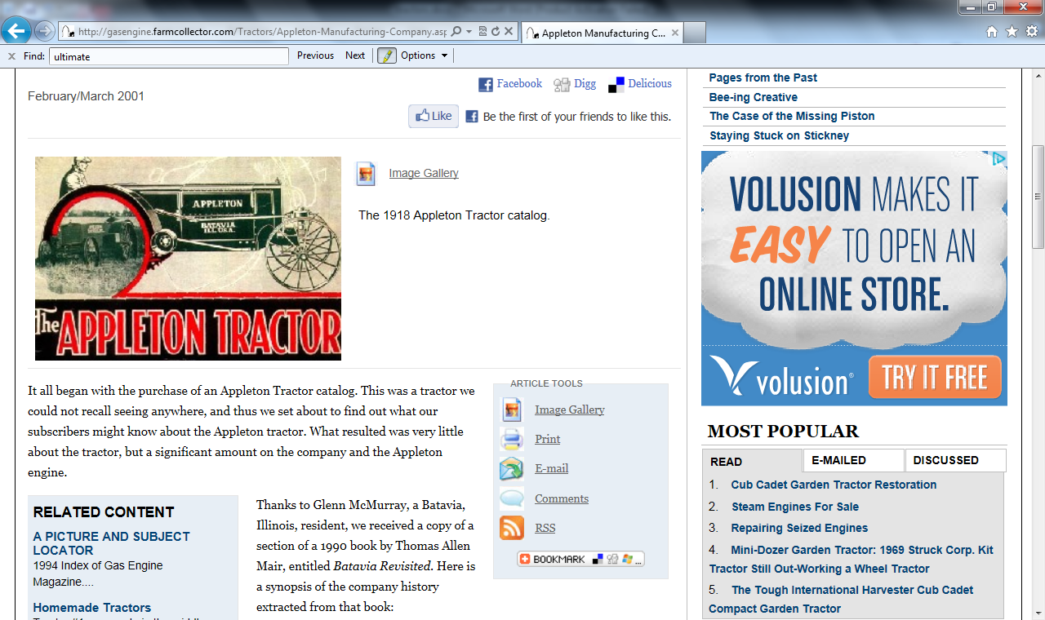

Arator

Armington, A.P. (USA)

Armstrong Sidley

Arnold-Sandberg (USA)

Assembled

Asso

Astoa (Spain)

Aston Martin (England)

Atlas (USA)

Aulendorf (Germany)

Aulson (USA)

Aultman (USA)

Aultman & Taylor (USA)

Austin (USA)

Austin (France/England)

Austin-Leyland BMC Sanayi (yTurkey)

Austrak (Australia)

Austro (Austria)

Austro-Pimus (Austria)

Auto Tractor (USA)

Automotive (USA)

AutoTrac (Canada)

Avance (Sweden) - Merged into Munktell

[Aveling - Marshall](http://en.wikipedia.org/wiki/British_Leyland) (England)

[Aveling & Porter](http://en.wikipedia.org/wiki/Aveling_%26_Porter) (England)

[Aveling-Barford](http://en.wikipedia.org/wiki/Aveling-Barford) (England)

Avery (USA) - purchased by [Minneapolis-Moline](http://en.wikipedia.org/wiki/Minneapolis-Moline)

Avia (Spain)

**B**

B.F. Avery (USA)

Babiole (France)

Backus (USA)

Badley (USA)

Bailor (USA)

Baird (USA)

Bajaj Tempo (India) - spun off and renamed [Force Motors](http://en.wikipedia.org/wiki/Force_Motors)

Baker, A.D. (USA)

Baldwin (Australia)

Balilla (Italy)

Balmar

Bambi

Bambia

Bantam (USA)

Banting Machine Co.

[Barford & Perkins](http://en.wikipedia.org/wiki/Barford_%26_Perkins) (England)

Bariole (France?)

[Barreiros](http://en.wikipedia.org/wiki/Barreiros_(manufacturer)) (Spain)

Bates (USA)

Bates Steel Mule (USA)

Bautz (Germany)

Bear (USA)

Bearcat (USA)

Beaver (USA)

Beeman (USA)

Belazerus (Belarus)

Bell, Robert (USA)

Beltrail (USA)

Ben (Italy)

Benz-Sendling (Germany)

Berliot (France)

Besser (USA)

[Best](http://en.wikipedia.org/wiki/Daniel_Best) (USA) - purchased by Holt > became [Caterpillar Inc.](http://en.wikipedia.org/wiki/Caterpillar_Inc.)

Bethlehem (USA)

Bi.Som.Trac (France)

[Big Bud](http://en.wikipedia.org/wiki/Big_Bud_747) (USA)

Big Bull (USA)

Big Four (USA)

Big Lizzie (Australia)

Bima (France)

Birrell (USA)

Bischoff

Bison (France)

BJR (Spain)

[Blackstone & Co](http://en.wikipedia.org/wiki/Blackstone_%26_Co) (England)

Blanc-Plaiche (France?)

[Blaw-Knox](http://en.wikipedia.org/wiki/Blaw-Knox) (England)

The Blewett Tractor Co. of Tacoma, Wash., from 1920-1923 made the Webfoot tractor. The Webfoot was a half-track type of tractor This tractor sold for $5,000.

Blumberg (USA)

BM Volvo (Sweden) - has evolved into the current [Valtra](http://en.wikipedia.org/wiki/Valtra), part of [AGCO Corporation](http://en.wikipedia.org/wiki/AGCO_Corporation)

BMB (England) (British Motor Boats)

[BMC](http://en.wikipedia.org/wiki/British_Motor_Corporation) (England) - From Merger of Austin & Nuffield, later became Leyland then finally Marshall (tractors)

Boenker (USA)

[Bofors](http://en.wikipedia.org/wiki/Bofors) (Sweden)

Bohrer

Bolgar (Bulgaria)

Bolinder (Sweden)- merged with Munktell to become Bolinder-Munktell

[Bolinder-Munktell](http://en.wikipedia.org/wiki/Bolinder-Munktell) (Sweden) - merged with Volvo to become BM Volvo/Volvo BM

Bolte (USA)

Boring (USA)

Borsig (Germany)

BOS Hydro-Trac (The Netherlands)

Boyett (USA)

Bradley (USA)

Braud (France)

Braun

Bray (England)

Bready (USA)

Breda (Italy)

Breed (USA)

Bristol (England)

British-Canadian (USA)

Brockenhexe (Germany)

Brockway (USA)

Brons (The Netherlands)

Brown (USA)

Brummer

Bryan (USA)

BTG (East Germany)

BTW

Bubba (Italy)

Bücher (Switzerland)

Buckeye (USA)

Buffalo

[Buffalo-Pitts](http://en.wikipedia.org/w/index.php?title=Buffalo-Pitts_Steam_Roller_Co.&action=edit&redlink=1) (USA)

Bührer (Switzerland)

BUKH (Denmark)

Bull

Then there was the Bull Tractor Co., whose meteoric rise and fall from first to forlorn was among the fastest in tractor history. Within a year of the Little Bull tractor’s introduction in late 1913, the company led the market in tractors sold.  
  
Then there was the Bull Tractor Co., whose meteoric rise and fall from first to forlorn was among the fastest in tractor history. Within a year of the Little Bull tractor’s introduction in late 1913, the company led the market in tractors sold.

Bull Dog (USA)

Bulldawg

Bull-Madison (USA)

Bullock (USA)

Though the name “Creeping Grip” sounds more like a disease than a tractor, at least three companies manufactured a caterpillar-type tractor by that name. The first one was made by the Western Implement & Motor Co. of Davenport, Iowa, in 1912, and was actually called the “Creeping Tiger,” which was quickly changed to “Creeping Grip.”

When the Bullock Tractor Co. of Chicago took over Western Implement, they kept the Creeping Grip tractor, but added the “Baby Creeper” to their line.

The Franklin Tractor Co. of Greenville, Ohio, also made a Creeping Grip tractor in 1921. Shortly thereafter, Bullock and Franklin combined. The new company did not last much longer.

Bulltra

Bungartz (Germany)

Bungartz & Peschke (Germany)

Bunton

Burn-Oil (USA)

The Burn-Oil tractor was manufactured in 1920 and perhaps 1921 by the Burn-Oil Tractor Co. of Peoria, Ill. Today the name is a distinct turn-off, with its smell reminder.  
  
In 1920 this machine carried a 15-30 rating, weighing 5,500 pounds, and listing at $1,650. “Apparently,” writes C. H. Wendel in *Encyclopedia of American Farm Tractors*, “this tractor attempted to use some of the better features of the Hart-Parr, Waterloo Boy, and Huber tractors, since there are so many similarities.”  
  
The tractor obviously burned oil as its fuel, but *Farm Implements* magazine wrote that it wasn’t such a good deal: “The number of oil-burning engines is increasing rapidly, as a result of the coal shortage and the special advantages of that type. A number of fires have resulted from the overheating of the exhaust pipes of these internal combustion engines, and a series of tests have been made to determine the hazard.”

BWS

**C**

C. & G. Cooper (USA)

C.L. Best (USA)

C.O.D. (USA)

The C.O.D. Tractor Co. of Minneapolis built a tractor from 1916-1919 called the C.O.D. It’s unclear how the name for this tractor was formed, or what it meant, but it probably was short for the last names of three of the major stockholders of the company: Conrad, Ogard and Daniel.

At least two models with several more variations were made of the C.O.D., the original 13-25 and the later 10-20. Several hundred of the tractors were made, but only five exist today. One of the dangers of these many companies before 1920 was how quickly they could go out of business; one North Dakota family invested heavily in the C.O.D. and, when the company went out of business, nearly lost their farm.

Caldwell (Australia) became [Caldwell Vale](http://en.wikipedia.org/wiki/Caldwell_Vale)

[Caldwell Vale](http://en.wikipedia.org/wiki/Caldwell_Vale) (Australia)

Calsa (Spain)

Cameron (USA)

Camisa

Campagnolo

Canadian (Canada)

Canadian-American

CanTRAN

Canycom

Carter

[Case Corporation](http://en.wikipedia.org/wiki/Case_Corporation)(USA) - purchased by Tenneco, and later merged with International Harvester to become [Case IH](http://en.wikipedia.org/wiki/Case_IH)

Case New Holland (India)

Case, J.I (USA) - was purchased by [Massey-Harris](http://en.wikipedia.org/wiki/Massey-Harris)

Cassani (Italy)

CAST (Italy)

Cayuga (USA)

CBT - Companhia Brasileira de Tratores (Brazil)

CDHL (USA)

Centaur (USA)

Centenario

Century (USA)

Ceres (France)

Certified (USA)

Challenger Tractor Co.

the Challenge Tractor Co. of Minneapolis, but never manufactured a single machine. Challenge Tractor applied for a trademark on Dec. 26, 1916, but that was the beginning and evidently the end of the road, according to records.

[Chamberlain (Australia)](http://en.wikipedia.org/wiki/Chamberlain_John_Deere) - purchased by [Deere & Company](http://en.wikipedia.org/wiki/Deere_%26_Company)

Champ (Thailand)

Champion (USA)

Champion (France)

Chaseside (England)

Cherry (Japan)

CIMAC (Italy)

Citroen (France)

Claeys (Belgium)

Clarktor

Clayson (England)

[Clayton & Shuttleworth](http://en.wikipedia.org/wiki/Clayton_%26_Shuttleworth) (England)

Cleveland Tractor Company/Cletrac (USA) - purchased by the [Oliver Corporation](http://en.wikipedia.org/wiki/Oliver_Corporation) in 1944

CMC (France)

Cobey (USA)

[Cockshutt Plow Company](http://en.wikipedia.org/wiki/Cockshutt_Plow_Company) (Canada) - purchased by [White Farm Equipment](http://en.wikipedia.org/wiki/White_Farm_Equipment)

Cockshutt Hart-Parr (Canada)

Codem (The Netherlands)

Coleman (USA)

Colpron (Canada) - rebadged Landini's

Colt (USA)

Common Sense (USA)

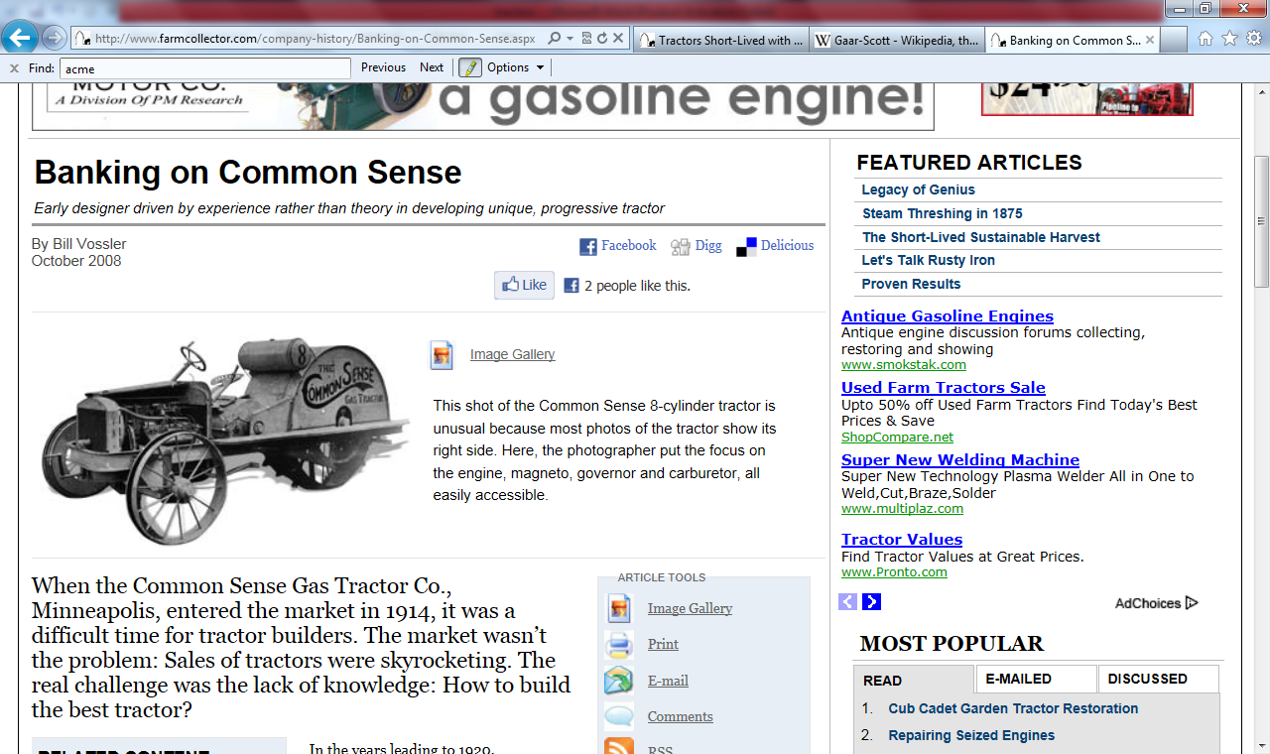

When the Common Sense Gas Tractor Co., Minneapolis, entered the market in 1914, it was a difficult time for tractor builders. The market wasn’t the problem: Sales of tractors were skyrocketing. The real challenge was the lack of knowledge: How to build the best tractor?  
  
In the years leading to 1920, manufacturers were experimenting with tractor design. In 1915, a writer in Modern Gas Tractor reported, “Considerable interest is being displayed in the three-wheel constructions. In fact, most of the light tractors offered this year have a single traction member and two steering wheels,” exactly the construction of the Common Sense.

The other stumbling block was the farmer, who had grown wary of too-good-to-be-true claims made by tractor manufacturers. Though it seems quaint today, prior to 1920 tractors were often built and sold without benefit of field-testing. The fastest-selling tractor of the time, for example, was the Little Bull. But when used in the field, the tractor was destroyed by dust grinding its open gears. Ford Tractor Co., Minneapolis, operated in a less than ethical manner (see Farm Collector, July 2008), and numerous other companies made exaggerated claims. Farmers were understandably nervous.

#### An educated design

H.W. Adams, tractor builder for Adams-Farnham Co., Minneapolis, from 1909-10, and Minneapolis Steel & Machinery Co., from about 1911-13, took notice of those problems. From a Dec. 31, 1917, article in Farm Implements: “I knew that too many tractors were the result of theoretical experts who worked on drawing boards, instead of the results given by tractors under actual working conditions in the hands of farmers,” Adams said. “I saw where such tractors could not help but fall down, so I decided to start from the other end. I learned first the practical features necessary, and then worked out the proper mechanical methods of obtaining those results.”

Experienced with steam threshing machines, stationary gas engines and other power machinery, Adams assisted in designing and building a new tractor for Minneapolis Steel & Machinery in 1913. When the experimental tractor was shipped to North Dakota, he went along. “He watched the tractor buck up against actual working conditions,” noted a writer in Farm Implements. “And not just for a couple of passes up and down the field. Adams stayed there for two years, working out improvements in design while eliminating the weaknesses of the tractor, until he knew everything he could know. When he returned to the factory, he surprised the officials there with his knowledge and concepts that they hadn’t heard anything about.”

#### With that experience under his belt, Adams began to think about starting his own company, one that would design and build tractors. An implement dealer helped him make the decision. The dealer led him around the corner of the building where no one would overhear the conversation and said, according to the article in Farm Implements, “Adams, why in the world don’t you build a tractor with cut steel gears and enclosed transmission … ” – the exact machine Adams had had in mind for years. In fact, he had a very clear vision of the tractor’s design: —No excess weight to waste power; —An absolute center draft for the number of plows pulled, to ensure even plowing and decrease strain on the tractor frame; —A drive wheel far enough from the furrow to get solid footing and prevent slippage; —All lubricated parts enclosed and running in oil, not sand; —Perfect accessibility of all working parts. He knew from experience if something went wrong and the farmer could easily get at the source of the problem to fix it, he would. If the offending part was hard to reach, however, it was less likely to be repaired; —An engine of sufficient power and flexibility to handle all belt work; —A careful selection of the very best material and equipment for every purpose, regardless of cost. Talking common sense

Adams formed his new company in 1914 without a name. Farm Implements reported Adams saying, “One day I was explaining my ideas to a farmer, and he said, ‘Well, now you’re talking common sense; a tractor like that ought to run.’ So I decided to call my tractor the Common Sense, and the name stuck.”

In late 1914, along with five North Dakota men, Adams organized the Common Sense Gas Tractor Co. in Minneapolis. The first tractor was a 15-25 Common Sense. According to P.S. Rose’s 1915 pamphlet, Report on Tractor Companies, the first Common Sense was sold in March 1915 and at least six more were produced that year.

An early advertisement in Gas Review magazine shows the Common Sense tractor at work in a field, with a boxy front end and hood very different from later versions. This 4-cylinder machine had a bore and stroke of 4-by-4-1/2 inches, ran in the furrow at 2.5 mph and could pull four 14-inch plows. It cost $1,250. It was 156 inches long, 78 inches wide and 66 inches high, with a 62-inch-tall rear drive wheel that had a 24-inch face. The tractor weighed 5,900 pounds.

The boxy Common Sense was probably an early experimental model, as all subsequent photos and drawings show a rounded, streamlined tractor built very much on the lines of automobiles of the day. Farm Implements said the company took advantage of mechanical designs already proven in automobile manufacture.

#### From a September 1915 article in Gas Review: “This tractor is not of the baby variety, neither is it big and clumsy. It appears to be excellently constructed throughout, and, being rather narrow, the load can be hitched in direct line with the center of gravity of the machine, thus eliminating side draft.” Making history: The first V-8 tractor

Perhaps in 1916, certainly by 1917, Adams produced his second model, a 20-40 with a 3-1/4-by-5-inch bore and stroke with two speeds forward and one reverse, capable of road speeds of up to 3.5 mph. The engine (a Herschell-Spillman 8-cylinder) could be revved up to produce 70 hp at the belt in emergencies. Painted red with a yellow hood, the tractor sold for $2,200 in 1919.

This Common Sense was the first tractor built with a V-8 engine. “The new tractor is no different from the others Common Sense Gas Tractor Co. has been putting out except for the larger motor,” reported an August 1916 article in Gas Engine. The tractor’s steady pull “means that it can go to places where they never would’ve attempted with the older machines and does the work with greater ease,” as well as more speed on the road.

“The 8-cylinder motor gives an absolutely steady pull to meet the steady load,” Common Sense promotional materials claimed. The company maintained the tractor could plow 20 to 25 acres a day using a half a gallon of gas and 3 quarts of oil per day. “Figure the low cost per acre for yourself,” the materials boasted. A later ad toned that down to 15 to 20 acres per day for the 6,000-pound machine. The company even offered a booklet explaining, “in plain English,” why the 8-cylinder engine was the best. The company acknowledged that the initial investment was steep but insisted farmers would see a return on their investment “through years of faithful service.”

Information on the 20-40 model is inconsistent: In one instance the tractor is identified as a 20-35; on another, it is identified as a 20-50. That confusion apparently existed before the engines had been tested, or else resulted from human error, as the latest information on Common Sense tractors mentions only the 15-25 and 20-40. One reference says the 20-40 had the same specifications as the 15-25, except for the larger engine and more power, while another said its size was bigger, 180 inches long, 72 inches wide and 66 inches high, which is probably accurate because of the larger engine.

#### No detail too small

Other advantages of the Common Sense tractors included a 10-inch running board, which prevented anyone from being thrown under the rear drive wheel. From company promotional materials: “You are at liberty to stand on this running board or go to the back of the tractor and watch the plows, or jump off and ride them if you desire.” The tractor was also said to have “perfect common sense steering” keeping the wheels in any furrow 2-1/2 inches deep, could be operated by men, girls or boys without danger, and featured an engine that could not be injured by operating it at high speed. Even the location of the operator’s seat merited extensive consideration. First, the designer noted, it must be the most convenient position for operation of the tractor, and second, it must be close to the engine, enabling detection of the slightest trouble by sound, “as trouble will first show in the sound of a motor.”

How many of each model were built? It’s difficult to discern, but the short answer is “not many.” In another P.S. Rose pamphlet, Manufactured and Estimated, 1916-1919, he said Common Sense Gas Tractor Co. built 15 tractors in 1916, 17 the next year, 18 the first half of 1918 (with an estimate of 40 for the second half), and a rosy prediction of 300 for 1919. There was no production breakdown by model.

Despite all the common sense injected into the company, something went awry. The Agricultural Depression of the early 1920s was still a year or two away, but more likely the tractor couldn’t get a foothold in a market glutted with output from some 200 tractor companies. In 1919, Farm Power Sales Co., Minneapolis, took over the company and sold Common Sense tractors, but probably didn’t manufacture them. By 1920, the first V-8 tractor produced began its slide into obscurity.

The Common Sense tractor was designed by H.W. Adams, who said in *Farm Implements*, Dec. 31, 1917: “I knew that too many tractors were the result of theoretical experts who worked on drawing boards, instead of the results given by tractors under actual working conditions in the hands of farmers. I saw where such tractors could not help but fall down, so I decided to start from the other end. I learned first the practical features necessary, and then worked out the proper mechanical methods of obtaining those results. One day I was explaining my ideas to a farmer, and he said, ‘Well, now you’re talking common sense. A tractor like that ought to run.’ So I decided to call my tractor the Common Sense. ...”

So Adams went out into North Dakota fields for two years, driving his tractor, watching others drive it, testing it, talking with farmers, before he brought the Common Sense tractor to market in 1915. The company lasted until 1922.

# Common Sense Tractor Model 20-50

The Common Sense Tractor came to market in 1914 and is another example of how tractor designers of that day were searching for the right profile and configuration best suited for the tractor.

Remember, no one knew what that secret for dependability and power was, so all types were being marketed.

The Common Sense was manufactured in Minneapolis, Minn. Its designer was H. W. Adams, who had earlier designed the Adams-Farnham tractor. It looked more like a steam engine with three wheels, two large, driving wheels and a single front wheel. The Adams -Farnham was a big tractor, weighing about five and one-half tons. It could pull a six-bottom plow.

The life of this company was only three years - 1909 to 1911.

The Common Sense Tractor attracted much attention because of its unusual design and features. It was the first V-8 powered tractor.

The eight-cylinder engine of the Model 20-50 was manufactured by Herschell-Spillman. The engine operated at 1200 RPM with a bore and stroke of 3 3/4 by 5 inches.

COMPACT Junior (Austria)

Conord

Consolidated (USA)

Continental (USA)

Co-op (USA)

Co-op (National Farm Machinery) (USA)

Co-op Implements (Canada)

Cooper

Corbitt (USA)

Corliss (USA)

Corn Belt Tractor Co.

Corn Belt Tractor Co., which made at least one tractor, also disappeared shortly after its inception.

Crown Iron Works

Crown Iron Works is listed as a tractor manufacturer in 1921 records, but it never made a tractor.

CTM

Cultivac

Cultor (USA)

Custom (USA)

Cutherbertson - James A. Cuthbertson (Scotland)

**D**

Dakota

Two more of La Fond’s tractor companies also never flew straight, the Dakota King Tractor Co. and the Hi-D Tractor Co. Besides those tractors, La Fond also designed the Pan tractor. La Fond was generously described in Pan Motor Co. literature as “one of the greatest Tractor Engineering Experts in America ... chief designing engineer of the Pan Tank-Tread Tractor ... a man of wide experience in the farm tractor business ...” and formerly “chief designing engineer” of the Dakota King Tractor Co., the Diamond Tractor Co. and the Hi-D Tractor Co. In fact, La Fond was a self-promoting huckster without the slightest record of success. His Pan, Dakota King and Hi-D tractors were all busts, and the Diamond Tractor Co. consisted only of a sign in a Minneapolis office building’s window in 1915.

Dammann (USA)

[Davey Paxman & Co.](http://en.wikipedia.org/wiki/Davey_Paxman_%26_Co.) (England)

David Bradley (USA)

[David Brown Ltd.](http://en.wikipedia.org/wiki/David_Brown_Ltd.) (England) - purchased by Tenneco and renamed Case

DECA (Argentina)

Deering (USA) - merged with other manufacturers to form [International Harvester](http://en.wikipedia.org/wiki/International_Harvester)

Defaut (France)

Detroit (USA)

Deuliwag (Germany)

Deutz (Germany) - merged with Fahr

[Deutz-Allis](http://en.wikipedia.org/wiki/Deutz-Allis) (USA) - formed when Deutz-Fahr bought Allis-Chalmers. Purchased by [AGCO](http://en.wikipedia.org/wiki/AGCO_Corporation) and became AGCO-Allis.

Diamond

Other less-than-stellar companies included the Diamond Tractor Co., which was exposed in a Jan. 7, 1919, Better Business Bureau investigation:  
  
*The Diamond Tractor Company was (L.A.) La Fond. He was all of it. He admits it. He had a free hand, and could as easily have assumed the title of office boy (had there been an office) or president as that of chief designing engineer. La Fond, on his own statement, never designed a single tractor, which has been successfully marketed. As a “tractor designing engineer,” his own creations – three tractors ... failed in inception. ...*

DF (China)

Diesel Ox (USA)

Dragon (USA)

Drexler (Austria)

Another tractor with an odd name was the Klumb, which was a dumb idea. At least, the name was – as anyone who remembers playground politics would know – simply because it could be made fun of so easily. **Dubuque Tracto**r & Truck Mfg. Co. of Dubuque, Iowa, made the Klumb Model F in 1920. The tractor had originally been designed by Paul Klumb of Sheboygan, Wis.

That same year the name was changed to “Klum” and the company to Liberty Tractor Co. of Dubuque. But it still didn’t make any difference; the tractor and company disappeared in 1920.

Dufuat

DUTRA (Hungary)

DUTRA Steyr (Hungary)

**E**

[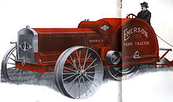](http://en.wikipedia.org/wiki/File:1916_Emerson_Tractor_(1).jpg)

[http://bits.wikimedia.org/skins-1.18/common/images/magnify-clip.png](http://en.wikipedia.org/wiki/File:1916_Emerson_Tractor_(1).jpg)

1916 Emerson Tractor, made by Emerson-Brantingham (USA)

[Eagle](http://en.wikipedia.org/wiki/Eagle_Manufacturing_Company) (USA)

[Ebro](http://en.wikipedia.org/wiki/Ebro_trucks) (Spain)

[Ebro-Kubota](http://en.wikipedia.org/wiki/Ebro_trucks) (Spain)

Eclipse (USA)

Edwin Alber

[Eicher Goodearth](http://en.wikipedia.org/wiki/Eicher_Motors) (India) - became just Eicher

EMCO (USA) - later Power Horse

Emerson (Canada)

Emerson-Brantingham (USA)

Empire (USA)

Enterprise

Enterprise Machine Co. listed both a Westman Model 40-45 and Model 20-22 tractor, though neither illustrations nor tractors have ever been uncovered to verify the firm built a tractor.

Erickson (USA)

**F**

Fageol (USA)

Farm Ette (USA)

Farm System

[Farmall](http://en.wikipedia.org/wiki/Farmall_tractor) (USA) - by International Harvester

Farmár (Czech)

Farmaster (USA)

Farmcrest (USA)

Farmer's Union Co-op (USA)

the Farmers Union Central Exchange of St. Paul, Minn., due in no small part to its CO-OP tractor, which was produced in at least five different cities by five different companies. The tractor was popular, in part, because it was built in so many different places, but also because the cooperative movement was strong among farmers when the tractors were produced during the 1930s-1950s.

FarmHandy (USA)

Farmliner Daedong (Australia) - built in S.Korea

Farmobile (USA)

Farmwell (England)

Farquhar, A. B. (USA) - merged into the Oliver Corporation

The Silver King tractor, built by Fate-Root-Heath Co. of Plymouth, Ohio, has one of the most interesting of all tractor names. In 1909, the company built its first Plymouth truck, and a year later, the Plymouth automobile. Thus they had the trade-name rights to “Plymouth” long before Chrysler thought of the name. The little company had the advantage, of course, of being located in Plymouth.  
  
In 1933, F-R-H brought out its Plymouth tractor. The company built 232 of them before Chrysler sued, as it had built its first Plymouth car in 1928, and wanted the “Plymouth” name. Chrysler lost, and paid F-R-H $1 for the Plymouth name. *A Brief History* of F-R-H says that one day the F-R-H brain trust sat down around a table to decide on a new name for their tractor. “They thought they had the king of all tractors on the market. They didn’t want to give up the ‘king’ part. One of the gentlemen around the board table had brought a bouquet of silver foliage from a plant at his home to put on the boardroom table. Someone said, ‘Let’s call it Silver King.’ And that’s the way it came about.”

FBW (Switzerland)

[Ferguson](http://en.wikipedia.org/wiki/Harry_Ferguson) (Ireland)

Fendt (Germany)

[Ferguson-Brown](http://en.wikipedia.org/wiki/Ferguson_Company) (England)

Fiat OM

[Fiat Someca](http://en.wikipedia.org/wiki/Someca) (France)

[Fiat-Agrifull](http://en.wikipedia.org/wiki/Fiat_Trattori) (Italy)

[Fiat-Goldstar](http://en.wikipedia.org/w/index.php?title=Fiat-Goldstar&action=edit&redlink=1) (South Korea) - now LS-New Holland

[Field Marshall](http://en.wikipedia.org/wiki/Field_Marshall) (England) - became Marshall

Finn Ursus

[Foden](http://en.wikipedia.org/wiki/Foden_Trucks) (England)

[Ford](http://en.wikipedia.org/wiki/Ford) (USA) - purchased by Fiat, now New Holland

Ford

Minnesota’s vast number of tractor companies created a tooth-and-nail competition among firms, which produced some deceiving sales tactics. The most offensive firm may’ve been the Ford Tractor Co. of Minneapolis – which had no association with Ford Motor Co., except in name. It was so-named by the owners to sell tractors on the coattails of the well-known automaker.

In fact, Ford Tractor Co. went so far as to pluck a man off the street with the last name of Ford – Carl B. Ford, sometimes cited as Paul B. Ford – in order to legitimize the “Ford” name. In the process, the tractor company swindled hundreds of people who purchased “Ford” tractors for later delivery.

[Ford-Ferguson](http://en.wikipedia.org/wiki/Ford_N_Series_Tractors)

[Fordson tractor](http://en.wikipedia.org/wiki/Fordson_tractor) (USA) - by Ford

Fordzon-Putilovec (Russia)

[Fortschritt](http://en.wikipedia.org/wiki/Fortschritt) (East Germany)

Foton (China) - now Lovol

[Four Drive](http://en.wikipedia.org/wiki/Fitch_Four_Drive) (USA) - also known as [Fitch Four Drive](http://en.wikipedia.org/wiki/Fitch_Four_Drive)

Four Wheel Traction (England)

[Fowler](http://en.wikipedia.org/wiki/John_Fowler_%26_Co.) (England)

Though the name “Creeping Grip” sounds more like a disease than a tractor, at least three companies manufactured a caterpillar-type tractor by that name. The first one was made by the Western Implement & Motor Co. of Davenport, Iowa, in 1912, and was actually called the “Creeping Tiger,” which was quickly changed to “Creeping Grip.”

When the Bullock Tractor Co. of Chicago took over Western Implement, they kept the Creeping Grip tractor, but added the “Baby Creeper” to their line.

The Franklin Tractor Co. of Greenville, Ohio, also made a Creeping Grip tractor in 1921. Shortly thereafter, Bullock and Franklin combined. The new company did not last much longer.

Frick (USA)

Froehlich (USA) - purchased by [Deere & Company](http://en.wikipedia.org/wiki/Deere_%26_Company)

FWD Wagner (USA)

**G**

Galloway (USA)

Gambles Farmcrest (USA)

Garrett (USA)

[Gaar-Scott](http://en.wikipedia.org/wiki/Gaar-Scott) (USA)

**Gaar-Scott & Co.**, was an [American](http://en.wikipedia.org/wiki/United_States) [threshing machine](http://en.wikipedia.org/wiki/Threshing_machine) and [steam](http://en.wikipedia.org/wiki/Steam_engine) [traction engine](http://en.wikipedia.org/wiki/Traction_engine) builder based in [Richmond, Indiana](http://en.wikipedia.org/wiki/Richmond,_Indiana). The company built simple and compound engines in sizes from 10 to 40 [horsepower](http://en.wikipedia.org/wiki/Horsepower). [Farm machinery](http://en.wikipedia.org/wiki/Agricultural_machinery) produced by the firm were advertised as part of "the Tiger Line" and used a tiger upon two globes as the company logo. It merged with the M. Rumley Co. in 1912 during a purchasing frenzy that put the later firm into insolvancy. The company was reorganized as [Advance-Rumely](http://en.wikipedia.org/wiki/Advance-Rumely) Thresher Company Inc. It did build a few gas tractors as well. However, the name eventually died out.

The [Abram Gaar House and Farm](http://en.wikipedia.org/wiki/Abram_Gaar_House_and_Farm), is a favorite historic house in the state today. The Gaar-Scott office building, designed by noted architect [John A. Hasecoster](http://en.wikipedia.org/wiki/John_A._Hasecoster) still stands in Richmond and is the headquarters of Richmond Baking, a large commercial baker.

Advance-Rumely Thresher Company was later purchased by [Allis-Chalmers](http://en.wikipedia.org/wiki/Allis-Chalmers) Mfg. Co.

Gas Traction Company

One name of a tractor which wasn’t as odd as it was confusing: the Big Four tractor, manufactured by the Gas Traction Co. of Minneapolis, and later by Emerson-Brantingham Implement Co. of Rockford, Ill.

The name was unclear. Without knowing the history of the companies, a person might assume the “Big Four” meant the tractor had four wheels – which it did – during an era when many three-wheelers were being built. But not all four wheels were big.

It also wasn’t that it could pull four plows, at a time when three were standard (it was actually rated for five plows). Or that it was the fourth style of tractor built by Gas Traction Co. (which it was, but that wasn’t standard knowledge, and it wasn’t why it was so-named).

It was because it was the first four-cylinder tractor on the market at a time when most others had two cylinders. The Big Four was built by these two companies from about 1908-1920, when other designs became more favored.

GBT (USA)

GeDe (The Netherlands)

Geiser (USA)

General (USA)

General (England)

George (USA)

Gibbons & Robinson

Gibson (USA)

Gilson (Canada)

Glasgow (England)

Global (USA)

GMW (Sweden)

[GoldStar](http://en.wikipedia.org/wiki/GoldStar) (South Korea) - later [LG](http://en.wikipedia.org/wiki/LG_Tractors). Now [LS](http://en.wikipedia.org/wiki/LS_Tractors).

Graham-Bradley (USA)

[Gray Tractor Manufacturing Co.](http://en.wikipedia.org/w/index.php?title=Gray_Tractor_Manufacturing_Co.&action=edit&redlink=1) (USA)

Greaves (India) - later SAME Greaves

Greyhound (USA)

Griffin (USA)

Grissly

Guaranteed

Others that claimed active tractor production included the Guaranteed Tractor Co., M&M Tractor Co., and Midget Tractor Co. All these companies called Minneapolis home, along with a half-dozen other firms that failed.

Güldner (Germany) later part of Linde

Gulliver (Italy) - now SEP

**H**

[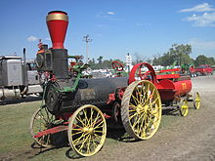](http://en.wikipedia.org/wiki/File:Harrison_Machine_Works_1882_tractor.JPG)

[http://bits.wikimedia.org/skins-1.18/common/images/magnify-clip.png](http://en.wikipedia.org/wiki/File:Harrison_Machine_Works_1882_tractor.JPG)

[Harrison Machine Works](http://en.wikipedia.org/w/index.php?title=Harrison_Machine_Works&action=edit&redlink=1) 1882 tractor.

Haas (USA)

Hahn-Eclipse (USA)

Happy Farmer (USA)

The logo for the Happy Farmer Tractor Co. of Minneapolis was one of the most unique of all, showing – what else? – a happy farmer in a close-up. The Happy Farmer was designed by D.M. Hartsough, who designed a number of other tractors, including the Big Four, Bull and Lion. The Happy Farmer was a three-wheeler tractor first produced in 1916, and then moved to La Crosse, Wis., shortly thereafter, as the La Crosse Tractor Co.

Two models of the Happy Farmer were made through 1918, a Model A (8-16 rating) and Model B (12-24 rating.) Photos and drawings of them show the tractors to be almost identical. A 1917 edition of *Farm Implements* magazine touts the Happy Farmer: “A year ago the company employed 50 persons; today they employ 500. ...”

B.F. Hamey, vice president and general manager of the La Crosse Tractor Co., said in the same article, “The rapid growth and large business is due principally to the tractor, followed closely by an efficient sales organization. The machine is in popular demand. The Happy Farmer tractor has passed the experimental stage and is delivering the goods. We expect to build and ship 3,000 or more tractors this year and our business would be three times as large were we able to build the tractors. These figures are for the United States alone. It is estimated that 2,000,000 farms in the United States are adapted for tractor farming. Thousands of horses are being destroyed as a result of the war and one tractor takes the place of five horses. We have sold tractors to many farmers whose farms do not exceed from 80 to 100 acres in size, and we have received letters from them declaring that the tractor was a profitable investment.”

In 1919 and 1920, the company added two more similar models, the Model F and Model G, both 12-24 models with slight differences from the earlier Model B. Curiously enough – and perhaps in keeping with the tractor name – the company tried to keep farmers happy by bringing back reined tractors in 1921 and 1922. The Model H and Model M tractors both were operated by the farmer standing on the implement behind the tractor, operating it with reins, just as they used to do with horses. The company disappeared in 1922, leaving these last models as two of the rarest of all tractors.  
  
The people who made the Happy Farmer also sold Waterloo Boy tractors, but stopped after developing the Happy Farmer, which resembles one of the 3-wheel Waterloo Boy models.

Harrison Machine Works ([Belleville, Illinois](http://en.wikipedia.org/wiki/Belleville,_Illinois), USA)

[Hart-Parr](http://en.wikipedia.org/wiki/Hart-Parr) (USA) - merged into the Oliver Farm Equipment Company in 1929 - purchased by [Oliver Corporation](http://en.wikipedia.org/wiki/Oliver_Corporation)

Hattat Agricultural Engines (<http://www.hattattarim.com.tr/en/home/>) - TURKEY

Heider (USA)

HELA (Germany)

HEMOS

Herriau

Hesston (USA) - tractors were part of [Fiat](http://en.wikipedia.org/wiki/Fiat). Hay equipment and name purchased by [AGCO](http://en.wikipedia.org/wiki/AGCO)

Hi-D

Two more of La Fond’s tractor companies also never flew straight, the Dakota King Tractor Co. and the Hi-D Tractor Co. Besides those tractors, La Fond also designed the Pan tractor. La Fond was generously described in Pan Motor Co. literature as “one of the greatest Tractor Engineering Experts in America ... chief designing engineer of the Pan Tank-Tread Tractor ... a man of wide experience in the farm tractor business ...” and formerly “chief designing engineer” of the Dakota King Tractor Co., the Diamond Tractor Co. and the Hi-D Tractor Co. In fact, La Fond was a self-promoting huckster without the slightest record of success. His Pan, Dakota King and Hi-D tractors were all busts, and the Diamond Tractor Co. consisted only of a sign in a Minneapolis office building’s window in 1915.

Highlander (England) - specialist [forestry](http://en.wikipedia.org/wiki/Forestry) conversions

Hindustan (India) - now MGTL *[Mahindra Gujarat](http://www.mahindragujarat.com)

Hinomoto (Japan) - acquired by Hitachi and renamed Tierra

Hofherr HSCS (Germany)

Hofherr-Schrantz (Hungary)

[Holder GmbH](http://en.wikipedia.org/w/index.php?title=Holder_GmbH&action=edit&redlink=1) (Germany)

[Holt Manufacturing Company](http://en.wikipedia.org/wiki/Holt_Manufacturing_Company) (USA) - merged with Best to form the [Caterpillar Tractor Company](http://en.wikipedia.org/wiki/Caterpillar_Inc.)

Homesteader (USA) - Clinton, AR - Garden Tractors

Homier Farm-Pro (USA)

[Richard Hornsby & Sons](http://en.wikipedia.org/wiki/Richard_Hornsby_%26_Sons)

Horwood Bagshaw (Australia)

[Howard](http://en.wikipedia.org/wiki/Rotary_tiller) (Australia) - Tractor, Rotavators & Rotary Tillers

Howard Farmers (England)

HSCS (Hungary)

Huber (USA)

Humber Anderson

Mayer Brothers’ Little Giant, and Humber-Anderson Mfg. Co.’s Little Oak tractor also stand out among the unusual names.

Hume (USA)

Hydratiller (USA)

**I**

ITM (Iran Tractor Manufacturing Company)[1](http://www.itm.co.ir/)

IFA (Germany)

Illinois (USA)

IMA (Argentina)[2](http://www.agroima.com.ar/)

Imperial (Australia)

Imperial Super Drive (Canada)

Intercontinental (USA)

International Harvester (Australia)

[International Harvester](http://en.wikipedia.org/wiki/International_Harvester) (USA) - Agriculture division sold to Tenneco and merged with Case to form [Case IH](http://en.wikipedia.org/wiki/Case_IH) in 1985.

Is Bora (Turkey)

Ishikawajima-Harima (Japan) - now Shibaura

ITC (USA)

[Ivel](http://en.wikipedia.org/wiki/Dan_Albone) (England) - invented by Dan Albone

**J**

J & H Howard

Jackson (USA)

Jeep (USA)

Jela

Jelbart (Australia)

Jiangling (China)

JMD (UK)

[John Deere Lanz](http://en.wikipedia.org/w/index.php?title=Heinrich_Lanz_AG&action=edit&redlink=1) (Germany) - Formerly Lanz AG

Jumbo (USA)

**K**

[Kaelble](http://en.wikipedia.org/wiki/Kaelble) (Germany)

The Kansas City Hay Press Co. of Kansas City, Mo. Built the Prairie Dog tractor in two models – L and D – from 1917 through 1920.

Kemna

KHD (Austria)

Kínai

Kinkead

Kinkead Tractor Co. – which started production in 1915, but quickly ended when R.S. Kinkead, the owner, was drafted during World War I

Kinnard-Haines

Kinnard-Haines Co. of Minneapolis manufactured the well-known and successful Flour City tractors in several sizes. The firm also turned out giants like the 21,000-pound Flour City Model 40-70 in 1910, down to the Flour City Junior and Junior Model 14-24, which weighed “only” 6,700 pounds.  
  
Kirschmann (USA)

Kitten (USA)

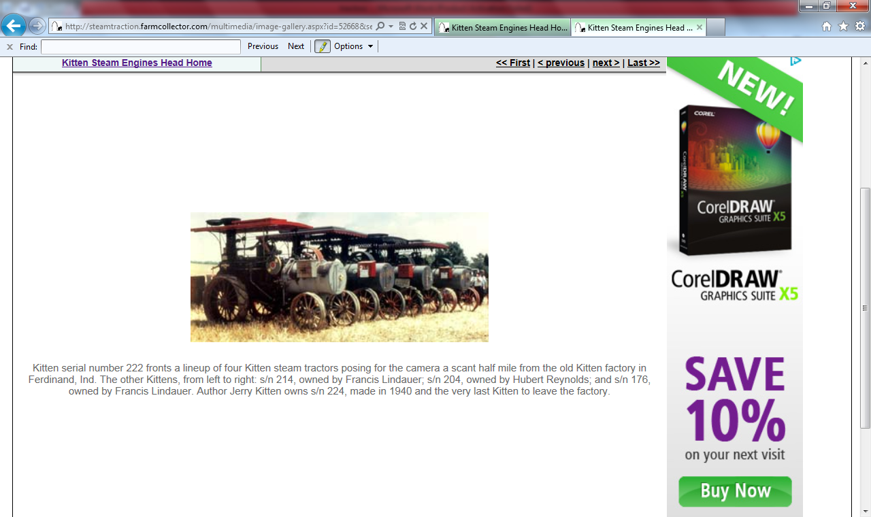

Kitten serial number 222 fronts a lineup of four Kitten steam tractors posing for the camera a scant half mile from the old Kitten factory in Ferdinand, Ind. The other Kittens, from left to right: s/n 214, owned by Francis Lindauer; s/n 204, owned by Hubert Reynolds; and s/n 176, owned by Francis Lindauer. Author Jerry Kitten owns s/n 224, made in 1940 and the very last Kitten to leave the factory.

Henry Kemp lives a little south of Ferdinand, Ind., near Troy. He has been running steam engines, saw mills and threshers all his life, and for the last 10 years he has operated Kitten steam engines at different shows in southern Indiana.

Henry's dad used to own a Kitten steam engine, so Henry started looking for a Kitten engine to buy. The only one he found was at the Reynolds-Alberta museum in Canada, so he bought Kitten engine s/n 222 and hauled it back home.

According to the Kitten book I have, this engine was made between 1935 and 1937.1 don't have much info on the owners, but a small note from Eiffel Plasterer shows that in 1966 he sold new fire grates to Lloyd Sanders of Kokomo, Ind., for Kitten s/n 222. Some time after that the Kitten wandered up to Canada, where it stayed until Henry brought it home – and it seems these lumbering giants are ever so slowly heading back to their homeland.

Just a few years ago there were no Kitten steam engines in Ferdinand, Ind., the town of their manufacture. But here we have a picture of four Kitten engines fired up in Ferdinand just about a half mile from the factory where they were manufactured. Today, there are seven Kitten steam engines, three Kitten saw mills, three Kitten water wagons and five Kitten separators close to home. And there are four more Kitten steam engines not far away. Of the 22 Kitten steam engines that are still around, half have found their way back to the Ferdinand area.

Henry now has a complete set of equipment from the Kitten factory. This includes Kitten s/n 222, a water wagon that Eiffel Platerer bought in the 1950s and a saw mill and a separator.

Kiva

Knudson (USA)

Kodiak (USA)

Koni

Kunow (USA)

**L**

L&T - John Deere (India) - joint venture, bought out by [Deere & Company](http://en.wikipedia.org/wiki/Deere_%26_Company)

The Lambert Gas Engine Co. of Anderson, Ind. made a tractor called the “Steel Hoof.” C.H. Wendel writes that the Steel Hoof’s “unique drive wheels were designed to contact the ground much like a horse’s hoof. As the wheel turned, the pads retracted, thus providing a self-cleaning wheel.” The Steel Hoof was made from 1912-1916.

LandTrac (USA) - by Long

[Lanz](http://en.wikipedia.org/w/index.php?title=Heinrich_Lanz_AG&action=edit&redlink=1) (Germany), - bought out in 1956 by John Deere & Company

The **Lanz Bulldog** was a [tractor](http://en.wikipedia.org/wiki/Tractor) manufactured by [Heinrich Lanz AG](http://en.wikipedia.org/w/index.php?title=Heinrich_Lanz_AG&action=edit&redlink=1) in [Mannheim](http://en.wikipedia.org/wiki/Mannheim), Baden-Württemberg, [Germany](http://en.wikipedia.org/wiki/Germany). Production started in 1921 and various versions of the Bulldog were produced up to 1960. [John Deere](http://en.wikipedia.org/wiki/John_Deere) purchased Lanz in 1956 and started using the name "John Deere-Lanz" for the Lanz product line. A few years after the Bulldog was discontinued the Lanz name fell into disuse. The Lanz Bulldog was one of the most popular German tractors, with over 220,000 of them produced in its long production life. The name "Bulldog" is widely used in Germany as a synonym for tractors even today, especially in [Bavaria](http://en.wikipedia.org/wiki/Bavaria).

Lauson (USA)

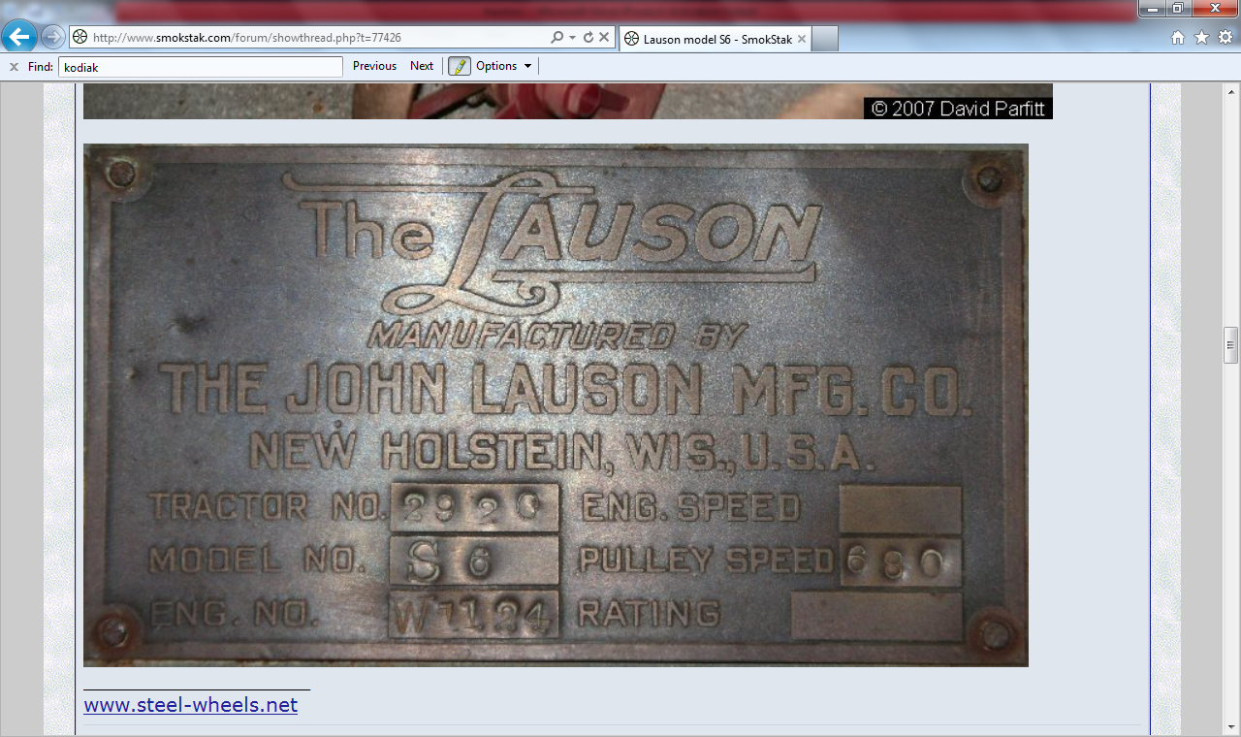

Lehr's Big Boy (USA)

Lely Multipower (USA)

Leo Rumely (USA)

LeRoi (USA)

LeTourneau (USA)

[Leyland](http://en.wikipedia.org/wiki/Leyland_tractors) (England) - later Marshall

LG Montana (USA) - now Montana

[LG-New Holland](http://en.wikipedia.org/wiki/LG-New_Holland) (South Korea) - now [LS-New Holland](http://en.wikipedia.org/wiki/LS-New_Holland)

Liberty (USA)

Lion

In 1915, the Lion Tractor Co. was prohibited by court order from producing Lion tractors (“strong as a lion, made of steel, sensation of the world, never tired, never hungry, never sick ...”) because, the complaint read, Lion misled buyers to believe they were buying a tractor made by P.J. Lyons of the Bull Tractor Co. A portion of the Lion’s design also was borrowed from the Little Bull Tractor Co.

The Lion Tractor Co. took payments from many farmers but never delivered tractors, and also claimed it manufactured hundreds of tractors, when in reality only three were produced. The company flouted the court ruling and continued to make Lion tractors even after an injunction.

Lightforce Deluxe

Lightforce Tractore

Linn maker of the [Linn tractor](http://en.wikipedia.org/wiki/Linn_tractor) - [Republic Motor Truck Company](http://en.wikipedia.org/wiki/Republic_Motor_Truck_Company) (USA)

Little Giant (USA)

Loko-Mobil

Long (USA)

LongAgri (USA)

Lyon

In 1915, the Lion Tractor Co. was prohibited by court order from producing Lion tractors (“strong as a lion, made of steel, sensation of the world, never tired, never hungry, never sick ...”) because, the complaint read, Lion misled buyers to believe they were buying a tractor made by P.J. Lyons of the Bull Tractor Co. A portion of the Lion’s design also was borrowed from the Little Bull Tractor Co.

The Lion Tractor Co. took payments from many farmers but never delivered tractors, and also claimed it manufactured hundreds of tractors, when in reality only three were produced. The company flouted the court ruling and continued to make Lion tractors even after an injunction.

**M**

M.R.S. (USA)

MacLaren

Madson (USA)

[Mann's Patent Steam Cart and Wagon Company](http://en.wikipedia.org/wiki/Mann%27s_Patent_Steam_Cart_and_Wagon_Company) (England)

Maverick (USA)

Mayer Brothers

Mayer Brothers’ Little Giant, and Humber-Anderson Mfg. Co.’s Little Oak tractor also stand out among the unusual names.

Maxitrac

McConnell (Canada) - sold to [AGCO](http://en.wikipedia.org/wiki/AGCO) Corporation, later AgcoStar

McCormick (USA) - merged with others to form [International Harvester](http://en.wikipedia.org/wiki/International_Harvester)

McCormick-Deering (USA) - by [International Harvester](http://en.wikipedia.org/wiki/International_Harvester)

McDonald (Australia)

McKee Ebro (Canada)

McLaren (England) see [J&H McLaren & Co.](http://en.wikipedia.org/wiki/J%26H_McLaren_%26_Co.)

McVicker Engineering Company

McVicker Engineering Co., whose owner, Walter J. McVicker, designed early Twin City tractors for Minneapolis Steel & Machinery Co.

MDW-[Fortschritt](http://en.wikipedia.org/wiki/Fortschritt) (East Germany)

Mecavia (France)

Medved (Russia)

MeMo (USA)

E. Meili Traktorenfabrik (Switzerland)

Mercer (USA)

Metis (Slovak)

Midget

Others that claimed active tractor production included the Guaranteed Tractor Co., M&M Tractor Co., and Midget Tractor Co. All these companies called Minneapolis home, along with a half-dozen other firms that failed.

Millennium (USA)

Minneapolis (USA) - merged with Moline to form [Minneapolis-Moline](http://en.wikipedia.org/wiki/Minneapolis-Moline)

[Minneapolis-Moline](http://en.wikipedia.org/wiki/Minneapolis-Moline) (USA) - purchased by [White Farm Equipment](http://en.wikipedia.org/wiki/White_Farm_Equipment)

Minnesota (USA)

Minnesota Tractor Co. that manufactured the Minnesota Model 18-36 in 1919,

Moffett (Ireland)

Mogul (USA)

Moline (USA) - merged with Minneapolis to form [Minneapolis-Moline](http://en.wikipedia.org/wiki/Minneapolis-Moline)

Monarch (USA) - purchased by [Allis-Chalmers](http://en.wikipedia.org/wiki/Allis-Chalmers)

Morris-Leyland (Turkey)

Motocultores Pasquali(Spain)

Motrac Werke AG. 1937-1969 (Switzerland)

Motransa (Spain)

Mountain State (USA)

MTW (Germany)

[Muir-Hill](http://en.wikipedia.org/wiki/Muir-Hill) (England)

Müller (Brazil)

Munktell (Sweden) - merged with Bolinder to form [Bolinder-Munktell](http://en.wikipedia.org/wiki/Bolinder-Munktell).

MVM (Russia)

[MWM (Motoren Werke Mannheim AG)](http://en.wikipedia.org/wiki/MWM_(Motoren_Werke_Mannheim_AG)) (Germany)

Myth-Holm (England) - formerly [Muir-Hill](http://en.wikipedia.org/wiki/Muir-Hill)

**N**

Nallahay

NanYue (China)

Naughton (Australia)

Nellie Belle (USA)

Nelson (USA)

[New Holland Agriculture](http://en.wikipedia.org/wiki/New_Holland_Agriculture)

New Holland Tractors (India)

Newman (England)

Nichols & Shepherd (USA) - merged to form [Oliver Farm Equipment Company](http://en.wikipedia.org/wiki/Oliver_Corporation) in [1929](http://en.wikipedia.org/wiki/1929)

Nilson Tractor Co.

Nordtrak (Germany)

Normag (Germany)

North Land (USA)

Northrop (England)

Northwest (USA)

[Nuffield](http://en.wikipedia.org/wiki/Nuffield_Universal) (England) - later [Leyland](http://en.wikipedia.org/wiki/Leyland_tractors) and then [Marshall Tractors](http://en.wikipedia.org/w/index.php?title=Marshall_Tractors&action=edit&redlink=1)

Nuffield Morris (Turkey)

**O**

[O&K](http://en.wikipedia.org/wiki/O%26K)/Orenstein and Koppel (Germany)

Oliver (Australia) OC-4, OC-12

[Oliver Farm Equipment Company](http://en.wikipedia.org/wiki/Oliver_Farm_Equipment_Company)

[Oliver Corporation](http://en.wikipedia.org/wiki/Oliver_Corporation) (USA) - purchased by [White Farm Equipment](http://en.wikipedia.org/wiki/White_Farm_Equipment)

Oliver Cletrac (USA)

Oliver Hart-Parr (USA)

OM (France)

One Man Motor Plow (Canada)

Orsi (Italy)

OTA (England)

Ottawa (USA)

OUTZ

**P**

P. J. Downes

PAL (USA)

Pan

Another company that bamboozled its customers was Pan Motor Co. of St. Cloud, whose Pan Tank-Tread tractor was hyped in magazines and at tractor shows. However, only one machine was ever produced, and the prototype didn’t have an engine mounted for months.

Panda

Panzer (USA)

Panoto (Turkey)

Paramount (USA)

Parca

Parrett (USA)

Pavesi (Italy)

Pavesi-Tolotti (Italy)

Peerless (USA)

Perl (Austria)

[Petropoulos](http://en.wikipedia.org/wiki/Petropoulos) (Greece)

PGS (Italy)

Phillips (Australia)

Phoenix (Australia)

Pioneer

Other well-known Minnesota tractor companies included the Pioneer Tractor Co. of Winona, Minn., that built the luxurious Pioneer Model 30-60 tractor. It came equipped with curtains in the cab, removable windows and 8-foot-high rear drive wheels.

Pioneer also produced the prototype Model 45-90 with 9-foot-high rear drive wheels. One farmer joked that when the Model 30-60 misfired, the owner saved a quart of gasoline. A Pioneer Model 30-60 in average condition is worth about $40,000, according to C.H. Wendel’s *Standard Catalog of Farm Tractors*.

Planet, Jr (USA)

Plymouth (USA) - became Silver King

PMA (Algeria) - now Cirta

Polytrac (Switzerland)

[Porsche](http://en.wikipedia.org/wiki/Porsche_Super) (Germany)

Port Huron (USA)

Power Track

Power-Horse (USA)

President (England) - Designed by BMB (British Motor Boats)

Price (USA)

Primul (USSR)

Primus (Germany)

PTZ (Kazhakistan)

Punjab (India)

**Q**

Quaker Mule (USA)

Quattrino

Quincy (USA)

**R**

RÁBA-Steiger (Hungary)

Rakovica (Yugoslavia)

[Ransomes, Sims & Jefferies](http://en.wikipedia.org/wiki/Ransomes,_Sims_%26_Jefferies) (England)

Rayes (USA)

Raygo Wagner (USA)

Red Star

Reeves (USA)

Rein Drive (Canada)

Remington (USA)

Renault agri (France) - purchased by [Claas](http://en.wikipedia.org/wiki/Claas) in 2003

Rhino International (USA)

Rice (USA)

Richard Continental (France)

Richter (Australia)

RIP (France)

Rite (USA)

Ritscher (Germany)

Roadless (England)

Robey (England) - Steam tractors

Rock Island (USA) - purchased Heider, was purchased by Case

Rockol (USA)

Rogers (USA)

Rohff (France)

Röhr (Germany)

Rollo (Denmark)

Rome (USA)

Ronaldson Tippett (Australia)

Roux

Royal (Germany)

Rumely (USA)

[Meinrad Rumely](http://en.wikipedia.org/w/index.php?title=Meinrad_Rumely&action=edit&redlink=1) emigrated from Germany in 1848, joining his brother [John](http://en.wikipedia.org/w/index.php?title=John_Rumely&action=edit&redlink=1) in the operation of a foundry in La Porte, Indiana. This basic operation gradually expanded by 1859 into the production of [corn shellers](http://en.wikipedia.org/w/index.php?title=Corn_sheller&action=edit&redlink=1) and complete [threshing machines](http://en.wikipedia.org/wiki/Threshing_machine) powered by [horses](http://en.wikipedia.org/wiki/Horse). Following success in this new field, Meinrad then bought out his brother's portion of the business and incorporated it as the M. Rumely Company by 1887. Starting in 1895, the line expanded to include steam-powered [traction engines](http://en.wikipedia.org/wiki/Traction_engine). Meinrad himself died in 1904, but his sons continued to manage the business. Rumely's most famous product, the [kerosene](http://en.wikipedia.org/wiki/Kerosene)-powered [Rumely Oil Pull](http://en.wikipedia.org/wiki/Rumely_Oil_Pull) traction engine, was first developed in 1909 and began selling to the public by 1910.[[1]](http://en.wikipedia.org/wiki/Advance_Thresher#cite_note-0)

Russell (USA)

**S**

S.W.Wood (USA)

[Samson](http://en.wikipedia.org/wiki/Samson_Tractor) (USA)

Sandusky (USA)

Schneider

Schramm (USA)

Scientific Farming Machinery Company (USA)

Shaw (USA)

Shire

Short Turn

Short Turn Short-Turn Tractor Co.’s Short Turn tractor – a drum-type machine touted for its sharp turns – sported an interesting name as well. The first Short Turns were produced in 1916, and a factory was built to manufacture them in Bemidji, Minn., in 1918. Two years later, the company and tractor disappeared, probably as a result of the Agricultural Depression of the early 1920s.

Silver King (USA)

Simpson Jumbo (USA)

SLC - John Deere (Brazil) - a joint venture, wholly purchased by [Deere & Company](http://en.wikipedia.org/wiki/Deere_%26_Company)

SM

Société Française de Vierzon (France) - purchased by Case

Speedy

Square Turn

The Square-Turn tractor was so-named because of, as Wendel writes, “a unique system of fibre-faced driving cones which enabled one drive wheel (at the rear) to travel forward and one to travel backward in making a sharp turn.”

Square-Turn Tractor Co. of Norfolk, Neb., made this three-wheeler, probably only in the early 1920s. The tractor weighed 7,400 pounds, and sold for $1,875 in 1920. “After a meteoric rise,” Wendel writes, “the Square Turn interests were sold at a sheriff’s sale in 1925.”

Squire (Australia)

[Steiger](http://en.wikipedia.org/wiki/Steiger_Tractor) (USA) - purchased by Case

Strife Tractor Co.

Strong

Superson

Sutcliff

**T**

TAS (USA)

Tasker

Taylor (USA)

Terra Power

Terratrac (USA) - crawler tractors built by American Tractor Company - purchased by J.I. Case

Thieman (USA)

Thomas-Bilt (USA)

Thorobred (USA)

Tiger (USA)

TigerTrac (USA)

Titan (USA)

Titan (Steiger) (USA)

Tom Moore (USA)

Tom Thumb

A number of Minnesota tractor companies gave their products unusual names or odd characteristics, such as the peculiar Tom Thumb Tractor Co.’s Tom Thumb tractor. It looked like a full-length tractor cut in half.

[Tractor Supply Co.](http://en.wikipedia.org/wiki/Tractor_Supply_Co.) (USA)

Tractormobile (USA)

Trojan (USA)

TSC Huskee (USA)

Turf Boss

Türk Traktör (Turkey) - now New Holland

TurkFiat (Turkey) - now New Holland

Turner (England)

[Twin City tractors](http://en.wikipedia.org/wiki/Twin_City_tractors) (USA) - merged to become Minneapolis-Moline

Twister (USA)

**U**

Uncle Sam (USA)

Unigraf

United (USA)

UniTrak (Germany)

Universal (USA) - built in Ohio

UPD

[Massey Ferguson](http://en.wikipedia.org/wiki/Massey_Ferguson) - (under license)

**V**

Vanguard (USA)

Vendeuvre (France) - purchased by [Allis-Chalmers](http://en.wikipedia.org/wiki/Allis-Chalmers)

[Versatile](http://en.wikipedia.org/wiki/Versatile) (Canada) - purchased by [Ford](http://en.wikipedia.org/wiki/Ford), now owned by Buhler

Victor Tractor

The oddest-looking tractor award might go to the Victor tractor, which looked like a washing-machine drum turned sideways. It was made by the Victor Tractor Co. and sold for $1,685. (This company shouldn’t be confused with the Victory Tractor Co., also of Minneapolis.)  
  
Victory Tractor

The oddest-looking tractor award might go to the Victor tractor, which looked like a washing-machine drum turned sideways. It was made by the Victor Tractor Co. and sold for $1,685. (This company shouldn’t be confused with the Victory Tractor Co., also of Minneapolis.)

Vierzon (France) - purchased by Case

Vittorio Cantatore (Italy)

Volvo (Sweden) - merged with Bolinder Munktells, now [Valtra](http://en.wikipedia.org/wiki/Valtra)

Volvo BM (Sweden) - now [Volvo Construction Equipment](http://en.wikipedia.org/wiki/Volvo_Construction_Equipment)

Volvo BM Valmet (Harvesters) (Sweden) - now [Valtra](http://en.wikipedia.org/wiki/Valtra)

Vevey tractors (Switzerland)

**W**

WACO (Austria)

Wagner (USA)

Wallis (USA) - purchased by Massey-Harris

Wallis & Stevens (USA)

[Wallis & Steevens](http://en.wikipedia.org/wiki/Wallis_%26_Steevens) {England) - Steam tractor (Note odd spelling of name)

Waltanna (Australia)

Walter Barrett (USA)

Wards (USA)

Warrior (Italy)

[Waterloo Boy](http://en.wikipedia.org/wiki/Waterloo_Gasoline_Engine_Company) (USA) - purchased by [Deere & Company](http://en.wikipedia.org/wiki/Deere_%26_Company)

Weber (USA)

Webfoot (USA)

Welte

Werner (Germany)

Western (USA)

Though the name “Creeping Grip” sounds more like a disease than a tractor, at least three companies manufactured a caterpillar-type tractor by that name. The first one was made by the Western Implement & Motor Co. of Davenport, Iowa, in 1912, and was actually called the “Creeping Tiger,” which was quickly changed to “Creeping Grip.”

When the Bullock Tractor Co. of Chicago took over Western Implement, they kept the Creeping Grip tractor, but added the “Baby Creeper” to their line.

The Franklin Tractor Co. of Greenville, Ohio, also made a Creeping Grip tractor in 1921. Shortly thereafter, Bullock and Franklin combined. The new company did not last much longer.

Wheel Ox (USA)

[White](http://en.wikipedia.org/wiki/White_Farm_Equipment) (USA) - purchased by [AGCO](http://en.wikipedia.org/wiki/AGCO) Corporation

White Oliver (USA)

Whiting-Bull (USA)

Wikov (USA)- (certain products now manufactured by [Wisconsin Engineering](http://en.wikipedia.org/w/index.php?title=Wisconsin_Engineering&action=edit&redlink=1) [4](http://www.WisconsinEng.cz))

WildCat (USA)

Williames (Australia)

nget (Australia)

Winget (UK) - More noted for site dumpers & plant (was part of [Babcock & Wilcox](http://en.wikipedia.org/wiki/Babcock_%26_Wilcox) for a time)

Wisconsin (USA)

Wood Brothers (USA)

Woods & Copeland (USA) - purchased by Rome

Woody

Worthington (USA)

**X**

**Y**

Yankee (USA)

**Z**

Zebra (USA)

<http://www.stackpolebooks.com/>

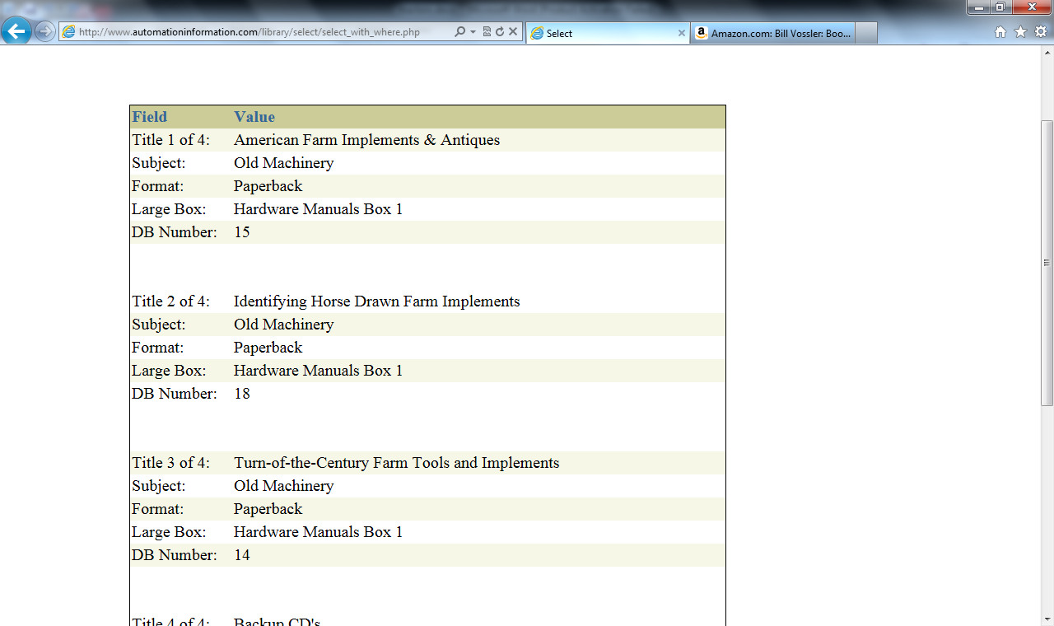

Record number 11 has title of Dictionary of American Hand Tools

<http://www.epa.gov/mold/mold_remediation.html>

<http://northdakota.hometownlocator.com/maps/countymap,cfips,039,c,griggs.cfm>

<http://www.genealogy-web-creations.com/>

<http://www.santacruzmah.org/>

<http://www.agclassroom.org/gan/timeline/farm_tech.htm>

<http://www.agclassroom.org/gan/index.htm>