This is my first blog.

I’m going to start it out by trying to describe the difficulties of making a blog site.

First of all, I admit I haven’t done the necessary research. I started looking into blog sites a few months ago, and they just seemed like a neat idea, but I don’t have a defined purpose for it.

My first step was to Google *Museum Blogs*. One result showed the a top 10 museum blog sites, another showed the top 25 and another showed the top 100. I saw Museum 2.0 listed on several lists and saw that the author was Nina Simon. Her writing and style seemed pretty good, so I decided that my first attempts would be to try to follow her pattern.

Here goes the technical stuff. Most of the future blogs will be much less technical.

The museum website is hosted at HostMonster. I can only say good things about them, and their technical support has always been very good. They use the cPanel interface.

At this point, I’ll mention that you should Google any terms you’re not familiar with. I’m not going to try to describe them here. If you can find a Google result on Wikipedia, they almost always have good explanations.

They have a section called SimpleScripts towards the bottom of cPanel and in the blogs section they had Wordpress, b2 evolution, Textpattern, NucleusCMS and Geeklog. I did a small amount of Googling on these and decided to try WordPress. It seemed to have a large user base and several support forums.

I clicked on WordPress and they had an Install button on the bottom of the screen. I clicked it and they had 4 items that I had to make decisions on:

1. The version 3.2.1 (stable) was the default choice. I could have chosen earlier versions, but decided to stick with the default.
2. The default url was www.griggscountyhistoricalsociety.com / yourblogname I chose museumblog for the name.
3. Step 3 was for plugins and themes. They said I could add these later, which sounded good to me. I didn’t select anything here.
4. A checkbox acknowledging that I had read the license agreement.

I hit the Complete button and they did the rest. They assigned me the username Admin and gave me a password that I could never remember. I decided to keep the secure password and added it to my list of passwords file.

I went to [www.griggscountyhistoricalsociety.com/museublog](http://www.griggscountyhistoricalsociety.com/museublog) and there it was.

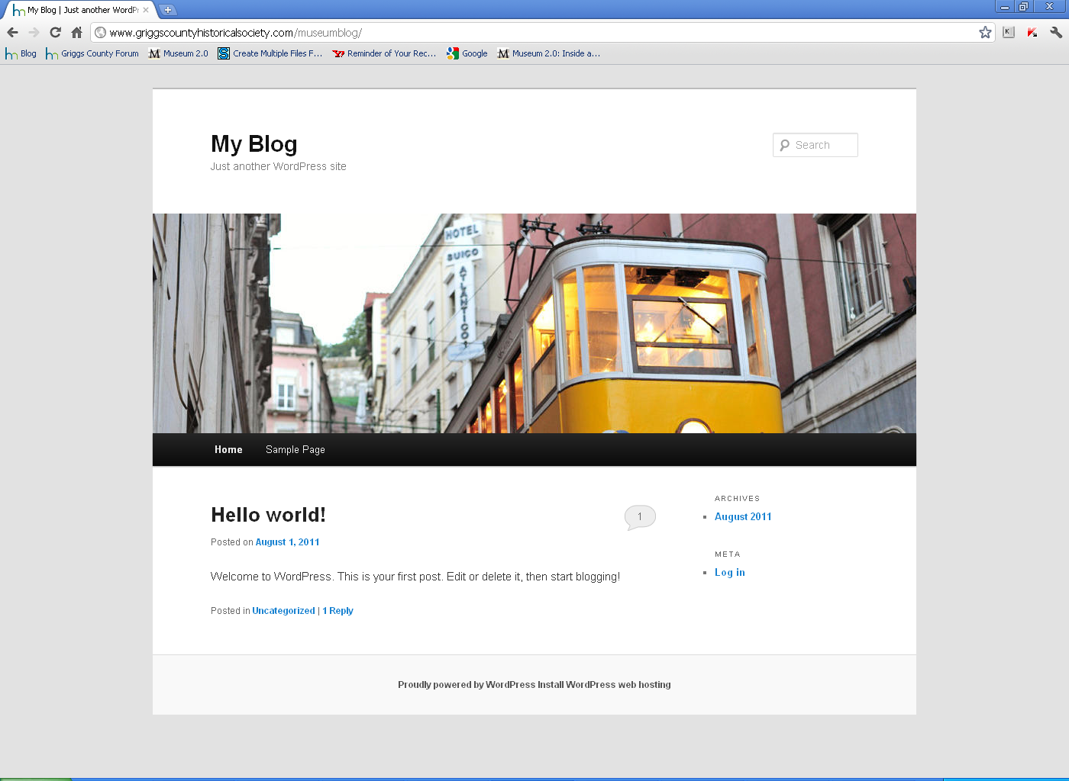

Picture of site after initial installation.