I’ve always been fascinated with cemeteries, graves and burial places and will try to write about some of them.

I found this information in some of the Myrtle Porterville boxes at the Institute for Regional Studies in Fargo.

She had a copy of an article that Dorcas Bolkan wrote in about 1928 from her an interview with her grandfather. He was C. P. Bolkan and she writes:

“As to battlegrounds the only one I know of was located on the Ben Johnson farm north of the Opheim schoolhouse, where our pioneer road meandered between the graves for some distance but the only information I have is what Omund Opheim had gotten from a half-breed by the name of Pete Grant, who with others were camping at Stump Lake in 1879 when Opheim was building his log cabin and on their way to Valley City the half-breeds stopped one night there (at Opheim’s). All that I can remember is that the fight had taken place 24 years previous to that time, which would be 1855, --that it was a fight between two bands of Indians, and may have been half-breeds, and that this Pete Grant was with one of the bands, and that he was 15 years old at the time and that he helped to take core of the ponies.”

“Now it may be if you could see Nels Opheim who lives just east of the Lutheran parsonage that he could tell you more. And if you see John Johnson who lived 2 blocks east of Opheims’ who helped break up the battlefield, perhaps he could tell you more. I know they found some more things there.”

Mary Brosten wrote about Ole Bolkan (C. P. Bolkan’s brother) that:

“Mr. Bolkan did not experience the thrill of seeing “wild” Indians, but he did see some who traveled back and forth digging snake root, which they sold for medicinal purposes, also he saw some who canoed down the Sheyenne, whose waters were much larger than now. They traveled between Standing Rock, South Dakota, to Devils Lake, North Dakota, which was a reservation where the government had given them land. However, he did see the results of an interesting happening. Two Indian tribes who were enemies had been out hunting. They met and immediately a battle followed. **Twenty-eight graves** mark the place where this happened. These graves were **very evident** when Mr. Bolkan first came here. He personally counted the mounds, also a half breed who used to be a trapper, not taking active part in the battle but had been stationed in a ravine tending horses while the fight was on, told him.”

“It is Mr. Bolkan's belief that we can find Indian graves on top of the hills all along the Sheyenne River. He has seen parts of skeletons brought to Cooperstown found on Martin Ueland's farm, also on the Aaretad farm. Indians brought remains all the way from the Red River Valley to be buried here. Their belief was that the body would come to life again. This vicinity was considered a very fine hunting ground, therefore they buried their heart of the Indians, hunting would be possible at once.”

This would have been a pretty major battle. I’m not aware of any other battles in North Dakota that resulted in 28 deaths. I sure wish I could find out more about the history of it.

I’d like to try to find the location of these 28 graves. Ole Bolkan said they were “very evident” when he first came here. I doubt if we could find any mounds at all 130 years later, but I would like to try to document the most probable corners of the burial ground with the GPS function on my cell phone. Maybe we can commemorate it somehow. Please stop by the Courier if you can provide any additional information.

Backup file information:

Box 01 folder 21 of the Myrtle Porterville files at the Institute of Regional Studies in Fargo.

C. P. Bolkan

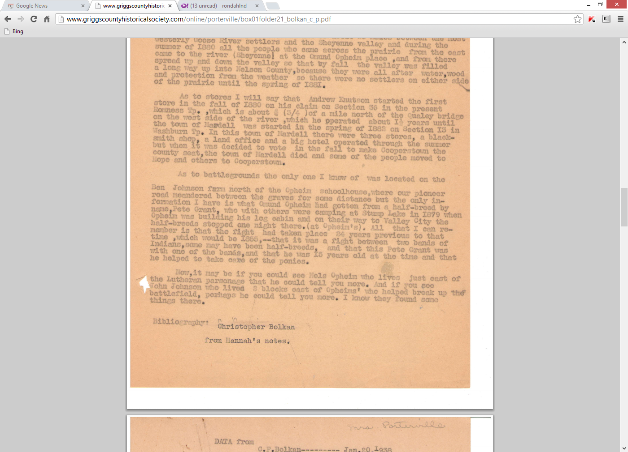

And from Ole Bolkan

