One goal for the story is to have the reader question the established facts. Were the Opheims really the first? What is the definition of the first settler? Should the Durhams be considered first if they came in 1879 and spent the winter? Should the homestead claim date establish who was first?

Also, there are references to a trading post being established north of Butte Michaud. If a non-indian spent a year there, should he be considered first?

I would have liked to have a lot more personal details on the Durhams. What kind of wife was she that would carry a six shooter and hunt with her husband.

And why would a pair of hunters and trappers come to this area? There were no markest to sell meat to. Was it buffalo robes? beaver skins? Did they take the beaver skins to the trading post north of Butte Michaud? Maybe the Metis with their ox carts?

The last paragraph would hopefully tell readers that they could contribute more research. Valley City newspapers?

I put some of the sources below and some questions to myself. Anyone is welcome to pursue anything that looks interesting to them. It would be a long time before I could get back to any questions.

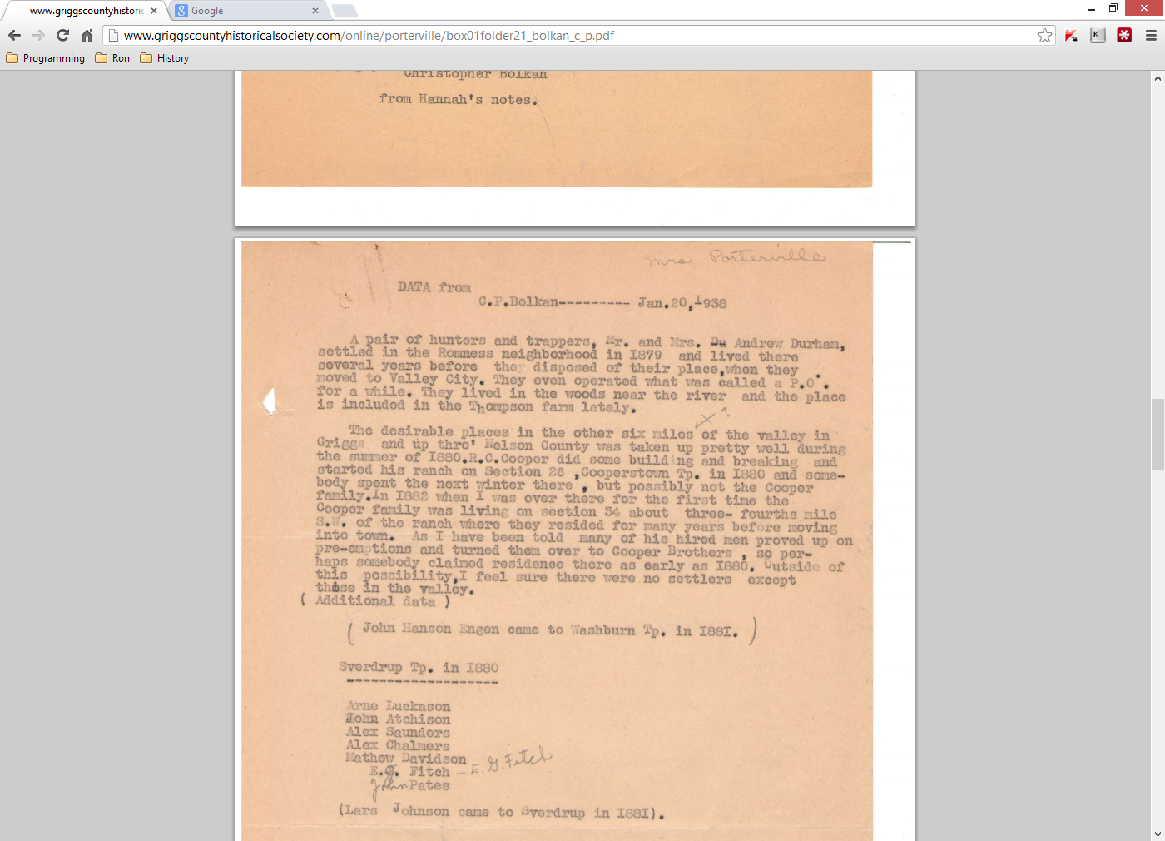

<http://www.griggscountyhistoricalsociety.com/online/porterville/box01folder21_bolkan_c_p.pdf>

Wow! All the places were taken up in the summer of 1880? Would the Durhams try to sell them meat? Or barter with them?

I think Arne Luckason was Bev Tranby’s grandmother’s brother. Was John Atchison related to the Atchison Rifle club name? Who were the other guys? Did they give up right away?

*******************************************************************************

The first post office "Durham" was established in the summer of 1880 in Section 8 of Romness Township at the home of Andrew Durham.  His brother-in-law, Frank Taper, was postmaster.  Another post office called Lybeck was established on Section 25 with Andrew C. Knutson as postmaster.  The mail was hauled from Newburg, near Hatton, and later a route was established from Valley City to Pembina.

Source: Cooperstown, North Dakota 1882-1982 Centennial page 22

<http://www.griggscountyhistoricalsociety.com/online/cooperstown_centennial/in_the_beginning/post_offices.php>

Andrew Knutson could be another story

The first post-office in Griggs County was established in the summer of 1880.  It was located on Section 8-147-58, later named Romness Township.  The post office was named 'Durham' and Frank Taper was appointed postmaster, with his sister, Mrs. Durham, as assistant.  That office was discontinued in a year or two and another post office called 'Lybeck' was established on Section 25, with Andrew C. Knutson as postmaster.  The mail was hauled from Newburg, near Hatton, and later a route was established from Valley City to Pembina.

While Mr. Taper was postmaster, he lived in the same house with Mr. Durham and his wife.  One evening during the summer, Mr. Taper and Mr. Durham had some trouble and according to Taper's story, Mr. Durham drove him off the place at the point of a gun, but he managed to take with him the contents of the post office, which consisted of a few letters.

Mr. Taper planned to take the post office down to Opheims but coming to John Hogenson's he was persuaded to leave it there.  The very next day, Mr. Durham and his wife, mounted on horses and each carrying a six-shooter arrived and as Mrs. Durham was assistant postmaster they agreed with them that she was the proper person to have it so the United States post office was moved back to the Durhams.  Mr. Hogenson related that he never saw Mr. Taper again.

Source: Griggs County History 1879 - 1976 page 6

<http://www.griggscountyhistoricalsociety.com/online/griggs_county_centennial/introduction/first_post_office.php>

http://www.griggscountyhistoricalsociety.com/online/griggs_county_centennial/introduction/first_post_office.php

The first Post Office was established in the summer of 1880, the first in Griggs County.  It was named "Durham" and Frank Taper was postmaster, and his sister was assistant.  This office was discontinued and another Post Office called "Lybeck" (a quiet stream) was established with Andrew C. Knutson as postmaster.  The mail was hauled from Newburg, near Hatton and later a route was established from Valley City to Pembina

A shanty built originally by a settler named Durum was the second house built in Griggs County.  In the spring of 1885 it was burned by a prairie fire.

Omund Nelson Opheim, who is called Pioneer Nelson, built the first house in Griggs County, near by the Sheyenne River.

Source: Griggs County History 1879 - 1976 Page 386

<http://www.griggscountyhistoricalsociety.com/online/griggs_county_centennial/romness_township/some_romness_firsts.php>

Durum vs. Durham? Shanty vs. house? Was it really the second house or was it first? The prairie fire of 1885 was another big story.

**********************************************************************************







External Links

1. <http://www.griggscountyhistoricalsociety.com/online/porterville/box01folder21_bolkan_c_p.pdf>
2. <http://www.griggscountyhistoricalsociety.com/online/cooperstown_centennial/in_the_beginning/post_offices.php>
3. <http://www.griggscountyhistoricalsociety.com/online/griggs_county_centennial/introduction/first_post_office.php>
4. <http://www.griggscountyhistoricalsociety.com/online/griggs_county_centennial/romness_township/some_romness_firsts.php>
5. <http://www.webfamilytree.com/North_Dakota_Place_Names/D/durham_(griggs_county).htm>
6. <http://www.webfamilytree.com/North_Dakota_Place_Names/L/lybeck_(griggs_county).htm>
7. <http://www.webfamilytree.com/North_Dakota_Place_Names/M/mardell_(griggs_county).htm>
8. <http://search.ancestry.com/cgi-bin/sse.dll?rank=1&new=1&MSAV=1&msT=1&gss=angs-g&gsfn=andrew+j.&gsln=durham&msbpn__ftp=1832&msrpn__ftp=Barnes+County%2c+North+Dakota%2c+USA&cpxt=0&catBucket=rstp&uidh=qpi&cp=0&pcat=ROOT_CATEGORY&h=17478571&recoff=7+8+9&db=ndcen&indiv=1>
9. <http://search.ancestry.com/cgi-bin/sse.dll?rank=1&new=1&MSAV=1&msT=1&gss=angs-g&gsfn=andrew+j.&gsln=durham&msbpn__ftp=1832&msrpn__ftp=Barnes+County%2c+North+Dakota%2c+USA&cpxt=0&catBucket=rstp&uidh=qpi&cp=0&pcat=ROOT_CATEGORY&h=17478571&recoff=7+8+9&db=ndcen&indiv=1>
10. <http://search.ancestry.com/cgi-bin/sse.dll?rank=1&new=1&MSAV=1&msT=1&gss=angs-g&gsfn=andrew+j.&gsln=durham&msbpn__ftp=1832&msrpn__ftp=Barnes+County%2c+North+Dakota%2c+USA&cpxt=0&catBucket=rstp&uidh=qpi&cp=0&pcat=ROOT_CATEGORY&h=48914165&db=1880usfedcen&indiv=1>
11. <http://search.ancestry.com/cgi-bin/sse.dll?rank=1&new=1&MSAV=1&msT=1&gss=angs-g&gsfn=andrew+j.&gsln=durham&msbpn__ftp=1832&msrpn__ftp=Barnes+County%2c+North+Dakota%2c+USA&msdpn__ftp=Valley+City+East%2c+Barnes%2c+North+Dakota%2c+USA&msdpn=59621&msdpn_PInfo=8-%7c0%7c1652393%7c0%7c2%7c3248%7c37%7c0%7c234%7c59621%7c0%7c&cpxt=0&catBucket=rstp&uidh=qpi&cp=0&pcat=ROOT_CATEGORY&h=614205&recoff=10+11+12&db=QGHeadstoneApps&indiv=1>