**Quaternary glaciation**, also known as the [**Pleistocene**](http://en.wikipedia.org/wiki/Pleistocene) **glaciation**, the **current ice age** or simply the **ice age**, refers to the period of the last few million years (2.58 [Ma](http://en.wikipedia.org/wiki/Annum) to present)[[1]](http://en.wikipedia.org/wiki/Quaternary_ice_age#cite_note-0) in which permanent [ice sheets](http://en.wikipedia.org/wiki/Ice_sheet) were established in [Antarctica](http://en.wikipedia.org/wiki/Antarctica) and perhaps [Greenland](http://en.wikipedia.org/wiki/Greenland), and fluctuating ice sheets have occurred elsewhere (for example, the [Laurentide ice sheet](http://en.wikipedia.org/wiki/Laurentide_ice_sheet)). The major effects of the ice age were [erosion](http://en.wikipedia.org/wiki/Erosion) and [deposition](http://en.wikipedia.org/wiki/Deposition_(geology)) of material over large parts of the continents, modification of [river systems](http://en.wikipedia.org/wiki/Drainage_system_(geomorphology)), creation of millions of [lakes](http://en.wikipedia.org/wiki/Lake), changes in [sea level](http://en.wikipedia.org/wiki/Sea_level), development of [pluvial lakes](http://en.wikipedia.org/wiki/Pluvial_lake) far from the ice margins, [isostatic adjustment](http://en.wikipedia.org/wiki/Isostasy) of the [crust](http://en.wikipedia.org/wiki/Crust_(geology)), and abnormal winds. It affected oceans, [flooding](http://en.wikipedia.org/wiki/Flood), and biological communities. The ice sheets themselves, by raising the [albedo](http://en.wikipedia.org/wiki/Albedo), effected a major feedback on [climate](http://en.wikipedia.org/wiki/Climate) cooling.

### Wisconsin glaciation, in North America

The [Wisconsin Glacial Episode](http://en.wikipedia.org/wiki/Wisconsinan_glaciation) was the last major advance of [continental glaciers](http://en.wikipedia.org/wiki/Continental_glacier) in the North American [Laurentide ice sheet](http://en.wikipedia.org/wiki/Laurentide_ice_sheet). This [glaciation](http://en.wikipedia.org/wiki/Glaciation) is made of three glacial maxima separated by [interglacial](http://en.wikipedia.org/wiki/Interglacial) warm periods (such as the one we are living in). These glacial maxima are called, from oldest to newest, *Tahoe*, *Tenaya*, and *Tioga*. The Tahoe reached its maximum extent perhaps about 70,000 years ago, perhaps as a byproduct of the [Toba super eruption](http://en.wikipedia.org/wiki/Lake_Toba). Little is known about the Tenaya. The Tioga was the least severe and last of the Wisconsin Episode. It began about 30,000 years ago, reached its greatest advance 21,000 years ago, and ended about 10,000 years ago. At the height of glaciation the [Bering land bridge](http://en.wikipedia.org/wiki/Bering_land_bridge) permitted migration of mammals such as humans to North America from Siberia.

It radically altered the geography of North America north of the [Ohio River](http://en.wikipedia.org/wiki/Ohio_River). At the height of the Wisconsin Episode glaciation, ice covered most of [Canada](http://en.wikipedia.org/wiki/Canada), the [Upper Midwest](http://en.wikipedia.org/wiki/Upper_Midwest), and [New England](http://en.wikipedia.org/wiki/New_England), as well as parts of [Montana](http://en.wikipedia.org/wiki/Montana) and [Washington](http://en.wikipedia.org/wiki/Washington_(U.S._state)). On [Kelleys Island](http://en.wikipedia.org/wiki/Kelleys_Island) in [Lake Erie](http://en.wikipedia.org/wiki/Lake_Erie) or in New York's [Central Park](http://en.wikipedia.org/wiki/Central_Park), the [grooves](http://en.wikipedia.org/wiki/Glacial_striations) left by these glaciers can be easily observed. In southwestern Saskatchewan and southeastern Alberta a suture zone between the [Laurentide](http://en.wikipedia.org/wiki/Laurentide_ice_sheet) and [Cordilleran](http://en.wikipedia.org/wiki/Cordilleran_Ice_Sheet) [ice sheets](http://en.wikipedia.org/wiki/Ice_sheet) formed the [Cypress Hills](http://en.wikipedia.org/wiki/Cypress_Hills_(Canada)), which is the northernmost point in North America that remained south of the continental ice sheets.

The **last glacial period** was the most recent [glacial period](http://en.wikipedia.org/wiki/Glacial_period) within the [current ice age](http://en.wikipedia.org/wiki/Quaternary_glaciation) occurring during the last years (from ≈110 [ka](http://en.wikipedia.org/wiki/Year#SI_prefix_multipliers) to 10 ka ago) of the [Pleistocene](http://en.wikipedia.org/wiki/Pleistocene).[[1]](http://en.wikipedia.org/wiki/Last_glacial_period#cite_note-0)

During this period there were several changes between glacier advance and retreat. The [maximum extent](http://en.wikipedia.org/wiki/Last_Glacial_Maximum) of [glaciation](http://en.wikipedia.org/wiki/Glaciation) was approximately 18,000 years ago.

Canada was nearly completely covered by ice, as well as the northern part of the USA, both blanketed by the huge [Laurentide ice sheet](http://en.wikipedia.org/wiki/Laurentide_ice_sheet).

**Glacial River Warren** or **River Warren** was a prehistoric river that drained [Lake Agassiz](http://en.wikipedia.org/wiki/Lake_Agassiz) in central [North America](http://en.wikipedia.org/wiki/North_America) between 11,700 and 9,400 years ago. The enormous outflow from this lake carved a mighty valley now occupied by the much-smaller [Minnesota River](http://en.wikipedia.org/wiki/Minnesota_River) and the [Upper Mississippi River](http://en.wikipedia.org/wiki/Upper_Mississippi_River).

Lake Agassiz was formed from the meltwaters of the [Laurentide Ice Sheet](http://en.wikipedia.org/wiki/Laurentide_Ice_Sheet) during the [Wisconsonian glaciation](http://en.wikipedia.org/wiki/Wisconsonian_glaciation) of the last [ice age](http://en.wikipedia.org/wiki/Ice_age). Agassiz was a huge body of water, up to 600-700 feet (~200 m) deep, and at various times covering areas totaling over 110,000 square miles (~300,000 km2).[[1]](http://en.wikipedia.org/wiki/Glacial_River_Warren#cite_note-0) Blocked by an ice sheet to the north, the lake water rose until about 9,700 years [Before Present](http://en.wikipedia.org/wiki/Before_Present) (BP), when it overtopped the *Big Stone* [*Moraine*](http://en.wikipedia.org/wiki/Moraine), a ridge of glacial drift left by the receding glacier, at the location of [Browns Valley, Minnesota](http://en.wikipedia.org/wiki/Browns_Valley,_Minnesota). The lake's outflow was catastrophic at times,[[2]](http://en.wikipedia.org/wiki/Glacial_River_Warren#cite_note-1) and carved a gorge through the moraine a mile (1.6 km) wide and 130 feet (~40 m) deep, which is now known as the [Traverse Gap](http://en.wikipedia.org/wiki/Traverse_Gap).[[3]](http://en.wikipedia.org/wiki/Glacial_River_Warren#cite_note-2)

From the gap issued the Glacial River Warren. From its inception until final abandonment of Agassiz' southern outlet, this stream drained the meltwater of that lake to the Mississippi valley. The drainage was not however continuous, as Lake Agassiz periodically had other outlets. The Laurentide ice sheet retreated and advanced with climatic variations and these changes in ice cover contributed to [isostatic](http://en.wikipedia.org/wiki/Isostasy) adjustments in the level of the land over which the watercourses ran. These changes in turn uncovered or blocked the lake's other outlets to the sea.[[4]](http://en.wikipedia.org/wiki/Glacial_River_Warren#cite_note-3)

**Lake Agassiz** was an immense [glacial lake](http://en.wikipedia.org/wiki/Glacial_lake) located in the center of [North America](http://en.wikipedia.org/wiki/North_America). Fed by glacial runoff at the end of the [last glacial period](http://en.wikipedia.org/wiki/Last_glacial_period), its area was larger than all of the modern [Great Lakes](http://en.wikipedia.org/wiki/Great_Lakes) combined, and it held more water than contained by all lakes in the world today.[[1]](http://en.wikipedia.org/wiki/Lake_Agassiz#cite_note-Perkins-0)

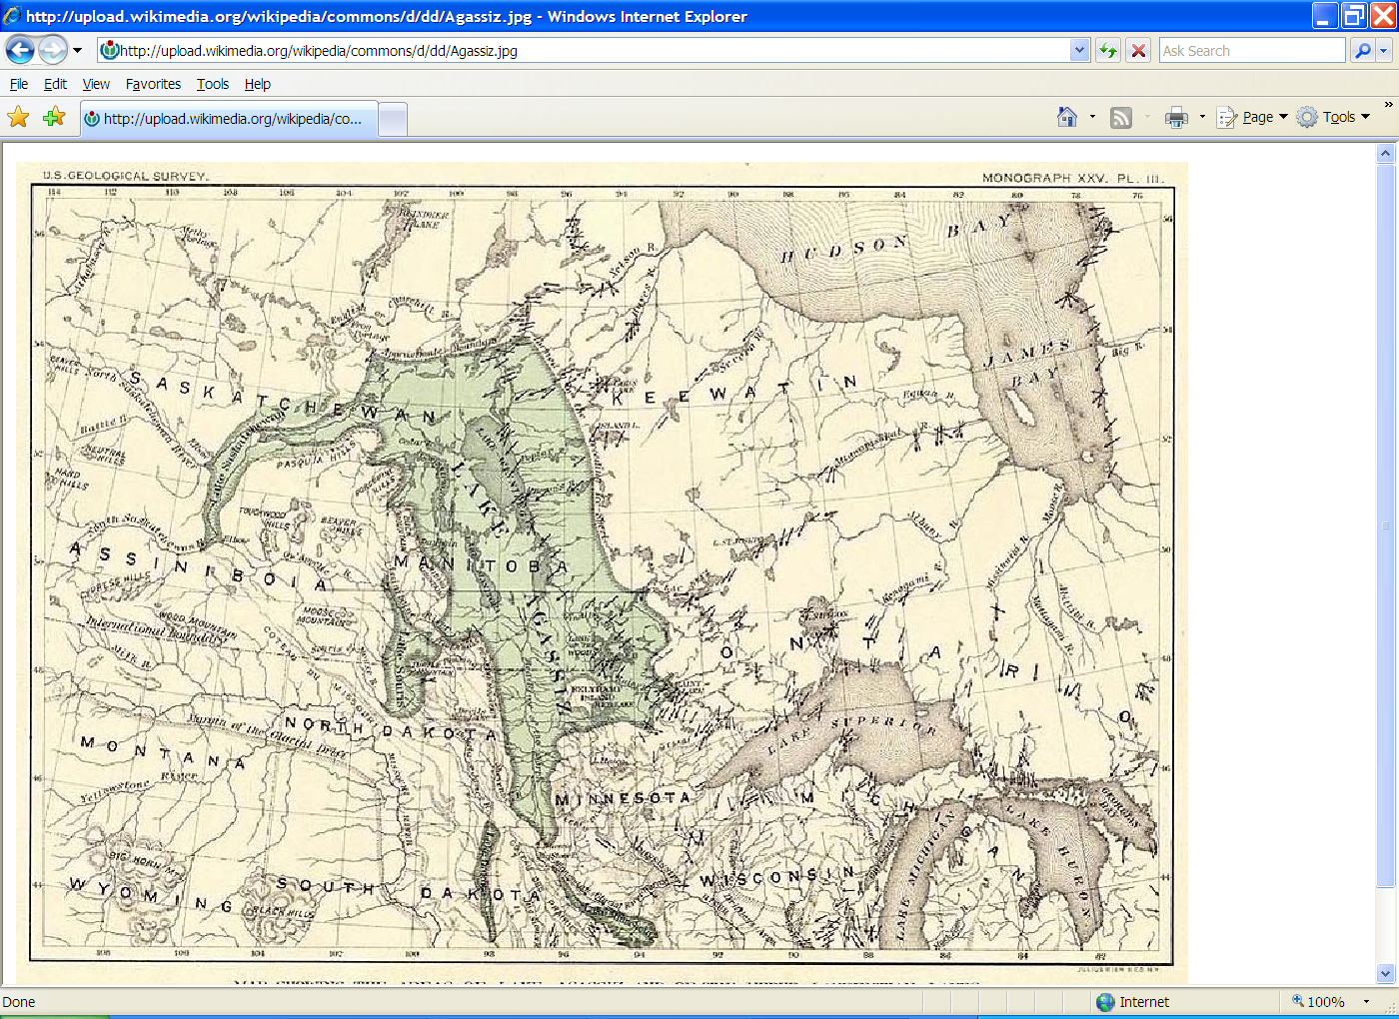

Geologists have come to a consensus on the likely geological history of Lake Agassiz.

During the last [Ice Age](http://en.wikipedia.org/wiki/Ice_Age), northern North America was covered by a glacier, which alternately advanced and deteriorated with variations in the climate. This continental ice sheet formed during the period now known as the [Wisconsin glaciation](http://en.wikipedia.org/wiki/Wisconsin_Glaciation#Wisconsin_glaciation.2C_in_North_America), and covered much of central North America between 30,000 and 10,000 years ago. As the ice sheet disintegrated, it created at its front an immense [proglacial lake](http://en.wikipedia.org/wiki/Proglacial_lake), formed from its meltwaters.[[2]](http://en.wikipedia.org/wiki/Lake_Agassiz#cite_note-1)

Around 13,000 years BP the lake came to cover much of [Manitoba](http://en.wikipedia.org/wiki/Manitoba), western [Ontario](http://en.wikipedia.org/wiki/Ontario), northern [Minnesota](http://en.wikipedia.org/wiki/Minnesota), eastern [North Dakota](http://en.wikipedia.org/wiki/North_Dakota), and [Saskatchewan](http://en.wikipedia.org/wiki/Saskatchewan). At its greatest extent, it may have covered as much as 440,000 square kilometers, larger than any currently existing lake in the world (including the [Caspian Sea](http://en.wikipedia.org/wiki/Caspian_Sea)).

The lake drained at various times south through the [Traverse Gap](http://en.wikipedia.org/wiki/Traverse_Gap) into [Glacial River Warren](http://en.wikipedia.org/wiki/Glacial_River_Warren) (parent to the [Minnesota River](http://en.wikipedia.org/wiki/Minnesota_River), a tributary of the [Mississippi River](http://en.wikipedia.org/wiki/Mississippi_River)),[[3]](http://en.wikipedia.org/wiki/Lake_Agassiz#cite_note-2) east through Lake Kelvin (modern [Lake Nipigon](http://en.wikipedia.org/wiki/Lake_Nipigon)) to what is now [Lake Superior](http://en.wikipedia.org/wiki/Lake_Superior),[[4]](http://en.wikipedia.org/wiki/Lake_Agassiz#cite_note-3) or west via the [Mackenzie River](http://en.wikipedia.org/wiki/Mackenzie_River) through the [Northwest Territories](http://en.wikipedia.org/wiki/Northwest_Territories).[[1]](http://en.wikipedia.org/wiki/Lake_Agassiz#cite_note-Perkins-0) Geologists believe that a major outbreak of Lake Agassiz about 13,000BP drained north through the [Mackenzie River](http://en.wikipedia.org/wiki/Mackenzie_River) into the [Arctic Ocean](http://en.wikipedia.org/wiki/Arctic_Ocean)[[5]](http://en.wikipedia.org/wiki/Lake_Agassiz#cite_note-4)[[6]](http://en.wikipedia.org/wiki/Lake_Agassiz#cite_note-5). A return of the ice for some time offered a reprieve, but after retreating north of the Canadian border about 9,900 years ago, Lake Agassiz refilled. The last major shift in drainage occurred about 8,400 years BP. The melting of remaining [Hudson Bay](http://en.wikipedia.org/wiki/Hudson_Bay) ice caused lake Agassiz to drain nearly completely. This final drainage of Lake Agassiz contributed an estimated 1 to 3 meters to total post-glacial global [sea level rise](http://en.wikipedia.org/wiki/Sea_level_rise)[[*citation needed*](http://en.wikipedia.org/wiki/Wikipedia:Citation_needed)]. Much of the final drainage may have occurred in a very short time, in two or one events, perhaps taking as short as a year.

Lake Agassiz' major drainage reorganization events were of such magnitudes that they had significant impact on climate, sea level and possibly early human civilization. Major freshwater release into the [Arctic Ocean](http://en.wikipedia.org/wiki/Arctic_Ocean) is considered to disrupt oceanic circulation and cause temporary cooling. The draining at 13,000 may be the cause of the [Younger Dryas](http://en.wikipedia.org/wiki/Younger_Dryas) [stadial](http://en.wikipedia.org/wiki/Stadial)[[1]](http://en.wikipedia.org/wiki/Lake_Agassiz#cite_note-Perkins-0)[[7]](http://en.wikipedia.org/wiki/Lake_Agassiz#cite_note-Broecker-6). The draining at 8,400 may be the cause of the [8,200 yr climate event](http://en.wikipedia.org/wiki/8.2_kiloyear_event). A recent study by Turney and Brown links the 8,400 drainage to the expansion of agriculture from east to west across Europe; he suggests that this may also account for various flood myths of prehistoric cultures, including the [Biblical flood](http://en.wikipedia.org/wiki/Deluge_(mythology)).[[8]](http://en.wikipedia.org/wiki/Lake_Agassiz#cite_note-7)

[Lake Winnipeg](http://en.wikipedia.org/wiki/Lake_Winnipeg), [Lake Winnipegosis](http://en.wikipedia.org/wiki/Lake_Winnipegosis), [Lake Manitoba](http://en.wikipedia.org/wiki/Lake_Manitoba), and [Lake of the Woods](http://en.wikipedia.org/wiki/Lake_of_the_Woods), among others, are relics of the ancient lake.

Clovis Comet

The **Younger Dryas impact event** or **Clovis comet hypothesis** refers to the [hypothesized](http://en.wikipedia.org/wiki/Hypothesis) large [air burst](http://en.wikipedia.org/wiki/Air_burst) or earth [impact](http://en.wikipedia.org/wiki/Impact_event) of an object or objects from [outer space](http://en.wikipedia.org/wiki/Outer_space) that initiated the [Younger Dryas](http://en.wikipedia.org/wiki/Younger_Dryas) cold period about 12,900 [BP](http://en.wikipedia.org/wiki/Before_Present) [calibrated](http://en.wikipedia.org/wiki/Radiocarbon_dating#Calibration) (10,900 BP uncalibrated).

One scenario proposes that an [air burst](http://en.wikipedia.org/wiki/Air_burst) and/or earth impact with a rare swarm of [carbonaceous chondrites](http://en.wikipedia.org/wiki/Chondrite#Carbonaceous_chondrites) or [comets](http://en.wikipedia.org/wiki/Comet) set vast areas of the [North American](http://en.wikipedia.org/wiki/North_American) continent on fire, causing the [extinction of most of the large animals](http://en.wikipedia.org/wiki/Quaternary_extinction_event) in [North America](http://en.wikipedia.org/wiki/North_America) and the demise of the North American [Clovis culture](http://en.wikipedia.org/wiki/Clovis_culture) at the end of the [last glacial period](http://en.wikipedia.org/wiki/Last_glacial_period).[[1]](http://en.wikipedia.org/wiki/Younger_Dryas_impact_event#cite_note-Kennett-0) This swarm would have exploded above or even into the [Laurentide Ice Sheet](http://en.wikipedia.org/wiki/Laurentide_Ice_Sheet) north of the [Great Lakes](http://en.wikipedia.org/wiki/Great_Lakes). An airburst would have been similar to but many orders of magnitude larger than the [Tunguska event](http://en.wikipedia.org/wiki/Tunguska_event) of 1908. Animal and human life not directly killed by the blast or the resulting coast to coast [wildfires](http://en.wikipedia.org/wiki/Wildfire) would have starved on the burned surface of the continent.

* c.[1000](http://en.wikipedia.org/wiki/1000) - [Viking colonization](http://en.wikipedia.org/wiki/Norse_colonization_of_the_Americas) of [Greenland](http://en.wikipedia.org/wiki/Greenland), Helluland (possibly [Baffin Island](http://en.wikipedia.org/wiki/Baffin_Island)), Markland (perhaps [Labrador](http://en.wikipedia.org/wiki/Labrador)) and [Vinland](http://en.wikipedia.org/wiki/Vinland) (probably Newfoundland). The Greenland colony lasted until the 15th century, but the estimated duration of the only known site at the Gulf of Saint Lawrence is estimated to be less than a decade.
* c.[1350](http://en.wikipedia.org/wiki/1350) - The Norse Western Settlement in Greenland is abandoned.

New France was the area [colonized](http://en.wikipedia.org/wiki/French_colonization_of_the_Americas) by France from the exploration of the [Saint Lawrence River](http://en.wikipedia.org/wiki/Saint_Lawrence_River), by [Jacques Cartier](http://en.wikipedia.org/wiki/Jacques_Cartier) in 1534. At its peak in 1712, the territory claimed by New France extended from [Nova Scotia](http://en.wikipedia.org/wiki/Nova_Scotia) to [Lake Superior](http://en.wikipedia.org/wiki/Lake_Superior) and from the Hudson Bay to the Mississippi River and the [Gulf of Mexico](http://en.wikipedia.org/wiki/Gulf_of_Mexico). The territory was then divided into five colonies, each with its own administration: [Canada](http://en.wikipedia.org/wiki/Canada,_New_France), [Acadia](http://en.wikipedia.org/wiki/Acadia), [Hudson Bay](http://en.wikipedia.org/wiki/Hudson_Bay), Newfoundland and [Louisiana](http://en.wikipedia.org/wiki/Louisiana_(New_France)). About 16,000 settlers came from France, and concentrated in villages along the St. Lawrence River and Acadia. There were few settlers elsewhere. Britain seized as spoils of war almost all the French areas east of the Mississippi by 1763. The [area around New Orleans](http://en.wikipedia.org/wiki/Louisiana_(New_France)) and west of the Mississippi passed to Spain, which ceded it to France in 1803, allowing France to sell it as the [Louisiana Purchase](http://en.wikipedia.org/wiki/Louisiana_Purchase) to the United States.[[1]](http://en.wikipedia.org/wiki/Colonial_history_of_the_United_States#cite_note-Cooke_1998-0)

The Anglo-French hostilities were ended in 1763 by the [Treaty of Paris](http://en.wikipedia.org/wiki/Treaty_of_Paris_(1763)), which involved a complex series of land exchanges, the most important being France's cession to Spain of [Louisiana](http://en.wikipedia.org/wiki/Louisiana_(New_France)), and to Great Britain the rest of New France except for the islands of [St. Pierre and Miquelon](http://en.wikipedia.org/wiki/St._Pierre_and_Miquelon). France was given the choice of retrieving either [New France](http://en.wikipedia.org/wiki/New_France) or its Caribbean island colonies of [Guadeloupe](http://en.wikipedia.org/wiki/History_of_Guadeloupe) and [Martinique](http://en.wikipedia.org/wiki/History_of_Martinique), and chose the latter to retain these lucrative sources of [sugar](http://en.wikipedia.org/wiki/Sugar),[[27]](http://en.wikipedia.org/wiki/Seven_Years%27_War#cite_note-26) writing off New France as an unproductive, costly territory.[[28]](http://en.wikipedia.org/wiki/Seven_Years%27_War#cite_note-27) France also returned Minorca to the British. Spain lost control of [Florida](http://en.wikipedia.org/wiki/Spanish_Florida) to Great Britain, but received part of [New Orleans](http://en.wikipedia.org/wiki/New_Orleans) and the [Louisiana Territory](http://en.wikipedia.org/wiki/Louisiana_Territory) west of the [Mississippi River](http://en.wikipedia.org/wiki/Mississippi_River) from the French. The exchanges suited the British as well, as their own Caribbean islands already supplied ample sugar, and with the acquisition of New France and Florida, they now controlled all of North America east of the Mississippi.

In 1762, France had ceded Louisiana to Spain, but by the secret Treaty of San Ildefonso (1800) the French had regained the area. Napoleon Bonaparte (the future Emperor Napoleon I) envisioned a great French empire in the New World, and he hoped to use the Mississippi Valley as a food and trade center to supply the island of Hispaniola, which was to be the heart of this empire. First, however, he had to restore French control of Hispaniola, where Haitian slaves under TOUSSAINT L'OUVERTURE had seized power (1801; see HAITI). In 1802 a large army sent by Napoleon under his brother-in-law, Charles Leclerc, arrived on the island to suppress the Haitian rebellion. Despite some military success, the French lost thousands of soldiers, mainly to yellow fever, and Napoleon soon realized that Hispaniola must be abandoned. Without that island he had little use for Louisiana. Facing renewed war with Great Britain, he could not spare troops to defend the territory; he needed funds, moreover, to support his military ventures in Europe. Accordingly, in April 1803 he offered to sell Louisiana to the United States.

The **Territory of Minnesota** was an [organized incorporated territory of the United States](http://en.wikipedia.org/wiki/Organized_incorporated_territory_of_the_United_States) that existed from March 3, 1849, until May 11, 1858, when the eastern portion of the territory was admitted to the [Union](http://en.wikipedia.org/wiki/United_States) as the [State of Minnesota](http://en.wikipedia.org/wiki/State_of_Minnesota).

The **Territory of Iowa** was an [organized incorporated territory of the United States](http://en.wikipedia.org/wiki/Organized_incorporated_territory_of_the_United_States) that existed from July 4, 1838, until December 28, 1846, when the southeastern portion of the territory was admitted to the [Union](http://en.wikipedia.org/wiki/United_States) as the [State of Iowa](http://en.wikipedia.org/wiki/State_of_Iowa).

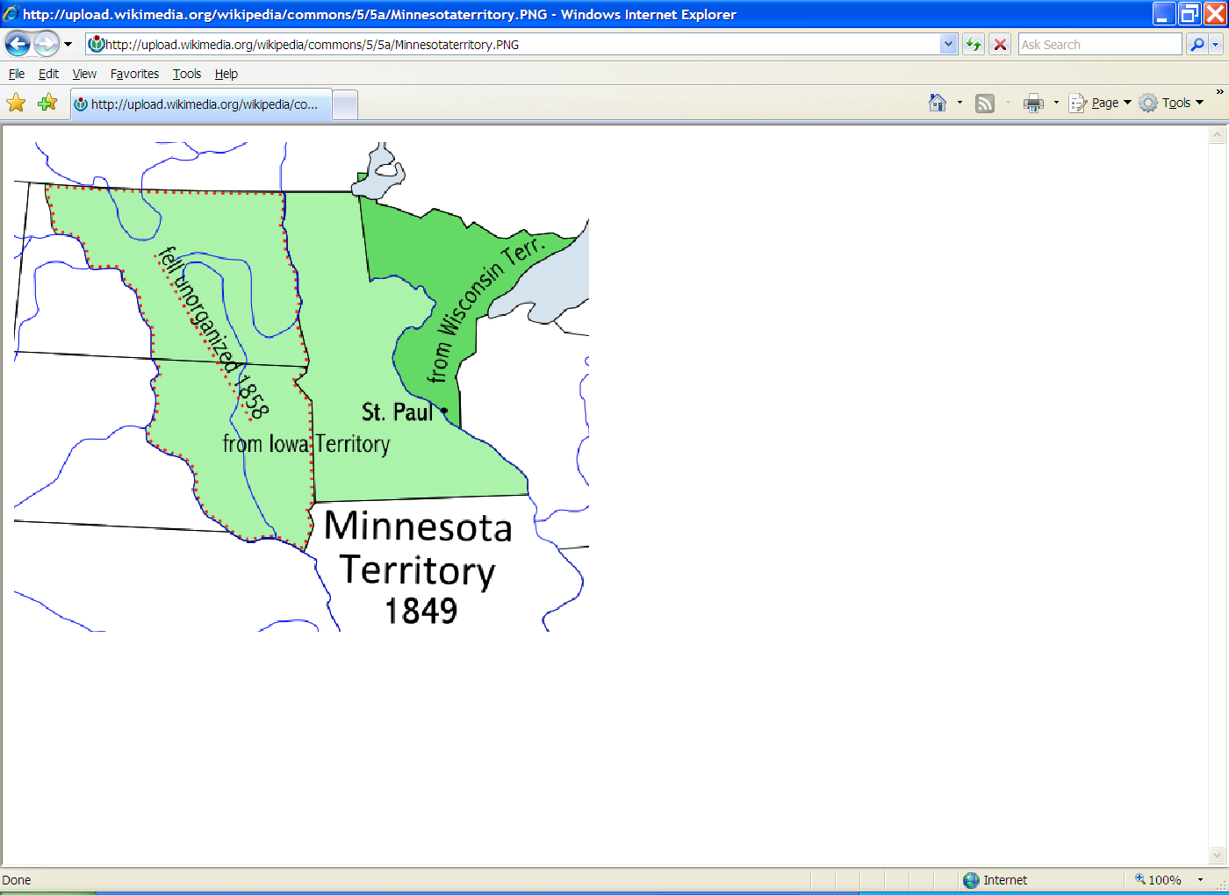

The **Territory of Iowa** was an [organized incorporated territory of the United States](http://en.wikipedia.org/wiki/Organized_incorporated_territory_of_the_United_States) that existed from July 4, 1838, until December 28, 1846, when the southeastern portion of the territory was admitted to the [Union](http://en.wikipedia.org/wiki/United_States) as the [State of Iowa](http://en.wikipedia.org/wiki/State_of_Iowa).

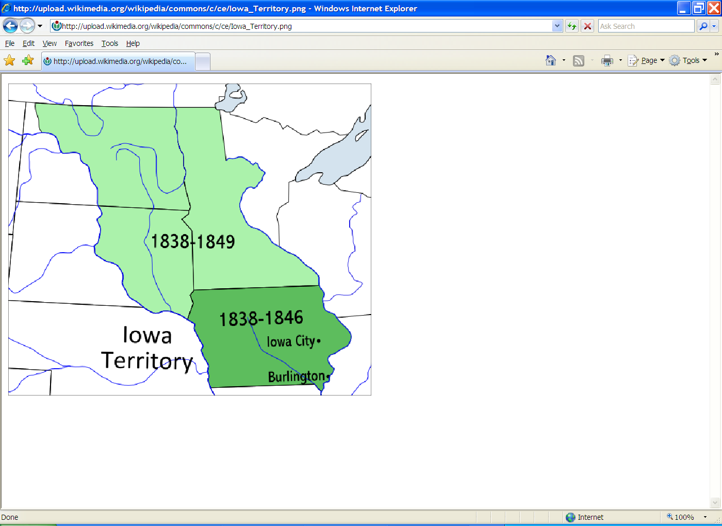

The **Territory of Wisconsin** was an [organized incorporated territory of the United States](http://en.wikipedia.org/wiki/Organized_incorporated_territory_of_the_United_States) that existed from July 3, 1836, until May 29, 1848, when an eastern portion of the territory was admitted to the [Union](http://en.wikipedia.org/wiki/United_States) as the [State of Wisconsin](http://en.wikipedia.org/wiki/State_of_Wisconsin). [Belmont](http://en.wikipedia.org/wiki/Belmont,_Wisconsin) was initially chosen as the capital of the territory, but this was changed in October 1836 to the current capital of [Madison](http://en.wikipedia.org/wiki/Madison,_Wisconsin).[[1]](http://en.wikipedia.org/wiki/Wisconsin_Territory#cite_note-0)

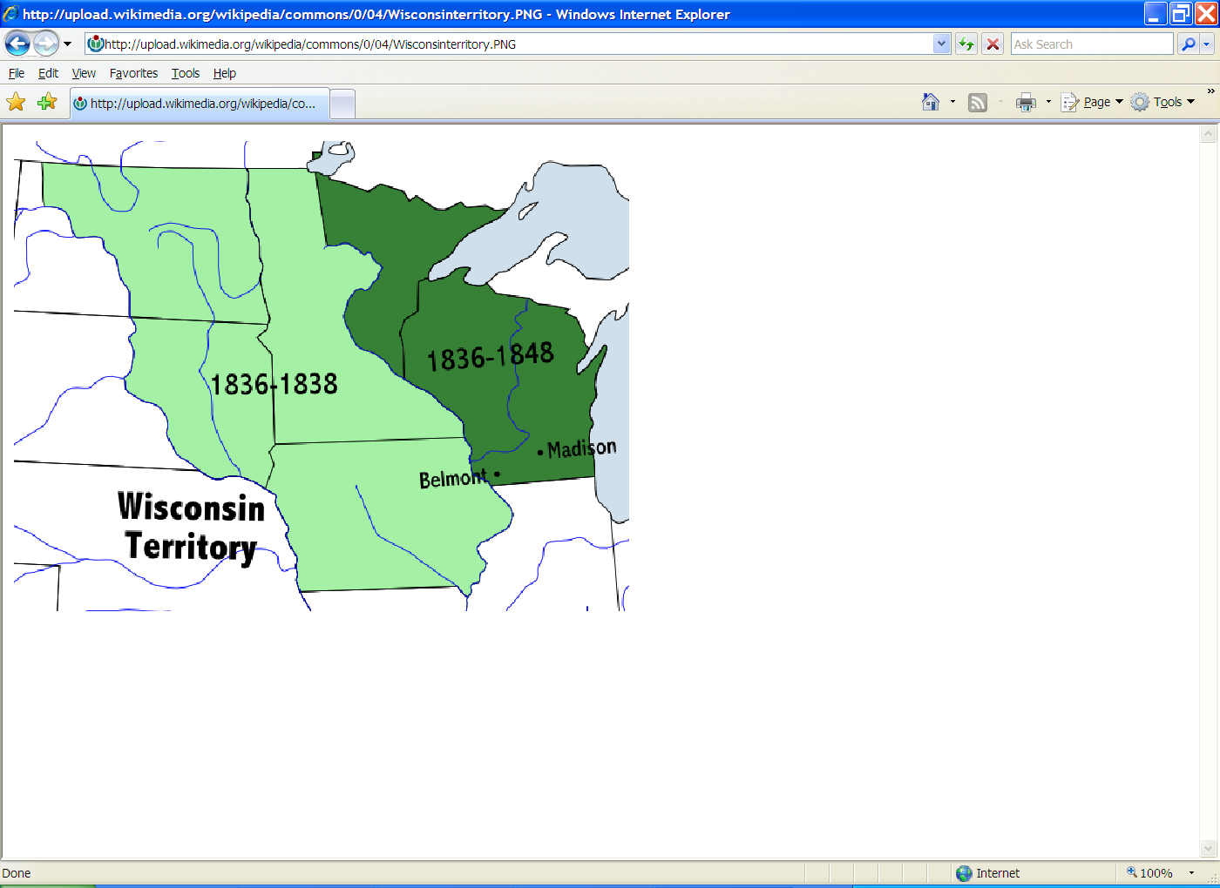

Treaty of 1818

* Article II set the boundary between British North America and the United States along "a line drawn from the most [northwestern point](http://en.wikipedia.org/wiki/Northwestern_point_of_the_Lake_of_the_Woods) of the [Lake of the Woods](http://en.wikipedia.org/wiki/Lake_of_the_Woods), [due south, then] along the [49th parallel](http://en.wikipedia.org/wiki/49th_parallel_north) of north latitude..." to the "Stony Mountains"[[3]](http://en.wikipedia.org/wiki/Treaty_of_1818#cite_note-Canado-American_Treaties_Text-2) (now known as the [Rocky Mountains](http://en.wikipedia.org/wiki/Rocky_Mountains)). Britain ceded all of [Rupert's Land](http://en.wikipedia.org/wiki/Rupert%27s_Land) south of the 49th parallel, including the [Red River Colony](http://en.wikipedia.org/wiki/Red_River_Colony). This settled a boundary dispute caused by ignorance of actual geography in the boundary agreed to in the 1783 [Treaty of Paris](http://en.wikipedia.org/wiki/Treaty_of_Paris_(1783)) that ended the [American Revolutionary War](http://en.wikipedia.org/wiki/American_Revolutionary_War). That earlier treaty had placed the boundary between the United States and British possessions to the north along a line going westward from the [Lake of the Woods](http://en.wikipedia.org/wiki/Lake_of_the_Woods) to the [Mississippi River](http://en.wikipedia.org/wiki/Mississippi_River). The parties failed to realize that the river did not extend that far north, so such a line would never meet the river. The new treaty also created the anomalous [Northwest Angle](http://en.wikipedia.org/wiki/Northwest_Angle), the small section of the present state of [Minnesota](http://en.wikipedia.org/wiki/Minnesota) that is the only part of the United States outside [Alaska](http://en.wikipedia.org/wiki/Alaska) north of the 49th parallel.

Treaty of Utrecht

In addition, Spain ceded [Gibraltar](http://en.wikipedia.org/wiki/Gibraltar) and [Minorca](http://en.wikipedia.org/wiki/Minorca) to Great Britain and agreed to give to the British the [Asiento](http://en.wikipedia.org/wiki/Asiento), a valuable monopoly [slave-trading](http://en.wikipedia.org/wiki/Slave_trade) contract. In North America, France ceded to Great Britain its claims to the [Hudson's Bay Company](http://en.wikipedia.org/wiki/Hudson%27s_Bay_Company) territories in [Rupert's Land](http://en.wikipedia.org/wiki/Rupert%27s_Land), [Newfoundland](http://en.wikipedia.org/wiki/Newfoundland_(island)) and [Acadia](http://en.wikipedia.org/wiki/Acadia). The formerly partitioned island of [Saint Kitts](http://en.wikipedia.org/wiki/Saint_Kitts) was also ceded in its entirety to Britain. France was required to recognize British [suzerainty](http://en.wikipedia.org/wiki/Suzerainty) over the [Iroquois](http://en.wikipedia.org/wiki/Iroquois) and commerce with the Far Indians was to be open to traders of all nations. France retained its other pre-war North American possessions, including Île-Saint-Jean (now [Prince Edward Island](http://en.wikipedia.org/wiki/Prince_Edward_Island)) as well as Île Royale (now [Cape Breton Island](http://en.wikipedia.org/wiki/Cape_Breton_Island)), on which it erected the [Fortress of Louisbourg](http://en.wikipedia.org/wiki/Fortress_of_Louisbourg).

New France

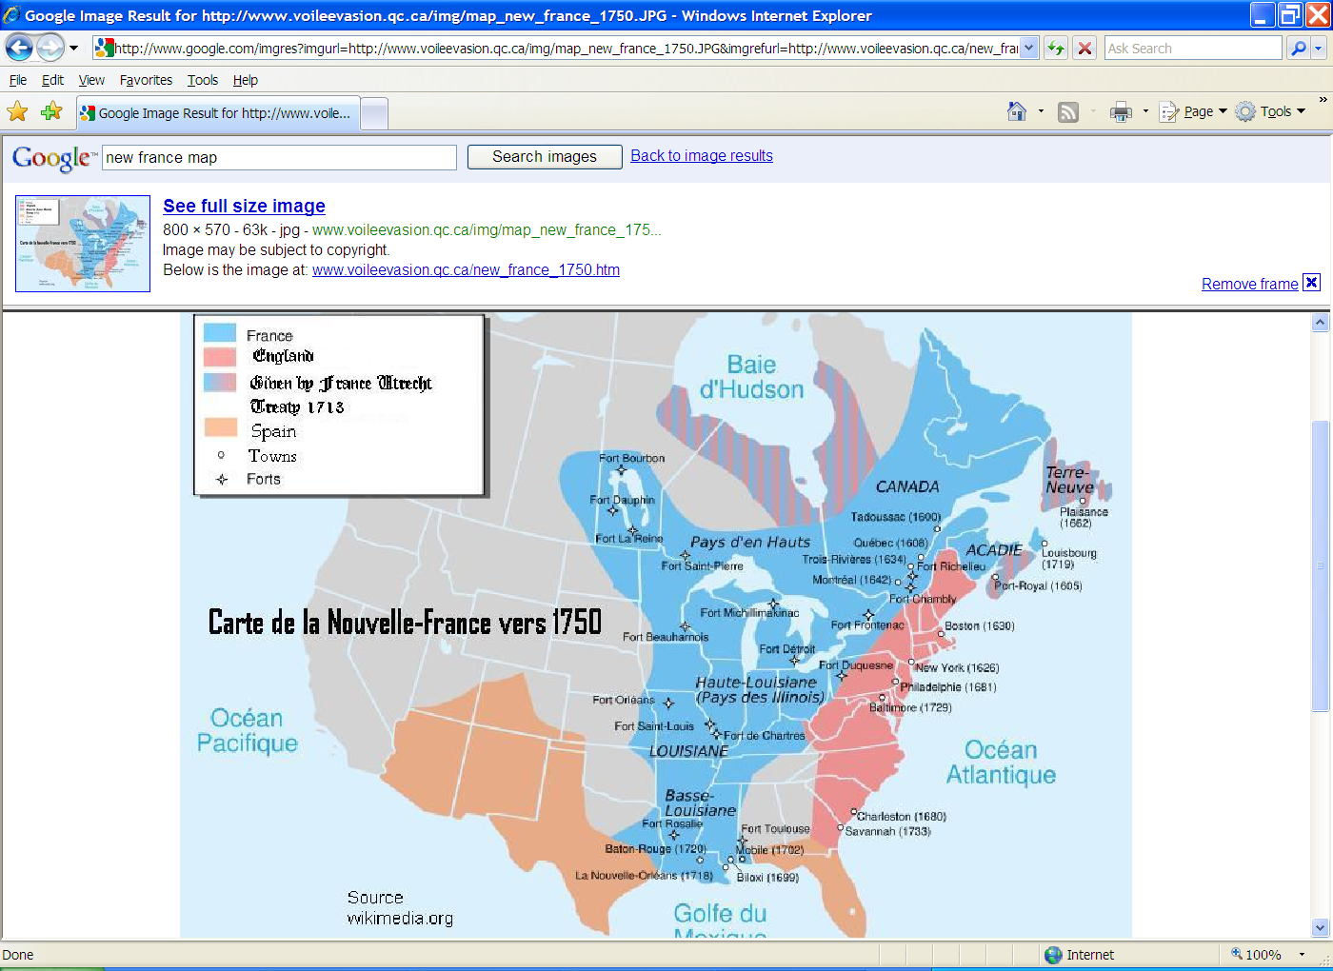

According to the [Bull of Pope Alexander VI,](http://www.reformation.org/bull-of-borgia.html) New Spain now included not just Mexico . . . but the ENTIRE New World. That meant that Mexico City was now considered the capital city of the entire New World!!

New Spain included the entire New World!!

"Containing in this donation, whatsoever main lands or islands are found or to be found toward India, or toward any other part whatsoever it be, being distant from, or without theaforesaid line drawn a hundred leagues toward the west and south from any of the islands which are commonly called De los Azores and Cape Verde. All the islands therefore, and main lands, found and to be found, discovered and to be discovered, from the said line toward the west and south, such as have not actually been heretofore possessed by any other Christian King or Prince, until the day of the nativity of our Lord Jesus Christ last past, from the which beginneth this present year, being the year of our Lord M.CCCC.LXXXXIII., whensoever any shall be found by your messengers and captains, We by the authority of Almighty God granted unto us in Saint Peter, and by the office which we bear on the earth in the stead of Jesus Christ, do for ever by the tenour of these presents, give, grant, and assign' to you, your heirs and successors (the Kings of Castile and Legion), all these lands and islands,with their dominions, territories, cities, castles, towers, places, and villages, with all the right and jurisdiction thereunto pertaining : constituting, assigning, and deputing you, your heirs and successors, the lords thereof, with full and free power, authority, and jurisdiction. Decreeing, nevertheless, by this our donation, grant, and assignation, that from no Christian Prince, who actually hath possessed the aforesaid islands and main lands unto the day of the nativity of our Lord aforesaid, their right obtained to be understood hereby to be taken away, or that it ought to be taken away. Furthermore we command you, in virtue of holy obedience (as you have promised, and as we doubt not you will do upon mere devotion and princely magnanimity), to send to the said main lands and islands, honest, virtuous, and learned men, such as fear God and are able to instruct the inhabitants in the Catholic faith and good manners, applying all their possible diligence in the premises. We furthermore inhibit all manner of persons, of what state, degree, order, or condition soever they be, although of Imperial and regal dignity, under the pain of the sentence of excommunication which they shall incur if they do to the contrary, that they in no case presume, without special licence of you, your heirs and successors, to travel for merchandise or for any other cause, to the said lands or islands, found or to be found, discovered or to be discovered, towards the west and south, drawing a line from the Arctic pole to the Antarctic pole, whether the main lands and islands found and to be found, be situate toward India or toward any other part, being distant from the line drawn a hundred leagues toward the west from any of the islands commonly called De los Azores and Cape Verde : Notwithstanding constitutions, decrees, and Apostolical ordinances whatsoever they are to the contrary : In Him from whom empires, dominions, and all good things do proceed : Trusting that Almighty God directing your enterprises, if you follow your godly and laudable attempts, your labours and travels herein shall in a short time obtain a happy end with felicity and glory of all Christian people. But forasmuch as it should be a thing of great difficulty for these letters to be carried to all such places as should be expedient, we will, and of like motion and knowledge do decree that whithersoever the same shall be sent, or wheresoever they shall be received with the subscription of a common notary thereunto required, with the seal of any person constituted in ecclesiastical dignity, or such as are authorised by the ecclesiastical court, the same faith and credit to be given thereunto in judgment or elsewhere, as should be exhibited to these presents.