

Teeter Totter



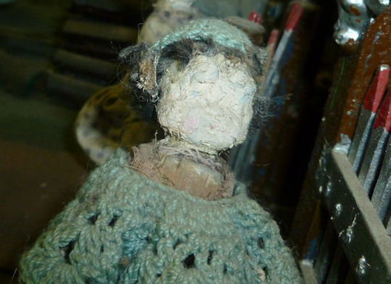

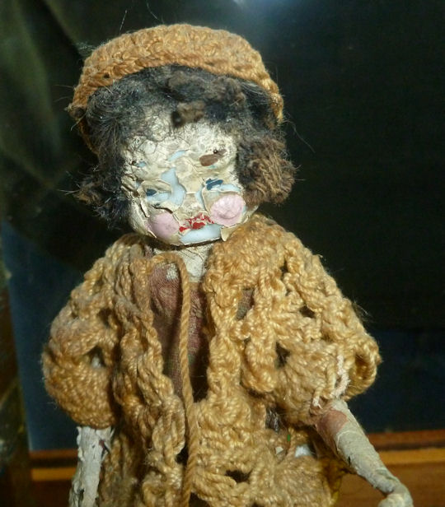

**Sawing Firewood**

**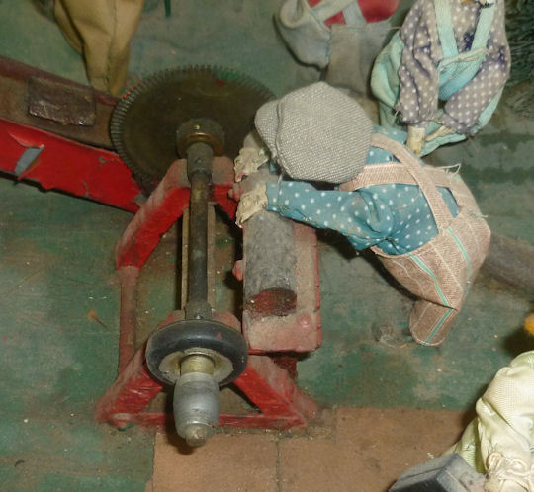**

**Two Men by Saw**

**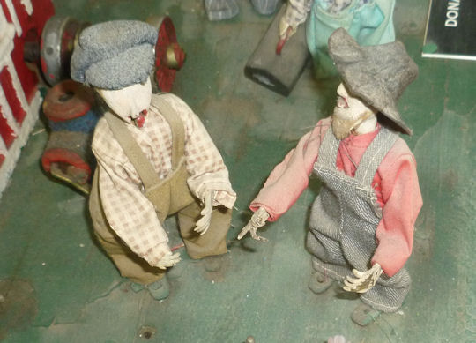**

****

**Bible Salesman**

**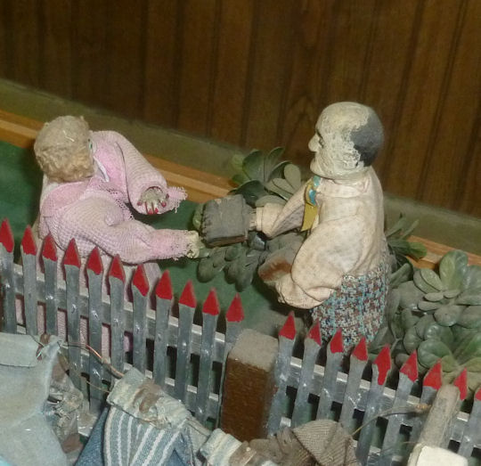**

**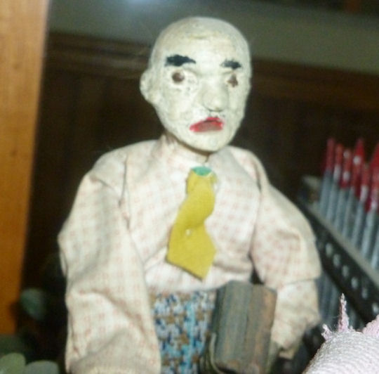**

**Automobile**

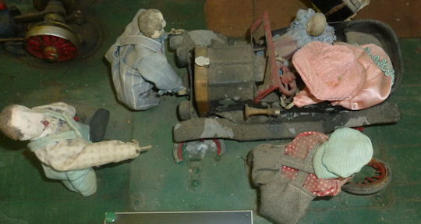



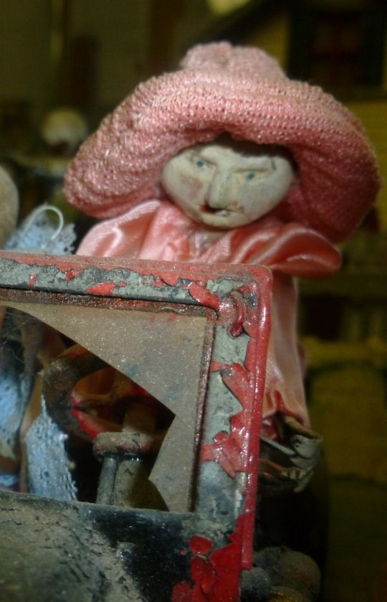

**Shotgun Wedding**

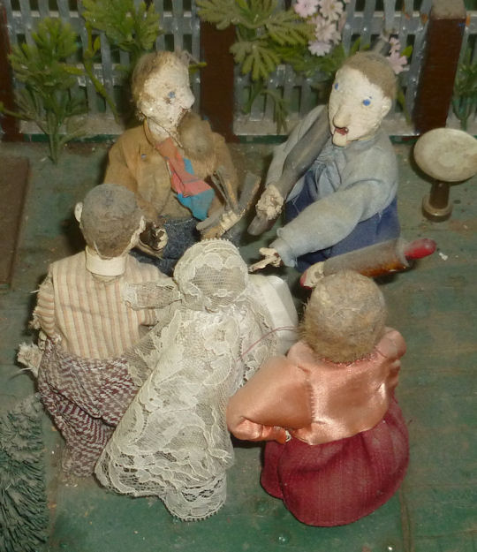

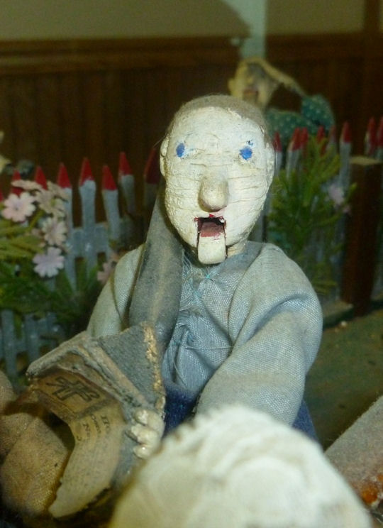

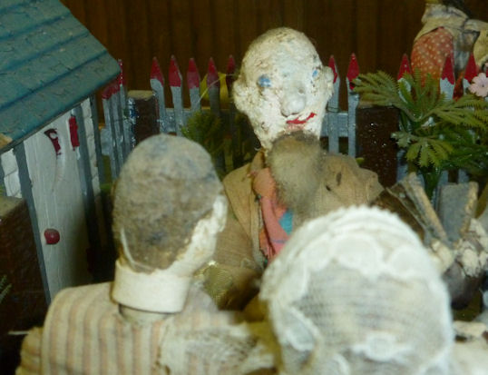

|  |  |  |
| --- | --- | --- |
| Z:\photos\room_04\man_washing_hands.JPG |  | Z:\photos\room_04\man_washing_hands02.JPG |
| Man Washing Hands |  | Man Washing Hands from Left |
| Z:\photos\room_04\man_washing_hands_02.JPG |  | Z:\photos\room_04\woman_ringing_bell.JPG |
| Man Washing Hands from Right |  | Woman Ringing Bell |
| Z:\photos\room_04\woman_churning_butter.JPG |  | Z:\photos\room_04\woman_churning_butter02.JPG |
| Woman Churning Butter |  | Woman Churning Butter |
| Z:\photos\room_04\woman_washing_clothes.JPG |  | Z:\photos\room_04\woman_hanging_clothes.JPG |
| Woman Washing Clothes |  | Woman Hanging Clothes |
|  |  |  |
| Z:\photos\room_04\man_with_pipe.JPG |  |  |
|  |  |  |
|  |  |  |
|  |  |  |