1830 13 miles of track

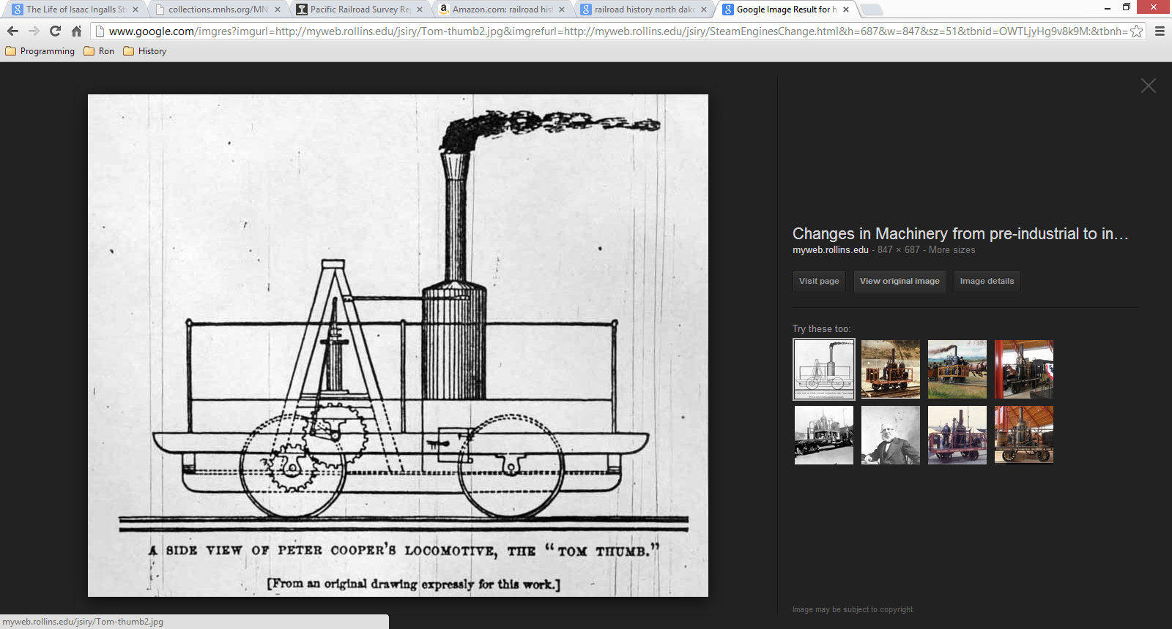



<http://www.the-ashpit.com/mik/1850s.html>