DEATHS
Feb. 9, 1883 Owing to the death of his infant and only child, aged 8 months, on Tuesday last, at Hope, Dr. VIrgo has postponed opening his drugstore in Cooperstown until next week.
May 25, 1683 Frenk L. Axt•ll, killed at Omund Nelson farm.
July 27, 1883 Struck by lightninga-Rev. E. Prindle and his eon-In-law,
H. M. Covell of Sanborn. They were lathing in a new house. (Probably not in Cooperstown)
Aug. 24, 1883 0ur First Bereavement-- Christian G. Nelson, 21 years₎
6 months, died last Friday afternoon. His brothers, Saeiuel and Peter took him to his old home at Decorah, Iowa for burial.
Sept. 7, 1883 On Tuesday morning, little Lottie Ressler of Lake essie,
aged 8 years, died of diphtheria.
Cot. 26, 1883 Mrs. Jurine Bull, aged 39 years died Wednesday morning
of consumption at her home six miles southeast of Cooperstown.
Nov. 2, 1883 Obituaries of John Blair Whidden and William S. Lenham.
Nov. 9, 1883 Sever Halvorson, living 6 miles east of this place, and
brother of the 1st precinct County Commissioner-Elect, died Tuesday night of typhoid pneumonia at the age of 38 years. He was an industrious farmer, and leaves a
wife and several children to deplore the fate that called him away.
Mar. 14, 1884 Victor Whidden, 3 years old, son of Mr. and Mrs. W. R.
Whidden, died in New York of diphtheria.
Mar. 21, 1884 Mr. Rockwell returned Tueaday night from his revival work
in various North Dakota towns, being called home by the death of Mr. Zimmerman's little girl, Myra, 5 years old, who died last Sunday of dropsy of the brain.
Mar. 28, 1884 Whidden's daughter Emily died also of diphtheria.
May 30, 1884 Died suddenly, H. S. Lenham, 62 years, landlord of Palace,
came to Cooperstown about 2 months ago. Burial service at Sanborn under Masonic Body.
July 11, 1884 Norman, 13 years old, son of Nelson Keele killed by
accidental discharge of shotgun while A hunting ducks in a slough on his father's farm.
Nov. 11, 1884 Gilbert Johnson, 26 years old, single, of Sec. 24-145-59,
died November 3 of consumption. Had it when he came.
Sept. 24, 1884 Infant child of S. B. Merryman, died September 10.
Dec. 5, 1884 At one o'clock today, Mrs. H. G. Pickett, accidentally
shot and killed herself with a revolver. qa
Jan; 2, 1885 Carrington News says the infant child of 5. A. Clough
and wife has been stricken with paralysis and recovery is doubtful. Mrs. Clough has gone to her old home with the baby.
Jan. 16, 1885 The Clough baby is dead in Michigan.
DEATHS
May 15
1885 The infant child of Mr. Fenner died of paralysis, Saturday.
Aug. ?, 1885 Death of O. Nelson, Wednesday evening.
Aug. 14, 1885 Miss Annie Church died at her father's Wednesday evening,
of consumption.
Nov. 6, 1885 Ferd. Retzlaff died at his farm Wednesday night--inflam-
mation of bowels--36, born at Pommern, Prussia--brother of H. Retzlaff, leaves wife and three children.
Dec. 18, 1885 Suicide of Frank Hunter.
Jan. 8, 1886 Mrs. Hiram Williams died Saturday of cancer of stomach.
Jan. 29, 1886 R. H. Belden and wife's baby died.
Mar. 26, 1886 Mrs. Edw. Bradley--Deicate condition.
Mar. 26, 1886 Mrs. Wm. Hetherington died Sunday of premature childbirth.
Apr. 30, 1886 Allen Breed--consumption.
Aug. 13, 1886 Infant of Ferdinand Retziaffs died Tuesday of congestion
of the brain.
Aug. 20, 1886 Infant of Geo. Newberry's died Tuesday.
Sept. 10, 1886 Peter Flagstad died about a week ago. Buried in Lutheran
Cemetery at Ottawa.
Oct. 8, 1886 Death of Peter Mathison.
Oct. 15, 1886 Lewis Peterson came from Wisconsin after the body of his
half-brother, George Isacson.
Oct. 15, 1886 Died--Fredrick H., youngest son of Allen N. and Josie
R. Adams--October 14--9months and 7 days.
Oct. 29, 1886 Father of Jens Strum of Ottawa, a very old man, died
Tuesday of a complication of troubles.
Dec. 17, 1886 Child of Thomas Truelson--diphtheria.
Dec. 17, 1886 Young child of Gunder Johnson--lung fever.
May 13, 1887 Young daughter of Andrew Benson of ConsOption. This is
three children he has lost her of the same disease.
July 22, 1887 Wife of Thomas Truelson--T.E.
Aug. 12, 1887 Six weeks old child of Julius Retzlaff died of cholera
infantum
Aug. 12, 1887 Four months old infant of Herb. Chamberlain, same.
Sept. 16, 1887 Halvor Offigsbo, Sr. died at Ottawa last week, Monday.
Feb. 3, 1888 Stork Knudson Liland, accidental shooting while hunting.
Feb. 17, 1888 Mrs. A. V. Johnson near Romness--37 years old.
Feb. 17, 1888 George, son df Prof. Hodge, died Monday morning.
July 6, 1888 Suicide of Albert Linsday--27--at Cooper Ranch.
Aug. 10; 1888 Mrs. Tande, 26, died of T.B. at H. P. Hammer's last night.
She was conscious and same. She leaves four children. Aug. 24, 1888 C. T. Whidden's little boy is dead of brain fever.
Sept. 7, Watne, age 30, I died of Bright's Disease.
Oct. 19, 1888 Miss May Laurence at home of parents,taken east for burial.
Jan. 18, 1889 Mrs. Louise Hurd in Colorado.
Jan. 25, 1889 Son of Mrs. A. C. Root died at Chicago, returned and
buried an the Willow farm.
Mar. 8, 1889 Mrs. Sadie A., age 30, wife of W. R. Whidden, died of
pneumonia.
Mar. 8, 1889 O. K. Wamme's little son died of bronchitis.
June 14, 1889 Little son of E. M. Ayrea died, age 9 months, 4 days.
Aug. 2, 1889 Little baby of Marouardt's. Funeral Thursday.
Aug. 2, 1889 Mrs. A. T.,Huso of Aneta--quick consumption.
Aug. 29, 1889 Baby WalksAied.
Aug. 29, 1889 Mrs. Karl'Flagstad, 65, summer complaint.
Aug. 29, 1889 J. C. Flynn baby--cholera morbus.
Sept. 6, 1882 Little child of Mr. and Mrs. Fred Williams, died.
.7—The i.:.fa.Lt of Mr. J
Paul  , .4. | a :few hoars er | 1- 4

ied
3
.111J-nday (h,..ess)
diai Wed. (¹¹4,B*) W46 1,anl of Pal hotel,
³1c130Le a .1 ewhere)
J. Veateren died Vied.. frz%n.injur es rec..eived in runaway of his team,
Carrie Rushes„, .ld A:ril 17, at her mothers
h.⁻yale--(inalarial fever), Gri,gs two years,
y 2--The fir...era:1 of F.D.renner Iced. s c,
l_{a} buryirg groual west of town.
9- Johnson, who has been visiting her zi,te-, tire. q⁻/,„
Belle⁻1, died Tues. night.
³⁰⁻⁻⁴ old $cr- +⁰2e4.14) He41? aetzlaff w
ace ideatshot by .01 arriat e
y f..)u:J.4 year old of Peter Johnson died last nigilt cf
diptheria.
29—The Sa.d. news reached Mrs. Chalrrip⁻e%.-7, last mail of the death and
,burial of her husband in tiontana------He was one of the first
pioneers along the rive r al⁻4.3. be poor .with a large fami° y
has unde?gwte may hardshi'os.
3— Charles, 3 year old son of MT. aad Mr-s. Augustus Haskell (operation) Se' t. 23.
10 mos. old daughter of Mrs. M.14Michaels--(bowels)
DEATHS
Sept. 6, 1889 Baby of MT. Sandberg, south of town.
Sept. 6, 1889 Died, September 2, Blanche, 5 month old daughter of
Sam Sansburn.
Sept. 27, 1889---Little girl of Mr. and Mrs. Isaac Isaacson--Inflammation of the bowels.
Dec. 20, 1889----Mr. Wagsness of Ottefy--consumption--wife and child left. Was postmaster and store keeper at Ottefy.
Mar. 7, 1890-----Infant daughter of J. H. Montgomery--abscess. Mar. 14, 1890----C. C. McDonald--consumption--ran Palace.
Apr. 4, 1890-----Erick J. Vestern--run-away, broken back, eta.
Apr. 18, 1890----Miss Carrie Rusness (19)--congestion of brain a.d Malaria fever.
May 2, 1890 F. D. Fenner died suddenly.
May 30, 1890 Freddie Retzlaff, H. Retzlaff's son, 4 years old, acci-
dentallY shot by Orrie, 6 years, son of J. Retzlaff with an Aunloaded" 32 Winchester rifle.
July 11, 1890 Nine-month old twin of Hon. Elmer Eliott, died of brain
fever.
July 11, 1890 Agnes, 8, daughter of Rev. Quamme--membr. croup.
July 18, 1890 Son, 4, of Peter Johnson--malignant diphtheria.
July 25, 1890 Son, 4, of Rev. Lundeby of Lee--diphtheria.
Aug. 22, 1890 Mr. Chalmers died in Montana, Aug. 29, short Biography.
Oct. 3, 1390 Three year old son of A. Haskell, drank lye when i years.
Operat. bad.
Nov. 14, 1890 Luella Elina, 10 month daughter of Mrs. M. L. Michaels,
inflammation of bowels from teething.
Nov. 14, 1890 Lillie, eldest daughter of J. G. Brown--typhoid.
Jan. 16, 1891 Eleven months old son of C. E. Skarie--teething.
Jan. 23, 1891 J. N. Michaels in Colorado--T. B.
Jan. 30, 1891 Mrs. J. C. Hazard--pneumonia.
Mar. 13, 1891 Mrs. C. H. Owen--(cause not given) Enterprise.
Mar. 13, 1891 Mrs. Blackwell went to Sanborn for funeral of daughter
of M. J. Davis.
Mar. 20, 1891 Since last week--oldest daughter of M. J. Davis of Sanborn
died of congestion of lump and malignant sore throat. Apr. 1%, 1891 John Michaelis,76, father-in-law of Carl Gartman, died
Monday.
Apr. 17, 1891 B. C. Bound and DeForest Conant, both dead in British'
Columbia.
Apr. 24, 1891 Mrs. Charley Ladbury--quick consumption.
Apr. 24, 1891 Seventeen month old child of Herman Hovel.
May 1, 1891 Otto Bucholtz, died suddenly.
May 15, 1891 Esper Johnson, living 5 miles west, sick one week--inflam-
mation of bowels.
May 22, 1891 John Lande--63--Inflammation of stomach and bladder.
July 10, 1891 Willie Pratt, 13, son of George W. Pratt--enlargement
of heart.
Aug. 21, 1891 Only son of Treas. Enger--measles-pneumonia.
Aug. 21, 1891 Mrs. Harmon of consumption, Cousin of Spenser.
Aug. 28, 1891 Eighteen month old daughter of Chas. Retzlaff--measles
and cold.
Sept. 4, 1391 Miss Betsy Gimblett--heart (sister of Mrs. Chas. Hall)
Oct. 30, 1891 Thirteen month old baby girl of John E. Johnson--spasms.
Jan. 8, 1892 Henry Hiller--exhaustion.
Jan. 22, 1892 M. L. Michaels in Texas--consumption.
Jan. 29, 1892 Miss Fannie Robisnon at Centralia, Washington--T. B.
Mar. 18, 1892 Mrs. Annie Fancher--after an operation for tumor.
Apr. 1, 1892 C. W. Blanchard, father-in-law of Western Houghton--cance7,
of liver.
0.
DEATHS
Apr. 1, 1892 Mrs. Will Stringer--2 daughters, 4 years and 6 weeks.
Apr. 1, 1892 Christina Lea, second daughter of C. A. Lea, 18 years old.
June 3, 1892 Mauley J. Davis--operation on leg and inflammation of
bowels.
June 3, 1892 Rier Anderson's son, Andrew--quick consumption.
June 17, 1892 Hattie, 9, daughter of Chas. Williams, died suddenly.
June 17, 1892 L. L. Hubbard at Kekoskee, Wisconsin, former Griggs
County resident.
July 8, 1892 Charley Glaspell, 25, inflammation of bowels.
July 8, 1892 Mrs. Robertson, 72, Mother of Mrs. Wm. Stewart.
July 15, 1892 Mrs. Ferdinand Fenner died last night, Inflammation of
bowels.
Aug. 12, 1892 Mrs. Otto Perchert--congestion of bowels.
Aug. 12, 1892 Mrs. John S. Byington, bride of one year, hemorage of lungs.
Aug. 12, 1892 Mrs. Olson, mother of Gilbert and Bent Olson, died Tues-
day of inflammation of bowels. She was nearly 80.
Sept. 9, 1892 Miss Agnes Hegne--typhoid--in Chicago.
Oct. 7, 1892 Infant son of H. S. Lyons--cholera infantum.
Oct. 7, 1892 Sixteen month old girl of T. E. Warner--cholera infantum.
Oct. 7, 1892 Cora Purinton, 16 years, bronchitis--I.e. T. B.
Oct. 14, 1892 Infant boy of John S. Olson--cholera infantum.
Oct. 21, 1892 Mrs. G. L. Virgo--inflammation of bowels-peritonitis.
Nov. 18, 1892 Two year old son of Rier Anderson—typo-malarial fever.
Dec. 9, 1892 Mrs. John N. Jorgenson--left two daughters and one son.
Deaths--I893:
Jan,. I3—Jamee Stewart of Helena-young man died last Sat. night (conge_tion of lungs)⁻-iaterred at 000⁻Deret)wn. Rev. Richard Hocking officiated,
Feb. 3--A very sad and fatal accident occurred wednesday. Ole Stromme and a neignor were out hunting and the gun one of them was carrying was accidentally discharged,, the charge taking effect in Mr. Strommels leg, He died from the shook.
_{a} 17—Marcus Milton Rob⁴Lnson died yesterday Lon iig at hiehome 11 this
city of dropsy. Born in Ballville, Sandusky Co. Ohio, May 22

1834, and came to Anaconda from Dakota, where he resided a number
of years. Mr. Robinson leaves a wife a daughter d two sons.
(Aaaconda, Mont.) Standard. The Rob'nsons were former
C oope rs town residents.
Mar. IOVe learn from the St. Clair (Mich') Republican of the death of Miss Maria Rankin, formerly a Cooperoteo:n reeideat.
I.y t8--G%-.1 lao-n1,?o J•⁷. B.B.Brown, and Mrs. Zimmerman
died Tuesday night at the grand old age of 88. Mr. Brown is an old pioneer of Griggs County-- The funeral took place at Congregational ch2rch Thurs. Rev. G.R„Searles officiating.
May 26--(Romness) Mr. Simmerson, an old settler, died last Friday. after a short illneee. He was one of the first settlers cu the Sheyeaae liver.
Sept. I—Died--Aug. 29, 1393 from stomach trouble and paralysis, Martha, wife of J,H.Van Voorhis, aged 59 -ears. Mrs. Van Voorhis was born in Alleghany Co. Penn, For the past eleven years she has lived In N. flak. She came to this state, with her family, from Colorado. She leaves together with her husband, four child yen, two married daughters krs. Loughry of Pa. and. Mrs. A•B.cox of Sanborn, and an unmarried son and daughter at home. - Funeral Conducted by Reif. 0.I.Chamnlin.
22--A little baby boy, fire and a half months old, belonging to To1,e 01soote 2rom ccL:
co o.isea.,;s. Rev, 00(.quamme officiated at the funeral Tuesday.
Oct. 8--Harry S. Lyons died yesterday at age of 32 from septic perotonitis. Leave wife and baby boy. ,
⁻)v. 24—nr=ath of Robert NeleoL (FfLosae(1) died Thurs. Morning, suffered from a tumor. Leaves wife and two children, as a member of
A.0.7.T„ Lodge. Rev. 0.1,,Cbamplin will officiate at funeral services.
Dec. 29-7oneral of Christian Zeimke, who died on last Friday at A.
Fenners, where he has been living was from the Congregational
e⁻⁻
church on Sunday afternoon. He tile 78 years old and had. been in ft county a long time.
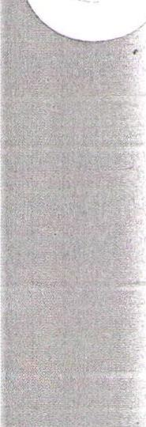
DFATHS--1894
7
Jan. I2--At Mardell, Mrs. pertha Hendrickson, aunt of Andrew Carlson died Dec. 22-36 yrs. Buried In Swedish Lutheran Cemetery at Nelson schoolhoJ.se.
Feb, 16.__m76. Thc)s (TiJablatt died Tues night—convulsions. Feb. 23-"–Mr. and Mrs. C.A.Hallis baby girl died last week.
Apr. I3--Peter H. Hammer—father of H.P.Hamnier died Wed. eve at 65. Leaves a widow and grown up family (asthma)
May 4--1mma Johnson oldest daughter of C.H. Johnson (typhoid malaria) ,June 8--Mr. and Mrs. Ole Halvorson's 2 1/2 rr. child died May -30. sick 3 weeks.
July 27—Jack Albert (living 16 mi. W of Cooperstown) operation. Aug. 31—The aim weeks old baby boy of Mr. and Mrs. Dubois Newell died last Sunday from cholera infantum.
Aug. 3I—The little child of Ole K. Triune died in Kerr's drug store Saturday afternoon.
Sept. 7--The infant girl of Mr. and Mrs. Iver Seim died last Saturday (cholera infantum)
Sept. 7--Karnes Hegge is now clerking for W.C.Jimeson at the postoffice annex fruit and grocery store.
Sept 2I—Fllef Fllefson, aged 37 of Dover Tp. died Sept. Ia..
Oct. I2--Alvin V. infant son of Mr. and Mrs. John .Tvers died Oct. 5-- aiged over 8 months.
Oct. 26—Ole Hogeason, single, in Jessie neighbohood, heart trouble. Nov. 2—Fataerinlaw of M. Simenson died Sat.-83 yrs.
Nov. 20--Henry Retzlaff (suicide) leaves widow and four children. Masonic funeral by Hope Masonic lodge.
Dec. 2I—A.A.Kingsley, age 84, came to Dakota about eight years ago. Took a homestead. leaves wife and six children.
Jan. 4--Wm. Steinborn, 18 yr. old son of August Steinborn--bronchitis, German minister officiated
Deaths-I895
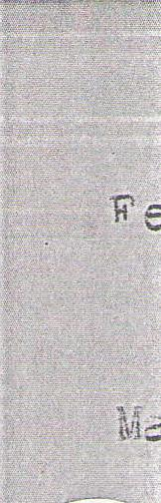
b. Geo. T. Barnard, fathe⁻ of Mrs. .P Smart and, Miss Frannie
Banaard died at his home in 3iverside, Col. 63 yrs. old. Paeu-
Lonia. Left for Cal. about six years ago- was one of Griggs pioneer settlers.
r. I5--Youngest son of Mr. and 117.6. S. Sanderson. April 26--John Stevens, 83, father of Julius Stevens died at home of Julius Stevens
Wednemday.
Detwiller (18 yrs). (heart)--son of_{s}Mr. and Mrs, Henry Detwiller.
y I7--Word was received at Cooperstown of the death of D⁻...Lois Newell, Tuesday, at Battle Creek, Mich.
fly I2--TA Ness (killed by lightning) July 4.
ug. 2--Six weeks old daughter Of Mr. and Mrs. Thomas Hare died Wednesday.
LG. 2--Christian Behm, 75, died Sunday.
• . I6--Died Aug. II, the week old infant of T.F.RObinson of Helena
ov. I--John J. Strande, a brother of Mrs. John Oie, died Friday (ty-
phoid fever)--39 yrs. old. Came to Griggs County in 1888.
DFATHS-1893
24--3 mos. old son of M. and Mrs. Al Richards died Fri. (Congestion of lungs).
Wet. 14--12 moQ. 0 dhte⁻2 of Mr. and Mrs. J.E..110Dermott Feb. 12.
(btomach)
Mar. 13—'⁷¹no year old son of Register of Deeds Hans 0.Lien died. Saturday night (Measels)
27--Wra.klin N. Brown 33 yrs. died. Born in Michigan, a nephew of B.B.Brown.
r. 27—Aniile 0. f , 21 years old died Mar. 17. (T.D.)
Apr. 10-14 yr. old sm of Mr. and Mrs. Pladland, Romness, died. Saturday from paralysis.
Apr. I0--Leo, 22 mos. old son of Mr. and Mrs. Horace Houghton died Saturday (scarlatina)
Apr. 10—Seven yr. old daughter of Mr. and Mrs. A.H.Berg died Thursday from complication of disorders.
Apr. 17--Micnel Retzlaff, father of Julius Retzlaff died. Monday from complications. 77 yrs. old. Leaves widow and several grown up children.
Apr. I7--7ngen Mary Johnson, 18 yrs. (epilepsy) daugli.te,T of 0hn T. and. Sarah Johnson.
May 8—Mrs. Gilbert Olson of Jessie died of lung fever.
May 15--Clara Aarestad, (16 yrs) daughter of Mr. and Mrs. Christian Aarestad (%B.)
May 27--William Henry Boyd, 9 yrs. son of R.W.Boyd who lives about 18
miles nw of eooperstown died. Monday from pneumonia.
June 26—James Alstad, 18, son of Postmaster Alstad at Ottawa, was killed.
by lightning, Monday.
July I0—Fluier Joseph tik):1⁻6,).:1, 3 yr. old sc.s of Mr. and Mrs. Albert Monson died Wednesday of croup.
Aug. 7--We are informed that Lauritz Ueland who started for Norway
several weeks ago, died two days before reaching Christiania. A-g. 2I--Peter Ruglestad died Tuesday at the home of Andrew Watne. (T.B.) Sept 4--The only child, of Mr. and Mrs. S.C.Gunderson died Sat. at age
of 14 months.
Oct. 2-0sc.J.r Nelson, living south of Cooperstown, died last Friday from entritis at age of 24 years.
Oct. 23—Died, Oct. 20, Alice, 4 year old daughter of Mr. and Mrs. Clinton Wilson.
Nov. I3--Wm. McIardie, 40 died. (lung trouble) Leaves a widow and a 13 year old daughter.
Dec. 18--Julia Qualey, IS yrs. old, daughter of Mr. and. Mrs. J.F.Qualey of Mardell (brain fever).
DFATHS--I897
0
J. 27--William Koch, an old German settler living north east of torn lial Monday-68 yrs. old. Leaves a widow and one daughter--aired all winter.
Feb. 5--Mrs. Guro Odegard, wife of T.J.Odegard died Sun. night after a long ilinees--77 yrs--was morther of Mrs. John Syverson, Mrs. N.C.Rukke and Mrs. Knui Tnompson. Leaves husband. and Children.
v. 26--Charles Williams, 43 yre died from cancer of face, last
Ssnday. He leaves a widow and two children . Sermon preached by Rev. :.A.31ras of Methodist church.
rii 9--Mrs. bH.Bustrask died Sun. from cancer.
A-ril 9--August Arnt died Tues. from m.B--23
2I--Mrs. August Johnson died at her home six miles southeast of town Saturday from lung trouble.
May 2I--W.c.Jimeeola, Jr. son of Postmaster Jizneson died Thursday frcsi ;,--eumosia. Leaves a wife and 3 children.
May 28--Karen Klubben, 15 yr. old daughter of Mr. and Mrs. Waldemar Klubben, living southeast of Cooperstown died from consumption Thursday.
May 28--1nga Mattson, committed to Jamestown asylum in 1890 died May S. Jane II--James B. Cooper, eldest brother, of 7.J. 1.r.roo)61!, died
in rolorado Springs, rol. after an illness of some months May
31, 1897.
June Id--Mrs. S.r.Guniereon died rri. after 5 mos. illness. Leaves husband and 6 mos. daughter.
Aug.13--5 yr. old daughter of Mr. and Mrs. John Fore⁻N, killed by getting under the wheels of a loaded wagon.
Sept. 3--Gunder Everson, father of Miss Randy Gunderson died Sept. I, at age of 69 yre.
Se)t. I0--Mrs. John Ressler, Sr. died Tueeday. At Jasiest mi. Leaves husband and several children.
Sept. I7--Anders M. Bakke, a farmer, living 23 mi. northeast of town died last Friday very suddedly.
Se_t. I7--Alfred, the 8 mos. old son of Mr. Henry resser, died
last Monday.
Oct. D--Rev. I. Lundeby of Bue died in St. Paul last Thurs. from the of of an o⁻seration .serformed on him a few days previous.
He leaves a wife and two daughters. His remains were brought back home and the funeral took place on Sunday afternoon, the remains being followed by the largest procession of teams ever s e an in tilz)
. I--The 2 mos. old child of Mr. and Mrs. Clinton Wilson died Tuesday. s . I--The infant child of Mrs. Archie Gorthy was found dead in bed last Wednesday.
c. I5--M's. Nels R. Nelson died Wed. Morning from typhoid fever.
Oct. 22--Thomas G. G^{l}mblett, 77 yrs. died. Among hie children were Wrs. Geo. Newberry, Mrs. C.A.Hall, Mrs. J.M,Taylor, ¹11'.!b. T. Glas:sell, 13v. 7.H.(⁷Tmblett Gimblett. L
roo2erstowa.
Nov.5--Died--Mrs. May (Hagen) Gilbertson, 26 yrs. at her home six miles S of roo)eretown.
Nov. I2--Mrs. r.r.Hicks at her farm home east of tIwn on ndlac.y--Pith measels . Her baby died of measles too. Four children are left, the oldest 12.
Nov. 19--Mrs. rred J. Stone of the Palace Hotel died Nov. 18 from septic fever. Left a susbas1 and tsto daughters.
2.
ii
Dec. 3—Thor Seruraga⁻?d. died from tyIhoid. Dneumonia at Devils Lake . Mr.
Serualgard 7f aZ3 born in Ceilbraxidadalen, Norway Mar. 31, and came with his ⁻-)arerits. to America in 1868. In 1882 he removed.
to Dakota, settling near Coo⁻ierstrma from V.i. ich place he removed in 1394 to Devils Lake L SS a wife and five children. and also
four brothers, Ole, Siver, Anton and Join all of rooperstova:.
- I7Thm Pelersin, 32 yrs. died in south part of Griggs on Dec. IO. Leaves wife and ado yted son. neceased came to these parts ⁻.L:rozn Strum, 'Wisc. a few years back, and a few weeks filed
- )1.1 a L:u inSW 1/4 of 34.
Dec. 24—Adolph Ness, little sin of Mr. and Mrs. N.A.Ness from measles and croup. Died Dec. 16 (one year and 9 mos.)
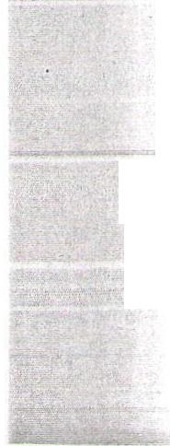
L.7ii.THS--1392

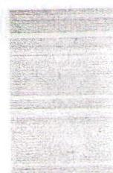

A42ound f ,allatin, an old settler, co _i_Litted Suicide Sunday⁻.
• 35-ens. Scot vande _7_,o3Ert died larc 3 (child birth).. Leaves a fivc children.
¹-- ___n_e 13arteau (7a⁻lde 7.o3art) )03211 in Ililisdale, Colueibia
e-TToi, z, 1361. ⁻1 126.4 C serried. ... 3
s⁻ent _est O her ti•_e and :Dakota,
, first years in latter place. Last Selteilber the faily ⁻voj to Veuilbrota,
G. 2. T e7ell Jle: at shone in T⁻eochester, "Ise. ,1arch 25.
⁻-s born in Ver-ont In 1213. (3⁻troe)
1--- es. 7aeria i. ⁻Turd of ⁻annaford,_:other of 1rs. h. M. Sinclair, died hareh 21, at aee of 77 ⁻ears.
Apr. 22--⁻.:11lia-1 Green, an old settler ti covnty, 79 years old, died her. 14. 1 was born near ⁻tor k in. 1612. hbout 1244 he moved
to Toronto To -nsh:⁻D„ ac, re-ar ---e for ._L-
e - - occupation
nr- on
consisted of sa-rine' and far...lin⁻. In 18/44⁻ie married “argaret
1.) c.) L1 - 2C,
Conels and in I353 they _loved to :Mirth '¹,ruce souse eighteen dies north of Lake Huron. hfter livinL at :_{o}rth 2ruce over c'llrty :ears he mdve, so t⁻nis state in 1035, near Daze; and 1037
roved to Grie,s. Te leaves a Trife and dau7hter.
f' May O. Iverson died ,ionday. hrs. Isabella Iverson as born in
or-ray, 'Dec. 23, 1336 and as over 62 ;ears old at her death. In 1652 she cane -it” her parents to America and settled near
3elvidere, Ill. In 1356 she moved -ith her parents to 1inne⁻sota and i2 1892 case to Ccoperstvm. 3esides her husband se leaves three sons and t-o dau,ghters--1rs. Julius Stevens and 1rs. Anton 7npr.
Ma; G. bhite, an old settler in 'Griggs, died Thursday at Valley
3 , City. Te leaves a wife and t-o Caughters. (Asthma)
Troulson, one of the early settlers in Griggs coming In the early eighties, 41 years old, died -ednesday. hle had a farm four miles southeast of to -n.
May 13----1rs. Andre- Sieiclair (Florence ⁻askell) 24 years old, died 1ay 8. :or at Csakis him, and -hen a re-, years old she -Ith her parents reJ,oved to Coopereton. In hugust, 1896, she qiarriec1 Andrew Sinclair. (C1_116birth). She leaves a husband and little daughter.
July 1. 3. Guest died Thursday. Leaves a husband and seven
children, the youngest, te.e only girl, four years old.
"-,Oct. ⁻ou on (71) father of the Thughton brothers, died at home
of his se ,eadlotOct. S fro- dro„sy and old age. Te as "Jorn
Jan. 22, Ilil at Haldemand, Can. and married _;:aranda Dutton, Oct.
"PIA,
2, 1249. leven children is the result of this union--three, girls
and eight boys. Leven sons no- live in 3T13:3. In 4i/X/7/ 1358 he settlec 12 St. Clair count, and resided there until 1390,
when he ca le to Griggs -.here he has lived ever since.
ov. 3---(⁻nder ⁻fd)-1rs. Ole TogderuC -.c buried Tuesday. (Childbirn). ⁻eaves a husband and two (2⁻⁻::f2e.⁻-
Au:. 12e-ell's. ⁻yde („lother of -..,. S. 7yde), 57 years, died Tuesday. Che ca.,ae to Griggs Couit last fall.
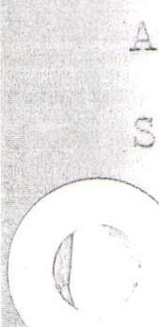
ept. 22-The sad death of 4ix. Church should be a lesson for care-
less hunters - c are in the habit of jumcinc, in and out of bugrgies and other vehicles ⁻^,ith loaded
)t. 13--Andrerr ,Ia:nuson (30) died Thursday at Ole Dahl holae frold peritonitis. .⁷.,e leaves a -ife.
1---Ile LaLtvedt, a fa:._:ier livin :_;cutfi of.Cctton7ood, died last
- 4C yea⁻22z cic7, and leaves a faelily hearth.
.DEATHS--1699
13
Jan. 1².--Ei.Tht months old son of Er. & Mrs. A.E. Richardson died Friday. (Pneumonia) -
Feb. 23---(Under Gallatin) Mrs. H. Johnson died 80 years old.
Ear. 9----Nels Opheim returned from Sheyenne Monday with the remains of Oscar Opheim; will be interred at Mardell.
Mar. 9----Julius Stevens died Saturday. He was born in Norway in 1855 and was 43 years old. His mother died in Norway, and he with his father and the rest of the family came to the United States
in 1872 and settled in Fillmore County, Minn. In 1879, he moved to Valley Uity and in 1883 to Cooperstown, where he has been engaged In the hardware business. In 1883 he married Julia B. Iverson and to this union four children were born: Ida, 15; Oliver, 14; Leo and Freddy. In 1885 Mr. Stevens was elected to the territorial legislature from this district being its first representative. He was a member of Griggs Lodge No. 13, A.O.U.W.
Mar. 23---Mrs. Johanna Heggblad, an old lady living twelve miles east of town, died last Saturday.
Apr. 6----Hans Lunde, 27, brother of R. S. Lunde died Friday. (Consumption)
Interred in Westley Cemeter, Rev. Rasmussen officiated. Apr. 13---C. G. Lunde died Tuesday. (Suicide)
Apr. 20---Mrs. W. H. Martin died from complications April 16. She was born in Guernsey County, Ohio, May 27, 1830. (69 years old) She has had ten children, seven living (four of them residents of Griggs). Have lived at Cooperstown ten years.
Apr. 20---Mrs. Jorgen Soma, septic fever, died April 17. (Child birth ten days ago.)
Apr. 27---Judge Charles H. Johnson (53 years old) died Aoril 24. uivil
War soldier. leaves a wife and five children. (Pneumonia)
Apr. 27---Mrs. Helena Halvorson Hammer, 70 years, died April 21. She was born in Norway, Oct. 17, 1828. Married Peter Christianson
Hammer and was mother of ten children, six boys and four girls, all living. Karl, Anton and Paul reside at Farmington, Minn. Mrs. G. N. Siegner of Spooner, Wisc.; H. P. Hammer, Herman and Gilbert, Mrs. Skofstad, Mrs. E. E. Downe and Mrs. George Condy
of Cooperstown. Nine years ago Mr. & Mrs. Hammer came to Cooperstown from Minnesota where they had lived eleven years since
coming from Norway. Mrs. Hammer has been an invalid for eight years--the result of a fall.
June 15---(Under Hannaford) Thomas Fluke died June 8. (Catarrh of Stomach) He was born in 1846 in Prince Edwards County, Canada. In 1887 he came to Dakota, to make his home. Leaves a widow and seven children.
Aug. 31---(Suicide) Alfred Larson, 42 years old and single, who worked
on the railroad grade with O. A. Lindrot's crew drowned himself in Long Lake. Left a note--
Aug. 31---Mrs. Gottfried Borchart died last Monday from consumption. Leaves a husband and six children.
Sept. 7---From Carrington a telegram conveying news of death of Archie L. BoMen from heart failure, Monday. Leaves a wife and little daughter. Interred at Cooperstown, Rev. B. A. Burns officiating. He was born in Meadeville, Penn. forty-one years ago last Dec.
In 1884 he moved to Cooperstown and from two to three years was landlord of the Palace Hotel and was also engaged in the general mercantile business with C.C. Buck under the firm name of Bowden & Buck. Of later years he was in the general store business at Wimbledon until about two years ago, since which time he had been handling farms and buying stock.
Sept. 7--Gertie, 13 year old daiwhter of Stephen Allen who lives about
28 miles northwest of Cooperstown, was killed Aug. 31 by falling from a load of hay.
Sept. 28-Mrs. Wm. Stewart died Sunday.(Consumntion) She was 39 years old. Leaves a husband and six children.
Sept. 28-Mrs. George Gullickson, 53 years old, died following an operation. Oct. 26--Emma. Ward, a teacher, daughter of Mr. & Mrs. David Ward of
Cooperstown, died Monday. She was born Sept. 29, 1880, and for
the past few years has been a resident of Cooperstown.
ov. 2---Joseph Allen, for many years a resident of Griggs and who operated
a farm in the Romness settlement, died of heart failure Monday. Nov. 16--Alfred Olson, 15 years old, died Wednesday. (Typhoid)
Dec. 7---William Collins, 50 years and single, was killed while working
on an elevator at Binford.
Dec. 7---Mrs. Toiler Nordhougen died Tuesday from a general breakdown. Leaves a husband and several children.
Dec. 28--Mrs. H. H. Helland died Thursday at her home two miles from Lake Jessie. She was 62 years old and leaves a husband, three sons and one daughter. Was interred in Westley Cemetery by Rev. A. A. Sather.

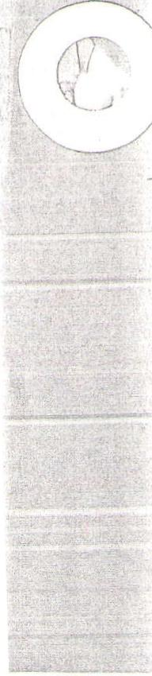

A Christmas spent alone in a 12x 14-foot shanty, miles from the nearest neighbors with a blizzard raging wildly was North Dakota's introduction for Ole O. Anderson of Sutton.
Christmas, Alone On Prairie, Initiation For
Ole Anderson To Griggs County In 1887
This is another in a series of historical articles published in or-to preserve better the facts of early GrIggsi county.
Mr. Anderson came to Griggs county with his uncle, Hans O. Lein, early in 1886, but he declares he did not learn to know the new country until the following winter.
"I was hired to do the chores for the winter," Mr. Anderson said. 'Since we had nothing but a sod barn in which to keep the cattle, my uncle planned to build a new barn. One day shortly before Christmas, he hitched a pair of oxen to the sleigh and started for Dazey, to get a load of lumber.
"He planned to make the trip in two days. But the next morning, a storm was under way. And it stormed for a whole week and he didn't get home until after Christmas.
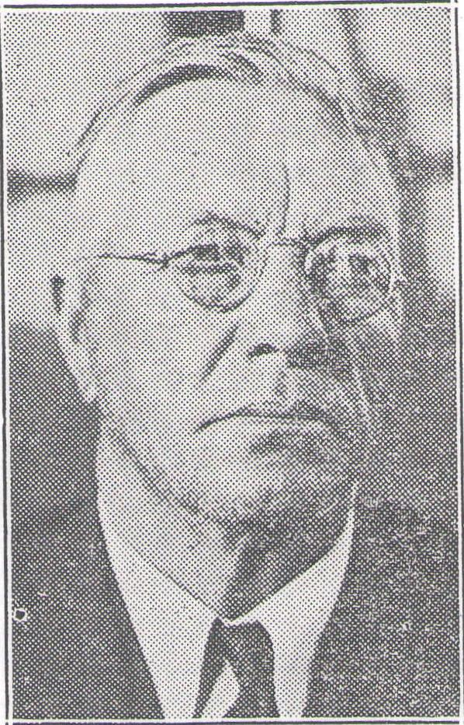
OLE O. ANDERSON
"That was my first Christmas in North Dakota and believe me it was a lonesome one for a 16-year-old boy."
Mr. Anderson, who is now a member of the Griggs county Board of county commissioners, was born in Norway. He came to America with his parents at the age of five and they lived the next 15 years in Monroe county, Wisconsin.
He helped his uncle break up the prairie for fields and in addition to his work behind the plow he took care of most of the cooking.
di
_{C}
ti
a,
T.
ci
F
tl
pi
iII
az
eu
"I was so tired many nights I went right to bed without a bite to eat," he declares.
Used Oxen
They hauled their grain to Hanna-ford with oxen. On one of those occasions, Mr. Anderson says, a storm came up and they failed to find shelter until four o'clock in the morning.
But hardships were not all, he remembers many a "good time at card parties and stag dances."
In the fall of 1895, Mr. Anderson was married to Anna Solberg and in the spring of 1897 they • bounght a farm in Mabel township. They have lived at that place since that time.

11.

Mrs. Anderson ,_{v} Of Finley Dies

WHAT'S YOUR
GUESST
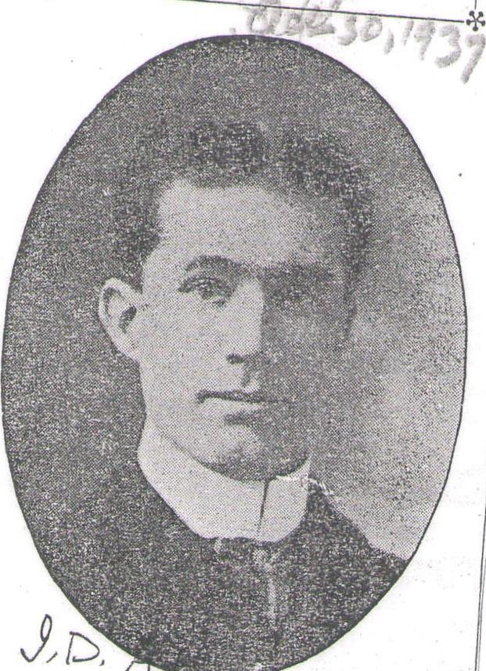
Can you identify the above picture from the Sentinel-Courier files ? To the person submitting the first cardj or letter (telephone calls will not I count) giving the correct name, a year's subscription to the
/ Courier will be awarded Sentinel-
.
Finley, N. D.—Mrs. Gustav R. Anderson, long time resident of Steele county, died Tuesday in the home of a son, Syell C. Sampson, Grand Forks, eight days before her 68th birthday.
Services will be at 2 Monday in Finley Lutheran church, Rev. O. A. Jordahl officiating. Burial will be at Finley with Boe funeral home in charge.
Born at Cobb, Wis., July 25, 1883, Mrs. Anderson came to 3 Steele county with her parents at the age of 16 and was married to Peter R. Sampson in 1900. He died in 1923 and in 1932 she was married to Mr. Anderson.
She also leaves four other sons,
Roy, Cecil, Attley and Lester, all
of Los Angeles; two daughters,
Mrs. Harold (Lorraine) Eide, Los
Angeles, and Mrs. Lawrence (EtiwLii3,tugsta Jessie, N. D. 10.1stepsons, Clarenae—Kridelian, Rogers, N. D., Harold of Whitefish, Mont., Ferdie of Williston, N. D., Elwood of Los Angeles, and Vernon of Seattle, Wash.
..-
d
A stepdaughter, Mrs. Melvin Boe, Bagley, Minn.; three brothers, Oscar Peterson, Portland, N. D., Alvin and Clarence Peterson of Los Angeles; four sisters, Mrs. Ole Anderson, Deer River, Minn., Mrs. Ted Ohnsager, Seattle, Mrs. Albin Carlson, Finley, and Mrs. Ener Carlson, Harvey, N. D.; 10 grandchildren and two great-grandchildren.
L.
A son preceded her in death. A brother was killed in World war I.
ad
7
Cooperstown, N. D. — Funeral services for Mrs. Mary Arneson, 75, of Cooperstown, who died Thursday in a Sharon, N. D., hospital, will be at 2 p. m. Monday in Sheyenne Valley Lutheran
church, Rev. E, T. Fryand officiating.
Mrs. Arneso
Dies In Sharon
Pallbearers will be Harry Eide, Henry Hanson, Richard Qually, Norman Ophiem and Theodore and Kenneth Monson. The body is in S. J. Quam funeral home here.
Mary Halvorson was born Feb. 19,1871, in Ettrick, Wis., and came here with her parents as a small child. She was married to Arne J. Arneson here Oct. 15, 1894. He died in 1917.
Survivors are two sons, Albin' M. and Clarence S., both of Cooperstown; two daughters, Mrs. Helmer Hilstad, Sharon, and Mrs. F.
E. Berger, Minneapolis, and a sister,
Siverina Halvorson, Cooperstown.
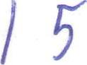

MRS, NELLIE E
A. E. F. CAPTAIN \
PICKS HIS BRIDE FROM COOPERSTOWN
BARNARD DEAD
Former Citizen of Griggs County Passes Away at Denver, Colorado. I A7
Miss Lilliann Blackwell Weds Wit- ham H. Dial—Settings for the
Wedding Are Exceptionally
At-
tractive—Couple Will Live in Akron, Ohio.
Jonquils, ferns and pink roses, simply arranged thruout the rooms in home of Mr. and Mrs. E. W. Blackwell, parents of the bride, formed very pretty setting for the wedding of Miss Lilliann Jane Blackwell and Mr. William H. Dial, which was solemnized at noon on Wednesday, February eighteenth. An improvised altar had been arranged in the reception hall, and before this the bridal party stood while Reverend Mr. Bennett read the double ring marriage service.
Miss Esther Glasoe very sweetly sang "Beauteous Night" and then, as she played the Mendelssohn Wedding Larch, Miss Lilliann, attended by ! - her sister, Miss Ruth, descended the stairs and was met by Mr. Dial and
his attendant, Hollis Blackwell,
brother of the bride. The bride wore a lovely gown of white organdie and lace and her boquet was a shower of
pink roses and freesia. Miss Ruth, - attired in gown of maize chiffon, carried a cluster bouquet of daffodils and fern.
After the wedding service, a four-course luncheon was served. The table was daintily decorated with sprays of smilax, yellow candles and a center of Jonquils with a Kew-pie bride and groom therein ensconsed. Unique and very pretty little place cards, painted by Miss Ruth, I were used. During the luncheon Victrola music was played, and Miss Glasoe sang several songs.
Of unusual sincerity and warmth are the congratulations and good wishes which friends within and without this community shower upon Mr. and Mrs. Dial, who left on the evening train for visits in iMinnea- !lolls and oh

The many old-time friends in Cooperstown and Griggs county of Mrs. Nellie E. Barnard, sister of Hon. R. C. Cooper of this city, will regret to hear of her death which occurred at her home in Denver, Colo., Monday night of this week. Mrs.• Barnard has been in poor health for two years and was in the sanitarium ;until last fall when feeling better she returned to her home. Four weeks ago she was taken very sick and has gradually failed froin that time. The real cause of her death was tumor of the liver. Mrs. Barnard received a -very severe shock Many years ago while out in a severe blizzard one night, being lost in the storm, and never really recovered from that shock. She and ⁻her husband came to Griggs county in 1881 and were among the first settlers here. About 1887 they moved to California and
Mr. Barnard died 1 Los Ange-
27.'
les about 14 years a_{r},o, the fam-
ily then moved to Colorado where they have lived ever since. Two children survive her, George and Emma. The deceased was born in 1843 and would have been 65 years old in April of this year. Mrs. Barnard was a devout
Christian woman, devoting the
44sad,
Te5o1„ aanpoal :worm( oeluold uonan mod aidoed
. 0A.9116,0¹1
3uptio.),I alp to Innom
1⁰ 2sraTo iteqiNT
4Inbiili-1
1103Uci
dp.IF
p.reoq ?aapiba..7 aaq oqf. lT 'FirS
2,nituoa aa₄aA).„ Ault." pauatm aoin
otp. „quill plow; awns ool oq Luf
⁻pp3s „`uado an; In anon nooq sun sso
Stu lly„ •oaaq sopiAnan Sanuonn qn.m „unnuonnutimoo 4a.⁻taas„ p
Jana pun at( g SI104.19i p₀31S.0
-11tutuoa aoj lasunoa 0P1
dldaa ‘stio4aupz.sum ,⁴tui
- sosopi 11B111.11131.1 ₆,;, M011 4SIT10111110A0.1 ode noL 'b
paiina ani nl aaon 11130111 nt
- sruannto.)Wa ea4411¹¹¹¹³04
-413,111130:_klIT 0113E)OS 13 viol. `soltris
atn tit i.ttate qainos unissau 'strei
.v 7 4sApttri—putqaos II Suanuaeo '131ssull-paAn pt al o'14 Sa4unoo taaAa ul „lsitton.nlo,kaa Purl 20111ItuPy—'uo42upisi
- snaoRni
-onau e lua6v j
SN31
early years of her life to the
building up of church work at
Cooperstown and helped to build
the present Congregational church of which she was a member at that time. She had a large circle of friends and her home was a hospitable one where the friends and neighbors used to gather to enjoy its genial warmth and hospitality. The old homestead is three miles east, of town and is now owned by Mrs. Thu. Upton. In the passing away of this estimable lady the children lose a loving parent, the relatives and nation a splen-_ did specimen of American motherhood.

Mrs. Bemis, Pioneer ,\'0 Teacher, Dies At 89
Cooperstown, N. D.—Funeral services for Mrs. Wetha Bemis, 89, pioneer Steele county school teacher who died at her Greenview township homestead Thursday, will be in the Presbyterian church here at 2 p. m. Saturday, Rev. W. Ray Radliff officiating.
Born Sept. 8, 1856, at-Lia.Pling-ten.; Wis. Mrs. Bemis was married to Henry A. Bemis there in 1876. The couple came to North Dakota in 1882, homesteading on the farm at Greenview. Mr. Bemis died in 1929. Active in civic affairs, Mrs. Bemis taught school in this area for 29 years.
She leaves a daughter, Mrs. Myrtle Porterville of Cooperstown, and two sons, Melvin H., Minneapolis, and Byron M. Bemis of Finley, N. D.
The S. J. Quam funeral home is in charge. Burial will be in the Cooperstown cemetery.

BlaGkwell, Drummer Boy
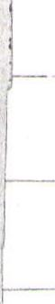
of Civil War Days, Dead
Charles E. Blackwell, 1308 Douglas avenue, who went into the Union army when 14 years old as a drummer boy, died at his home today. He was 71 years old, and was a member of Zion commaridery and the Loyal Legion of the United States. Mr. Blackwell was a resident of North Dakota for many years. where he was engaged in the lumber business. Before going to North Dakota he lived in Minneapolis and returned to this city about a year ago. He is survived by his' wife, two sons and a daughter.
Mrs. Hannah Bye
Services Friday $-⁻6
Services for Mrs. Hannah Bye,[ -resident of Fargo five years and formerly of Galesburg and Hunter, N. D., will be at
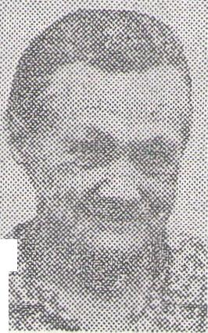
2 Friday in Stardahl Lutheran chur ch near Galesburg, R e v. Manley Gjer de officiating.
Marie Ann Norby and three g r anddaughters, Imogene, Joyce and Dorothy will 1, sing, with Mrs. Joseph Moen as organist. Mrs. Bye
Pallbearers will be Robert Kyllo, Herbert Halvorson, Otto Moen, Peder Paulson, Tony Erickson and George Baldock. Honorary pallbearers will be Julius and John Kyllo, A lber t Norby, Edwin Thompson, Otto Justad and Martin S tockmoe.
Burial will be in the church cemetery with 0. J. Hanson funeral home in charge.
of his life before him, was •a visitation such as the community never before has known. In many a home, not alone his own, men and women
.aia auuuiueia
for support and ^{y} fell to the floor. Help was immediately summoned, Dr. Reese, who is caring for the practice of Dr. Westley in his absence, and who, also, was a school mate_ of Dr. Brimi's, arriving within ten minutes of the time he fell. Though all possible restoratives were
resorted to, there was no evidence of life. Dr. Truscott of Binford, deputy coroner under Dr. Brimi, was summoned and agreed with Dr. Rees that the cause of death was heart •
failure.
None knew that Dr. Brimi had been at any time troubled by his heart. However, he had told Mrs. Brimi at one time that he did not have as strong a heart as he might. But it is certain that his condition) was never such as -to cause him any alarm. He had been very energetic and apparently strong of body in every respect. But it is known tha he realized throughout Monday night that his heart was not functionin as it ought.
He returned about 'six o'clock in the evening from a call at Hanna-ford, visited with I. D. Allen, who was making a clock repair at his of-, lice, and went home to supper. Dur-i ing the visit with Mr. Allen there was no hint that the doctor was feeling other than his usual self, nor was there evidence of illness at his supper.
Upon the departure of MrS. Brimi for the meeting at the school hour the doctor entered into an evenin of play and entertainment with hi children, Betty, age 9, Robert, ag 6, and William, a little over two yeans of age. The children have Since told of occurrences at home which indicate that not all was well with their father, -though they thought nothing of it then. The doctor had groaned twice or three time: during the evening, and -once used his stethoscope to study his hear action. With the children away it bed he announced that he was going, to his office to look after the fur, nace fire' urged ⁻them not to be afraid and that their mother would, be home very soon. His leaving in this manner was not at all unusual, but there is the chance that, while
wept.⁻ And wtih .them the children were stilled. Here was a death that even the children observed in more than the casual way. Here was a death which was a severe and personal loss to hundreds. Twenty-seven years of activity as a citizen and as a doctor had not, then, been wasted years, but years in which he
had done much to serve, ease and
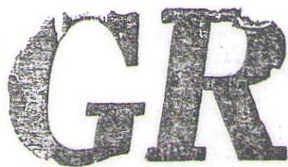 | I | 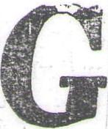

make happy those with whom he came in contact. Words to not respond at an hour like this to give expression to the true feeling of the whole community,—one of sympathy to the wife and children in their loss and of realization that we have all lost heavily in this passing.
SENTINEL—VOL. 27—NO. 40
411 MINIIKOrilMIMOIMI
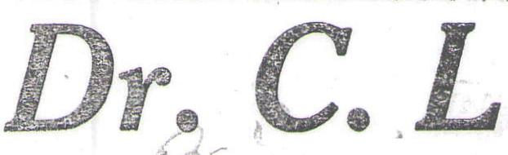
•
HEART A RH C^{I}
CAUSES END; WAS
A MOCK TO ALL
Passed Away Monday Even-
ing on Way From Home
to His Office.
PIONEER DOCTOR HERE
Remains to Eau Clare, Wis.,
for Burial; Has Three
Children.
Funeral services will be held at the Lutheran church at 1:30 this - (Thursday) afternoon, Rev. Estrem officiating. The remains will be taken to Eau Claire, Wis., for burial this afternoon.
Dr. Brimi is dead, carried out of life so quickly as to liken that in-. terval between his apparent health and death to a flash.
On Monday night, following an evening at home with his three child' en, while MTs. Brimi was in attendance at the Parent-Teachers' ,e⁻e..ting at the school house, he left home at about 10 o'clock for his office, apparently to replenish the furnace fire there. He never reached his office. He got as far as the Benson photo studio and residence, which is next door to his office. Mr. Benson, while in the act of locking the door, pushed open the storm door, to observe that Dr. Brimi wasstanding there. "I'm a very sick man; let me come in," Mr. Benson says, were the last words spoken by the doctor. He helped himself almost', inside the house when he placed his
Carl Linneaus Brimi was barn at Eau Clare, Wisconsin, on April 9, 1876, a son of Mr. and Mrs. Sever Brimi. At Eau Clare he attended the grade schools and high school, but did not finish the high school work before entering Rush Medical College, Chicago, to stury for -the career which was to be his. He. graduated from that college in 1897, following which he spent several months as an interne there.
In January following the year of his graduation, he came to Cooperstown and established himself in his profession. That and the several years which followed did not hold for him in his work the conveniences which are available today. It was in those years that the life of a country doctor called for the greatest sacrifices from the man. Those sacrifices Dr. Brimi made. Long hours on the prairie, in bitter cold, behind a team of horses, with surroundings all strange, were only a few of the discomforts which he had to encounter. From the very time of his establishing here he has been recognized as an able physician, and there ire hundreds of homes which have been made the II-apple–r in dark hours through the confidence inspired in the thought "Brimi is here." His work had won him a very fine practice.
On June 28, 1904, Dr. Brimi was married to Miss Elizabeth Ann
he did have his furnace to look after,
he was urged to leave more⁻for the
reason that he desired to get to his several years. To this union the office where he could obtain some three children, who have been ham-known of that walk from home to
stimulant for the heart. All that is led in an earlier paragraph, were his office, a distance of less than
three blocks, has been written.
this community whose death might
bring as deep a sorrow as fell over
the people when the word that Dr.
Brimi was dead was drifted about.
For twenty-seven years he has been
a
a constant resident of Cooperstown,
a fine character respected and loved
on every hand. And then, carried
It is difficult to suggest another of ,11,1anke, who had been in Cooperstown born. The family was a great delight to -the doctor, and the hours with his children were daily looked forward to by him. In this case Death robs a home of a parent who vas very much a part of the life of le was most needed.
Brimi offered his services to the gov-
eems to rob them at an hour when
ach occupant of that home, and
During the recent world war Dr. away as he was, without a word of nment and was stationed at Fort warning, with only forty-seven years ^{Riley} _{and} Camp Dodge.
of life behind him and the best part
0 N JANUARY 6, 1951, at ii:o8 Los os Angeles was
Those frightening explosions you may have heard — or heard of
mirth About the "Softie ROOM"
Condensed from The Saturday Evening Post
The Saturday Evening Post (December 4, '54), copyright 1954 by The Curtis Pub. Co., 67
Independence Square, Philadelphia 5, Pa.
rocked by a mysterious explosion Investigation revealed no sign of a dynamited building or shattered gas main.
A similar unaccountable explosion occurred in Dallas, on February 25, 1952. The sheriff's department promptly instituted a search for some skulking nihilist believed responsible for four previous blasts that had terrified the city.
During the ensuing months the elusive "ghost 'bomb" — the newspapers already had a name for it —struck other communities from coast to coast without warning. Houses were jolted in the San Francisco area, and the frightened occupants were convinced that an earthquake had occurred. Nassau County in New York suffered a near-panic when the eerie missile exploded over Long Island with "thunderous force."

Corey Ford
t%i< l.04^A. ev-eA)
Chicag2S was the victim of a midmorning explosion that started wild rumors of a fallen flying saucer. Tacoma, Wash., reported plate-glass windows broken; Ottawa, Canada, was hit with such concussion that plaster showered down over housewives working in their kitchens; when Boston was shaken, sight-seers in search of a crashed airliner caused one of the worst traffic jams in history.
What our startled cities have been hearing — a sound we must be prepared to hear more and more from now on — is the so-called sonic boom, latest and least understood phenomenon of the air age we live in. When a jet airplane flies faster than the speed of sound, it sets in motion an impulse similar to the bow wave of a motorboat. The plane may be eight miles high and invisible to the naked eye — a fact which accounts for much of the ghost-
S'..3
_{m}r,
• 69
silty party. Colonel I something about )prehend the misand slunk indoors. Air Force tests are he desert or open ger jet jockey who buzz job over a is subject to severe
:n no known cases )logical effects on n the sonic boom, or shock. There 2.s of harm to live-the sudden blast. n in the West, a several hundred in a corner of the p death. Cattle on been stampeded, s against barbed been reported by c farms, when the alarmed by the young.
all the experts )m is here to stay. can control its no way to elimi. A boom generye has been heard _ Nay.
idustry and the ig every possible lent unnecessary nities. The most in panic. Instead boom, they urge, Mail the sound as at we hate mod-
'r craft never anticipated the possi,_{r}ck. bility that the shock waves would
ruary
jet. tonic tund g at
egui the rack hing genomc the
ver, ) its ited i of o it, ame six sity opy teal ling out I to -ace t as no fter
trd, the or wo, ant )on the the
de-
ur-
1955 THE TRUTH ABOUT
have any such explosive effect. Aero-
nautical experts were as baffled as the
rest of the public by the early news-
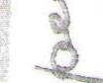
paper scareheads about the ghost
bomb. The solution of the mystery ,_{tu}was accidental.
In March 1950, Lt.' Col. Richard Johnson was performing a routine sei-17s7rexperimental dives at Wright Air Development Center near Dayton, Ohio. He was flying the F-86A, entering his dives at 43,00o feet. In order to establish the same path on each dive, a radar-tracking technique was used. After the first dive, the radar operator called Colonel Johnson abruptly and requested him to terminate his mission; there had been an explosion inside the radar shack. A lengthy investigation failed to reveal any sign of damage.
Again Johnson dived his F-86A through the sonic barrier, and again the bewildered radar operator reported an explosion and asked him to land. By this time, Johnson and other observers had begun to suspect a connection between the dives and the blasts. He made four more tests along the same dive path; four more explosions resulted.
Colonel Johnson returned to his home in a near-by suburb, where he found his wife pacing the sidewalk excitedly in front of their house. While he'd been off flying today, she informed him, the neighborhood had been rocked by six separate dynamite blasts, and local police and fire departments were searching high
15
THE "SONIC BOOM" 69
and low for the guilty party. Colonel Johnson mumbled something about hoping they'd apprehend the miscreant promptly, and slunk indoors.
Today official Air Force tests are conducted over the desert or open water, and any eager jet jockey who attempts a sonic buzz job over a populated district is subject to severe disciplinary action.
There have been no known cases of adverse physiological effects on human beings from the sonic boom, save from fright or shock. There have been instances of harm to livestock panicked by the sudden blast. At a poultry farm in the West, a sonic boom caused several hundred chickens to pile up in a corner of the pen and smother to death. Cattle on the range have been stampeded, gashing themselves against barbed wire. Losses have been reported by the owners of mink farms, when the nervous females, alarmed by the boom, killed their young.
On one point all the experts agree: the sonic boom is here to stay. Flight regulations can control its force, but there is no way to eliminate it completely. A boom generated in a shallow dive has been heard as far as 5o miles away.
The aviation industry and the Air Force are taking every possible precaution to prevent unnecessary trouble for communities. The most serious danger lies in panic. Instead of fearing the sonic boom, they urge, the public should hail the sound as convincing proof that we hale modern aircraft.
tmetireount
',EMBER 8, 1932 | COURIER—VOL. 50—NO. 36

Leading Figure

Pioneer Builder Dies
A man whose life and deeds have been indissolubly linked with the development and progress of Griggs county is lost to the people in the death of Halvor P. Hammer. No single man, probably, has had larger or more far-_reac.hing..contacts with the people of this section in which he Played_.suc.h a_ large part as a builder. His death is widely mourned and his passing -takes from.⁻ the community a man whose life has been closely ;woven into⁻its fabric.
Mr. Hammer well typified and glorified a kind of pioneer to which
this country will be forever indebted. It was through the vision of him
and his kind that this land has
been transformed from the unbro-
ken wilderness and prairie into its
present state. In doing so he cre-
ated a large personal fortune, but
that was only incidental to his in-
terest in the work in which he led.
His life has been one such as of which story books tell. A poor and penniless Norse immigrant he selected the new Northwest, with many others of his kind, as a place to make his home and fortune. He succeeded admirably in attaining the goal to which he aspired. From homesteading and farming he branched out into various phases of business, and his success was for years a by-word over a large territory. Late years and a depression robbed him of
HALVOR P. HAMMER the fruits of earlier toil, but not
of the pride and memory of accomplishment while it was being created.
Though his business connection included practically all kinds found within the county, his first and foremost business of farming held his greatest interest. In it he excelled •to a great degree and his efforts won him state and national recognition.
All that H. P. Hammer accomplished during⁻ the unsually full years which comprised his span of life was made in spite of early handicaps of poverty, ack of educaton and want of opprtunity, except that which his own ingenuity and resource created for himself. He was in every sense' a self-made man, and one to whom many with far more auspicious beginnings looked often for advice and help.
In his business dealings he made an enviable reputation for his honesty and integrity. In his prosperous years he was ever ready to aid the deserving, and many have been helped through his efforts.
In his passing the city and county has lost a man whose activity and influence have made for him a permanent place in its history. It is a niche such as few of its citizens will occupy, whether that occupancy is considered in the light of the living or in the place reserved for its honored and reverenced dead.
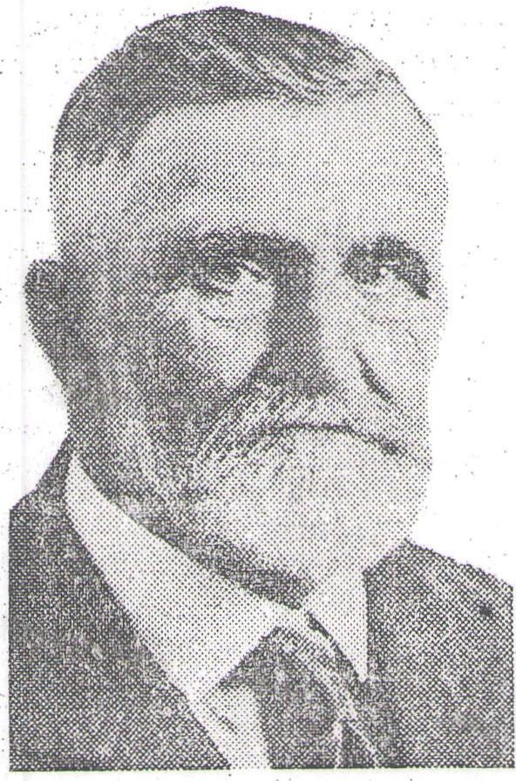
_.0
In History Of
Griggs Is Dead.
Hundreds Pay Tribute Mon-
day To H. P. Hammer at
Rites Held In City
Resided Here 50 Years
Was Outstanding In Various
Fields Of Activity In
This Section
Hundreds of friends and neighbors of Halvor P. Hammer, paid tribute to a dominant figure in the development of Cooperstown, Griggs county and central North Dakota Monday afternoon as funeral services were held for one who had served as leader in this section for half a cenutry.
The services were held in the Cooperstown Lutheran church where so many gathered that scores were turned away. Rev. I. O. Jacobson officiated.
Mr. Hammer died at his home here 8 o'clock last Friday morning as the result of two paralytic strokes suffered earlier in the week.
Been Here 50 Years •
Since the spring of 1882—fifty years •ago when Mr. Hammer settled on a homestead near Lee post-office, then located about 20 miles north of the present site of Cooperstown—has the name of H. P. Hammer been a vital part of the history of this section.
Engaging in farming at that point for four years, Mr. Hammer moved to Cooperstown in 1886 and purchased the livery stable from the Green Mountain Stock Ranching company and also a meat market from Julius Retzlaff.
These ventures were the beginning
of a long and varied business career that saw Mr. Hammer active in the general mercantile business, banking, real estate, farming, stock-raising and other activities.

Celebrated Pitcher Returns F |  |  |  | 

Chet Hoar, celebrated hero of Cooperstown's early baseball history, whose flaming fast bill and superb control wrote many a dizzy chapter of victory into diamond annals, this week came back to the old lair where he gained his fame.
Now a resident of Pasadena, Cal., he and Mrs. Hoar, a sister of Mrs. Theo. A. Marquardt, were guests at the Marquardt home in this city from Saturday until Wednesday. They were enroute to their home on the coast after visiting in Minnesota.
Thus, after 40 years, the man who made baseball in Cooperstown, once again trod the streets and walks along which his name has become a legend.
For many a great baseball player and many a great pitcher has been written into the records of baseball in this community, from the mighty Hugh McDaniels, to the recent remembered figure of Floyd Stromme.
But in that vast array stands out the name of Chet Hoar, the invincible hurler to whom all hitters looked like the Great American Out. Hoar, whose fireball was a burning white streak across the plate,.
whose curve was a dizzy, slashing
swerve, whose control was the su-
preme perfection of pitching art.
Hoar, the shut-out king. Hoar,
the invincible.
In Cooperstown, Hoar recalled that Cooperstown once beat the Fargo team of the old Northern league two times in one day and shut them out both times. He recalled how the team won the state championship at Devils Lake, how it traveled on lengthy trips into southern Minnesota, meeting all corners.
A quiet, retiring person, the former ace whom old timers swear was as good as any pitcher in baseball, spoke in a low, subdued voice that seemed to be habitual with him. His eyes, though he is now past sixty, are still bright and keen, but age and hard work have taken the spring from his legs. He operates a transfer line in Pasadena now. Lean and muscular, he stands a little over six feet and even at his present age, the pitcher's build is still very apparent.
In the Sentinel-Courier office, he enjoyed chatting with friends who
came, 1⁻1-6‘arh,,, inat, iii cv,s Iii-toari.icularly did he enjoy reading the old files of 40 years ago. He remembered a game played with Wheatland which was written up in the July 12, 1900, issue of the Courier. He remembered lots of things
While walking down the street on Tuesday, he met a group of young fellows whom he did not know. But as he passed, he heard one of them remark to the others in a whispered voice, "That's Chet Hoare."
He keeps upon the game. He knew all about Bob Feller, sensational young hurler of the Cleveland Indians, and he kept track of Floyd Stromme after seeing his name in the papers, not knowing he was from Cooperstown.
He recalled how people came from miles around with horse and buggy to see the baseball games. He remembered with pride his great catcher, Tamber, who slid off the freights every spring and always mysteriously disappeared when the season was over.
Not least, of course, was his joy in renewing old acquaintances, and in meeting the second generation wearing the old, familiar names.

Hadlock Dies In
McVille Monday
Came From New York State; Was Once Employed By Publishing Company
William Hadlock, Lenora township farmer, who had been a resident of Griggs county since 1909, died at the McVille hospital Monday from a heart attack.
Hadlock was born hi New York state, and on Nov. 4, 1909, was married to Anna Mattson at South Bend, Ind.
He farmed in Griggs until 1926, when he went to Minneapolis and resided there until 1932. He was ern, played in the Twin Cities by the Webb Publishing company.
He returned here in 1932 and had been living here since.
Surviving are his wife and a daughter, Mrs. Olivi van Hoensen of Cat-ton, N. Y. Mrs. Hadlock has a brother, Jens Mattson, at McVille.
Rites were scheduled for Friday.
Tom Halvorson Is „Buried Tuesdiy.
Last rites for Tam Halvorson, res ident of this community for many years, were held in the Cooperstown Lutheran church Tuesday following his death Sunday in the McVille hospital. Rev. P. H. Holm-Jensen officiated at the rites.
Since 1904, Halvorson had counted this community his home. A single man, he worked mostly as a farm laborer and at various times followed the carpenter's trade.
He was born April 7, 1881, in Norway and came to this country as a young man. He had only one known relative in the United States, this being a cousin, Austin Berg, of Cloquet, Minn.
He had been in the hospital for three weeks preceding his death. Interment⁻ waspnade in ⁻the Cobper town cemetery.
••••••• tvwx un rtaken.
Pioneer Griggs Lady Dies On West Coast
Griggs county friends have received word of the death at Roseberg, Ore., on October 9, of Mrs. Fred Hodgman, one of the early day residents of this county. Death occurred at Roseberg and resulted from a stroke. Mrs. Hodgman had been making her home with a daughter at Myrtle Creek, Ore.
The Hodginans were early residents of the county and homesteaded about four miles north of Coopers-tows.
Mrs. Hareland Of
Hannaford Is Dead
Mrs. Ludvig Hareland of Hanna-ford, died on Thursday of last week after an, illness of several weeks.
Funeral services were held Monday of this week at the Hannaford Lutheran church, with Rev. E. 0. Lee officiating.
She and her family lived east of Hannaford a short distance until a few years ago when they moved into the village. She has lived there since.
She was 52 years old. Recently she Suffered repeated strokes.
Her husband and children survive.

h o u s 'nstantly
Kilied in ar 4ccident

William H. Hadlock.
William H. Hadlock, age 58 years,
5 months and 2 days, died at Joplin,
Montana, Dec. 6, 1916.
Mr. Hadlock was born July 4, 1858, near Darlington, Wisconsin. In ₄, 1881 he came to Barnes county as a pioneer, and to Griggs County in the fall of 1896, making his home here _ until a few years ago, when he removed to Montana, where he resided
until the time of his 'death.
Mr. Hadlock served Griggs county as county ,commissioner for two terms, resigning from the board at the time of his removal to Montana. He was always honest, faithful ancl conscientious in ,the performance of his public duties and as a friend and
neighbor was universally liked and
respected. His numerous old time friends and acquaintances in this county will regret exceedingly his taking away.
Deceased is survived by one brother, R. M. Hadlock, and three sisters, Mrs. Weltha Bemis of Cooperstown,
N. D.; Mrs. Frank Wilson, JoplinA4 Mont.; and Mrs. James Wright, Hampshire, Wyoming.
Services were held over the remains at Valley City on Sunday afternoon, and interment was made in the Valley City cemetery.
Valley City Courier: William Hadlock, a former citizen of Griggs county, and some years ago a memter of the Griggs county board of county commissioners, died very suddenly at Joplin, Mont., last Friday. The deceased was walking across the street and at once pitched forward and died from .aeiirt
failure. Ile was unmarried. and
was engaged at farming, Ths re-
n:sins were brought o Valley Oily Sunday morning by his sister, Mrs, Weltha Bemis, of Cooperstown, and Reese Hadlock, a brother, from Joplin. The funeral was held on Sunday afternoon, Rev, W, C, Lyon officiating, Interment was made in Woodbine cemetery alongside of his mother, who died some years ago. Many of our old time citizens remember the deceased, Wm, Had-lock was a man of very few words, but one of strong friendship for those whom he called friend.
_;1
Meets Death While Helping
Husband and Son Saw
Wood at Farm.

- --
Obituary
Elsie Theresa Pfeffer was born on February 7, 1898, in Waterville, Minn., the daughter of Mr. and Mrs. Ben Pfeifer. In 1901 the family moved to Delamere, this state, four years later moving to Jessie where she grew up and received her education.
On. January 1, 1919, she was united' in marriage to Etho J. Husel, living here one year, near Jessie the following year; and near Finley another year, when they moved to the Husel farm south of Cooperstown where they have lived since. Three boys were born, Raymond, 15; Donald, 6 and Harold, 4. They with her sorrowed husband, survive, as well as five brothers and six sisters; Ben of Chicago; Mrs. Frank Zimperih, Jessie; Harry, Crookston, 1V1inn.; Mrs. Joe Moraski, Kansasville, Wis.; Mrs. R. L. Croak, Fargo; Caroline, Seattle, Wash.; Agnes, Detroit, Mich.; Mrs. D. C. McAllister, Seattle, Wash.; Melvin, Fargo; Joseph, Moorhead; Al, Chicago. Both parents and one sister preceded her in death.
Out-of-town attendants at the funeral were: Mr. and Mrs. C. H. Husel and Betty of Fargo; Gertrude A. Pfeifer of Bismarck, Mrs. J. R. Law of Fargo, Mr. and Mrs. Melvin Pfeifer of Fargo, Mr. and Mrs. R. L. Cronk of Fargo, Ed. Crist and S. F. Wankel of LaMoure, Mr. and Mrs. Fred, Wankel of Grand Rapids, Mr. and Mrs. A. C. Bjerken of Fargo, and Mr. and Mrs. Harry Pfeifer and Delaine and Vernon of Crookston, Minn.

RI" | 1 • WVIF 7.111,

Funeral Held on Tuesday
Leaves Husband and Three
Sons to Mourn Over
Tragic Passing.
A tragedy which prostrated members of her family and shocked the entire county occurred at the farm home of Mr. and Mrs. Etho Husel
last Saturday when Mrs. Husel was instantly killed while helping her husband and son saw wood with a circle saw. Mrs. Husel was struck in three places with parts of the broken saw blade, one part striking her in the forehead and cutting a fatal gash down across her face and neck. Another piece struck her in the chest while the third caused a gapping wound in her arm.
Mrs. Husel had been assisting her husband, who had been ailing, with farm work during the morning. Part of the mernin:g was spent in grinding feed, following which they decided to saw into stove lengths several fallen trees. The three were engaged in this work and had sawed two of the timbers.
Examines Saw
Believing that the saw was not functioning properly Mr. Husel stopped the machinery and made a thorough inspection of it, testing the boxes for tightness, the shaft, etc. Everything seemed in good order and two more trees were sawed and then the third tree was lifted to the saw. Less than three inches into the Wood the saw broke, the shattered pieces striking Mrs. Husel, causing her instantaneous death. Mr. Husel saw her fall, stopped the machinery and rushed to town for a physician. Death had been instantaneous, however.
Brother Of Fargoan Dies At Cooperstown
George C. Hartman of Cooperstown, N. D., brother of Mrs. Anna M. King, 813 Ninth st S, Fargo, died Saturday in Cooperstown. A pioneer settler of Mable township, near Sutton, N. D., he was born June 15, 1861, in Wesley, Ontario. Feb. 23, 1895, he was married to the former Maude Sprague in Cooperstown. Surviving besides Mrs. King, are his wife, three sons, David J., of Glendale, Calif.; Robert S., of Taft, Calif., and Tom S., of Cooperstown, and a brother, Henry A. Hartman of Jackson, Mich.
Funeral services will be today in the Cooperstown Presbyterian church at 2 p. in. (MWT), Rev. W. Ray Radliff officiating. Burial will be in the Hartman memorial cemetery.
Funeral services were held in the Presbyterian church in Cooperstown, in which deceased was an ardent worker, on Tuesday of this week with Rev. D. D. Jansen of Jamestown officiating, after short services had been held from the home. Bur, ial was made in the Cooperstown cemetery. __Pall hearers were Ed L.t_uprich, M. E. Wilkinson, Carl Kruschwitz, Geo. H. Johnston, Alfred Retzlaff and Matt Bendickson.
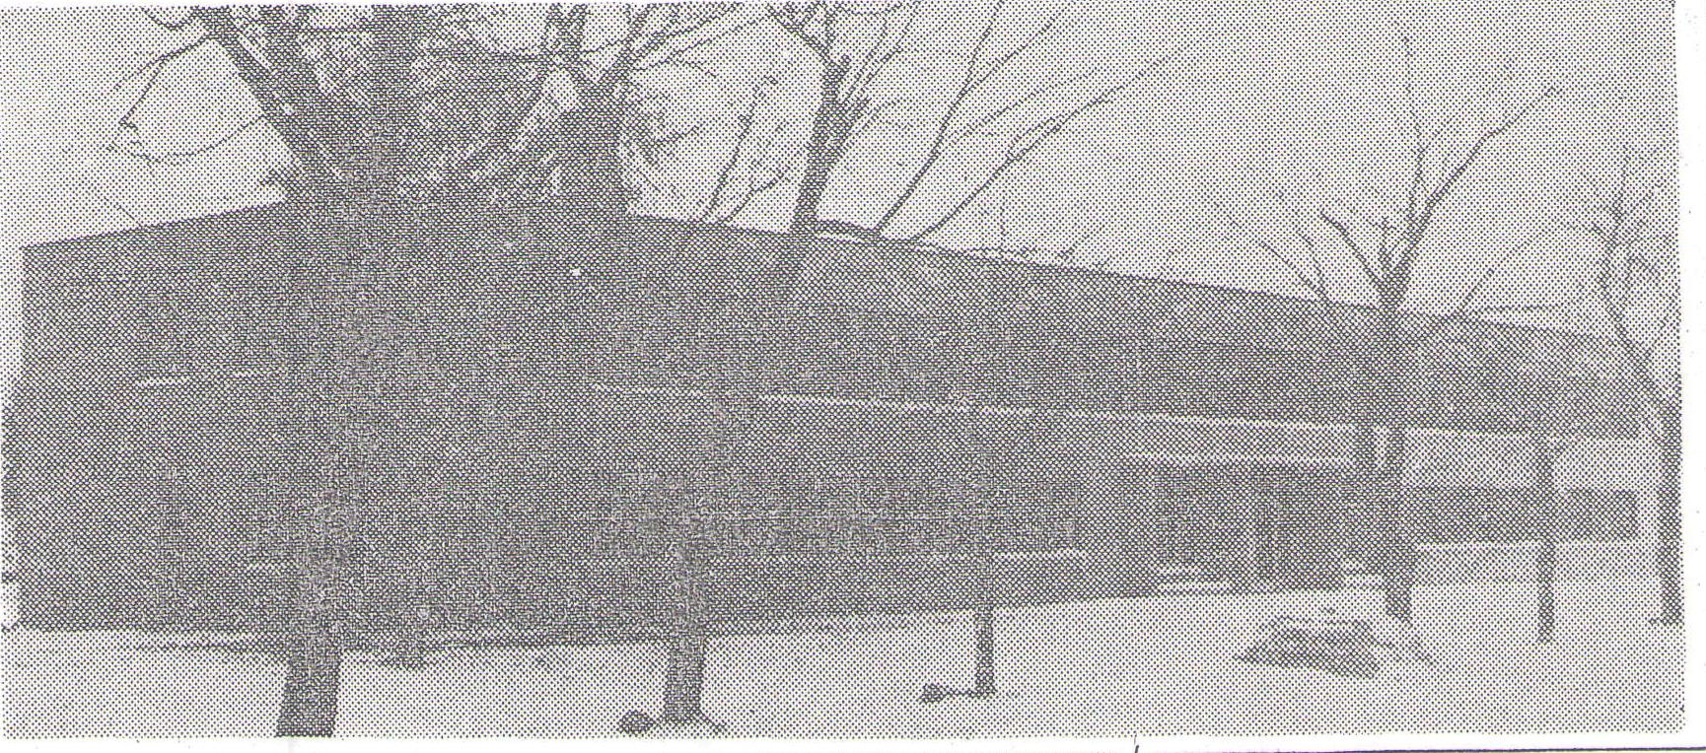

pen $450,000
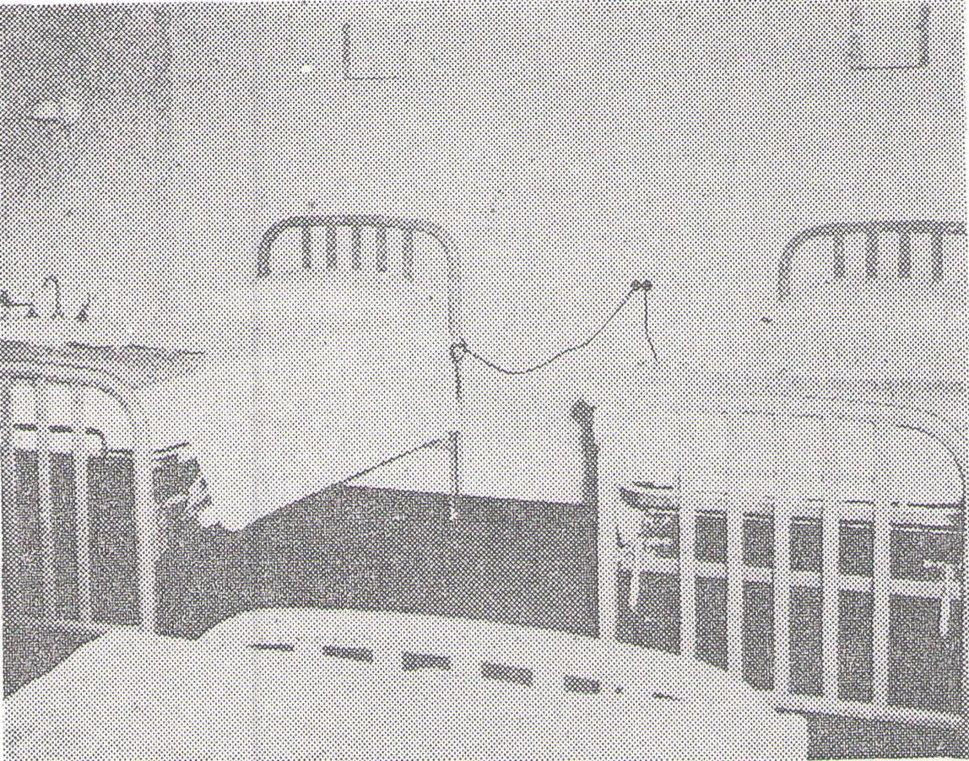
THE GRIGGS COUNTY COMMUNITY HOSPITAL, a $450,000, 26-bed hospital, was opened last Thursday at Cooperstown, N. D. The exterior photo was taken by Jarrett Studio, Cooperstown, and the picture of the hospital room by Alan E. Frigaard of Cooperstown.
a
•
n
7.
d
T.
n
d
r.
e
7.
g
ti
T | 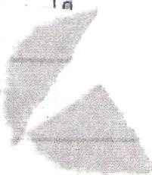 | 

Hospital At
, )
Cooperstown
Special To The Fargo Forum
Cooperstown, N. D.—The $450,000 Griggs county Community hospital was opened here Thursday after receiving state health department approval.
The 26-bed hospital, for which bids were let in the spring of 1948, began operation without special ceremonies. E. S. Berdahl of rural Cooperstown was the first patient, with three others being admitted by afternoon.
Mrs. Robert Mack is administrator and superintendent of nurses. There are seven nurses at present of 14 employees.
I t t t
Dr. K. M. Wakefield, who came here a month ago from Winnipeg, will be joined this weekend by Dr. W. L. Fennell, also of Winnipeg.
* * *
.Opening of the hospital culminates plans of many years. Of toe cost, county residents contributed more than $314,000, much _{t} of it coming from operation of the Cooperstown non-profit, monopoly i liquor store. The federal govern-nit At_{o}irnished the balance.
Arneson is president of the Griggs County Hospital association. Other executive board members are Ed Reitan, vice president, Carl Johnson, treasurer, and Tupper Howden, secretary.
1
a

It Has Had Noted Publishers

Newspaper At Cooperstown 75
Years Old

BY A STAFF WRITER

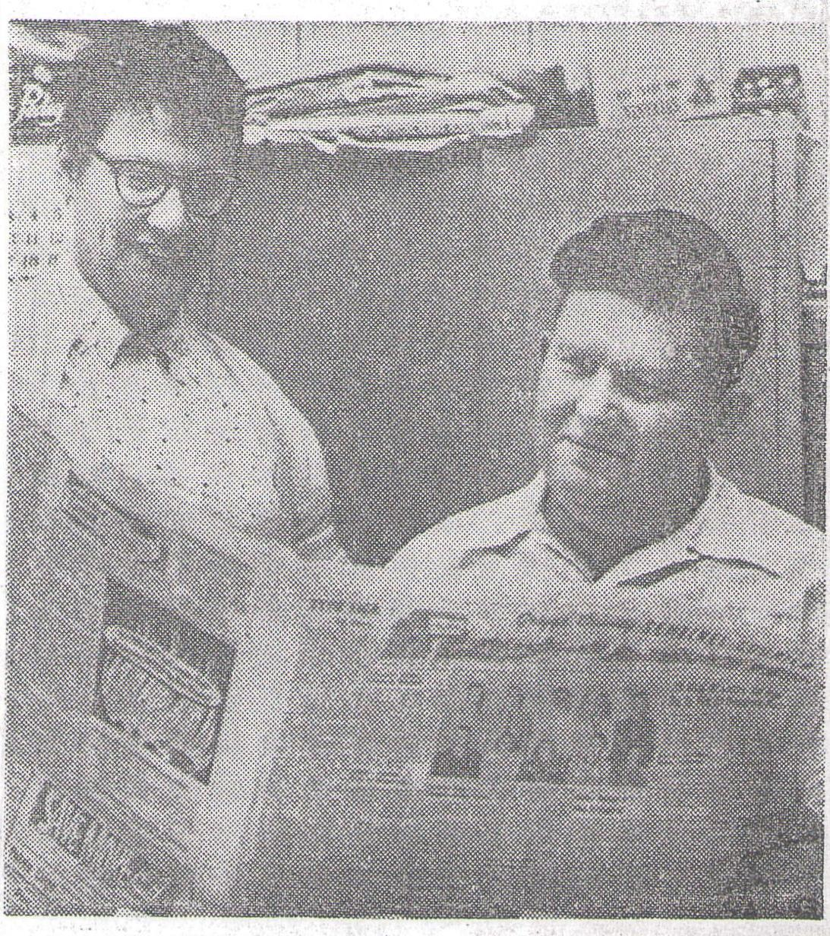
MR. AND MRS. G. J. FRIGAARD, publishers of the Griggs County Sentinel-Courier at Cooperstown, N. D., glance over an
+ ÷
issue of the weekly newspaper, which is 75 years old this year. (Forum Photo)
paper designated by the governor. a record of
The Cooperstown newspaper was
so designated.
"It sure must have been fine while it lasted," Mrs. Frigaard said. "But then they changed the law.
"It must have led to a reform move," she added.
* * *
The Cooperstown Courier, and the Griggs County Sentinel, with which it was merged, have provided residents of the area with
the city almost since
its founding.
And Mrs. Frigaard, who writes a highly readable and witty column for the newspaper now, is the latest of several who have had a way with a paragraph.
As an example, from the April 27, 1888, edition, come these comments from an anonymous columnist:
"Although I have only voted the Republican ticket, I believe the
COOPERSTOWN, N. D. {/B — The Griggs County Sentinel-Courier is 75 years old, and its present owners are planning a birthday party soon.
The weekly newspaper has had several distinctions, Mrs. G. J. Frigaard, wife of the publisher and a columnist for the paper, said.
The newspaper was founded by a man who later purchased the Detroit Free Press in Michigan, one of the nation's better known newspapers. He was Edward D. Stair, who in addition to his newspaper career was a nationallpaper career was a nationally known financier.
And two of the newspapers' editors later served for years in the United States Congress.
One was Gerald P. Nye, a United States senator from North Dakota for 20 years.
The other was James H. Sinclair, who had been a manager of the Griggs County Sentinel, which along with the Cooperstown Courier became the present newspaper. Sinclair, who died in 1943, was a representative from North Dakota 2nd District for 16 years, until his defeat in 1934.
"The paper had another distinction too," Mrs. Frigaard said, in mulling over the institution's history.
"In the early days of statehood it was the official state newspaper for the publishing of "estray" notices, which announced that a valuable, domestic animal had been found.
For a few years before the turn of the century, a person who found such an animal was required by state law to publish a notice of the find three times in a weekly newspaper in the area. If the animal was not claimed, it was the duty of the newspaper to publish a notice in a state weekly -news-
Republicans are getting the big head."
And, "Simon Ouren says⁻it would be better for all to give the sheriff a bucket of tar, and no warrants to issue. And it would make for less taxes."
* * *
The Cooperstown Courier was founded Jan. 26, 1883, by Stair.
Stair, who had worked as a reporter for the Fargo Argus for a short time before moving to Cooperstown, sold the newspaper a year later to one Frederick Adams. He sold it five years later to Percy Trubshaw, who in turn sold it in 1912 to H. S. Rearick.
Rearick in 1901 purchased the Griggs County Sentinel. Among signatures on the deed of sale was that of James H. Sinclair, t h e newspaper's manager.
A few years later, Rearick sold to a group of farmers in the Cooperstown area. Nye became the paper's manager, and held the position until he was appointed in 1925 to fill a vacancy in the United States Senate.
He was elected in 1926 and was a senator until his defeat in 1945.
* * *
The late Harry M. Thompson, who died in 1948, purchased the newspaper after taking over the managership when Nye left.
For a short time the newspaper was operated by Mrs. Thompson, who later turned over the operation to Mr. and Mrs. Kenneth Anderson, now publishers of the Barnesville Record-Review in Minnesota.
The Frigaard family, long-time residents of Cooperstown, purchased the newspaper in 1949. For a time Alan, now of Marshall. Minn., and a brother of the present owner, held an interest.
It is now owned by Mrs. M. G Frigaard, the publisher's mother and Mr. and Mrs. F. G. Frigaard The present publisher was sher iff of Griggs County from 1948-50

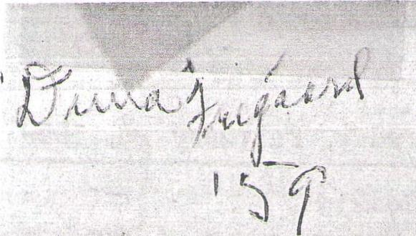
TYPE LICE
by Duna
All the winter vacationers are still down south but the sunshine is here in North Dakota, living up tc the slogan somebody coined that goes somewhat like this: "Sunny Nodak, when the sunshine spends the winter."
It may seem warm now by the subzero standards we've measured by in the past month, but 1958 topped it. February 25, 1958, the mercury stood at 66 degrees in Cooperstown — a mark that's not likely to be equalled for some time to come.
I'm trying to be scientific about it and find some good' use for the end of February and beginning of March. Reading has lost its appeal; so has knitting. It seems too early to start spring sewing and housecleaning. It's even too early for spring fever. Wading in mud puddles is out; I'm too old for that.

Lincoln, Washington and I have had our birthdays,
Valentine's day is over, Easter is a long way off.
The seed catalogs are beginning to lose their charm; the furniture seems to have aged ten years since last fall. Pretty soon it will be muddy outdoors and there'll be tracks all over the floors.
About the only thing the end of February and beginning of March are good for is borrowing trouble. Help yourself.
If I seem excessively gloomy, you'll forgive me. The other day I transplanted some cactus plants and ran a spine into my left index finger. No amount of coaxing or prodding with a needle will bring it out. I've been typing on the cactus sticker for nigh unto two days and I'm getting pretty fed up. It just doesn't seem
vlarracceQ1,,

COURTENAY, N. D''.—The fu-_{t}11/10⁴(;ei_ he⁾

time merchant here, will be at under the firm name, Foshodlt _{Brothers.}
1:',30 Wednesday in Courtenay
Presbyterian Church. The Rev.
In recent years he had con- tinned it with a son, Howard. His
Dr. Philip Rice .willofficiate.
first wife, Emma Haggberg, died
Born in Norway Dec. 13, 1837, and he married her sister, Min- Mr. Fosholdt moved to Iowa nee Haggberg, April 28, 1905, at with his parents in 1881 and to Cokato, Minn.
Griggs County, Dakota Territory, Besides his wife and Howard: in 1882. The family homesteaded he leaves two other sons. Harold near Cooperstown, and he attend- of Williston, N. D., and Clarence, ed Bruflat Academy at Port- of Marshfield,' Wis.; five grand land, N. D., taking a business children and five great-grand

children.
Eddy Funeral Home of James town, N. D., will have the service.
0. T. Foshyjdt Rit s Wednesday
•
neral of 0. T. Fosholdt, 91, long-land operated it will a brother,
course.
In 1892 he became a a general store here. twice had fire losses
partner in
The store
and after
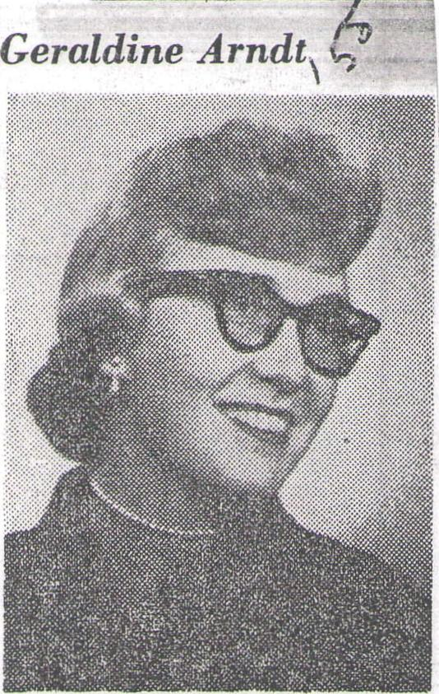
Geraldine Arndt
July 24 is the date chosen by
Miss Geraldine Ann Arndt, daugh= ter of Mr. and Mrs. William F. Arndt, 421 10th St. N., Moorhead,'
for her wedding. She will become the bride of Torkel Fuglestad, son of Mr. and Mrs...H. E. Fuglestad, 523 4th St.
The ceremony will be in Our Savior's Lutheran Church of Moorhead.
Miss Arndt and Mr. Fuglestad are graduates of Moorhead High School. Miss Arndt attends Concordia College. Mr. Fuglestad attended the college before entering the Navy. He is serving in the Mediterranean.
(Clay Applications)
Malta _Ye.id and Bernice Haaland,
both Coeirr Viiivn, N. P.
Robert F. Bolinger and Shirley A.
McCannel, both Ft. Riley, Kan.
'Alfred Fogdgud⁻'_{i} Rites At Walum
WALUM, N. D.—The funeral of Alfred Fogderud, 64, will be at 2 Friday in St. Olaf (Evangelical) Lutheran Church in Walum, the Rev. Axel Thompson officiating. I Mr. Fogderud died Monday in his farm home, across the county line in Barnes County, south of here. He was born on the same farm, Aug. 18, 1893, the son of Mr. and Mrs. Andrew Fogderud.
He attended local schools and a term at NDAC and married Millie Bjugstad in Barron, Wis. Feb. 16, 1916. They had farmed here since.
Besides his wife he leaves three sons, Harley and Gerald of Hanna-ford, N. D., and Floyd of Columbia, Calif.; a daughter, Mrs. Donald (June) Lende, Walum;
A brother, Conrad of Hannaford; three sisters, Mrs. Eric (Cora) Wallin, Laura and Eva Fogderud, all Steele, N. D., and 13 grandchildren.
The body, is at Quam Funeral Home of Cooperstown, N. D.
Cooperstown Funeral) For Herman Feske,.
COOPERSTOWN, N. D. =The; funeral of Herman Feske, 77, of Binford, N. D., lifelong resident of this area, will be at 2 Friday in Quam Chapel, the Rev. Carl P. Cornelius officiating.
Mr. Feske died in a local hospital Tuesday. Born at Michigan,' then Dakota Territory, Nov. 18.1 1880, he grew to manhood in the area and farmed until retiring. He had never married.
He leaves a brother, Charles W. Feske of Cooperstown. Four brothers and three sisters preceded him iri death.

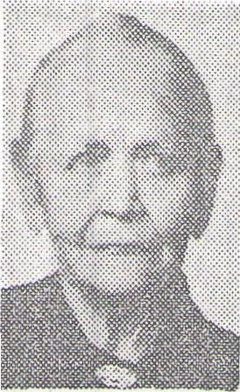
Mrs. T. T. Fuglestad, 96, of Cooperstown, N. D., who came to Griggs County in 1883, died Sunday at her farm home six miles southeast of Cooperstown.

Mrs. Fuglestad Dies At 96;  Sealed In Griggs In 1883 | 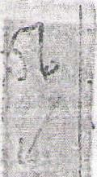


anniversary.
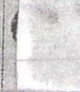
Sketches Of Pioneer Life i4
o,
Are Of Value To The State
A story of pioneer life in North Dakota is contained in the remi:
niscences of an early day resident of the Cooperstown, N. D., area, in the Concordia College library.
Titled "Memories From the School of Life," the sketch was written about 1937 by Torkel T. Fuglestad, who homesteaded in Dakota Territory in 1383.
Following his death last June 24, the account, written originally in Norwegian, was translated jointly by Mr. Fuglestad's son, Prof. R. E. Fuglestad, professor of biology at Concordia, and by Dr. Charles H. Skalet, professor of Greek and Latin at Concordia.
Running t o 19 typewritten pages, the account is mimeographed and bound in paper covers. It tells briefly why Mr. Fuglestad chose to come to America and of some of the ex periences common to most of the settlers who established homes in advance of the tide of migration.
There are references to the financial troubles of the early days; an account of a prairie fire and its amusing side; a tale of one of the blizzards which-occasionally visit the Northwest, and other stories of the struggles of the settlers.
Mr. Fuglestad also records one of the human traits which alleviate the burdens of mankind, that of going to the assistance of a less fortunate neighbor.
The sketch is a valuable addition to the accounts of life in the early days of settlement in North Dakota. It is to be hoped that many of those remaining in the thinning ranks of early day settlers will leave reminiscences to guide the historians in their , ,,search for the correct storyp;of the Northwest.
She was the mother of R. E. F u g lestad, 523 4th St. S.. Moorhead, professor of biology at Concordia C o 1- 1 e g e, and of Bjorn Fuglestad, Cooperstown, a Mrs. Fuglestad state representative from Griggs-Steele.
The funeral will be at 2 Thursday in Wesley Lutheran Church at Cooperstown. The Rev. Sanford. Soma will officiate with Quam Funeral Home in charge. A-4- - "'"'⁼'Abigael Osland was born
1359, in Norway. She was Manic
to Mr. Fuglestad June 15, 1880. Coming to the U. S., they home-1. steaded in Griggs County in 1833.; She had continued to reside on the farm in Bald Hill Township until her death. They built their first;-1 home—a sod house—about 20 feet from the present farm home.
Mr. Fuglestad died June 24, 1954,
nine days after their 74th wedding I ;
Surviving are four daughtersd
Mrs. Lars (Inga) Loge, Mrs..
Swen (Lisa) Loge and Mrs. Os-
I
wald (Gudrun) Aalgaard, all Cooperstown, and Mrs. R. (Thelma) Norheirn, Pasadena, Calif., I three sons, R. E., Bjorn and Thor-I; veld of Luverne, N. D.; 36 grand-I, children and 56 great-grandchiP dren.

c"⁻⁻•⁻•

BOok Relates
Pioneer ineidenis
A new addition to the Concordia College Library is a book originally written in Norwegian entitled "Memories from the School of Life."
The book was written by Torkel T. Fugelstad, •the father of Prof. R. E. Fugelstad of the biology department. It was translated by Dr. C. H. Skalet of the language department, and Prof. Fugelstad.
Depicted in the book is early life in Norway and the life of the pioneers around Cooperstown, N. D., where Torkel T. Fugelstad homesteaded in 1883.
Stories of drought, blizzards and prairie fires, exemplifying the ingenuity and courage of the pioneers, are related in the volume.
Marcia Pearson,s Fuglestad To We
Mr. and Mrs. C. Edwin Pearson of St. Paul announce the engagement of their daughter, Marcia, to Dr. Vercel Fuglestad, son of Mr. and Mrs. R. E. Fuglestad of 523 4th St. S. Moorhead. The wedding will be held May 29 in Arlington Hills Lutheran Church in St. Paul.
Miss Pearson will be graduated in May from the Bethesda Hospital School of Nursing. Dr. Fuglestad is a graduate of Concordia College and the Baylor University College of Medicine in Houston, Tex. He is now completing his internship at Miller Hospital in St. Paul.
Miss Pearson was honored at a miscellaneous shower given by Miss Minnie Sigdestad and Mrs. Joel B. Sigdestad. She was also
honored at a shower given by the interns at Miller Hospital in St.
'Miss Pearson,
Fuglestad Wed
In St;Paul ^{Y}A
The wedding of Miss Marcia Pearson, daughter of Mr. and Mrs. C. Edwin Pearson, St. Paul, and Dr. Vercel Fuglestad, son of Mr. and Mrs. R. E. Fuglestad, 523 4th St. S., Moorhead, took place in the Arlington Hills Lutheran Church in St. Paul Saturday.
Dr. Melvin Hammasberg officiated at the ceremony.
The bride wore a ballerina dress with a bodice of white imported lace and a nylon tulle skirt, She carried a colonial bouquet of pink roses, snaps dragons and sweetpeas.
The maid of honor, Miss Mar' lene Anderson of St. Paul, wore a blue lace ballerina dress and carried a colonial bouquet like that of the bride.
Miss Mary June Sigestad of Moorhead was soloist.
Cormac Fuglestad of Moorhead was best man. Spencer Loge, Cooperstown, N. ID., and Roald Fuglestad, Moorhead were ushers. The reception was held in the Fireside Room of the church.
After a wedding trip to northern Minnesota Dr. and Mrs. Fuglestad will be at home at 170 Summit Ave., St, Paul. FortraVdr the bride chose a print linen dress and wore a corsage of pink tole/ and sweetpeas.
Morning, May 30, 19,4⁻
r -
_,-T. T. Fugles &Dies At 98;
At Coopershc n Over 70 Years
Torkel T. Fuglestad, resident of 13, 1856, in Norway and married the Cooperstown, N. D., corn- Abigael Osland there June 15, 1880. munity more than 70 years, died They came to the U.S. the same Thursday in his gsys, - .,, year and in 1883 they homesteaded
farm home six z in Bald Hill Township, Griggs
miles southwest County, where they have since re-
of Cooperstown. sided.
He was 98. Mr. Fuglestad also leaves a third
Mr. Fuglestad son, Thorvald of Luverne, N. D.;
was the father four daughters, Mrs. Lars (Inga)
of Prof. R. E h ± Loge and Mrs. Swen (Lisa) Loge,
Fuglestad, 523 both Cooperstown, Mrs. Oswald
4th St. S., Moor- *
, (Gudrun) Aalgaard, Hannaford,
head, professor N. D., and Mrs. R. (Thelma) Nor-
of biology at helm, Pasadena, Calif.; 37 grand-
Concordia Col- children and 49 great-grandchil-
1 e g e, and of dren. Three children preceded
B j o r n Fugle- Fuglestad him in death.
stad, a representative in the North Mr. Fuglestad had been an offi-
Dakota House of Representatives. Cer in the Norwegian Array be-
Despite his advanced age, Mr. fore coming, to America. Fuglestad had been relatively
active to the day of his death. He
and Mrs. Fuglestad had observed Griggs Couple
their 74th wedding anniversary June 15. She is 94.
d74Y eark
In 1947, at the age of 91, he took '
, e
his first airplane ride, going on a i s.
Special to The Fargo Forum
visit to Norway. i
The funeral will be at 2 Sunday COOPERSTOWN, N. D.—N ar-
il) Wesley Lutheran Church south ly 100 persons gathered on •t h e
of Cooperstown, the Rev. Sanford T. T. Fuglestad farm near here
Soma officiating. Burial will be at Sunday to help the Fuglestads
Cooperstown_{u} with the S. J. Quam
neral Home in charge. celebrate their 74th wedding an-
niversary.
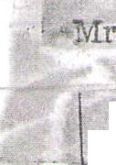
* * * On hand were six of the couple's
. yuglestad was born March ;even children, and a number of
the 35 grandchildren and 49 great
* * * grandchildren. Of their three sons
Family members with Mr. and and four daughters, only Mrs.
t
Mrs. R. E. Fuglestad, 523 4th St.
_ Rosenius Nordheim, who lives in S., Moorhead, will be their son, ^{r}` Pasadena, Calif., was unable to Se. Ilford, a graduate student in so-
attend.
cial s' Afare at the Florida State Their children include: Bjorn
Lolversity at Tallahassee, and Fuglestad, Mrs. Swen Loge and their son and daughter-in-law, Dr. Mrs. Lars Loge, and Mrs. Gudrun and Mrs. E. V. Fuglestad of St. • Aalgaard, all of Cooperstown; Paul. Another son, Tork, a seaman, Thorwald, Luverne, N. D., and will spend the holiday at Naplesa R. E. Fuglestad, Moorhead. Italy. He has recently visited th •-• The Fuglestads were married Isle of Capri and Rome.
June 15, 1880. The couple, now
* * * ' 98 and 94, gathered on the farm-
)

t-
0
7
house lawn with the guests, took
i
part in the community singing and

Passed Away Early Sunday
Morning Following the
Injury.

1 Mr. Elsaas was a devout church
man and a leader in the Ringsaker
congregation church work, where
f^{r}uiferal services over his remains were held yesterday.
Surviving Mr. Elsaas, besides his wife and two sons, are two brothers and two sisters: John, Ole and Mrs. Chris Jacobson, all of Pekin, and Mrs. John Knutson of Romness township.
Carl Elsaas will ever be remembered as the best kind of neighbor, friend, husband and father. His passing is a distinct blow to the whole community, which is united in
_{oF HoRsE iN HEAD} a .sfpirit _{and} of sympathy for the sorrowed
w sons.
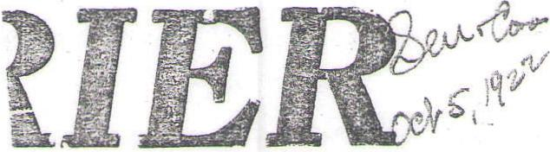
COURIER—VOL. 40—NO. 24
'CAR, ELSAAS IS
KIL1 ED BY KICK
FUNERAL HELD TUESDAY
Was Very Highly Respected
by All Who Knew
Him.
Though four days have since his
/passing, this community has not yet been able to fully realize that Carl • Elsaas, farmer residing north and east of Cooperstown, is no longer of this world. His end was brought about so suddenly and so unexpectedly that his many friends will long experience difficulty in realizing that he,is gone.
Saturday evening at about 8:30 o'clock Mr. Elsaas was in the barn on his farm caring for the horses. One of his boys was just outside the barn, and it was this boy, and he 'alone, who witnessed the injury inflicted upon his father through the kick of one of the horses. The hoof of the horse struck Mr. Elsaas squarely upon his right temple. The blow caused such injury that the j)man never regained consciousness passing away at seven o'clock the next morning.
Funeral services were held at the Ringsaker church Tuesday afternoon Rev. Estrem officiating, and the throng in attendance at the funeral strongly showed the high esteem in 'which Carl Elsaas was held by the many people who knew him.
Carl Otto Elsaas was born in Ottertail county, Minnesota, July 18, 1881. In 1889 he moved with his parents to Griggs county, where he has since made his home.
In 1900-he bought the farm where he lived until time of his death on October 1st. In 1905 he married Miss Amanda Johnson. To this union two sons were born, Mancer and Chester, lads who have just reached the age to greatly appreciate the worth of their father. The boys and Mr. Elsaas were inseparable pals.
Mrs. Matt Evanson Dies At Minot Home on Wednesday
Mrs. Matt Evanson, former Coop-. erstown resident and known here as. Ida Stevens, died at Minot on Wed-, nesday of last week, according to word received by her Cooperstown friends.
Mrs. Evans= was the daughter of Mr. and Mrs. Julius Stevens who liv-I ed in Cooperstown for a period of ¹ about 35 years. They both died here. Mr. Stevens was in the hardware business, and later Mrs. Stevens operated a millinary store.
Mrs. Evanson left here about 25. years ago.
She has three brothers, Oliver, Leo and. Fred. _
;Willie Erickson
Dies In⁻Glasgow
Youth Ws Born in Coopers, town; Had Wife and 2-Year Dld Son
Willie Erickson, 24, former Cooperstown youth, passed away late Wednesday at Glasgow, Mont., after 'an extended seige of pneumonia and spinal menengitis. Funeral services were held in the Free Lutheran church at Zahl, N. D., the home of his parents. Interments was made in the Riverview cemetery at Williston.
Willie Erickson was born April 12, 1911 in this city. In 1929 he graduated from the high school in Thief River Falls, Minn., and went to Zahl in 1933 following his marriage to Miss Sophia Frandsen at Bottineau that year. For the past 18 months he had been employed at the Midwest lumber yard in Glasgow.
He •is survived by his wife, one son, Richard, 2 years; his parents, Mr. and Afrs. Edward Erickson of Zahl; five brothers, Harold of Glasgow, Trygve of Cooperstown, Leif of Crookston, Minn.; Arthur and LeRoy at Zahl; two sisters, •Mrs. Nels Vol-del of Sanborn, and Mrs. G. A. Beito of New Effington, S. D.
VOL 24, NO, 35 ,„
a
Even C. Evenson
i
11 a 41
Even C. Evenson quietly passed ' away at his home here last Saturday evening, Jan. 14. The direct cause of his death being carcinoma of the stomach and the bowels. While the deceased had been suffering from the dread disease for many months and his life dispaired of, the end expected from day to day, his death ., was a severe shock to his wife, children and dear ones who had - gathered at his bedside.
Even C. Evanson was born at Baldwin, Wis., on May 26, 1860, died Jan. 14, 1'928 and on the next birthday would have reached the age of 68 years.
1882 he migrated to Griggs county, N. D., where' he was anioag the first settlers of that vicinity to take up a homestead and where he made his home until 1925 when he moved to' Medicine Lake, Mont., where he engaged in farming until a year and a half ago when no longer able to stand the vigorous farm work, moved' to Medicine Lake and purchased the Cafe which he conducted with the aid of his'wife until his death.
In, 1884 he was united' in marriage to Miss Emma Stee of Griggs -county. To this union five- children were born, one died in infancy, the four living are: Rose Sletten of Hannaford, N. D.; Mrs. Clarice McF-ul of Piapot, Sask., Canada; Manley Evenson and Mrs. Lillian Saby of Medicine Lake.
In 1906 his first wife passed away and in 1913 he was married to' Katherine Saby who • he leaves a widow who deeply mourns his loss.
Besides the wife and children the 'deceased leaves two brothers, Ole of S. St. Paul, Minn., and Melvin of Parshall, N. D.,. four sisters, Mrs. S. K. Larsen, Mrs. P. K. Larsen, Mrs. Conrad Olson all of Baldwin, Wis., ( and Mrs. _Ed Heleman of Chicago, Ill. All the children and his brother Melvin and sister Mrs. S. K. Larsen were in attendance at the funeral.
The deceased was a man of even temperament and a personality which' made friends of all acquaintances. He was a home loVing man who centered every thought and worked hard for the proper bringing up of his children and the welfare of his home.
The sorrowing widow and child -1 ren have the sympathy of the community in their bereavement.
The Medicine Lake (Mont.) Wave:
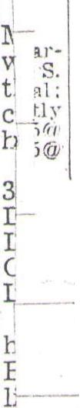
Jam Evers Rites Set At Binford.

:Y;
in-
iz-4c: 1. 2 im. :ies
6c:
2
un,
ing
st-
n
funs
Selected--
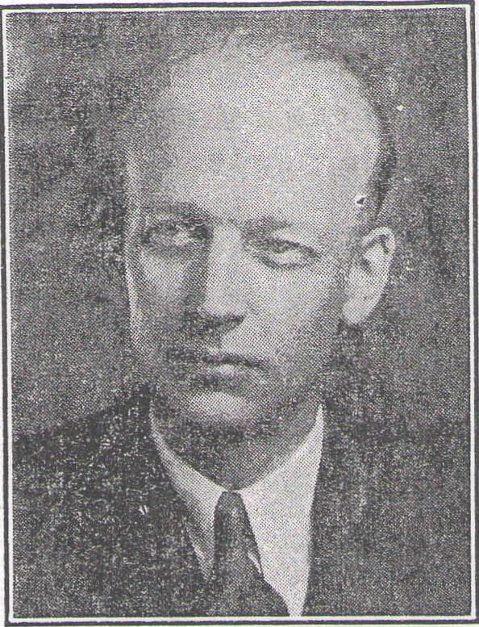
Shown above is E. V. Estenson, superintendent-elect of the Cooperstown school system. Mr. Estenson will come here from Sharon where he served as school head for the past 15 years. He holds a master's degree, granted by the University of Wisconsin and in ,addition has completed the equivalent of one year's work toward a doctor's degree. I
Ot
•°` I
Ole Egela
Rites Today
Cooperstown, N. D. — Services for Ole Egeland, 82, who died at his farm home near here Saturday, will be at 2 p.m. today at the Romness Methodist church. Burial will be in the church cemetery.
He was born June 4, 1868, at Flikefjord, Norway, and came to the United States in 1893. From 1893 to 1917 he lived at Rugby, N. D., moving from there to Mc-Ville, N. D. He moved to Aneta, N. D., in 1927 and in 1944 came to Cooperstown.
He married Anna Sophia Torgerson at Warren, Minn. Mrs. Egeland, who survives, is also a native of Norway.
Other survivors are four sons, Oscar of Salem, Ore., Thimlmar of Aneta, N. D., Arthur of Grand Forks, N. D., and Theodore of Cooperstown; three daughters, Mrs. H. B. (Anna) Blanchard of Grafton, N. D., Mrs. D. A. (Esther) Cuba of Macomb, Ill., and Mrs. C. P. (Selma) Brodahl of Grand Forks; a brother, Peter of St. Louis; a sister, Gurena of Norway, and nine grandchildren.
Quam funeral home of Cooperstown is in charge.
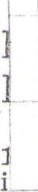
1 y Morning, September 4, 1951
Binford, N. D. — Services for John Evers, 89, will be at 2 p. m. Thursday in the Binford hall, S. J. Quam funeral home of Coopers-
! town in charge. Burial will be in the Binford cemetery.. Mr. Evers died Sunday in a Valley City hospital.
Born in Bruce county, Ontario, Canada, he came to North Dakota. in 1881 and in 1883 homesteaded in Clearfield township south of here. He made his home there until a year and a half ago when he retired. In 1892 he married Sarah Hellwig, in Ontario.
Surviving are Mrs. Evers; two sons, Albert and Norman of Bin-ford; a daughter, Miss Martha Evers of Binford; seven grandchildren, and five brothers, Charley in Ontario, August of Binford,
— Louis of Edmonton, Alberta, Canada, Dan of Kitchener, Ontario, and Ben of Bremerton, Wash.
Grandmother 'Sls Of Fargoan Dies.
Mrs. Esten 0. Estenson, long time resident of the Climax, Minn., community, died Sunday in the home of a daughter, Mrs. Esther Dillon, Crookston, Minn.
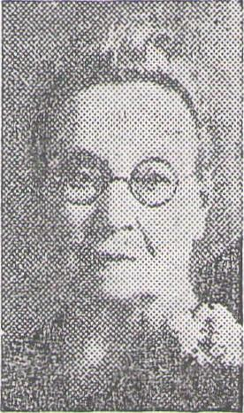
She was the grandmother of Mrs. Howard Berget, 331 Ninth av S.
13! ³
to
at -
pr, e
Tr
za
d
ve
is
I.
Services will be at 2:30 Thursday in Sand Hill Lutheran church of Climax. Houske funeral home Mrs. Estenson of Crookston is in charge.
Mrs. Estenson also leaves her husband; four sons, Oliver, Thomas and Haakon of Climax and Ivan of Minneapolis, formerly of Fargo; nine grandchildren and 12 great-”ft rulehiltirPn A son. Georsze duo
Mrs. Evers Dead; Rites Thursday⁻4/
Binford, N. D. — Mrs. John (Sarah) Evers, 80, resident of this area 58 years, died Sunday in a Valley City, N. D., hospital.
Services will be at 2 Thursday in S. J. Quam chapel, Cooperstown, N. D.
Mrs. Evers, formerly Sarah Hell-wig, was born in Ontario, Canada, March 27, 1870. She was.married in Canada in 1892 to John Evers, who had previously homesteaded in Griggs county, N. D.
Following their marriage they settled on his homestead in Clearfield township, farming there until two years ago when they moved into town.. Mr. Evers died May 7, 1950.
She leaves two sons and a daughter, Albert, Norman and Martha Evers, all of Binford; five fisters, Mrs. Alvina Evers, Detroit, Mich., and Mrs. William Berry, Mrs. Maggie Evers, Mrs. Joseph George and Mrs. Clara Cochrane, all in Canada, and seven grandobildrpri
Mrs. Ermatinger, Rural Valley City, Dies At 54
Valley City, N. D.—Mrs. William Ermatinger, 54, lifelong resident of this area, died at Medina, N. D., Wednesday. The former Susan Viola Keys was born at Leal, N. D., March 2, 1895.
Surviving are Mr. Ermatinger; five sons, Glen, Ralph and Dennis of Valley City, Edward of Wimbledon and Leonard of Springfield, Ore.•, a brother, Ralph Keys, Luverne, N. D.; a sister
Claren (Nina) Slerrt⁻n, Coo ers-
t_{r6}:11,...N:R., an our grandchil-
d n.
Services will he today in Sibley Trail church, Rev. Thomas Barnard officiating and HolbergPeterson funeral home in charge.
‘‘‘
Binford Woman Fatally Burned(4
Valley City, N. D.-(1P)-Mrs. August Evers, 82, of Binford, N. D., was fatally burned in an accident at her home Sunday morning.
She was carrying an ashpan partly filled with red coals outdoors when she tripped and fell into the burning embers. Her clothing caught fire and her entire body. was burned, doctors said.
She died in a hospital here Monday.
Rites For Mrs. Evers/ At Binford Friday y⁽g/
Binford, N. D. — Services for Mrs. August Evers, 82, who was fatally burned at her home here Sunday will be Friday at 11 a.m. in the home, Rev. Ray W. Radliff of Cooperstown officiating, and at 1 p.m, in the Masonic temple at Cooperstown, conducted by the Order of Eastern star. Burial will be at Valley City with S. J. Quam funeral home of Cooperstown in charge.
Mrs. Charles Ernst returned Sunday by bus from\A3rainerd, Minn., where she had gone to,.attend funeral services for iler_{l}mot.1₁er_{i} the late Mrs. Anna M. Brown. Services were held from the Catholic church at 8:20; Thursday morning and burial was at Evergreen cemetery.
Shirlee Ellingsen,, Billings Married
Shirlee Ann Ellingsen, daughter of Mr. and Mrs. K. M. Ellingsen
of Cooperstown, N. D.. and Dennis
M. Billings, son of Mrs. Irene
in the home Of tne tanie
The couple left on a wedding
p to Canada and will make their
aome at Noonan, N. D. where both
will teach.
By GIFFORD HERRON

North Dakota Whirligig
Legislative Session Produces
Little New Political Timber
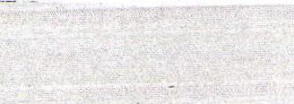
That was pretty well demonstrated last year. Coming out without a GOP convention endorsement, Dahl easily defeated the endorsed candidate for lieutenant governor, Orville Hagen of Arnegard, in the primary.
As for retirement, Dahl chuckled and said, "I don't think I'll ever be inactive in North Dakota politics as long as I'm on my feet."
Which brings up the argument of why should Dahl be any different from most others who have led active political lives. They just don't have a tendency to quit.
And the name Dahl seems to be a magic one to draw North Dakota votes.
Besides his six terms as lieutenant governor and an unsuccessful candidacy for the GOP g u b e r n atorial endorsement in 1956, Dahl has also served as state senator from Griggs-Steele, he was a candidate for commissioner of agriculture and labor and he was one of the wheel horses in the days of the Republican Organizing Committee.
* * *
1.7 1 • 1
Albert Dahl'
Dies At 77 L...
COOPERSTOWN, N. D. —JAI-
°
bert Dahl, 77, retired Cooperstown area farmer, died Wednesday in a Cooperstown hospital.
The funeral will be at 1 Friday in Trinity Lutheran Church, the Rev. A. P. Tidemann officiating. Quam Funeral Home is in charge.
Born at Fergus Falls, Minn., Nov. 20, 1879, Mr. Dahl grew to manhood there and married Anna Jensen at Alexandria, Minn., Dec. 17, 1903 They came to this area in 1905. Mrs. Dahl died Jan. 10, 1940.
He leaves three sons, Duane of Seattle, Alford of Yakima, Wash., and Selvain, in Montana; a Baugh: ter, Mrs. Jeannette Testerman, Seattle; two brothers, Conrad of Stewartville, Minn., and Manton of St. Paul, and three grandchildren.
A son, Martin R. Dahl, was killed in France June 17, 1944, w le serving with the mechanized
World War II.
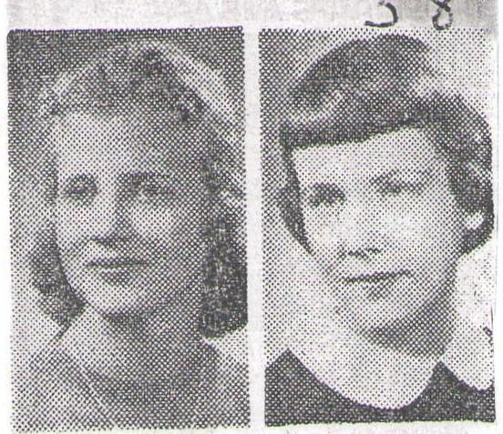
torate of this great state six times."
Some believed the announcement meant that the veteran political figure, who will be 67 next Sunday, was retiring from political life.
Others believed it ,=,as Dahl's way of announcing his candidacy for governor in 1960.
It's certainly no secret that Dahl would like to be governor of North Dakota. He tried for the Republican endorsement for governor in 1956 but was defeated in the convention by Gov. John E. Davis.
"It isn't either one of those reasons," said Dahl when asked what he meant in his statement. He declined to elaborate much on what he did mean.
A lot can happen in the next year so Dahl says it's too early for any announcement for candidacy.
Asked if he would accept a convention endorsement for governor, Dahl said:
"I'm not too concerned about conventions."
State Editor
There wasn't much action or talk during the 1959 Legislature to create speculation as to which legislator may be a candidate for what office in 1960, except possibly a statement by Lt. Gov. C. P. Era h I shortly Terre' the session adjourned.
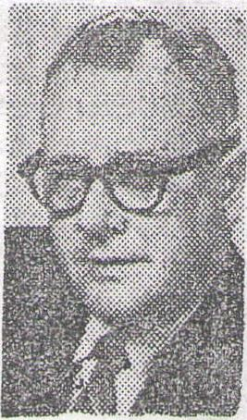
During t h e closing hours
of the session, Herron Dahl, president of the Senate, addressed the senators. His remarks, printed in the Senate Journal, the official record, were in part:
"When the gavel falls to indicate that the motion to adjourn this 36th legislative session for the State of North Dakota sine die, it will end. my career as presiding officer tf the Senate, a position I have enjoyed very much and an honor that has been bestowed upon me by the elec.
Honor students
Named At Sharan
Miss Halverson Miss Bergan
• SHARON, N. D, — Co-valedic-
torians have been named for the
Sharon High School graduating
class, according
to Supt. Ervin
They are Jewe 1 1 Halverson, daughter of Mr. and Mrs. Hubert Halverson, and Kay Bergan, daughter of Mn and Mrs. Arnold Bergan.
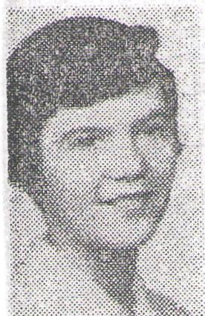
Salutatoria
Miss Duncan Mary Dune daughter of Mrs. Myrtle Dunc
Dilitcan-Ufion fliws Announced
" Mrs. Miles W. Duncan of Sharon, N. D , announces the marriage of, her daughter, Judy Ann, to
W. Utton of mo*::Ktim Grand Forks, son of Mr. and Mrs. Dana H. Utton of Minneapolis.
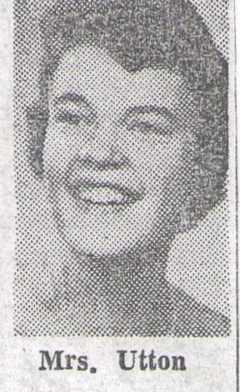
T h e wedding took place in the Sharon Presbyterian Church, with the Rev. Harvey Senecal of Cooperstown, N. D., officiating.
Mr. and Mrs. Utton will be at home at 307% DeMers Ave., East Grand Forks, Mimi Both will be seniors at the University of North Dakota this fall, where she is a member of Gamma Phi Beta Soror ity. He is employed by radio and television station KNOX in Grand Forks.
Former Lt. Gov. Dahl Suffers Slight S 41.
COOPERSTOWN, N. -
Former Lt. Gov. C. P. Dahl hospitalized here after suffering a "mild stroke" Thursday morn- ing.
Dahl is in satisfactory condition; according to his son, D. Philip Dahl, Bismarck, wno is attending his lather.
Local Ladies Attend Funeral Of Sister⁻f'
Mr. and Mrs. Edwiri ahl and Mrs. Leonard Larson went to Fargo on Thursday with Mr. and Mrs. Martin Vasfaret. From there they accompanied Mr. and Mrs. Dean Bruns and Mrs. Milo Vasfaret t o Menomonie, Wisconsin, to attend the fnueral on Saturday of Mrs. Charles Ordemann, sister of Mrs. Larson and Mrs. Dahl.
Mr .and Mrs. Vasfaret remained at the Milo Vasfaret home to take care of the children.
Mrs. Ordemann entered the Memorial hospital in Menomonie December 26. Mrs. Larson and Mrs. Dahl "were called to her bedside January 6 and spent a week. She was thought to be improving, but on February 14 she suffered a stroke and died February 17.
Mrs. Ordemann had visited her sisters here many times. Others who attended the funeral were her brother Mr. Russell Plummer, and his wife; and a nephew, Darwin Dahl of Chicago, ₁111., and his wife.
On their way home. Sun-!day the people from here visited at the Robert Bruns Home in Minn pa nnl i
Dahl Released
From Hos ital
COOPERSTOWN, N ,D, liP)—C. P. 'Dahl, former North Dakota lieutenant governor and state senator and long prominent in Republican politics, was dismissed Thursday from a hospital here after being treated for a light stroke suffered Dec. 12. Dahl, 65, said he feels "just' fine" and had thrown off a slight speech difficulty that had troubled him for a few days. His physician agreed that Dahl had "come along fine."
Dahl, who said he will rest at his home here for a few days, declared he expects to take part in the 1958 political campaign.
"This won't slow me up," lie as serted. "I'll be active some place."
He declined, however, to -
ate on that statement.'
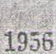
Dahl was a bidder at `tli Republican state endorsing cOnVerition for its endorsement for goliernor. However, the convention endorsed John E. Davis. now 20V-
Enos Erwin Downe was born on _{i} June 11, 1870, in Westminister, near St. Thomas, Ontario, Canada. Shortly after the family moved to Exeter, Ontario, and here he spent the early
days of his life. His mother died
while he was an infant. He _{rece}i_{ve}d IGGS COUNTY, NORTH DAKOTA, •

Will E Carl al
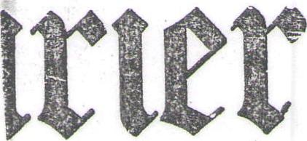
COURIER—VOL. 52—NO. 23
Enos E. Downe
Suicides After
Despondency
Enos -E. Downe County Citi-
zen Dies at Home Satur-
day Morning
Lived Here Since 1893
Jas Widely Engaged in Busi- ness Enterprises During Residence Here
Despondency brought on by a seige of melancholia from which he was suffering, on Saturday morning of last week caused the suicide of E. E. Downe, one of Cooperstown and Griggs county's best known citizens. Mr. Downe had been ill at his home here for several weeks. The news was a great shock to all of his wide acquaintance.
On Friday evening Mr. Downe had retired as usual. Saturday morning he was heard to be up and around in his room at about 8 o'clock. His wife, who occupied an adjoininng room, heard his movements, unaware of the preparations he was making to take his own, life. The rash deed was performed with a twelve guage shotgun, with a cartridge from which the Shot and wadding had been partially
removed. Hence the discharge made little detonation. In suiciding Mr. Downe had sat in a chair, placing the gun barrel in his mouth with the butt resting against a radiator. He had then used a coat hanger to release the trigger. •
Hearing an unusual noise in his room, only slight because of the partially loaded shell, Mrs. Downe, apprehensive of what had happened, rushed into the room to find him lying ⁻on the floor. Medical aid was summoned, but death had been instantaneous.
his early education in the Canadian schools and In boyhood made his confession in Christ and united with the Methodist _Episcopal _church.

Is Buried Tuesday
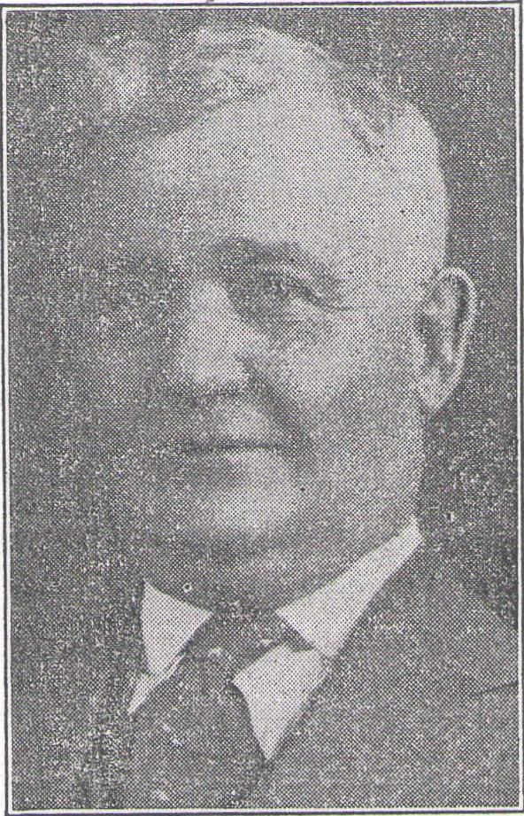
E. E. DOWNE
Prominent Griggs county citizen and business man and former mayor of Cooperstown who was buried following funeral services held locally on Tuesday afternoon.
••••••-
p. 01,Vt4l^{"--}
344 L. A. Benson, the former Clara Duea, 1019 Ninth av S, wall honored at a dinner given by 3 group of friends in the Silver room of the Graver hotel Tuesday evening. Covers were laid for 15. A gift of sterling silver was present.' ed. Before her marriage, Mrs. Benson was , head of The piano and organ department of Concordia college.
-.••••••••••
Completing his education he was for a time employed as cabinet-maker in the Earn Organ and piano factory at Woodstock, Ontario. In the spring of 1893 helocated in Cooperstown where for a time he followed the carpenter trade. Later he entered the meat business and conducted a meat market in this city until disposing of in 1914.
In 1897 he was united in marriage to Miss Christine Hammer, who passed away in 1914. On November 21, 1918, he was united in marriage to Mrs.. Clara. Bothwell Markvvoo•, who survives him. Others who are left to mourn are four brothers and two sisters: William R. Downe of Virden, Manitoba, Rev. John Wesley Downe of Exeter, Ontario, a retired minister of the Methodist Episcopal church, Frederick H. Downe of Woodstock, Ontario, Albert E. Downe of Houston, Minn., and Misses Emily and Mary Elizabeth Downe of London, Ont. A step-daughter, Mrs. J. E. Ballenger of Lincoln, Neb., and a step-son, Eugene Markwood, also survive.
Prominent In County
Mr. Downe has long held a position of, great prominence in the county, due to his large business interests. During his residence here he had accumulated a large fortune, the largest share of which had been invested in Griggs county farm land.
In the city he held the office of mayor for two terms, during which he gave a splendid administration and spent much of his time in promoting the city's interests. He was liberal in his support of the local Presbyterian church, was a member of the local Masonic and Knights of Pythias orders, the Cooperstown Commercial club and was instrumental in organizing s. Kiwanis club several years ago. •
Funeral Tuesday

I | 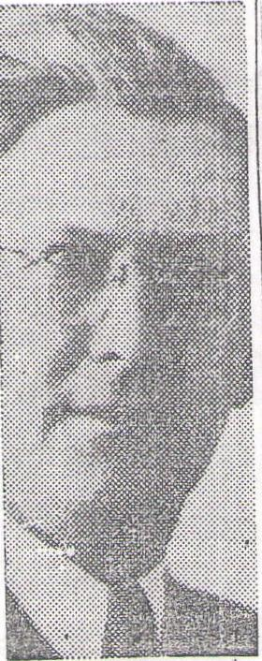

Dahl
Funeral services, which were largely attended, were held from the Presbyterian church on Tuesday afternoon of this week. Dr. LeRoy C. Cooley preached the funeral sermon. Musical numbers were furnished by Mrs. O. M. Jenson, Who sang two solos, and also songs by a men's quartet. Mrs. S. J. Qualm. played the accompaniment, with Geraldine Stringer at the organ. Pall bearers were Theo. Marquardt, 0. J. Thompson, W. P. Hammer, H. G. Hammer, A. E. Detwiller and J.' W. Sanders, the latter of Killarney, Manitoba, an
old school mate of the deceased. Burial was made in the Cooperstown. cemetery.
_{HENRY DAHL HAD} yearto town became eschool, astd_{f}e_{r}n_{on}tl of _{h}?o_{l}op .Coopers-

1./CeeUll. ille 61 alte
in Romness township in the spring
of 1919, and in the fall of that same
Mrs. T. H. Dahl
Died Febrqary 27
Resident 61—County Since
1884 Passes Near Binford
From Pneumonia
By MRS. C. E. PETERSON
Ingeborg Knudsdatter Thune was born in Vang, Valders, in Norway on July 9, 1858, christened on October 3, 1858 and confirmed June 18, 1873. Death came Friday morning at 3:00 o'clock following an illness of pneumonia and pleurisy resulting from an attack of influenza. At the time of her death she was 72 years, 7 months and 16 days of age.
Deceased came to Northfield, Minnesota in 1879, going from there in 1881 to Granite Falls, where two years later, she was united in marriage to Thorwald H. Dahl. Rev. Ole Lokensgaard performing the ceremony. In 1884 Mr. and Mrs. Dahl moved to Griggs county, where they have since made their home on a farm four miles south of Binford. Ten children, six boys and four girls, were born to this union, one boy, Anton, preceding his mother in death 23 years ago.
Mrs. Dahl was the soul of kindness. In any case of sickness or trouble, she would be ready with help or sympathy. Her memory will be cherished as a good neighbor and faithful friend.
Deceased leaves to mourn her passing her husband, Thorwald H. Dahl and the children, namely, Mrs. Ida Pittenger, Mrs. Helda Vangen, John Dahl, Edwin Dahl, Ivex Dahl, all of Biitford, Knute Dahl, Cooperstown,_{i} Thomas Dahl, Hannaford, Mrs. Annie Johnson of Granite Falls, Minn., and Mrs. Mathilda Edwards of Killdeer. All the children were present at the funeral. There are also 40, grand children and 6 great-grand- children, besides other relatives, who survive.
Impressive funeral services were held on Monday at 2:00 p. m. at the Trinity Lutheran church, of which congregation deceased was a member. !Rev. Ovrebo of Aneta officiated. The floral tributes were many and beautiful, and the attendance was one of the largest held in this community. Interment was made in the cemetery west of Binford.
y^{ea}r he • would have graduated.
GIVE
FINALLY _{TO} ₁ Henry_{n}is _{n d}remembered bey _{in} his _{s}school _{as} _{a}
h
Li
mighty _{on}t_{t}y
fine
s
_{en}y_{t}o.ung man and an ex-
_{e}i i_{l}g
UP LOSING FIGHT In addition to his mother and fath-
er, Henry is survived by three broth- ers, August, Helmer And John, and two sisters Agnes and Esther. All were p resent at the funeral yesterday excepting August, who is suffering an illness contracted in the same manner as that of his departed brother.
Senior Class of High School
Attends Funeral Yester-
day in Body.
MRS. F. SCHLINSS DEAD
Mrs. George Paintner, Sr.,
Passes to Her Reward at
Revere. Home.
The whole community is united in its sincerest nature of sympathy for the so rrowing father, mother, brothers and sisters.
1
3

Rites Monday or
Dahl, Cooperstown
Cooperstown, N. D. — Funeral services will be at 2 Monday in Cooperstown Lutheran church, Rev. H. J. Hansen officiating, for Oscar Dahl, 59, farm resident here 37 years who died Tuesday evening following a stroke.
Mr. Dahl had been employed at the Garfield Olson farm south of Cooperstown and was stricken while doing chores. He had previously been under a physician's care.
He was a veteran of six months service in World war I. Military rites will be in charge of the American Legion. The body is at S. J. Quam funeral home.
Born at Dalton, (Otter Tail county) Minn., Sept. 11, 1887, Mr. Dahl came to this area in 1910. He was unmarried. He leaves four brothers, Albert and John of
Cooperstown, Conrad of Stewartville, Minn., and Minton of South St. Paul, and a sister, Mrs. Serena Melby, Carrington, N. D.
Dies At Cooperstown
Cooperstown, N. D.—Miss Emma Dahlbom, 62, lifelong resident of this community, died here Thursday. She was born in Clearfield township, Griggs county, June 28, 1885. She leaves her mother, Mrs. Christine Dahlbom; t w o brothers, Andrew and Jack; a sister, Anna, and a niece, Marliss Ann Dahlbom, all of Cooperstown.
Funeral services will be in Bethlehem church, of which she was a, member, at 3 Sunday, Rev. K. P, Wuflestad officiating. S. J. Quam funeral home is in charge.
Cooperstown Soldier At School In England
S. Sgt. Neil C. Duffy, son of Mr. and Mrs. M. W. Duffy, Cooperstown, is enrolled in a liberal arts course at the University of Bangor, Wales, England, under the army education program. Overseas since August, 1944, Sgt. Duffy, participated in the Ardennes, Rhineland and Central Europe campaigns as a rifle squad leader.
I
E
f
Henry Arnold Dahl, eighteen year _ old son of Mr. and Mrs. Anton Dahl j r of Romness township, and A senior in Cooperstown high school, passed n away at his home at eleven o'clock ₁ r Saturday night.
The death causes much pain, not alone on the part of his parents, t brothers and sisters, but on the part of a great body of school and neighborhood friends who are going to miss this fine young man exceedingly.
Funeral services were held yesterday at the Romness Methodist church, Rev. Gilbertson of McVille officiating. The senior class of the Cooperstown high school attended the funeral in a body. The attendance and mourning at the funeral was evidence of the very high esteem in which Henry Dahl was held.
e
e
Death followed an illness running over two weeks, an illness contracted from drinking water used while with a threshing crew. Influenza,⁻ complicated with typhoid fever, was a complication from which the young man had slight chance of recovery. However, he was last week showing signs of recovery when symptoms of perforation of the bowels was discovered. A surgeon was brought from Vallley City to perform an operation, which was the only chance left to save the life of the boy. But the operation proved of no avail, Henry breathing his last Saturday night. -
Henry Arnold Dahl was born on February 7, 1904, in Romness township, having been at the time of his death a life-long resident ⁻There. He was baptized by Rev. P. NI. Hauge on March 1 3, 1904, and was confirmed by Rev. Korsmo on September 14, 1919.
SAD ACCIDENT.
RGO "0707 TAMS DAILY REPTIBLICA
.•••:1=11..
Page 7—THE FARGO FORUM—Friday Morning, April 4, 1947
YOUNG DAUGHTER OF MAYNARD CRANE OF COOPERS-
TOWN ACCIDENTALLY KILLED IN MINNESOTA.
One of the most distressing accidents that ever occurred in this vicinity took
place near Fisher, Minn., yesterday,
when Alice, the 13 year old daughter
of Mr. and Mrs. Maynard Crane of Cooperstown, was crushed to death under the wheels of a binder. The little child was visiting at the home of Mr. and Mrs. F. R. Parsons near Fisher, and was playing about the yard yesterday afternoon with a number of other children. She was amusing herself with a little pony, which she finally hitched
-to the end of a binder tongue. In some manner the pony was startled, and started forward. The little child fell in front of the machine, and the pony pulled the binder over her, the large wheel passing over her head, crushing the skull, death ensuing instantly.
Northfield Girl
Local Man Wed, ,,,T
Will Make Home In
Minneapolis Where Groom Is Now Employed
Evelyn Clarke, daugnter or Mr. and Mrs. Joseph F. Ziegler of Northfield, Minn., became the bride of Clarence Christianson, former Coop- efitown youth, in a ceremony per- form hl June '16 in the Methodist Parish4ouse of that city by Rev. LeRoy TT:Klaus, it was revealed here .ebit wOk.
TiCe<weddifikwas conducted in the traeht)onal csetting of flowers and music:vith fh father giving the bride in/na'arrra.ge. Attending the couple vie* Mrs,/( Constance Clark, the bride's ' er, who was
maid of honor, an anley John-
son of Cooperstown, o' was best
man.
Sixty guests attended recep-
tion which was given following the wedding. The couple left etbereaf ter on a wedding trip thibugh orthern Minnesota and the Glacier and Yellowstone national parks.
The bride is a graduate of Northfield high school. Mr. Christianson, who graduated from the local high school, also attended St. Olaf college in Northfield.
They will make their home in Minneapolis where the groom is employed with the Walgreen Drug company.
Crane, Lumber
Firm Founder,
Dies In Florida
Maynard Crane, 90, president of Crane-Johnson company, lumber dealers, which he founded in Cooperstown, N. D., March 1,
1883, died Wednesday in Man-
darin, Fla., where he made his
home.
Mr. Crane served four terms in the North Dalkota senate from 1903 to 1909, representing Griggs and Steele counties and had also been on the governing board of NDAC.
Born at Caldwell,. N. J., Dec. 25, 1856, he was educated at Newark, N. J., and at Mandarin, where his parents moved when he was 14. He went into the coal and lumber business in New Jersey at 18. His father had acquired some land in Dakota territory, and he sent Maynard to the Cooperstown area to establish title to the land, later financing the establishment of the lumber company.
One of Mr. Crane's reminiscences was the purchase by the company in its early days of large quantities of buffalo bones. He recalled two huge piles each 300 feet long and as high as the bones could be thrown from wagons, awaiting shipment east. The sale of the bones enabled many early settlers to finance their first years on Griggs county farms until the land produced crops, Mr. Crane said.
The Crane-Johnson company
a later expanded its operations to
include offices in many other
0
towns in North and South Dakota. The main office was moved to Fargo about 30 years ago and had remained here since except for a period of time when it was at the West Fargo yards. A Fargo yard was established about four years ago. Mr. Crane continued actively interested in the firm but had lived in Florida most of the time in recent years.
He married Sarah Elizabeth Fitch of New York city in 1886. Mrs. Crane died in 1914, He leaves • a daughter, Mrs•. Robert (Kathleen) L a du e, Tuckahoe, N. Y., and two grandchildren. Another daughter, Alice Maynard Fitch, died in 1903.
Mr. Crane was a member of Northern Light lodge 45, A. F. and A. M., Cooperstown, of Dakota Consistory, Scottish Rite, and of El Zagal temple of .the Shrine. Funeral services will be in Mandarin at a time to be set.
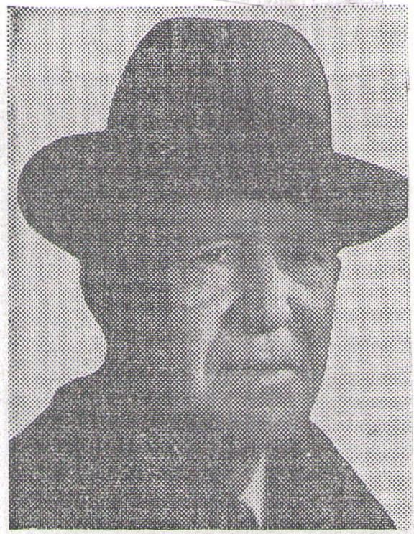
FUNERAL SERVICES will be at 11 a. m. today in Mandarin, Fla., for Maynard Crane, pioneer North Dakota lumberman and president of Crane-Johnson com pany, who died Wednesday in his Mandarin home. Mr. Crane, who came to Dakota territory about 1880, left Fargo 10 years ago, but had continued as president of the lumber company.
HARRY CLARK. OLD PIONEER, DIES IN LE ROY, NEW YORK

Mrs. Christenson
Of Tyrol Is Dead
Fifty-four Year Old Lady Is Laid To Rest After Services June 4 if
Mrs. Otto Christenson, a resident of Griggs county for 25 years, died at her home in Tyrol township Saturday morning, June 2, after a long illness. At the time of her death she was 54 years, 3 months and 21 days of age. Funeral services were held the following Monday at the Ottawa church. Rev. :S. T. Nelson of Aneta conducted the services.
Pauline Pederson was born. Febru_, try 11, 1880, at Helgeland, Norway, c',id was baptized and confirmed in
ie Lutheran church. She came to America in 1909 and has since that time made her home in Griggs county. In 1916 she was united in mar• riage to Otto Christenson..
She is survived by her widower; three children; Jinnie, Norman and Ruth; two sisters, Mrs. Theo. Moe, Cooperstown, and Mrs. Nels Loerntson, Kent Wash.; two brothers, Albert Pederson:, Bergen, Norway, and Hans Pederson, Seattle, Wash. Two brothers preceeded her in death.
;_.
There are many here who remember the man and will be interested in learning that Harry ,Clark, a Griggs county pioneer, passed away at his home at LeRoy, New York, on _ March 14th. He had reached the age of 83 years. V
'Mr. Clark left here about 25 years ago of ter farming for years in the north part of the county. For many years he was postmaster at Willow, That was during, the days when mail was carried by stage from Hannaford north.
Mr. Clark was a 'Civil war veteran and ,a man who stood very high the estimation of all who knew him. His wife died several years ago. He is survived by his daughter, Miss Elizabeth, and two sons, Calvin at LeRoy, and Lee at Washington, D. C.
Henry Catis
Died Nov. 25
Mr. Henry Curtis, one of our most highly esteemed and beloved citixens, passed away Monday night, November 25, 1929, at the age of sixty years, five months and ten days.
Mr. Curtis was born in Ada, Michigan, and moved to North Dakota with his mother, brothers and sisters at the age of twelve years, where he has ever since made his home. He was one of the true pioneers, having seen the country change from virgin prairie to a well settled and cultivated country dotted with small towns and he has done his share toward the building.
He was united in marriage with Miss Christena Stewart, May 23, 1894, which union was blest with four children, Florence, Edgar, Howard and Merle. They made their home on the homestead in Broadview township. Mr. Curtis during his residence in this community was honored with many positions of trust in the church, the township and in the school district.
Mr. and Mrs. Curtis early affiliated themselves with the Congregational Church of Sibley Trail and also aided in the building of a church at Karnak, the townsite of which was on their land.
His son Merle and Mrs. Curtis preceded him to his heavenly home, the former, May 22, 1924, and the latter, January 3, 1919. Altho the loss of his dear companion left him lonely and disconsolate, he carried on with
courage and cheerfulness for the sake of his children and grandchildren, wlio will miss his presence deeply. During the trials and vicissitudes, which every one must meet in this life, he sought and found strength from One who never fails to guide us thru the Valley of the Shadow.
Deceased leaves to mourn his passing his daughter Florence and two sons, Edgar and Howard, his brother Mark Curtis and sister Elizabeth, other relatives and a host of friends.
Funeral services were held from the Fadbury Congregational Church Thursday, November 28. Rev. Ernest Meyer of Hannaford officiated at the services. Interment was made in the Ladbur_{y} cemetery. Many besides the relatives braved the bitterly cold wintry wind to pay their last respects to the memory of this fine man.
The community and friends, far and near, extend their heartfeit sympathy to the family in their bereavement.
Card of Thanks
We wish by tis means to express our most sincere thanks to all wh.) assisted us during the long illness and afterwards of our father and brother. we are deeply grateful to Rev. Meyer for his kind words; to the members of the choir who assisted at the funeral services; for the beautiful floral offerings, and to all who have been kind, to us in this our great bereavement.
Mr. and Mrs. H. R. Kinn
Mr. and Mrs. E. T. Curtis
Mr. Howard Curtis Mark Curtis and family

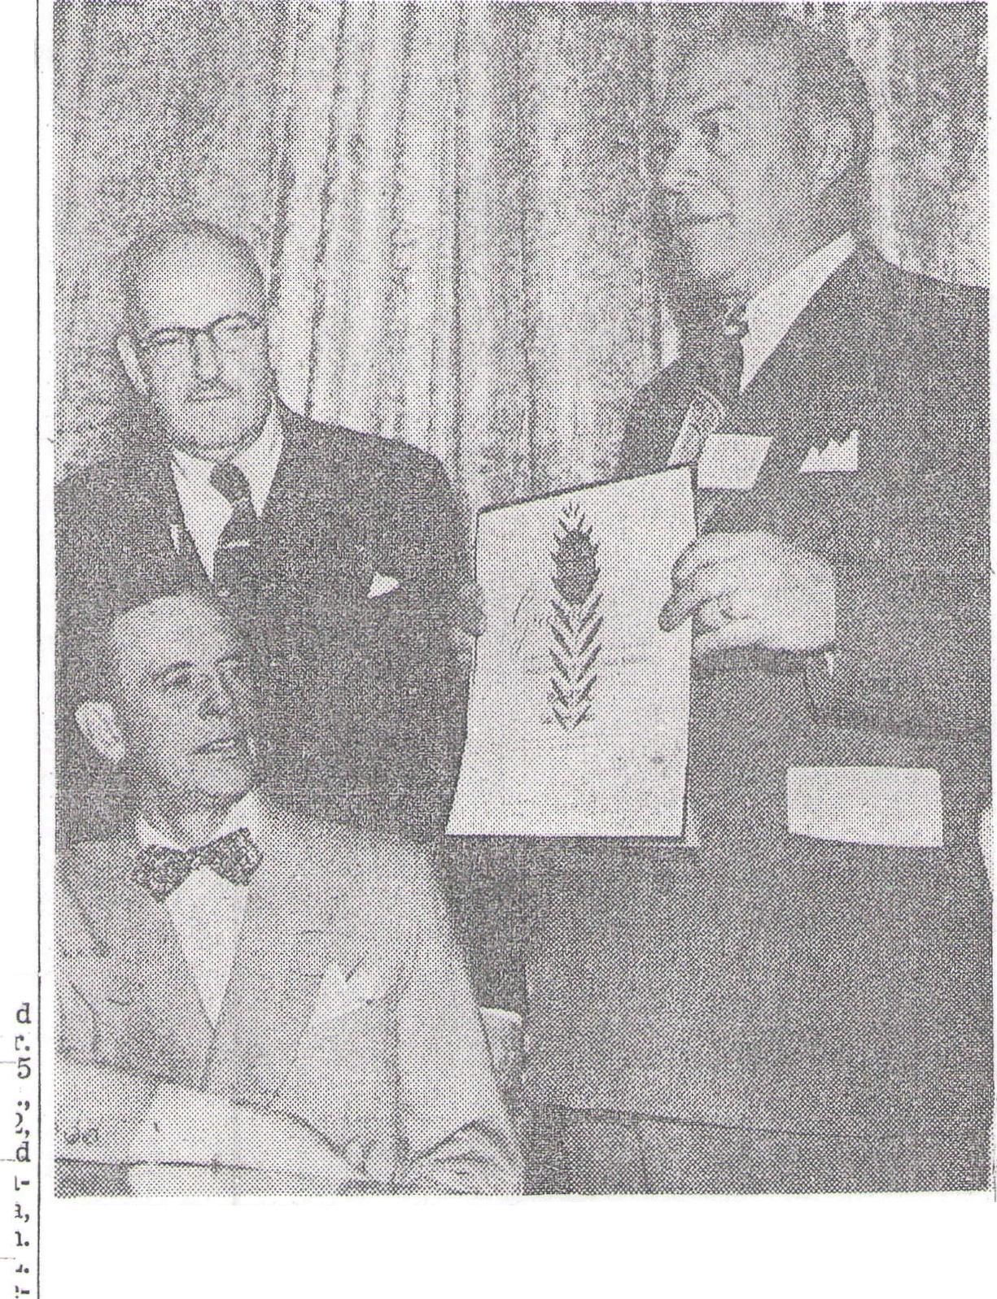
Polio Tare

Murdered Friday
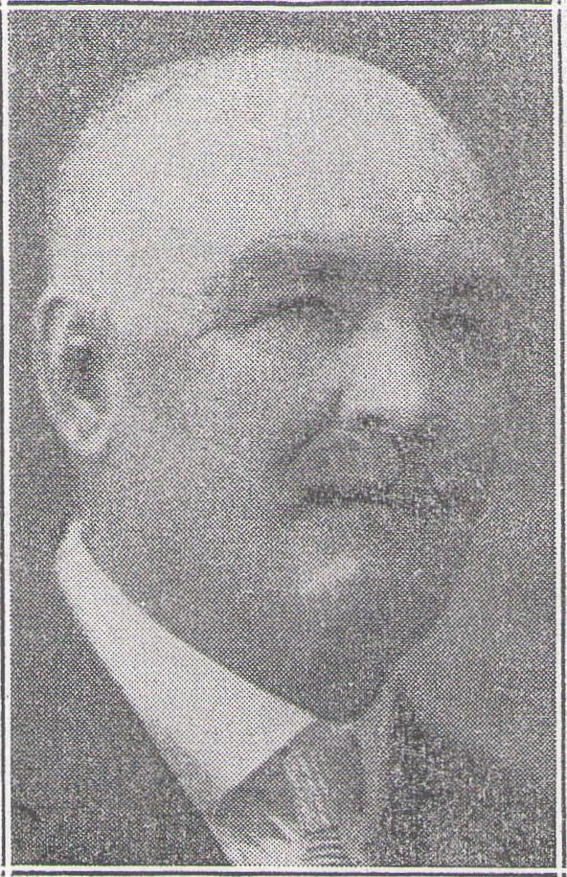
ALBERT CAMPBELL
Prominent Griggs county farmer living northwest of Cooperstown, last Friday was shot and killed by John Slabber, 50, a neighbor. Funeral services were held at the Masonic Temple on Tuesday of this week. Slabber was sentenced to life imprisonment when he appeared before Judge Englert at the court house Monday afternoon.
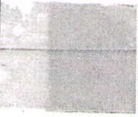
1
g
F
F
t
li
r - 1
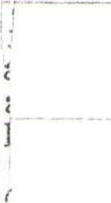
Here usiness circles
ei. Forum Staff Writer
A tag day 1. 4. 4. + ♦ .1.
—will be ‘-f
Fasig⁻tggs Gets National Award
1
-1 t f r
a
r
it
a.
n
LS
n
i-
d
and conscientious service to hi:, consumers and community."
WARD D. BRIGGS, president of Crane-Johnson company, Fargo, has been awarded the Master Merchant certificate by the American Lumberman magazine, Chicago. The award is made to outstanding building materials dealers throughout the country selected by the editors of the national trade magazine.
Mr. Briggs, a former president of Northwestern Lumbermen's association, received the award from Arthur A. Hood, editor of .American Lumberman, at the recent Northwestern convention in Minneapolis. The certificate cites Mr. Briggs for "intelligent manage
ment, progressive merchandising In back is Mr. Hood.
+ + + + ••¹ + • +
Crane-Johnson Co. and its presi, dent were featured in a three-page article in a January issue of the magazine. The cover pictures the exterior of the West Fargo Lumber and Supply company with an insert of Mr. Briggs. He is the only retail building materials dealer thus far in North Dakota and South Dakota to receive the Master Merchant award.
a
⁻d
e
Mr. Briggs is shown in the above photo holding the certificate. William Badeaux, seated, is secretary of the Northwestern association.
:Mrs. Rose Clem
Of Cooperstown ies^{t6\-}J
-• Cooperstown, N. D. — Services :will be Saturday at 10 in the St. % George's Catholic church here for :Mrs. Rose Feibiger Clemens, 78,
•
who died at her farm home Wed': nesday. Burial will be in the
- i church cemetery.
She was born Oct. 27, 1871, in Germany and came to the United States with her father in 1886, settling at Jessie, N. D. She was married to Gustaf Clemens Aug.
- 11, 1891, at Jamestown. Mr. Clemens died in 1937.
- Mrs. Clemens is survived by five daughters, Isabelle of Coopers, town, Mrs. Iver (Anne) Bodell of : White Sulphur. Mont.; Mrs. Julius :'(Martha) Sletten of Juanita, N. D., Mrs. Albert Rickford of Wallum, N. D., and Mrs. Frank
(Minnie) Nierenberg of Cooperstown; two sons, Harry of Hanna' ford and August of Cooperstown; 24 grandchildren and 11 great grandchildren.
-- Guam funeral home of Coopers-
John Carlsons, Aneta;50 Note 60th Anniversary
Aneta, N. D. — Mr. and Mrs. John Carlson, farmers in the Aneta community for 48 years, celebrated their 60th wedding anniversary.
They have five children—Carl, John and Anna, all at home; Levi of Great Falls, Mont., and Mrs. Gilmore Helgeland of Stockton, ^{+rn's}
Calif. — four grandchildren and
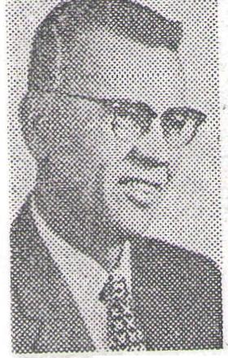

Arvid Benson Supply Co. of buildings and room is provided Moorhead, which recently pur- for a packing and shipping de-chased the Cass-Clay Creamery partment, and storage areas. The
I n c. property area is on NP trackage.
at Main Avenue a n d 9th Street in Moorhead, will open a new retail h a r dw a r e, appliance, b o a t, o u t board motor a n d sporting goods
Benson e stablish
ment there about Oct. 15.
Benson has a crew literally tearing out the insides of the 225 by 150-foot building area.
The structures, including main building and former garage, provide some 40,000 square feet of floor space. Of this about 23,000 square feet will be devoted to the retail store operation, the remainder for warehouse storage.
Benson purchased the building and land, with a frontage of 225 feet on Main Avenue, from Cass-Clay Creamery, Inc. in J u 1 y. Also included in the transaction were three 25-foot lots, each 150 feet deep on Main Avenue⁻ on the west side of 9th Street which will be used for parking.
The project, including property purchase, represents an investment of more than $150,000.
COOPERSTOWN, N. D. (AP) — Wednesday by Al Bakken, Griggs A routine investigation of a fire County States attorney.
Oct. 24 which destroyed the Farm- Burmeister, 59, was arrested by ers Union Grain Terminal Assn. Sheriff W. E. Haeter of Coopers elevator at Jessie, N. D., has un- town Tuesday, waived preliminary covered alleged practices .of fraud hearing before Justice of the by the elevator manager, George Peace Melvin Nelson here and was
Burmeister, it was reve#Ied, bound over to district court in
lley City. Trial is set for today
efore Judge John Sad.
¹- Burmeister is charged with is,
suing a check for $98.94 on June
4, supposedly in payment for 102
bushels of barley. He admitted
in a confession that he had en,
lorsed the check, forging the patron's name and Cashed it in a Binford, N. D., store.

Burmeister said he had repeat
3d the act four other times in the )eriod immediately prior to the
are and had also issued frauduLent storage tickets for grain never

received.

He planned, Burmeister told of
ficials, to make good the five
checks, totalling approximately
$400, by giving farmers less weight
for their grain than they should

actually receive, so that his rec

ords , would show an overage in

stead of a shortage.

Investigation by Vance Arneson,
deputy state fire marshal, and Er

nest D. Grossman of the National Board of Fire Underwriters, re

vealed a discrepancy in Bur
meister's records.

here was no evidence of arson
the fire. Arneson saki
Practices Of rqu_{i}d
Uncovered During F PrObe
The original Cass-Clay Creamery building, 60 by 100 feet, has been torn down, providing additional parking space along the Northern Pacific railway right-of-way.
Cass-Clay was organized in 1935 and in 1941-42 built an addition to the original structure, adding a garage and warehouse in 1947- 48. A new plant in Fargo was occupied in 1957.
Features of the new Moorhead layout will include a large display area for hardware, a room for display of lighting fixtures, a "marine center" in the former garage space for display of boats, outboard motors and sporting goods, a large area for display of electrical appliances, a large office area and warehousing fa cilities.
Two freight elevators serve the
Alfred Bailey/Di
Alfred Bailey, 07, Cooperstown:; N. D., city employe, died at 7:30l p.m. Sunday in a Fargo hospital) He had been admitted earlier in the day after becoming ill and being brought here by Quam Ambulance.An autopsy was sched-' uled. Quam Funeral Home of Cooperstown will have the service.
nannaford Rites; For Mrs. Bakkeil.‘
HANNAFORD, N.D.—Mrs. Mar. kus Bakken, 75, long time resident here and mother of a Fargoan died Tuesday in a hospital it Cooperstown, N.D., after a cere bral hemorrhage the day before.
Mrs. Bakken was the mother of John Bakken, 315 18th St. S., Far. go. The funeral will be at 2 Fri. day in Hannaford Lutheran Church, the Rev. Alex Thompson official.ing.
Mrs. Bakken, the former Mini Sebby, was born in Hardanger, Norway, Aug. 13, 1882, and was married to Mr. Bakken here in November, 1911.
Besides her husband and the Fargo son she leaves another son, Arthur of Crookston, and two daughters, Mrs. Claude ^{Minn.,}Myr- tle) Freer, Hannaford, and Mrs. Iva/. (Thelma) Nelson, Phelps, N.Y.
,The' body is at Quam Funeral
Ilcime of Cooperstown.
IT. Anna B attie
Of Hannat d Dead
HANNAFORD, N. D. — Mrs. Anna Beattie, 70, died unexpectedly Sunday at the home of her son-in-law and daughter, Mr. and Mrs. Erwin Steffen of Cooperstown, N. D.
W. D. Sinclair Funeral Home
Benson Plans Big Hardw&,
Boat Center, Appliance Store
The "marine center" will be a highlight of the display area. It will be reached by main double-door entrances off Main Avenue and a parking 1 o t, through an arcade-type corridor flanked on either side by large lighted window displays.
The center will be fitted with equipment resembling a ship's deck, with marine type railings and a balcony on one side overlooking the display area. The balcony will overlook the display area, where boats will be shown on an aqua-colored floor.
The marine center will occupy 10,000 square feet of floor space and the balcony will be 110 feet long and 65 feet wide.
On an tipper floor occupying the front of the main structure, 1,500 square feet of rental office space will be provided. This area will be reached by a separate entrance off Main Avenue.
Space, also has been provided for shops to repair and service outboard motors and electric ap-, pliances.
The Benson firm w ill move from its location at 1625 1st Ave. N. This property, 90 by 150 feet, has been put up for sale or lease. Benson also owns a tract along 1st Avenue, 300 by 150 feet, which will be sold.
The firm will continue al,:an S & Q (formerly Janney-Semple: Hill) outlet for hardware merchandise, also as a General Electric, Scott motors , and AlumaCraft and Glastron boat dealership.
Representatives of the supply houses have been here for two or three weeks assisting in setting up the new merchandising display areas and they say the new establishment will be one of the largest hardware, appliance, boat and outboard motor establishments between Chicago and the West Coast.
Benson recently established the Benson Oil Co., distributor in the Fargo-Moorhead area for the Carter Oil Co.
Benson is a native of Cooperstown, N. D. He was graduated from high school at Hannaford, N. D. and a short time later entered the hatchery business 'there. He became associated with M. W. Cousineau in the hatchery business in Moorhead in 1937 and in 1949 purchased Cousineau's interests. He changed the name to Arvid Benson Supply in 1950 and moved the business from Center ?venue in Moorhead to the 1st Avenue location.
Ilosintaltzec, In N.
DICKINSON, N.D. (AP) — A Minneapolis woman and a North Dakota woman remained hospitalized at Dickinson late Friday after a school bus-car accident near Belfield.

D. Crash ⁴¹
, Injured were Mrs. Mabel Boe, 70, of Hannaford, N.D., mother of Norman Boe, 47, St. Paul, driver of the car, and Mrs. Jenny Ellingsworth, 66, of Minneapolis, Boe's aunt. Both women were in good condition.
Officers said a converted pickup truck used as a school bus at Bel-field was making a left turn off U. S. Highway 10 near Belfield Thursday when it was struck from the rear by Boe's car.
Frank Heiser, 62, of Fryburg was the bus driver. Three of the five children aboard were treated for cuts and bruises after the bus rolled over on its top.
Mrs. BO4hee, 52, _{A},
r
Dies Near Sutton')
SUTTON, N. D. — Mrs. John Boschee, 52, died Monday at her farm home near here after a short illness.
Mrs. Boschee, the former Ella Bierman, was born Jan. 14, 1900, at Aberdeen, S. D. She was married to Mr. Boschee Jan. 31, 1923. They resided for a time in the McClusky, N. D., vicinity before rnovling to their present farm nine (years ago.
Survivors a r e Mr. Boschee; three daughters, Mrs. Woodrow Larson of Glenfield, N. D., Mrs. William Warner of Leal, N. D., and Lorraine, at home; a son, Dennis, at home; nine brothers and two sisters all residing in the Aberdeen vicinity, Mrs. Otto Krause and Mrs. Ed Krause, Ernest, John, Albert, Carl, Oscar, Harold, Frank, Nels and Bennie Bierman, and one grandchild.
Service will be- at .2 Thursday in the Mabel Lutheran Church near Sutton, the Rev. Corliss Rasmussen of Cooperstown officiating. Burial will be in the church cemetery. Quam Funeral Home of Cooperstown is in charge.

AIT
,-„ | -,cs

7ednesday naming. about 5 o lock On d T. lson Chein or "Piener, uns found in his a⁻en at ? is far=, on the river
(Sheyenne) dead. Lis horses had became entangled in a wire fence and ste⁻yoed. de r body was lyinG face dem utile the face was beaten into
n unrecocnizable L'ass. 1:e had left tom (Coopersto7n) i in the evening before
e gat o'clock.11is been
v.7as seen running at various-points on the
er road without a driver;and at 0,10 point, his body was 'ooundinG on
Gild ride was over the Sheye= on the river. It is now dis-
from rheunn:bian and to alleviatE
the actin bed the horses junDed.
brill48. and throurh•Eardell to his place Torod that the debeased was sufferinc
in tem ,been drinking considorably„altheuch he coroner's jury caaosed of
'A nioery „had ufile
uns not a drir77ir₄ nan
.3t ^{j}evens,...Letzlaff„_,G.Ackett and 2,2honDson,
roue t hat dye ct=;tee to
his death frame, a.t?elelzy_{l}heart disease or both; but coroner ttiff= the sJou2ding he received herr:les wore
runnnc_{l}ou2ficient to account for ⁻the death concussion ⁻)roducin
2. ielcon-Cp1:01- lerlver uife and c'lildron_{s}also (rand-children and a confartaUe ⁻⁻rno?erty. .e was settler in
Cor⁻rIty end was unn⁻niTiously respected by all uho Imeuhira His
⁻loral occurred Thursday and ⁻-no ln⁻7gely attended fran Cooperstown arid tii.o county."

